***“Studying the Gentile Prophets”—Intro to Obadiah***

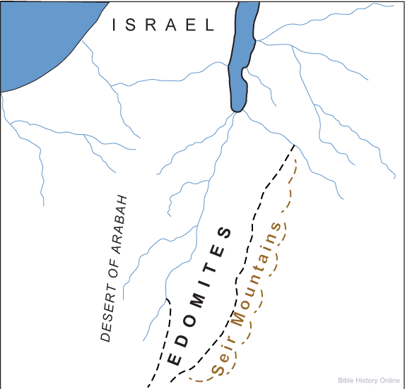

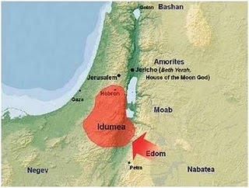

**The Edomites were the descendants of Esau, the firstborn son of Isaac and the twin brother of Jacob. In the womb, Esau and Jacob, twin sons of Isaac and Rebekah, struggled together, and God told their mother, Rebekah, that they would become two nations, with the older one serving the younger (**[**Genesis 25:23**](http://biblia.com/bible/esv/Gen%2025.23)**). As an adult, Esau rashly sold his inheritance to Jacob for a bowl of red soup (**[**Genesis 25:30-34**](http://biblia.com/bible/esv/Gen%2025.30-34)**), and he hated his brother afterward. Esau became the father of the Edomites and Jacob became the father of the Israelites, and the two nations continued to struggle through most of their history. In the Bible, “Seir” (**[**Joshua 24:4**](http://biblia.com/bible/esv/Josh%2024.4)**), “Bozrah” (**[**Isaiah 63:1**](http://biblia.com/bible/esv/Isa%2063.1)**) and “Sela” (**[**2 Kings 14:7**](http://biblia.com/bible/esv/2%20Kings%2014.7)**) are references to Edom’s land and capital. Sela is better known today as Petra.  
  
The name “Edom” comes from a Semitic word meaning “red,” and the land south of the Dead Sea was given that name because of the red sandstone so prominent in the topography. Esau, because of the soup for which he traded his birthright, became known as Edom, and later moved his family into the hill country of the same name.** [**Genesis 36**](http://biblia.com/bible/esv/Gen%2036) **recounts the early history of the Edomites, stating that they had kings reigning over them long before Israel had a king (**[**Genesis 36:31**](http://biblia.com/bible/esv/Gen%2036.31)**). The religion of the Edomites was similar to that of other pagan societies who worshiped fertility gods. Esau's descendants eventually dominated the southern lands and made their living by agriculture and trade. One of the ancient trade routes, the King's Highway (**[**Numbers 20:17**](http://biblia.com/bible/esv/Num%2020.17)**) passed through Edom, and when the Israelites requested permission to use the route on their exodus from Egypt, they were rejected by force.  
  
Because they were close relatives, the Israelites were forbidden to hate the Edomites (**[**Deuteronomy 23:7**](http://biblia.com/bible/esv/Deut%2023.7)**). However, the Edomites regularly attacked Israel, and many wars were fought as a result. King Saul fought against the Edomites, and King David subjugated them, establishing military garrisons in Edom. With control over Edomite territory, Israel had access to the port of Ezion-Geber on the Red Sea, from which King Solomon sent out many expeditions. After the reign of Solomon, the Edomites revolted and had some freedom until they were subdued by the Assyrians under Tiglath-pileser.  
  
During the Maccabean wars, the Edomites were subjugated by the Jews and forced to convert to Judaism. Through it all, the Edomites maintained much of their old hatred for the Jews. When Greek became the common language, the Edomites were called Idumeans. With the rise of the Roman Empire, an Idumaean whose father had converted to Judaism was named king of Judea. That Idumaean is known in history as King Herod the Great, the tyrant who ordered a massacre in Bethlehem in an attempt to kill the Christ child (**[**Matthew 2:16-18**](http://biblia.com/bible/esv/Matt%202.16-18)**).  
  
After Herod's death, the Idumaean people slowly disappeared from history. God had foretold the destruction of the Edomites in** [**Ezekiel 35**](http://biblia.com/bible/esv/Ezek%2035)**, saying, “As you rejoiced over the inheritance of the house of Israel, because it was desolate, so I will deal with you; you shall be desolate, Mount Seir, and all Edom, all of it. Then they will know that I am the Lord”** Rebekah was fulfilled: the older child served the younger, and Israel proved stronger than Edom.

**“This is the shortest of all the books of the Old Testament, the least of those tribes, and yet is not to be passed by, or thought meanly of, for this penny has Caesar’s image and superscription upon it; it is stamped with a divine authority. This book is entitled, The Vision of Obadiah. Who this Obadiah was does not appear from any other scripture. Some of the ancients imagined him to be the same with that Obadiah that was steward to Ahab’s household (**[**1 Kings 18:3**](http://www.biblestudytools.com/1-kings/18-3.html) **); and, if so, he that hid and fed the prophets had indeed a prophet’s reward, when he was himself made a prophet. But that is a conjecture which has no ground. This Obadiah, it is probable, was of a later date, some think contemporary with Hosea, Joel, and Amos; others think he lived about the time of the destruction of Jerusalem, when the children of Edom so barbarously triumphed in that destruction. However, what he wrote was what he saw; it is his vision. Probably there was much more which he was divinely inspired to speak, but this is all he was inspired to write; and all he writes is concerning Edom. It is a foolish fancy of some of the Jews that because he prophesies only concerning Edom he was himself an Edomite by birth, but a proselyte to the Jewish religion. Other prophets prophesied against Edom, and some of them seem to have borrowed from him in their predictions against Edom, as** [**Jeremiah 49:7**](http://www.biblestudytools.com/jeremiah/49-7.html) **and** [**Ezekiel 25:12**](http://www.biblestudytools.com/ezekiel/25-12.html) **, etc. Out of the mouth of these two or three witnesses every word will be established. This book is wholly concerning Edom, a nation nearly allied and near adjoining to Israel, and yet an enemy to the seed of Jacob, inheriting the enmity of their father Esau to Jacob.”**

1. **Why is there an “everlasting hatred” between the Edomites and the Israelites?** The “Everlasting Hatred” started in the womb and continues into modern times. The judgment against this protagonist is mentioned in more O.T. books than it is against any other foreign nation. EDOM IS THE ARCH ENEMY/RIVAL OF ISRAEL.
2. **Read Genesis 25:12-28. Discuss the lineage of Jacob and Esau.**
3. **Did the struggle between Jacob and Esau begin before their births? See Hosea 12:3/**
4. **What happened to the Edomites under King David in 2 Samuel 8:14? They served them.**
5. **In Genesis 25:25-28, examine why the natural birth order was not followed?**
6. **What does the word “Esau” mean? It is a loose interpretation of Seir, where he came from, and the color red, the color of the soil in that area. ESAU HAD ALREADY OCCUPIED EDOM WHEN JACOB RETURNED FROM HARRAN (Genesis 32:3, 36:6-8, Deuteronomy 2:4-5, and Joshua 24:4.)** 
   1. **Review the early name for Edom, “Seir.” Use Genesis 32:3 and 36:8.**
   2. **WHEN WAS ISRAEL DENIED PASSAGE BY EDOM? Refer to Numbers 20:14-32, 21:4, and Judges 11:17-18. King’s Highway. When the King of Edom refused to all the children of Israel to pass through his land on their way to Canaan, they detoured around the country because of his show of force and because God ordered them to do so rather than wage a war with them then.**
   3. **Review Deuteronomy 23:7-8, where Israel was forbidden to abhor his Edomite brother.**
   4. **See Numbers 24:18 when Balaam predicted the conquest of Edom.**
   5. **Examine Joshua 15:1 and 21, Joshua was allotted the territory of Judah up to the borders of Edom, and not extending into their lands.**
   6. **In I Samuel 14:47, King Solomon (two centuries later) was fighting the Edomites.**
   7. **In 2 Samuel 8:13-14, David conquered Edom.**
   8. **Review 2 Kings 8:20-22 and 2 Chronicles 21:8-10, where under Jehoram, Edom rebelled.**
   9. **Examine 2 Kings 14:7 and 2 Chronicles 25:11-12, Amaziah invaded Edom.**
   10. **Edomites invaded Judah and carried off captives in 2 Chronicles 28:17. JUDAH NEVER AGAIN RECOVERED EDOM.**
   11. **Discuss Edom’s behavior when the Southern Kingdom was taken captive by the Babylonians? See Psalm 137:7-9 and Psalm 17:7-9.**
7. **What does the name of the second twin, Jacob, mean? He was born grasping the heel of his brother, Genesis 25:26, and his name means, “may God protect.” It can also mean “heel,” “deceitful,” and “sly.”** 
   1. **Refer to Romans 9:11-13.**
   2. **Name other examples of God by-passing the “first born.” Seth vs. Cain, Shem vs. Japheth, Isaac vs. Ishmael, Jacob vs. Esau, Judah and Joseph vs. Rueben, Moses vs. Aaron, David vs. all his brothers.**
8. **Review Genesis 25:29-34. Why would Esau so easily give up his birthright?** 
   1. **Refer to the Book of Jasher, Chapter 27**, “1 And Esau at that time, after the death of Abraham, frequently went in the field to hunt. 2 And Nimrod king of Babel, the same was Amraphel, also frequently went with his mighty men to hunt in the field, and to walk about with his men in the cool of the day. 3 And Nimrod was observing Esau all the days, for a jealousy was formed in the heart of Nimrod against Esau all the days. 4 And on a certain day Esau went in the field to hunt, and he found Nimrod walking in the wilderness with his two men. 5 And all his mighty men and his people were with him in the wilderness, but they removed at a distance from him, and they went from him in different directions to hunt, and Esau concealed himself for Nimrod, and he lurked for him in the wilderness. 6 And Nimrod and his men that were with him did not know him, and Nimrod and his men frequently walked about in the field at the cool of the day, and to know where his men were hunting in the field. 7 And Nimrod and two of his men that were with him came to the place where they were, when Esau started suddenly from his lurking place, and drew his sword, and hastened and ran to Nimrod and cut off his head. 8 And Esau fought a desperate fight with the two men that were with Nimrod, and when they called out to him, Esau turned to them and smote them to death with his sword.9 And all the mighty men of Nimrod, who had left him to go to the wilderness, heard the cry at a distance, and they knew the voices of those two men, and they ran to know the cause of it, when they found their king and the two men that were with him lying dead in the wilderness.10 And when Esau saw the mighty men of Nimrod coming at a distance, he fled, and thereby escaped; and Esau took the valuable garments of Nimrod, which Nimrod's father had bequeathed to Nimrod, and with which Nimrod prevailed over the whole land, and he ran and concealed them in his house.11 And Esau took those garments and ran into the city on account of Nimrod's men, and he came unto his father's house wearied and exhausted from fight, and he was ready to die through grief when he approached his brother Jacob and sat before him. 12 And he said unto his brother Jacob, Behold I shall die this day, and wherefore then do I want the birthright? And Jacob acted wisely with Esau in this matter, and Esau sold his birthright to Jacob, for it was so brought about by the Lord. 13 And Esau's portion in the cave of the field of Machpelah, which Abraham had bought from the children of Heth for the possession of a burial ground, Esau also sold to Jacob, and Jacob bought all this from his brother Esau for value given. 14 And Jacob wrote the whole of this in a book, and he testified the same with witnesses, and he sealed it, and the book remained in the hands of Jacob. 15 And when Nimrod the son of Cush died, his men lifted him up and brought him in consternation, and buried him in his city, and all the days that Nimrod lived were two hundred and fifteen years and he died. 16 And the days that Nimrod reigned upon the people of the land were one hundred and eighty-five years; and Nimrod died by the sword of Esau in shame and contempt, and the seed of Abraham caused his death as he had seen in his dream.17 And at the death of Nimrod his kingdom became divided into many divisions, and all those parts that Nimrod reigned over were restored to the respective kings of the land, who recovered them after the death of Nimrod, and all the people of the house of Nimrod were for a long time enslaved to all the other kings of the land.”
9. **Name example of the “true covenant” God made for His people.** 
   1. **Review Sarah vs. Hagar in Genesis 16:4-6 and Genesis 21:8-14.**
   2. **Examine Isaac vs. Ishmael in Genesis 16:10-12 and Genesis 21:17-18.**
   3. **Refer to Jacob vs. Esau in Genesis 25:29-34 and Genesis 27:41.**
10. **Note that Ishmael’s lineage and Keturah’s lineage are today’s Arabs. Comments. See Genesis 28.**

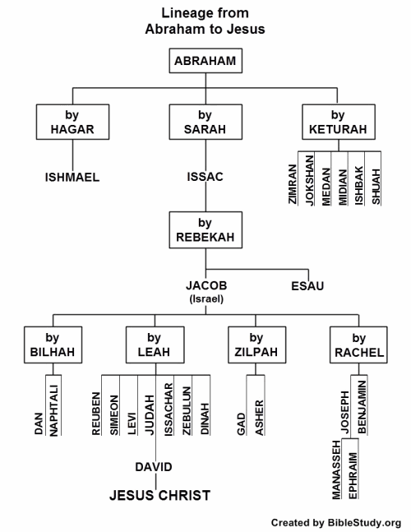

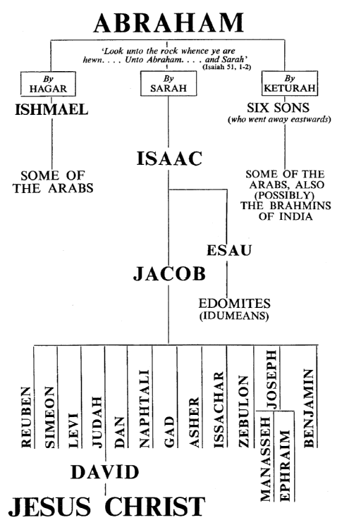

1. **Who are the Idumeans? In 126 B.C.,** **they were conquered by the Jewish Army in the high priest John Hyrcanu; they were forced to die, fell or proselytized into Judaism. mountainous country, called also Mt. Seir. According to the Book of Genesis, it was given to Esau[Heb.,=hairy], in the Bible, son of Isaac, who sold his birthright to his younger twin, Jacob, for lentil stew and who was tricked by Jacob out of his father's blessing. Also known as Edom [Heb., =ruddy], the disinherited Esau settled on Mt., also called Edom, and his descendants. It extended along the eastern border of the Arabah valley, from the Dead Sea to Elat. Edomite history was marked by continuous hostility and warfare with Jews, Assyrians, and Syrians. At the end of the 2d cent. B.C., they were subdued by Hasmonaean priest-king John Hyrcanus I, forcibly circumcised, and merged with the Jews. Herod, dynasty reigning in Palestine at the time of Jesus. As a dynasty the Herods depended largely on the power of Rome. They are usually blamed for the state of virtual anarchy in Palestine at the beginning of the Christian era.  
   Antipater (65 B.C...  the Great was Idumaean. The Romans grouped Idumeans with Judaea and Samaria in one procurator ship. After the destruction of Jerusalem, Idumaea was included in Arabia Petraea. THE EDOMITES, LATER KNOWN AS IDUMEANS, BECAME ASSIMILATED INTO THE PALESTIANS OF TODAY.**
2. **Review various national judgments in the Bible.** See Ezekiel 25-32. Ammon, Moab, Edom, Philistia, Tyre, Sidon, and Egypt. THESE ARE ALL MUSLIMS/ISLAM TODAY.
3. **Why is the judgment against Edom mentioned in more Old Testament books than any other?** **Review these:**
   1. **See Isaiah 11:14, 34:5-17and 63:1-6.**
   2. **Jeremiah 9:25-26, 25:17-26 and 49:7-22.**
   3. **Lamentations 4:21-22,**
   4. **Ezekiel 25:12-14, 28: 25-26 and 35:15.**
   5. **Joel 3:19.**
   6. **Amos 1:11-12 and 9:11-12.**
   7. **Obadiah 1:1-21.**
   8. **Malachi 1:4.**
4. **To review, who are the Edomites? Why do they hate Israel so much?**
5. **Consider the Book of Obadiah, which is devoted entirely to the judgment which is to come upon the Edomites. Could this small book lend contemporary insight for today’s chaos and confusion? 21 VERSES DEVOTED ENTIRELY TO THE JUDGMENT OF EDOM.**

[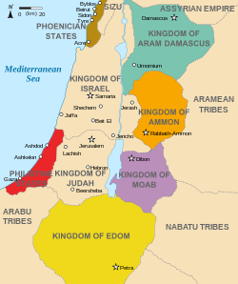](https://en.wikipedia.org/wiki/File:Kingdoms_around_Israel_830_map.svg)

***And, here are the promises:***

**Zechariah 2:8. “For thus says the Lord of hosts: “He sent Me after glory, to the nations which plunder you; for he who touches you touches the apple of His eye.”**

**Genesis 12:3, “And I will bless them that bless thee, and curse him that curseth thee: and in thee shall all families of the earth be blessed.”**

**Romans 5:10, “10For if when we were enemies we were reconciled to God through the death of His Son, much more, having been reconciled, we shall be saved by His life.”**