***“Reviewing Revelation”—Introduction***

**This entire book is largely Jewish, with Chapters 6-19 representing the 70th week of Daniel perfectly. It “bookends” the Bible, with the first bookend being Genesis, “Paradise Lost,” and Revelation ending as “Paradise Regained.” The word, Revelation means “the unveiling, uncovering, or disclosing” and comes from the Greek work, “apokalupsis.” “Apocalupto” means to unveil; “Apo” means “away from;” “Kalumma” a veil—the taking away of a veil. In short, what is revealed in The Book was given unto Jesus by God the Father, to show unto His servants the things “which were to shortly pass.” The title of this book is: “THE REVELATION OF JESUS CHRIST.” This answers the confusing question that appears in Mark 13:32-33, “**But of that day and hour no one knows, not even the angels in heaven, nor the Son, but only the Father. 33Take heed, watch and pray; for you do not know when the time is.” **With the Book of Revelation, and after His ascension into heaven, we understand that Jesus now knows all. THE AUTHOR OF REVELATION IS JESUS CHRIST and the writer of it is John. Twice the book notes that this writing was dictated by an angel: Revelation 1:1 and 22:8. Revelation 22:16, “**I, Jesus, have sent My angel to testify to you these things in the churches. I am the Root and the Offspring of David, the Bright and Morning Star.” **REVELATION IS A PROPHETIC BOOK, NOT HISTORICAL. IT IS THE ONLY BOOK WHICH PROMISES A BLESSING TO ITS READER, Revelation 1:3, “**Blessed *is* he who reads and those who hear the words of this prophecy, and keep those things which are written in it; for the time *is* near.” **THE FORMAT OF THIS BOOK IS ‘SIGNS,’ OR ‘SIGNIFIED,’ Revelation 1:1, “**The Revelation of Jesus Christ, which God gave Him to show His servants—things which must shortly take place. And He sent and signified *it* by His angel to His servant John.”

**Note the “triangular” parallels in this book:** THE BEGINNING, the Church; THE MIDDLE, Israel, and THE ENDING, Saved Nations. Also, Which is, Which was, and Who is to come. See also the **“Threefold Office of Jesus” displayed—1. Prophet, the Word, the “Faithful Witness;” 2. Priest, the Lamb, the “First Begotten from the Dead;” 3. King, the Lion, “Prince of the Kings of the Earth.”** Revelation 1:4-6 is usually described as “The salutation.” This addressed the seven church in Asia (Asia= western end of Asia Minor, bordering on the Aegean and Mediterranean Seas, the approximate size of the state of Pennsylvania). One must wonder why these “seven” churches were mentioned when the Church of Close, Colossian 1:12, the Church at Hierapolis, Colossians 4:8, and Troas, Acts 20:6-7 are not mentioned.

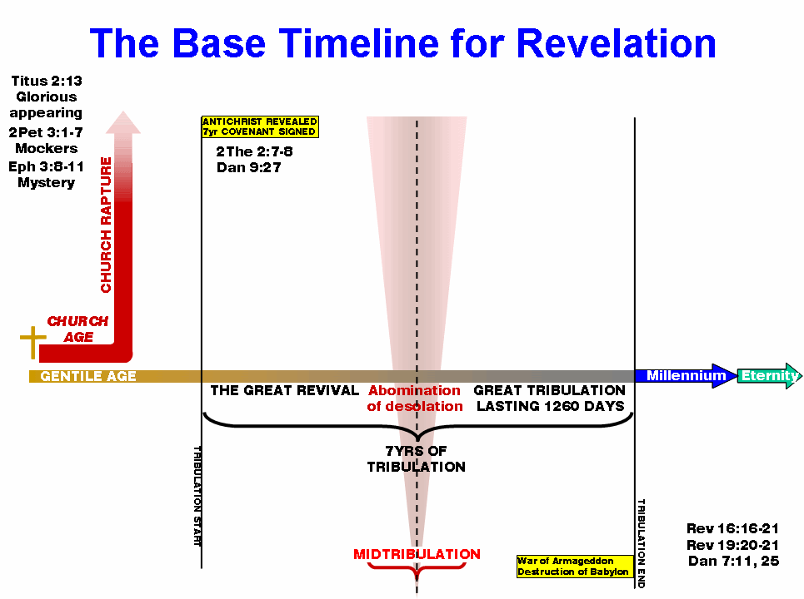

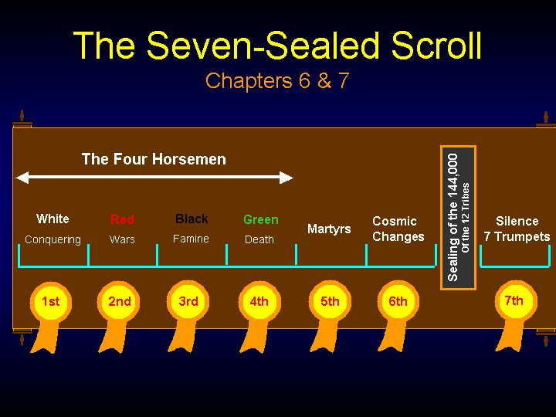

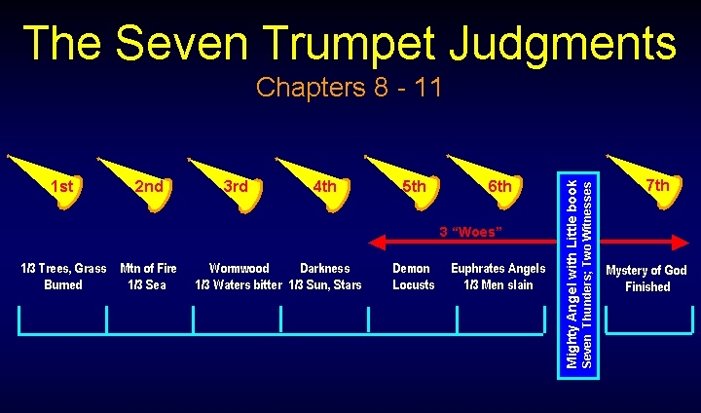

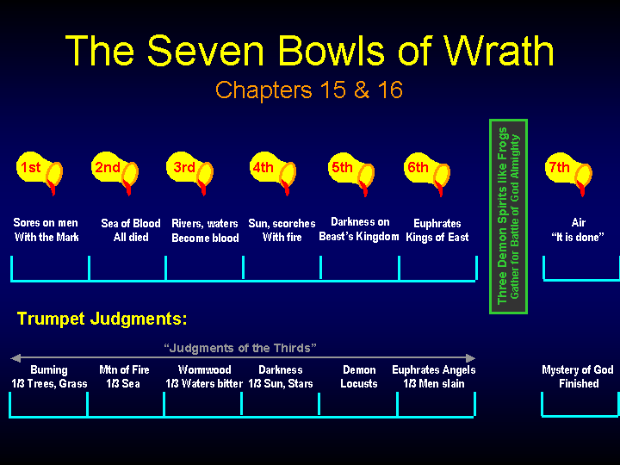

**Revelation is “the consummation of all things.” It is the only book promising a special blessing to the reader. There are ere are 404 verses containing over 800 allusions from the Old Testament. THIS IS THE CLIMAX OF GOD’S PLAN FOR MAN! The word, Revelation means “the unveiling, uncovering, or disclosing” and comes from the Greek work, “apokalupsis.” “Apocalupto” means to unveil; “Apo” means “away from;” “Kalumma” a veil—the taking away of a veil. In short, what is revealed in The Book was given unto Jesus by God the Father, to show unto His servants the things “which were to shortly pass.”** The word *revelation* never occurs again in the book that has come to bear that name. Every other time the book refers to itself, it is as a *prophecy* (v. 3; compare 22:7, 10, 18) or a "book of prophecy" (22:19). *Revelation* should therefore be understood in much the same sense as in 1 Corinthians 14:6, 26, where Paul lists "a revelation" among the things prophets in early Christian congregations received from God in the Spirit--along with knowledge, prophecy, teaching (v. 6), a psalm, a teaching, a tongue, an interpretation (v. 26).

Paul uses the phrase "revelation of Jesus Christ" in Galatians 1:12 to refer to the divine message God gave the revelation to Jesus Christ to show it in turn to *his servants.* The point is much the same as in John's Gospel, where Jesus insists again and again that the words he speaks are not his own words, but the words of "him who sent me" (for example, John 7:16-17, 28; 8:28; 12:49-50). The most likely date for this book was during the rule of Domitian. He was the king of Rome during the years **AD 81 to 96. The main purpose of the book is to show how Jesus will come again. He will win the fight against the devil. Jesus will save his people. He is with them now. And he will be with them beyond the end of time.** .

• Chapters 2 and 3 were for the 7 *churches in Ephesus, Smyrna, Pergamum, Thyatira, Sardis, Philadelphia and Laodicea. But they contain lessons for the *church in all ages.

•From chapter 4 the book describes events that are still in the future. But in it there are lessons for us today as well.

•The general plan of the book is in date order. But there are parts that are not in this order.

•Some *prophecies are in plain language. We should believe what they say. But many *prophecies are complex descriptions.

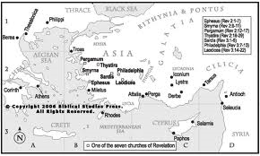

1. **The Introduction (1:1-11, 19) “Revelation” is singular.**
   1. **What does the word, “Revelation,” mean? It means to unveil or uncover, or revelation. It is used as a noun 19 times and as a verb 26 times.**
2. **Explain “The Title”—“The Revelation of Jesus Christ.” Why?**
   1. **Refer to John 16:14, “He shall glorify Me.”**
3. **What does the Bible promise about its design? See Matthew 5:17-18 and Romans 15:4.** 
   1. **Review the “Secret Things.”—Deuteronomy 29:29**
4. **The book, which God gave to Him. Who is Him? (Jesus Christ)**
5. **Who wrote the revelation? John**
   1. **Who wrote the seven letters? Jesus**
   2. **In verse 1, talk about “signified,” or “signs given” for our learning.**
   3. **What year was Revelation written? 85-90 A.D., Domitian, the Roman ruler, was the leader.**
6. **What was “The Salutation?” (1:1-3) Blessed is he who hears and keeps those things which are written thereof**
7. **What was “The Exaltation?” (1:5b, 6)**
8. **Explain “The Chief Theme.” (1:7)**
9. **How was “The Eternity of the Son of God” explained? (1:8)**
10. **Who was “The Prophet—John?” (1:9-11) Son of Zebedee and Salome, early disciple of John the Baptist; he knew the high priest and Nicodemus; one of the inner circle, with Peter and James; present at the Transfiguration,**
11. **How many epistles are in the New Testament? 14 Pauline +7 General + 7 written by Jesus in Revelation=28**
12. **What are the "Big Themes” in this book?** Catastrophic end-crisis of present age; Reappearance of the King of Kings to reclaim the earth, internment of Satan in the Abousso, Millennial reign of Christ, Final insurrection and the abolition of sin, and New Heaven and New Earth
13. **Jesus endorses this book and authors it. Read Rev. 22:16.**
14. **What is the “unique promise” in this book? See Revelation 1:3.**
15. **What is the curse promised in Revelation? Rev. 22:18-19.**
16. **Examine the “Heptadic Structure” of Revelation.** The Sevens
    1. **The Seven Churches, Rev. 2-3**
    2. **The Seven Seals, Rev. 6:1-8, 5**
    3. **The Seven Trumpets, Rev. 8:7-11, 19**
    4. **The Seven Personages, Rev. 12: 1-13, 18**
    5. **The Seven Vials, Rev. 15: 1-16, 21**
    6. **The Seven Dooms, Rev. 17: 1-20, 15**
    7. **The Seven New Things, Rev. 21:1-22, 5**
    8. **The Seven Beatitudes, Rev. 1:3, 14:13, 16:15, 19:9, 20:6, 22:7, 22:14**
    9. **Subtle Sevens**
       1. **Seven Features, Rev. 1**
       2. **Seven Letter Divisions, Rev. 2-3**
       3. **Seven Personages, Rev. 12-13 (Man-Child, Woman, Dragon, 7-headed beast, False Prophet, Michael, and Lamb)**
       4. **Seven Years of Judgement, 11:3, 12:6, 14, 13:5**
       5. **Seven “I Am’s” of Christ, 1:8, 11, 17, 18; 21:6, 22:13, 16**
       6. **Seven Doxologies in Heaven, 4:9-11, 5:8-13, 9-12, 11:16-18, 14:2-3, 15:2-4, 19:1-6, 20, 21**
          1. **Note the four “escalating doxologies” in Revelation 1:6, 4:11, 5:13, and 7:12.**
       7. **Seven New Things, Rev. 20-21--**
       8. **Seven Examples of Worship**
          1. **Holy, holy, holy—Rev.4:8**
          2. **Worthy art thou—Rev. 4:11, 5:8-10**
          3. **Unto him that sitteth—Rev. 5:11-13**
          4. **Salvation to our God; Amen; blessing—Rev. 7:9-12**
          5. **Kingdoms of the World, we give thanks—Rev. 15:11-18**
          6. **Great and marvelous—Rev. 15:2-4**
          7. **Four halleluiahs—Rev. 19:1-8**
    10. **Vision in Chapter 1 with Seven Features**
        1. **Hair and head compare with Daniel 7:9.**
        2. **Eyes, flames of fire, see also Hebrews 1:13 and 4:13.**
        3. **Feet, symbol of walk, brass, judgment, Numbers 21—brazen serpent**
        4. **Voice of many waters, examine Ezekiel 1:24, 43:2, and Daniel 10:6**
        5. **Right hand, 7 stars; lampstands, in the midst, in his hands**
        6. **Mouth, two-edged sword, Hebrews 4:12, Ephesians 6:17, and Isaiah 49:2**
        7. **Countenance, sun, Matthew 17**
17. **Discuss the “Divine Outline” of the Book of Revelation. Use Revelation 1:19.** 
    1. **See “The Things Which Thou Hast Seen” (The Vision of Christ)—Revelation 1.**
    2. **Refer to “The Things Which Are” (The Seven Churches)—Revelation 2-3.**
    3. **Examine “The Things Which Shall Be Hereafter” (Things following after the Church)—Revelation 4-22.**
18. **Explain the phrase, “I was in the spirit,” Revelation 1:10.** 
    1. **See also Revelation 4:2, 17:3, and 21:10.**
19. **Which things are “out of place” in the Bible, that Revelation corrects? Israel, not in their land; Church is in heaven; Lamb is on His own throne; Satan is bound.**
20. **Who are the three “women” center-front in Revelation? The pregnant woman of Revelation 12, the Virgin Bride of Christ, and the Harlot/Mystery Babylon.**
21. **Who are the “Seven Spirits” in Revelation 5:6?**
    1. **Refer to Isaiah 11:2.**
22. **In Verse one, what is “signified?” Note: key word “sign.”**
23. **What was “The Salutation?” (1:1-3) Blessed is he who hears and keeps those things which are written thereof**
24. **What was “The Exaltation?” (1:5b, 6)**
25. **Explain “The Chief Theme.” (1:7)**
26. **How was “The Eternity of the Son of God” explained? (1:8)**
27. **Who was “The Prophet—John?” (1:9-11) Son of Zebedee and Salome, early disciple of John the Baptist; he knew the high priest and Nicodemus; one of the inner circle, with Peter and James; present at the Transfiguration,**
28. **How many epistles are in the New Testament? 14 Pauline +7 General + 7 written by Jesus in Revelation=28**
29. **Jesus endorses this book and authors it. Read Rev. 22:16.**
30. **Who are the seven spirits before the throne in Verse 4? Are they the same as the seven-fold nature of the Holy Spirit?** 
    1. **(Cry out for an outpouring of): The Spirit of the Lord….Is. 11:2, Rev. 4:5, Judges 6:34, Judges 14:6, I Sam. 16:13**
    2. **(Cry out for an outpouring of): The Spirit of the Wisdom of the Lord….Is. 11:2, I Cor. 2:7-9, James 1:5-6, Ex. 28:3, Deut. 34:9, Proverbs 10:23**
    3. **(Cry out for an outpouring of): The Spirit of the Understanding of the Lord….Is. 11:2, Rev. 4:5, Prov. 2:1-5, Col. 2:2**
    4. **(Cry out for an outpouring of): The Spirit of the Counsel of the Lord….Is. 55:8-9, Heb. 10:35-36, Matt. 7:7-8, Romans 6:16-18**
    5. **(Cry out for an outpouring of): The Spirit of the Might of the Lord…Is. 11:2, Rev. 4:5, Heb. 13:18-20, John 8:31-32**
    6. **(Cry out for an outpouring of: The Spirit of the Knowledge of the Lord): Is. 11:2, Rev. 4:5, John 5:30, Psalm 25:14**
    7. **(Cry out for an outpouring of): The Spirit of the Fear of the Lord…Is. 11:2, Rev. 4:5, Gal. 5:24-25, Prov. 8:13, Acts 9:31**
    8. **Please note—the fire that came from the Holy Spirit was the same fire that came down at Pentecost**

**STRUCTURE OF THE BOOK OF REVELATION**

**"REVELATION BEGINS"**

Chapter 1 – Prologue  
Chapters 2-3 – The Seven Churches  
Chapter 4 – Heaven  
Chapter 5 – The Large Scroll  
Chapter 6 – The First Six Seals

**"PARENTHESIS I – THE RESCUE HIGHLIGHTED"**

Chapter 7 – Deliverance

**"THE DAY OF THE LORD"**

Chapter 8 – Seventh Seal Events [Trumpet Judgments 1-4]   
Chapter 9 – Completion of 70th Week [Trumpet Judgments 5-6]

**"POST 70TH WEEK EVENTS"**

Chapter 10 – The Little Scroll  
Chapter 11 – Daniel 9:24 Completed [Trumpet Judgment 7]

**"PARENTHESIS II – COSMIC CONFLICT HIGHLIGHTED"**

Chapter 12 – The Beginning  
Chapter 13 – The Beginning of the End  
Chapter 14 – The End of the Beginning  
A. Deliverance of the elect  
B. Decree to the wicked  
C. Destruction of the wicked

**"THE DESTRUCTION OF ANTICHRIST – FINAL WRATH OF GOD"**

Chapter 15 – Prelude to Bowl Judgments  
Chapter 16 – Bowl Judgments 1-7

**"PARENTHESIS III – DESTRUCTION HIGHLIGHTED"**

Chapter 17 – The Great Harlot  
Chapter 18 – The Great City  
Chapter 19 – The Great Army

**"THE MILLENNIAL REIGN OF CHRIST"**

Chapter 20: 1-6 – The Beginning of the Millennium  
Chapter 20:7-15 – The End of the Millennium

**"THE CONCLUSION"**

Chapter 21 – New Heavens, New earth, New Jerusalem  
Chapter 22 – Epilogue

The key to the structure of the book of Revelation can be discerned from the seventh chapter of Daniel and Matthew 24 and Revelation 4-21

**The Structure of the Revelation**

Critical to our discussion are chapters 4-20 of the Revelation. It is our position that chapters 4-11 give the general overview of the end times. Revelation 12-13 gives the specific focus on the persecution of the saints. Chapters 14-21 detail the destruction of the beast, the coming of Christ and the kingdom that follows. As with Matthew 24:4-31, the book of Revelation fills in many details left out of Daniel’s seventh chapter summary, but the basic structure is the same.  
**Revelation 4-11 gives an overview of the end times. Revelation 4 opens with a throne room scene.** God the father is seated on a throne surrounded by his court of elders, living creatures and angels. **Revelation 5** presents the coronation of the Lamb as executor of the Father’s will. **Revelation 6** outlines the "beginning birth pangs" and the "tribulation" of the saints. **Revelation 7** highlights the deliverance of God’s first fruits of unsaved national Israel and the righteous saints of the ages to heaven. Revelation 8-9 details the beginning of God’s wrath. **Revelation 10** underscores the end of Gentile dominance on earth and **Revelation 11** reports God’s reclamation of the earth (God’s reign begins)... Most students of Revelation recognize a difference the common trait of the ***last three seals between the first four seals*** and the **last three seals** is the wrath of God. **The fifth seal martyrs** request that God pour out his wrath on the living earth-dwellers. **The sixth seal** announces the imminent outbreak of God’s wrath. **The seventh and final seal begins the actual outpouring of God’s wrath as seven trumpets.** **The seven trumpets demonstrate a similar pattern to the seals. That is, the first four trumpets are different from the last three trumpets**. **The final three trumpets are characterized as three "woes."** These represent the worst expression of God’s wrath the wicked will ever experience on earth. However, **between trumpets six and seven is a break in the advancement of the story line**. This break serves the purpose of allowing John opportunity to announce the completion of *the mystery of God*. He writes, "…in the days of the voice of the seventh angel, when he is about to sound, then the mystery of God is finished (…Rev 10:7)." **The apostle Paul defined the mystery of God as God’s special work in Christ to bring Gentiles to glory (Col 1:24-2:5). The completion of the mystery of God also ties into the completion of the "times of the Gentiles," (Dan 9:24, Luke 21:24, Rev 11:2). These events coincide with the completion of the ministry of the two witnesses (Rev 11:4-13).**

**With the sounding of the seventh trumpet, God the father takes back his rightful physical rule over the earth. John states, "The kingdom of the world has become the kingdom of our Lord, and of His Christ; and He will reign forever and ever (Rev 11:15b)."** The first order of business for the new King will be the removal of all the wicked (both human and demonic) from the earth.

A war in heaven results in Satan’s restriction to earth for a short time (Rev 12:7-17). This is the basis of the unparalleled persecution. Death will reign on the earth during the persecution of God’s saints. **The three primary perpetrators of death will be the beast (Rev 13:7), the false prophet (Rev 13:12), and the image of the beast (Rev 13:15). The target of Death will be the woman (the Jews) and her offspring (the church) (Rev 12:17).**

The third aspect of the end-time sequence that appears in both Daniel 7 and Matthew 24 concerns the **destruction of the beast**. Having highlighted the persecutors in Revelation 12-13, **Revelation 14-19 focuses on the destruction of the beast and his kingdom. Chapter 14 begins this important section with the Lord and 144,000 Jews standing on Mount Zion.** **This is the first time the Lamb is pictured physically on the earth in the Revelation. Three angels announce doom upon the earth**. **The chapter ends with a summary description of God’s wrath against the wicked on the earth**. The fifteenth and sixteenth chapters of the Revelation detail the **bowl judgments** against the beast, his kingdom and those who take his mark. Revelation 17-18 highlights the destruction the beast’s city**. Revelation 19 highlights the destruction of the beast’s armies.** The final aspect of the end time sequence concerns the kingdom of the Most High God. **Revelation 20 indicates that after the destruction of the beast, the Lord Jesus will set a temporal kingdom on earth for one thousand years.** All the wicked of the nations, Satan and his demons are removed from the earth. Christ and the beheaded reign on the earth after which the final revolt of Satan occurs and the eternal judgment ends human history as we know it.

Daniel 7, Matthew 24 and the Revelation manifest a discernible structural pattern with respect to the sequence of events concerning the end times. First, a general overview is given. Then a specific look at the unparalleled persecution of the saints is outlined. The final element of the three accounts concerns the destruction of the perpetrator of the unparalleled persecution and the kingdom of God that follow.

**OVERVIEW OF THE BOOK OF REVELATION**

Fifty plus years after the teaching of the Olivet Discourse, Christ, through an angelic messenger, revealed yet more end-time truth to John, information vital for the understanding of the last days. Ultimately, the prophetic truths contained in the book of Daniel, the Olivet Discourse, and the Revelation can be traced to our Lord. It is the Revelation about Jesus Christ as ultimate Judge, which gives us a synthetic view of both Daniel and the Olivet Discourse. In the first verse of Revelation, chapter one, we are told that the contents of the book are written for the bondservants of Christ, i.e. the living elect of God who, by definition, must be the true church. Thus, in the last days described in the book of Revelation, Christ weaves together three different programs for three different groups of people representing the entirety of mankind in the last days. Obedient and disobedient members of the church, unbelieving Israel, and the world in general compose these three groups.

Beginning in chapter four, John is taken up into heaven where we, the reader, as is John, are given a marvelous view of the throne of God and the activities that will occur in the last days of human history as we know it. Other than the incredible glory of heaven itself, the focal point is an unopened scroll in the hand of Him who sits on a throne, sealed with seven seals. The question then arises as to who is able to break the seals, and thus permit the conditions necessary to effect the contents of the scroll. Pointing to the Lamb of God, one of the twenty-four elders told John that only the "Lion that is from the tribe of Judah" is worthy to open the scroll. This fact is supported earlier in the New Testament (cf. Acts 17:31).

**Revelation then begins to chronicle the events that will occur, beginning with the breaking of the seven seals**. The seals represent conditions that must first occur before God brings His final judgment upon the world. Christ had already taught His disciples and Daniel that this final time of judgment would transpire within the context of the Seventieth Week. When all the prior conditions are met, He will then remove His faithful saints before He pours out His wrath on those who remain during the most prophesied event in all Scripture, the Day of the Lord. This judgment is described by Christ Himself as a judgment that will parallel the judgment of God during the days of Noah, but this last time, as Peter teaches, it will be a judgment by fire, not water!

**The first six seals are opened by the Lion of Judah**, setting the stage for the final judgment of Christ. The fourth seal is broken and the wrath of Satan, through Antichrist, tests mankind in a final attempt to control all that dwell on the earth. **The sixth seal is opened and the sign of the Day of the Lord, foretold again and again in the Scriptures, is given.**

The final wrath of God will be completed and concluded with the battle of Armageddon. At this final battle, Antichrist and his armies will be quickly defeated by Christ and the angelic host of God. Antichrist and his false prophet are then thrown directly into the lake of fire.

In the last chapters of Revelation, Christ then shows John the events that occur on earth, following the Lord's return. **Revelation 19 ends with the assigning of Antichrist and the false prophet to the lake of fire**. The armies of Antichrist are killed by the Lord's word and eaten by birds. Following Armageddon, chapter 20 opens with the description of God's final program for Satan. He will be rendered immobile and isolated in a bottomless pit for a thousand years (Rev. 20:1-3). Then the raptured saints of the ages are seen seated on thrones. Then the beheaded saints who refused to worship Antichrist or take his mark will be resurrected to reign with Christ for a thousand years (Rev. 20:4-6). Satan is released after the thousand years is completed to deceive the nations one last time to fight against Christ, but is again defeated as before the thousand years began (Rev. 20:7-10). The wicked dead and all of those who died during the thousand-year reign of Christ are resurrected and judged (Rev. 20:11-15). Revelation 21 opens with the creation of a new heaven and a new earth with the New Jerusalem coming down from heaven (Rev. 21:1-8). The New Jerusalem, described in some detail, is seen coming down to earth from heaven (Rev. 21:9-27). The book finishes with a call for all to obey the message of the book and a warning to those who reject what is taught.

Three times**, each at a critical break in the sequence of events** described in the book of Revelation, Christ gives more detail to John for clarification. The ***first* interlude** deals with the rescue of God's faithful who do not succumb to Antichrist (Rev. 7:1-17). **The *second* deals** with an explanation of the actual work of Satan and his Antichrist during the great hour of testing where he will demand a choice of allegiance from mankind on earth before the wrath of God begins (Rev. 12-14). **The *third* and final interlude** describes the destruction, in some detail, of the false religious system and the city that supports it (Rev. 17-18).

**Structure**

|  |  |
| --- | --- |
| **The *Lord meets with John** | **Revelation 1:1-20** |
| John tells us about his book | Revelation 1:1-3 |
| John greets the *churches | Revelation 1:4-8 |
| Jesus Christ speaks to John | Revelation 1:9-16 |
| Jesus tells John to write | Revelation 1:17-20 |
|  |  |
| **Letters to the 7 *churches** | **Revelation 2:1-3:22** |
| To the *church in Ephesus | Revelation 2:1-7 |
| To the *church in Smyrna | Revelation 2:8-11 |
| To the *church in Pergamum | Revelation 2:12-17 |
| To the *church in Thyatira | Revelation 2:18-29 |
| To the *church in Sardis | Revelation 3:1-6 |
| To the *church in Philadelphia | Revelation 3:7-13 |
| To the *church in Laodicea | Revelation 3:14-22 |
|  |  |
| **\*Worship in heaven** | **Revelation 4:1-5:14** |
| *Worship of God who created all things | Revelation 4:1-11 |
| *Worship of the *Lamb | Revelation 5:1-14 |
|  |  |
| **The 7 *seals** | **Revelation 6:1-8:1** |
| The first 6 *seals | Revelation 6:1-17 |
| Security and *salvation | Revelation 7:1-17 |
| The seventh (7th) *seal | Revelation 8:1 |
|  |  |
| **The 7 *trumpets** | **Revelation 8:2-11:19** |
| Preparation for the *trumpets | Revelation 8:2-5 |
| The first four *trumpets | Revelation 8:6-12 |
| The cry of the *eagle | Revelation 8:13 |
| The fifth (5th) *trumpet | Revelation 9:1-12 |
| The sixth (6th) *trumpet | Revelation 9:13-21 |
| The strong *angel and the little book | Revelation 10:1-11 |
| John measures the *temple | Revelation 11:1-2 |
| The two witnesses | Revelation 11:3-14 |
| The seventh (7th) *trumpet | Revelation 11:15-19 |
|  |  |
| **War in heaven and on the earth** | **Revelation 12:1-14:20** |
| The woman and the *dragon | Revelation 12:1-6 |
| War in heaven | Revelation 12:7-12 |
| War on the earth | Revelation 12:13-17 |
| The *beast from the sea | Revelation 13:1-10 |
| The *beast from the earth | Revelation 13:11-18 |
| The *Lamb on the hill called Zion | Revelation 14:1-5 |
| Messages from three *angels | Revelation 14:6-13 |
| Harvest of the earth | Revelation 14:14-20 |
|  |  |
| **The 7 last troubles** | **Revelation 15:1-16:21** |
| Preparation for the troubles | Revelation 15:1-8 |
| The 7 bowls of God’s anger | Revelation 16:1-21 |
|  |  |
| **God destroys Babylon** | **Revelation 17:1-19:5** |
| The *beast and the evil woman | Revelation 17:1-18 |
| The funeral of Babylon | Revelation 18:1-24 |
| The crowd praises God in heaven | Revelation 19:1-5 |
|  |  |
| **The return of Christ** | **Revelation 19:6-21** |
| The marriage of the *Lamb | Revelation 19:6-10 |
| Christ the king appears | Revelation 19:11-16 |
| The defeat of the enemies | Revelation 19:17-21 |
|  |  |
| **The rule of Christ** | **Revelation 20:1-15** |
| The *angel binds *Satan | Revelation 20:1-3 |
| Jesus Christ rules on earth | Revelation 20:4-6 |
| The end of *Satan | Revelation 20:7-10 |
| God the judge of everybody | Revelation 20:11-15 |
|  |  |
| **The new heaven and the new earth** | **Revelation 21:1-22:5** |
| The new *creation | Revelation 21:1-8 |
| The new Jerusalem city | Revelation 21:9-27 |
| The river of life | Revelation 22:1-5 |
|  |  |
| **Final words** | **Revelation 22:6-21** |
| The promise that Christ will come soon | Revelation 22:6-13 |
| An invitation but … | Revelation 22:14-19 |
| Promise and reply | Revelation 22:20-21 |
|  |  |

**Here are the Promises…**

**Deuteronomy 29:29, “The secret *things belong* to the Lord our God, but those *things which are* revealed *belong* to us and to our children forever, that *we* may do all the words of this law.”**

**Revelation 1: 5b-8, “To Him who loved us and washedus from our sins in His own blood, 6and has made us kingand priests to His God and Father, to Him *be* glory and dominion forever and ever. Amen.7Behold, He is coming with clouds, and every eye will see Him, even they who pierced Him. And all the tribes of the earth will mourn because of Him. Even so, Amen.” 8“I am the Alpha and the Omega, *the* Beginning and *the* End,” says the Lord, “who is and who was and who is to come, the Almighty.”**

**Vocabulary for the Book of Revelation**