***“Studying the Southern Kingdom Prophets”—Zephaniah 1 (The 11th Hour Prophet)—Coming Judgment***

SAMUEL

SAUL

DAVID

SOLOMON

Southern Kingdom—Judah

Northern Kingdom—House of Israel

I Samuel 2 Samuel I Kings 2 Kings

1 Chronicles 2 Chronicles

**The Monarchy**

**“Introduction of Zephaniah”—Zephaniah 1:1**

**“The Judgment Announcement”—Zephaniah 1:2-6**

**“The Judgment Defined”—Zephaniah 1:7-13**

**“The Judgment Described”—Zephaniah 1:14-18**

***CHIASMIC STRUCTURE OF ZEPHANIAH***

1. **Judgment on all the Earth 1:2-3**
   1. **Judgment on Judah and Jerusalem 1:4-2:3**
      1. **Judgment on the surrounding nations 2:4-15**
2. **Judgment on Jerusalem 3:1-7**
3. **Judgment on all the Earth 3:8**
4. **During the time of Zephaniah, an interesting character from the Bible emerges, Huldah. See 2 Kings 22:14-20 and 2 Chronicles 34:22-33.** 
   1. **Who is she and why is she important?**
5. **Review the phrase, “Day of the Lord,” introduced by Joel, and used seven times in Zephaniah and ‘alluded to’ 19 times.** 
   1. **Review Isaiah 2:5-3:26, Ezekiel 13:5, Joel 1:15, 2:1, 11, Zephaniah 14:1 and 1:7.**
   2. **See also the “day of darkness” reference, “day of fire,” and “earth trembling,” as in Ezekiel 30:3, Joel 2:1-11, and Isaiah 34:4.**
   3. **Discuss the devastation of Israel in this time. Use Zechariah 14:1-2, Zephaniah 1:7-18, Obadiah 15 and 21, and Daniel 12:1.**
   4. **This period is called “The Day of Wrath,” in Revelation 6:17. Elaborate.**
      1. **Where do we see “the Wrath of the Lamb?” Use Revelation 6:16.**
6. **Who are the Kings of Judah?**

**[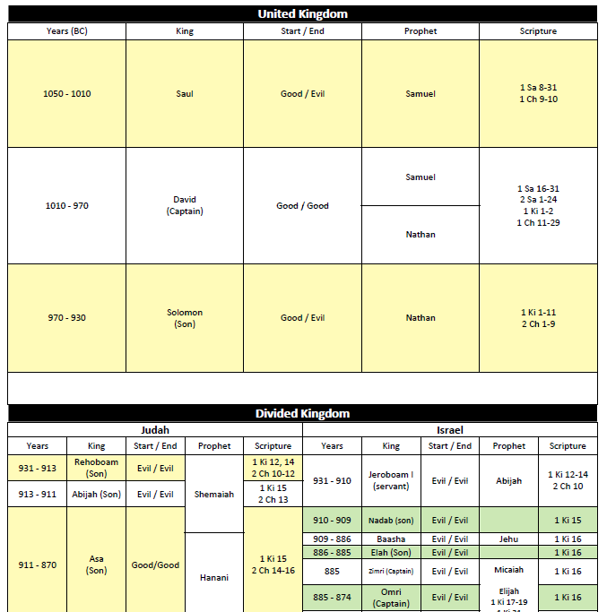](https://craigtowens.files.wordpress.com/2014/07/kings-of-israel-judah2.jpg)**

1. **Who is Zephaniah?** 
   1. **What does the name “Zephaniah” mean?**
   2. **When was Zephaniah born?**
   3. **Describe the period in which Zephaniah lived?**
2. **Discuss why Zephaniah is often paralleled with the Gospel of John.**
   1. **Compare John 3:16 with Zephaniah 3:17.**
   2. **See also Hebrews 12:6 and John 15:1-2.**
3. **What does “utterly consume” imply here?** 
   1. **Compare this section with Matthew 24:21 and Daniel 12:1**.
4. **Verse 3 echoes also in Revelation 8:1, Jeremiah 30:5-7, and Joel 3:2-17. Elaborate.**
5. **Review the reference, “man, beast, fowls, and fishes.” Refer to Genesis 1:20-26.**
6. **Is God now turning His judgment “against Judah**?”
7. **Who is Baal**?
   1. **Parallel these verses with Zephaniah: Zephaniah 1:5 =Jeremiah 8:2, 19:13, Jeremiah 5:2, 7= Zephaniah 1:5b, Jeremiah 8:8-9=Zephaniah 3:4.**
   2. **Use 2 Kings 21:3-7 and 23:4-15.**
   3. **The KJV calls the “idolatrous priests” by the name of “Chermarims.” Who are they?**
   4. **Compare this section with the Church of Laodicea in Revelation 3:14-22.**
   5. **Judgment begins with the “household of God**” **in I Peter 4:17. Why?**
   6. **Talk about this thought: “Who will God “cut off?””**
      1. **Baal worshippers and priests.**
      2. **Worshippers of the heavens and stellar bodies. See Jeremiah 19:13 and 2:29 and Deuteronomy 4:19.**
         1. **Refer to Manasseh’s pagan worship in 2 Kings 21:3, 5 and 23:4-5.**
      3. **Worshippers who combine worship of God with Milcom (Molech).** 
         1. **Child sacrifice was practiced; refer to Jeremiah 32:35, 2 Kings 16:3 and 21:6.**
      4. **Back-sliders who have turned from following God. Elaborate.**
8. **Which two groups are highlighted in verse 6?**
9. **Talk about how the phrase, “Be silent in the presence of the Lord God” parallels with today’s irreverence of God.**
10. **Verse 7 introduces Joel’s term, “The Day of the LORD.” Why is this important?**
11. **In verse 7, who are the “guests?” See Zephaniah 2:7.**
12. **Discuss the warning to punish “the princes and the king’s children.” See 2 Kings 23-24.** 
    1. **Review Zedekiah’s fate in 2 Kings 24-25, Jeremiah 32:4, and Ezekiel 12:13.**
    2. **See also about “Huldah.” Refer to 2 Kings 22:14 and 2 Chronicles 34:22.**
    3. **What is the reference to the king’s children in foreign apparel?**
13. **Define “Leap over the threshold.”**
14. **Once again we see, “on that day.” Is this “the Day of the Lord?”**
15. **Discuss the invasion of the Babylonians that Zephaniah is predicting here. Use also Zephaniah 1:10-17 and 2:4-7.**
    1. **Where is the “Fish Gate?”**
    2. **Where is Maktesh?**
    3. **Compare Verse 11, where unfair merchants are cut down, to Colossians 3:5-6.**
16. **Compare searching Jerusalem with “lamps/candles” to searching for leaven on Passover.** 
    1. **Can this mean that no one will be able to hide from the wrath of God?** 
       1. **Parallel with Luke 8:17 and Mark 4:22.**
    2. **Who are the men settled in complacency?** **Could this be the American Church?**
17. **Parallel Zephaniah 1:13=Deuteronomy 28:30, 39, Zephaniah 1:15=Deuteronomy 4:11, and Zephaniah 1:17=Deuteronomy 28:29.** .

**\*\*\*VERSES 14-18 GO BEYOND THE LOCAL, PREFIGURING INVASION****THE GREAT TRIBULATION IS YET FUTURE!**

1. **What is the “local application” for Zephaniah’s time here in this verse?** 
   1. **Discuss the “Day of Wrath.” THE GREAT TRIBULATION.**
   2. **Compare this section with Revelation’s description of the Tribulation.**
      1. **Talk about how trumpets precede the bowls of wrath in Revelation 8:1-6.**
2. **Note God’s emphatic “I will.” Discuss.** 
   1. **Will men’s money in the last days mean anything?**
3. **Sum-up the message of Zephaniah 1. What is the application for modern America?**

**And, here are the promises…**

**Zephaniah 1:7, “Hold thy peace at the presence of the Lord God: for the day of the Lord is at hand: for the Lord hath prepared a sacrifice, he hath bid his guests.”**

**Zephaniah 3:17, “The Lord your God in your midst, the Mighty One, will save, He will rejoice over you with gladness, He will quiet you with His love, He will rejoice over you with singing.”**

|  |  |  |  |  |  |
| --- | --- | --- | --- | --- | --- |
| **Chronology of Israel's Kings and Prophets**  (Dates approximate. See notes at end of chart.) Prophets in *italics* are mentioned in the text, but no books bear their names. For some kings, the primary name is followed (in parenthesis) by an alternate name. | | | | | |
| **Prophet** | **King of Judah** | **Date BC {co-regency} (Span)** | **Date BC {co-regency} (Span)** | **King of Israel** | **Prophet** |
| Samuel | Saul (bad king) | c.1050-1010 (40 years) | The nation was united. | | |
| Samuel, *Nathan* | David (**good**) | c.1010-970 (40 years) | Jerusalem was Israel's capital city. | | |
|  | Solomon (good to bad) | c. 970-931 (40 years) | The Temple was built in Jerusalem. *The nation split after Solomon.* | | |
| *Shemaiah* | Rehoboam (bad) | 931-913 (17 years) | 931-910 (22 years) | Jeroboam I (bad king) | *Ahijah* |
|  | Abijah (bad) | 913-911 (3 years) | 910-909 (2 years) | Nadab (bad) |  |
|  | Asa (**good**) | 911-870 (41 years) | 909-886 (24 years) | Baasha (bad) |  |
|  | Jehoshaphat (**good**) | 870-848 {873-870} (25 years) | 886-885 (2 years) | Elah (bad) |  |
|  | '' |  | 885 (7 days) | Zimri (bad) |  |
|  | '' |  | 885-874 {885-880} (12 years) | Omri (bad) |  |
|  | '' |  | 874-853 (22 years) | Ahab (bad) | *Elijah, Micaiah* |
|  | '' |  | 853-852 (2 years) | Ahaziah (bad) | '' |
|  | Jehoram (bad) | 848-841 {853-848} (8 years) | 852-841 (12 years) | Joram (bad) | *Elijah, Elisha* |
|  | Ahaziah (bad) | 841 (1 year) |  |  | '', '' |
|  | Athaliah (queen) (bad) | 841-835 (6 years) | 841-814 (28 years) | Jehu (bad) | *Elisha* |
| Joel, *Zechariah* | Joash (**good**) | 835-796 (40 years) | 814-798 (17 years) | Jehoahaz (bad) | '' |
|  | Amaziah (**good**) | 796-767 (29 years) | 798-782 (16 years) | Jehoash (bad) | '' Jonah- to Nineveh |
|  | Azariah (Uzziah) (**good**) | 767-740 {791-767} (52 years) | 782-753 {793-782} (41 years) | Jeroboam II (bad) | Amos, Hosea |
|  | '' |  | 753-752 (6 months) | Zechariah (bad) | Amos, Hosea |
|  | '' |  | 752 (1 month) | Shallum (bad) | Hosea |
|  | '' |  | 752-742 (10 years) | Menahem (bad) | '' |
| Isaiah | '' |  | 742-740 (2 years) | Pekahiah (bad) | '' |
| '', Micah | Jotham (**good**) | 740-732 {750-740} (16 years) | 740-732 {752-740} (20 years) | Pekah (bad) | '' |
| '', '' | Ahaz (bad) | 732-716 (16 years) | 732-721 (9 years) | Hoshea (bad) | '' |
| '', '' | Hezekiah (**good**) | 716-687 (29 years) |  | Israel captive to Assyria | |
| '' | Manasseh (bad) | 687-642 {696-687} (55 years) |  |  |  |
|  | Amon (bad) | 642-640 (2 years) |  |  |  |
| Zephaniah, Habakkuk, Jeremiah | Josiah (**good**) | 640-608 (31 years) |  |  | Obadiah- to Edom |
| Jeremiah | Jehoahaz (Shallum) (bad) | 608 (3 months) |  |  | Nahum-to Nineveh |
| '' | Jehoiakim (bad) | 608-597 (11 years) | -- Judah's first captivity to Babylon. *(Daniel is among the captives.)* | | |
| '', Ezekiel | Jehoiachin (Jeconiah, Coniah) (bad) | 597 (3 months) | -- Judah's second captivity to Babylon. *(Ezekiel is among the captives.)* | | |
| '', '' | Zedekiah (bad) | 597-586 (11 years) |  | | |
| Ezekiel Daniel | *Jerusalem and the first Temple are destroyed* | *586* | -- Final captivity to Babylon *Daniel ministers throughout the full 70 years of Judah's captivity.* | | |
| Haggai Zechariah Malachi | *Prophets to the returned remnant* | c. 520 c. 520 c. 400 | A remnant returns to Jerusalem. The city and the second Temple are rebuilt. | | |

1. **Dates in {brackets} indicate a period of co-regency with the prior king(s).**
2. **Span includes the period of co-regency (if any).**
3. **Where the Bible text summarizes a king's reign --  
   - - Partial years were *sometimes* counted as full years.  
   - - A brief overlap of reign (eg., during the transfer of power from father to son)   
   may be counted as a full year for both kings.**
4. **Primary reference used for dating: Scofield Reference**