***“Studying the Southern Kingdom Prophets”—Joel (“God is Jehovah”) 1—Locusts in Judah***

**Joel’s recorded prophecies are short but direct. He described God’s coming judgment as an “invasion of locusts”—a clear and terrifying image for Iron Age Israelite society. However, Joel is best known for predicting the** [**“pouring out” of the Holy Spirit**](http://www.biblegateway.com/passage/?search=acts+2:14-24) **which would occur hundreds of years later at Pentecost, as described in Acts 2. *There are four Major Prophets, with Daniel and Ezekiel being the Babylonian prophets, and Jeremiah and Isaiah prophesying to Judah. There are twelve minor prophets.—Hosea, Joel, Amos, Obadiah, Jonah, Micah, Nahum, Habakkuk, Zephaniah, Haggai, Zechariah, and Malachi. Northern kingdom prophets were: Hosea and Amos, Nineveh prophets were: Jonah and Nahum, Southern Kingdom prophets were: Joel, Obadiah, Micah, Habakkuk, Zephaniah, and the post-exile prophets were: Haggai, Zechariah, and Malachi. Chronological order of the prophets: (Before the exile)—Obadiah, Jonah, Joel, Amos, Hosea, Isaiah, Micah, Nahum, Zephaniah, Habakkuk, Jeremiah. (During the exile)—Jeremiah, Ezekiel, and Daniel. (After the exile)—Haggai, Zechariah, and Malachi. Joel could have been written between 838-756 B.C., and he is the earliest “writing prophet,” quoted twice by Amos. (Joel 3:16=Amos 1:2 and Joel 3:18=Amos 9:13). Joel doesn’t rail against idolatry like Amos, and there is no mention of either the Assyrian invasion, 722 B.C., or Babylonian invasion in 587 B.C. The only enemies mentioned by Joel are the Philistines, Phoenicians, Edomites, and Egyptians. Had he lived after Joash, he would have mentioned the Syrians among the enemies whom he enumerates since they took Jerusalem and carried off immense spoil to Damascus.* Since there is no idolatry highlighted and the temple services with the priesthood seem to be flourishing at this writing, scholars believe that this writing describes the state of things during the high priesthood of Jehoiada, through whom Joash had been placed on the throne. Thus, it would seem that Joel lived in the early years of King Joash, 2 Kings 11:17-18, 12:2-16, and 2 Chronicles 24:4-14. There is no king mentioned in his writing, which points to Queen Athaliah’s reign when she had all of her grandchildren put to death. The exception to the slaughter was baby Joash who was spared in a secret “hiding” of him by his aunt in the temple complex (he was the only surviving royal seed). Seven years later, the young Joash was crowned king of Judah, 2 Kings 11:12-16, and Queen Athaliah was slain by her own people. The book of Joel could have been written just prior to Joash’s coronation in 835 B.C. Joel was contemporary with, and probably knew, both Elijah and Elisha who were prophesying to the northern kingdom, with Joel prophesying to the southern kingdom. One of the earliest “writing” prophets, Joel offered his writing to include the fullest view of the consummation of all written prophecy. This is a much neglected book among Bible prophecy. It records Israel’s place in God’s program, from Babylon all the way through the Millennium. Joel has a lot to say about the Gentile nations and their collision course toward Armageddon, with its primary theme: THE DAY OF THE LORD. He references it five times: Joel 1:15, 2:1-2, 2:10-11, 2:30-31, and 3:14-16. Others who use this term are: Isaiah, Jeremiah, Ezekiel and Daniel; often they say, “That day.” Zechariah particularly emphasizes “that day.” Joel is the one who introduces that term to prophecy, called the “law of first mention,” which is very significant!**

**The book of Joel makes two major points: 1. God is in control of world events--nothing happens anywhere in the world that is outside of God’s control and nothing that happens to a believer is outside of God’s control. 2. God responds to repentance.—where there is true repentance, God responds. “Joel” means “Yahweh is God,” and this is an inversion of the name “Elijah,” which means “God is Jehovah.” There is no personal history on the prophet Joel, although we do understand that he speaks to Judah from Jerusalem. Since the temple is mentioned four times in his writings (Joel 1:9, 13, 14, and 2:15), it had to be standing when he wrote.**

**ORDER OF EVENTS IN JOEL**

**2:1-10 Gentile Invasions: Armageddon**

**2:11 Destruction of the Invaders**

**2:12-17 Repentance of Judah**

**2:18-27 Response of YHWH**

**2:28-29 Effusion of the Spirit (Peter alludes to in Acts)**

**2:30-32 Return and Establishing the Kingdom**

**3:1-16 Judgment of the Nations**

**3:17-21 Full Kingdom Blessing**

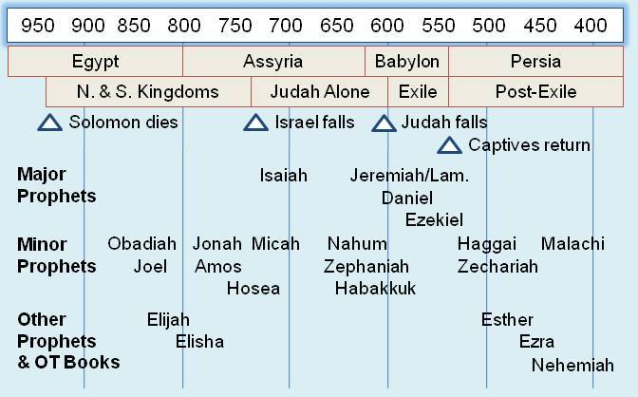

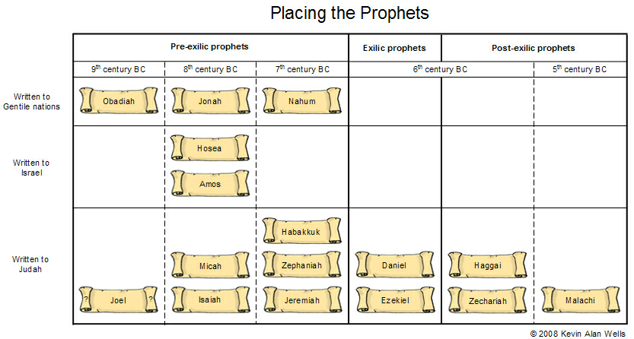

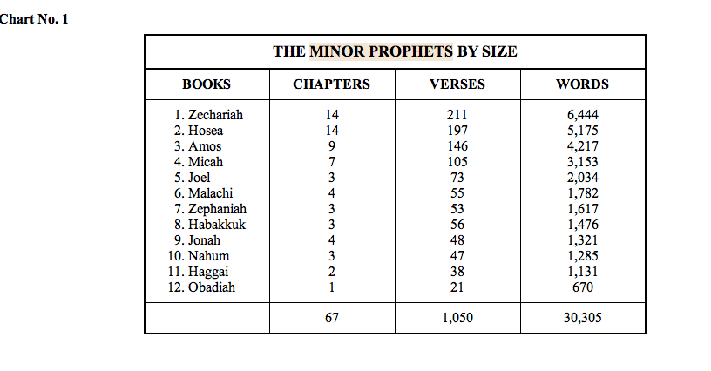

***Joel 1 - The Day of the Lord and Judah….Joel, prophet to the Southern Kingdom of Judah, never mentions the northern kingdom in his writings.***

**Joel l: 1-4, “The word of the Lord that came to Joel the son of Pethuel. Hear this, you elders, and give ear, all you inhabitants of the land! Has *anything like* this happened in your days, or even in the days of your fathers? Tell your children about it, *let* your children *tell* their children, and their children another generation. What the chewing locust left, the swarming locust has eaten; what the swarming locust left, the crawling locust has eaten; and what the crawling locust left, the consuming locust has eaten.”**

1. **Discuss “The remarkable plague of locusts upon Judah” in verses 1-4.**
2. **When was the book of Joel written?** Dating this book is difficult, with many scholars settling on the time of approximately 835 B.C. Remember the northern kingdom of Israel fell in 721 B. C. and the southern kingdom in 586 B.C.; this makes Joel a pre-exilic prophet. And, included in that list are also Obadiah, Jonah, Hosea, Amos, Isaiah, and Micah. Joel is one of the earliest writing prophets, with the exception of Obadiah, 845 B.C.
   1. **Joel is quoted twice in the N. T. See Acts 2:17-21 and Romans 10:13.**
   2. **Joel does not mention any king in his excerpts. Read 2 Kings 8:26 and 2 Kings 11:1-3.**  In835 b.c. was a time of turmoil and transition in Judah, at the end of the reign of the Queen Mother Athaliah and the beginning of the reign of King Joash. Athaliah seized power at the sudden death in battle of her son Ahaziah, who only reigned one year (2 Kings 8:26, 2 Kings 11:1).
      1. **Who was Queen Athaliah? See 2 Kings 11:4-21.**  Athaliah killed all her son’s heirs, except for one who was hidden in the temple and escaped - one-year-old Josiah (2 Kings 11:3). Her six-year reign of terror ended in 835 b.c. when the High Priest Jehoiada overthrew Athaliah and set the seven-year-old Josiah on the throne (2 Kings 11:4-21). If Joel prophesied in 835 b.c., then the judgment he described came toward the end of the six-year reign of ungodliness under Queen Athaliah. No wonder God brought a heavy hand on Judah!
      2. **Discuss why Joel’s writing might have been during Athaliah’s reign? Review 2 Kings 8:26 and 2 Chronicles 22:2-4, 7.** During her tumultuous six years as queen over Judah, Athaliah reigned as an evil dictator. She was the granddaughter of Israel’s wicked King Omri, which made her either the daughter or niece of King Ahab, one of Israel’s vilest kings (2 Kings 8:26). Athaliah “coached” her son Ahaziah to follow the wickedness of Ahab, and allowed Ahab’s counselors to advise him (2 Chronicles 22:2-4). When her son, Ahaziah, was killed in battle, she declared herself queen, and she set her other sons to evil, even desecrating the temple and its sacred things (2 Chronicles 24:7).
      3. **Read 2 Kings 11:16. Re-visit the fate of Athaliah. “**11 When Athaliah the mother of Ahaziah saw that her son was dead, she arose and destroyed all the royal heirs. 2But Jehosheba, the daughter of King Joram, sister of Ahaziah, took Joash the son of Ahaziah, and stole him away from among the king’s sons *who were* being murdered; and they hid him and his nurse in the bedroom, from Athaliah, so that he was not killed. 3So he was hidden with her in the house of the Lord for six years, while Athaliah reigned over the land.4In the seventh year Jehoiada sent and brought the captains of hundreds—of the bodyguards and the escorts—and brought them into the house of the Lord to him. And he made a covenant with them and took an oath from them in the house of the Lord, and showed them the king’s son. 5Then he commanded them, saying, “This *is* what you shall do: one-third of you who come on duty on the Sabbath shall be keeping watch over the king’s house, 7The two contingents of you who go off duty on the Sabbath shall keep the watch of the house of the Lord for the king.

8But you shall surround the king on all sides, every man with his weapons in his hand; and whoever comes within range, let him be put to death. You are to be with the king as he goes out and as he comes in.”9So the captains of the hundreds did according to all that Jehoiada the priest commanded. Each of them took his men who were to be on duty on the Sabbath, with those who were going off duty on the Sabbath, and came to Jehoiada the priest. 10And the priest gave the captains of hundreds the spears and shields which *had belonged* to King David, that were in the temple of the Lord. 11Then the escorts stood, every man with his weapons in his hand, all around the king, from the right side of the temple to the left side of the temple, by the altar and the house. 12And he brought out the king’s son, put the crown on him, and *gave him* the Testimony;they made him king and anointed him, and they clapped their hands and said, “Long live the king!”13Now when Athaliah heard the noise of the escorts *and* the people, she came to the people *in* the temple of the Lord. 14When she looked, there was the king standing by a pillar according to custom; and the leaders and the trumpeters were by the king. All the people of the land were rejoicing and blowing trumpets. So Athaliah tore her clothes and cried out, “Treason! Treason!”15And Jehoiada the priest commanded the captains of the hundreds, the officers of the army, and said to them, “Take her outside under guard, and slay with the sword whoever follows her.” For the priest had said, “Do not let her be killed in the house of the Lord.” 16So they seized her; and she went by way of the horses’ entrance *into* the king’s house, and there she was killed.”

1. **What does the name of “Joel” mean? What does “Pethuel” mean?** “Sincerity of God” The name Joel means ‘Jehovah is God’ and therefore constitutes a short confession of faith, somewhat like, ‘Jesus is Lord.’”
2. **What is Job describing in verse 2?** He is focusing on a locust invasion of monumental proportion.
   1. **Who are the “old men?”** Tradition, elders, judges who sat at the city gate.
   2. **Why the phrase, “Tell ye your children?” Verse 3. See Deuteronomy 4:9, and 6:6-7.**
   3. **Verse 4 deals with four different kinds of creatures or four phases of a locust. Explain.** 
      1. **McGee thinks these four locusts are parallel to the “Four Horsemen.” Talk about that prospect.**
      2. **Compare with the locusts in Egypt.** Locusts are orthopterans, like cockroaches, mantises, grasshoppers and crickets—over 24,000 species, and can grow to 10” in length. They eat the plants and the roots of the plants. They march like military and can fly 17 hours at a time. **See Numbers 33:4, Jude 10:14, and Exodus 9:16.**
         1. **Gnawing locust, 1st phase**
         2. **Swarming locust, 2nd phase**
         3. **Licking locust, caterpillar, 3rd phase**
         4. **Consuming locust, cancer worm. Jeremiah 51:27, 4th phase**
   4. **Was the time of the “chewing locusts” in this part of the scripture present-time or futuristic?** Joel is going to use the locust invasion, which really happened, as a springboard to the “Big One,” THE DAY OF THE LORD. What the chewing locust left, the swarming locust has **eaten**: Joel isn’t announcing a coming judgment of the Lord. He describes their *present state* - devastated by successive swarms of locusts, first **chewing**, then **swarming**, then **crawling**, and finally **consuming**. Judah will experience a time of famine and financial ruin because of these locusts.
      1. **How unusual was this plague of locusts?** This plague was so unusual

that Joel says, “**Tell your children about it**.” The times were

remarkably difficult that parents would tell their children, “I lived through the plagues of locusts.”

* + 1. **In verse 3, is the plague of locusts literal?**
    2. **What else could be going on?**
       1. **Locusts have no king, Proverbs 30:27**. Locusts are often used to represent demons in the scripture.
       2. **Compare with Revelation 9:3-11 and Amos 7:1.**

**Joel l: 5-7, “Awake, you drunkards, and weep; and wail, all you drinkers of wine, because of the new wine, for it has been cut off from your mouth. For a nation has come up against My land, strong, and without number; his teeth *are* the teeth of a lion, and he has the fangs of a fierce lion. He has laid waste My vine, and ruined My fig tree; he has stripped it bare and thrown *it* away; its branches are made white.”**

1. **In verses 5-7, why are “drunkards and drinkers of wine” referenced?** An army of locusts against Judah. With the locusts’ devastation, there would be no vines or vegetation left in the land.
   1. **Examine the “fig tree” and “vine” reference. Is this a reference to Israel, God’s people?** **My vine . . . My fig tree**: God looks at the vines and fig trees of Judah and says they belong to Him, even in judgement.
   2. **Who is the “nation**?” Joel has now shifted his emphasis from the literal to the future. **See Revelation 9:7-8 and Proverbs 30:25-27.** (Where both locusts and ants are depicted as a military army.)
   3. **In verse 7, could Joel be saying, “My vine,” “My fig tree” to represent God’s own people, the House of Israel**? Judah and Israel are both often represented by the vine and fig tree.
      1. **See Jotham’s parable in Judges 9:10-11.** Jotham confronts them with a parable, speaking of the Olive Tree, the Fig Tree, Wine, the Bramble Bush…Jotham is referring to referring in idioms to the Olive Tree/Genetic, The Fig Tree/political, The Vine/spiritual, and The Bramble/Satan’s empire.

**Joel 1:8-12, “Lament like a virgin girded with sackcloth for the husband of her youth. The grain offering and the drink offering have been cut off from the house of the Lord; the priests mourn, who minister to the Lord. The field is wasted, the land mourns; for the grain is ruined, the new wine is dried up, the oil fails. Be ashamed, you farmers, wail, you vinedressers, for the wheat and the barley; because the harvest of the field has perished. The vine has dried up, and the fig tree has withered; the pomegranate tree, the palm tree**

**Also, and the apple tree; all the trees of the field Farmers ashamed? Vinedressers wail? are withered; surely joy has withered away from the sons of men.”**

1. **Explain “lament like a virgin girded with sackcloth**.” Joel tells Judah that they should wail and mourn, with all the emotion and **passion of a young widow.** They should not act like this is a normal occurrence. **See Deuteronomy 22:23.**
   1. **Is Joel pushing Judah to turn back to their God**? In this, Joel doesn’t minimize the suffering at all. He deals with the suffering in a real way and says, “Let’s turn back to the Lord.”
   2. **How does the land mourn**? The priests mourn . . . the land mourns . . . be ashamed, you farmers, wail, you vinedressers . . . surely joy has withered away: In vivid and poetic images, Joel shows how the whole nation mourns this great destruction brought by locusts.
   3. **Discuss the picture of all of the tress withering**.
   4. **How does the desolation caused by the locusts cause “The grain and the drink offering to be cut off?”** Queen Athaliah’s reign was wicked, but she allowed the temple ceremonies to continue. This shows us that the devil doesn’t mind ceremonies in themselves, and that the devil is more interested in *corrupting* true religion than *eliminating* it.
   5. **The theme of this section is “absence of harvest.”** **Explain.**

**Joel 1:13-14, “Gird yourselves and lament, you priests; wail, you who minister before the altar; come, lie all night in sackcloth, you who minister to my God; for the grain offering and the drink offering are withheld from the house of your God. Consecrate a fast, call a sacred assembly; gather the elders *and* all the inhabitants of the land *into* the house of the Lord your God, and cry out to the Lord.”**

1. **What does “Gird yourselves and lament, you priests” imply?** Joel calls the religious leaders to lead the nation in repentance.
2. **Discuss “lie all night in sackcloth.**” **Use I Kings 21:27.**
3. **List the ways Joel tells the priests to do the work of the repentance**.
   1. **Consecrate a fast**: Make getting right with God so important that even eating isn’t important
   2. **Call a sacred assembly**: Call for God’s people to come together and repent
   3. **Gather the elders**: The leaders of the people should make a special point to be part of the work of repentance
   4. **Bring the people into the house of the Lord your God**: Come to the place where you *should* meet together with God
   5. **And cry out unto the Lord**: Finally, simply cry out to God and trust that He will respond in mercy.
4. **Comment on “the grain offering and drink offering being withheld from the house of God.”** When there was grain and wine to bring, the people of Judah still brought offerings to the temple, either out of tradition or godly obedience. Now that there is no produce, there is no offering for the house of their God.

***NOW, JOEL IS GOING TO SHIFT TO THE FUTURE!!***

**Joel 1:15-20, “Alas for the day! For the day of the Lord *is* at hand; it shall come as destruction from the Almighty. Is not the food cut off before our eyes, joy and gladness from the house of our God? The seed shrivels under the clods, storehouses are in shambles; barns are broken down, for the grain has withered. How the animals groan! The herds of cattle are restless, because they have no pasture; even the flocks of sheep suffer punishment. O Lord, to You I cry out; for fire has devoured the open pastures, and a flame has burned all the trees of the field. The beasts of the field also cry out to You, for the water brooks are dried up, and fire has devoured the open pastures.”**

1. **What is the “Day of the Lord?”** **THIS IS THE FIRST MENTION OF THE DAY OF THE LORD. The tribulation opens with the Four Horsemen; parallel this with the four locusts opening Joel’s locusts in Joel. Joel is the first writer to mention The Day of the Lord. All the other prophets understood this. For the day of the Lord is at hand**: The idea behind the phrase **the day of the Lord** is that this is *Gods’* time. Man has his “day,” and the Lord has His **day**. In the ultimate sense, **the day of the Lord** is fulfilled with Jesus judges the earth and returns in glory. In a lesser sense, a time of judgment as Judah experienced with the locusts and drought is also an example of **the day of the Lord**. During the tribulation, the locusts/demons appear in Revelation 9. **THE SECOND COMING OF CHRIST BEGINS THE DAY OF THE LORD. “The Day of Man” began in Genesis 3; the “Day of the Gentiles” in Daniel 2.** This is a technical expression which is fraught with meaning. It occurs 75 times in the Bible. It includes the Millennial Kingdom, which comes at the second coming of Christ, but Joel is going to point to the fact that it begins with the Great Tribulation Period, the time of great trouble. It ends when the Millennium ends with the Lord Jesus putting down all unrighteousness and establishing His eternal kingdom upon the earth forever.
2. **Is the drought and disaster described by Joel paralleled anywhere else in the Bible**? **See Luke 13:1-5.** Jesus was confronted with the problem of a disaster that killed 18 people. Instead of acting as if it were just an accident of blind fate, Jesus used it as a wake-up call for repentance.
3. **Name some Biblical synonyms for “Day of the Lord.**” Day of Destruction, Day of Battle and War, Day of Thy Power, Day of Grief and Desperate Sorrow, Day of the Lord’s Sacrifice, Day of Trouble and Distress, Day of Trumpet and Alarm, Day of Wasteness and Desolation, **Day of His Coming,** Day of Our Lord Jesus Christ, **Wrath of the Lamb,** Great Day of His Wrath.
   1. **James, at the great council of Jerusalem, outlines the church age through the Day of the Lord in Acts 15:14-18. Discuss his writing.** 
      1. **James is quoting Amos 9:11. Examine.**
         1. **What is “after this?”** After the rapture of the church. God deals with the church and Israel differently.
         2. **In Romans 11:25, Paul emphasizes this. Discuss.**
   2. **See Isaiah 13:6. “Howl ye; for the day of the LORD is at hand; it shall come as a destruction from the Almighty. 7 Therefore shall all hands be faint, and every man’s heart shall melt: 8And they shall be afraid: pangs and sorrows shall take hold of them; they shall be in pain as a woman that travaileth: they shall be amazed one at another; their faces shall be as flames. 9 Behold, the day of the LORD cometh, cruel both with wrath and fierce anger, to lay the land desolate: and he shall destroy the sinners thereof out of it. 10 For the stars of heaven and the constellations thereof shall not give their light: the sun shall be darkened in his going forth, and the moon shall not cause her light to shine. 11 And I will punish the world for their evil, and the wicked for their iniquity; and I will cause the arrogancy of the proud to cease, and will lay low the haughtiness of the terrible. 12 I will make a man more precious than fine gold; even a man than the golden wedge of Ophir. 13 Therefore I will shake the heavens, and the earth shall remove out of her place, in the wrath of the LORD of hosts, and in the day of his fierce anger.”** The “Day of The Lord” is the Biblical, Old Testament term used to refer to start of the end of age judgments of the book of Revelation which God will pour out on the world starting with a massive global earthquake. This is a time when God will actively intervene in the affairs of humanity with devastating impact. These judgments will be experienced by the entire world population at a time when society has been lulled into a false sense of security. The Day of The Lord will also overlap with the 70th week of Daniel, the prophesied final 7 years on Earth before the Second Coming of Jesus Christ. But as the Scriptures above clearly detail, God will at this time, in anger, send catastrophic judgments that will cause every man’s heart to “melt” in fear**. Many verses in the Old Testament give the same confirmation:**
   3. **Zephaniah 1:14 The great day of the LORD is near, it is near, and hasteth greatly, even the voice of the day of the LORD: the mighty man shall cry there bitterly. 15 That day is a day of wrath, a day of trouble and distress, a day of wasteness and desolation, a day of darkness and gloominess, a day of clouds and thick darkness,**
   4. **Zephaniah 1:7 Hold thy peace at the presence of the Lord GOD: for the day of the LORD is at hand: for the LORD hath prepared a sacrifice, he hath bid his guests. 8 And it shall come to pass in the day of the LORD’s sacrifice, that I will punish the princes, and the king’s children, and all such as are clothed with strange apparel.**
   5. **Amos 5: 18 Woe unto you that desire the day of the LORD! to what end is it for you? the day of the LORD is darkness, and not light. 19 As if a man did flee from a lion, and a bear met him; or went into the house, and leaned his hand on the wall, and a serpent bit him. 20 Shall not the day of the LORD be darkness, and not light? even very dark, and no brightness in it?**
   6. **1 Thessalonians 5:2** **For yourselves know perfectly that the day of the Lord so cometh as a thief in the night. 3 For when they shall say, Peace and safety; then sudden destruction cometh upon them, as travail upon a woman with child; and they shall not escape.**
   7. **Isaiah 13:6 Howl ye; for the day of the LORD is at hand; it shall come as destruction from the Almighty. 7 Therefore shall all hands be faint, and every man’s heart shall melt**:
   8. **Joel 2:1 Blow ye the trumpet in Zion, and sound an alarm in my holy mountain: let all the inhabitants of the land tremble: for the day of the LORD cometh, for it is nigh at hand; 2 A day of darkness and of gloominess, a day of clouds and of thick darkness, as the morning spread upon the mountains: a great people and a strong; there hath not been ever the like, neither shall be any more after it, even to the years of many generations.** Notice the passage above from Joel describes an army whose destruction is so horrific that there has never been anything like it, nor will there be in the future. This coincides with how Jesus described the end times to His disciples:***” 21 For then shall be great tribulation, such as was not since the beginning of the world to this time, no, nor ever shall be.”*** (Matthew 24). This verse is often cited for why many people refer to the end times as “The Tribulation” or the “7 Year Tribulation.” However, Jesus is using the term “great tribulation” to describe what is Biblically, the Day of The Lord and all the judgments that follow. The “Day of The Lord” is a very clearly detailed event that will in essence, kick off the final judgments of the **world before the Second Coming of The Lord Jesus Christ.**
4. **Sum-up the essence and central theme of Joel 1. Discuss its importance in end time’s prophecy.**

**And, here are the promises:**

**Joel 2: 28-29, “And it shall come to pass afterward That I will pour out My Spirit on all flesh;  
Your sons and your daughters shall prophesy, Your old men shall dream dreams,  
Your young men shall see visions. 29And also on *My* menservants and on *My* maidservants  
I will pour out My Spirit in those days.”**

**Ephesians 5:1-2, “Therefore be imitators of God as dear children. 2And walk in love, as Christ also has loved us and given Himself for us, an offering and a sacrifice to God for a sweet-smelling aroma.”**