**The Destiny of Daniel—Chapter 9, Part 1 and 2—Daniel’s Prayer and The Seventy Weeks**

**Part 1: Daniel 9:1-23, Daniel’s Prayer, 538 B.C.**

**Daniel in Chronological Order**

**Chapters 1-4, 7-8, 5-6, 9-12**

**Daniel was carried into captivity 606 B.C. (68 years have gone by in his captivity when this vision occurs)**

1. **Study “The Olivet Discourse.” Read Matthew 24:1-35. Mark 13:1-37, Luke 21:5-36.** Seen in Matthew 24-25, Mark 13, and Luke 21.Peter, James, John, and Andrew were in attendance.
   1. **What does Jesus warn them of?** Not to be deceived.
   2. **What does “sorrows” mean?** Birth pangs
   3. **What is Jesus’ reference to “the abomination of desolation spoken of by Daniel the prophet?**”
      1. **What is this?** This is a technical phrase which happened in history; an erection of a pagan god/idol in the Holy of Holies; happened the first time in 167 B.C. by Antiochus Epiphanes. This led to a three year revolt by the Macabees and the victory is celebrated at Hanukkah.
2. **Discuss the three stages of captivity of Judah.**
   1. **605 b.c. - Jerusalem was attacked and Daniel and other captives were taken to Babylon.**
   2. **597 b.c. - Jerusalem was attacked and treasure was taken from the temple.**
   3. **587 b.c. - Jerusalem falls and the nation was exiled.**
3. **Jesus referenced Daniel 9 in: Matthew 24** is a private briefing on the Mount of Olives to Peter, James, John and Andrew **(entire chapter), and the parables of Matthew 25, Mark 13, Luke 21**. “And Jesus went out, and departed from the temple: and his disciples came to him for to shew him the buildings of the temple.2And Jesus said unto them, See ye not all these things? verily I say unto you, There shall not be left here one stone upon another, that shall not be thrown down.3And as he sat upon the mount of Olives, the disciples came unto him privately, saying, Tell us, when shall these things be? and what shall be the sign of thy coming, and of the end of the world? 4And Jesus answered and said unto them, Take heed that no man deceive you……” **Compare the Mark and Luke passages with the verses In Matthew.** “All these things spake Jesus unto the multitude in parables; and without a parable spake he not unto them: That it might be fulfilled which was spoken by the prophet, saying, I will open my mouth in parables; I will utter things which have been kept secret from the foundation of the world.Then Jesus sent the multitude away, and went into the house: and his disciples came unto him, saying, Declare unto us the parable of the tares of the field.He answered and said unto them, He that soweth the good seed is the Son of man;The field is the world; the good seed are the children of the kingdom; but the tares are the children of the wicked one; The enemy that sowed them is the devil; the harvest is the end of the world; and the reapers are the angels. As therefore the tares are gathered and burned in the fire; so shall it be in the end of this world.The Son of man shall send forth his angels, and they shall gather out of his kingdom all things that offend, and them which do iniquity; And shall cast them into a furnace of fire: there shall be wailing and gnashing of teeth.Then shall the righteous shine forth as the sun in the kingdom of their Father. Who hath ears to hear, let him hear.”
4. **What are the signs of His return that are referenced by Jesus in Matthew 24?** When Jesus issued His “Olivet Discourse,” the “69 Weeks” was already behind Him and the “after” when He would be “cut off”/crucified was within two days.
5. **In Matthew 24:15-16 review “Abomination of Desolation.”** 
   1. **Who was Antiochus Epiphanes?**
   2. **What happened in 167 B.C.?**
   3. **How does this relate to end times and the anti-Christ?**

**Read Daniel 9:1-19, Daniel’s Interrupted Prayer**

1. **What time frame is set-up in verse 1?** 538 B.C., 1st year of Dario us the Mede; Darius is a title. **Compare to the time frame of Daniel’s prayer in Chapter 6 that “threw him into the lions’ den.” Could this be the same incident?** Since this is the first year of Darius, this could very well have been the prayer that Daniel was praying right before he was thrown into the lions’ den. Darius was a new king then, as well. In the first year of Darius the son of Ahasuerus, of the lineage of the Medes, who was made king over the realm of the Chaldeans; in the first year of his reign I, Daniel, understood by the books the number of the years *specified* by the word of the Lord through Jeremiah the prophet, that He would accomplish seventy years in the desolations of Jerusalem.
2. **In Verse 1, how old was Daniel? Who was king? What empire?**
3. **The first nineteen verses of Daniel 19 are about prayer. How do we know that this was important to Daniel? What is “evening oblation?”** 3 P.M. at the temple in Jerusalem. Daniel’s prayer is a prayer of confession, supplication, and intercession.
   1. **Compare with 2 Timothy 3:16.**
4. **What “books” by Jeremiah the prophet were in Daniel’s reference? Look up: Jeremiah 25:11-12, Jeremiah 29:4-10, also, Isaiah 44:28, which pointed to Cyrus releasing the Jews to their homes. Also, look at the reference in the Lord’s Prayer in Matthew 6:10, 13 (about the Lord’s kingdom**)—Should we be praying for the Second Coming of Christ? The Rapture?
5. **Verse 2 speaks of “years” appointed for Israel’s punishment. Discuss Jeremiah 25:11-13 and 29:10. He** knew that effective prayer comes out of knowing and praying both God's word and our present circumstances. His study of prophecy showed him a *specific number* - the 70 years described in [Jeremiah 25:11-13](http://www.studylight.org/desk/index.cgi?q1=Jeremiah+25:11-13&t1=en_nas) and [Jeremiah 29:10](http://www.studylight.org/desk/index.cgi?q1=Jeremiah+29:10&t1=en_nas), and his knowledge of the times led him to know those passages applied to his time.
6. **Versus 3-6 is Daniel’s confession. Is this individual or corporate? Why?**
7. **Verse 7 and Verse 9 speak of God’s righteousness. Read Nehemiah 9:33.**
8. **Verses 8, 10, 11, and 12 speak of transgression of Israel. List them.**
9. **Define “national destiny.” Read 2 Chronicles 7:14; is it applicable here?**
10. **In Verse 13-16, who does Daniel blame for the calamity Israel finds itself engulfed in? Why is Jerusalem “singled out” in this entreaty?**
11. **What is the flavor of Daniel’s attitude towards Israel’s actions? Jerusalem?**
12. **Before Daniel is interrupted, his intensity increases. Re-read verses 17-19, and note the use of stronger verbs and the feeling (even through the writing) of great anxiousness and turmoil.** 
    1. **Find the strong verbs; list them.**
    2. **Does Daniel tremble before God? “Oh” is actually a groan, not translated.** 
       1. **Compare with Romans 8:26….**groaning of the Holy Spirit.
13. **What was Daniel’s pattern for his prayer? Powerful, pointed, or effective? Note the specifics of how Daniel prayed. He…**
    1. **Prayed scripturally... (verses 1 and 2)--“understood by books.” Is this equivalent to our Bible?** 
       1. **Read Jeremiah 29:10-12, this was written 30 years prior. How does this apply to America, facing end times?**
    2. **Meditated on God’s Word. Read Psalm 119:148.** Means to ponder and meditate and think upon.
    3. **Prayed humbly. See Daniel 9:3, and determine what does “sack cloth and ashes” represent?** Sack cloth (burlap—stiff, rough cloth put under their clothes to keep them humble…pain on body to remind them) and ashes on their head. Sack cloth is a symbol of repentance and mourning. Outward sign of humility. It kept them focused on prayer. Best prayers are when you are hurting…penitent.
    4. **Prayed with a passion.** (verse 3) **What does “plead” mean?** 
       1. **See Genesis 32:28**…Jacob wrestles with God with a passion and gets his prayer answered; Theophany in the O.T…Christophany
       2. **What words show passion? Emphatic emphasis?**
    5. **Confessed his sins specifically and corporately in verses 4-15. Why?**
       1. **Read Proverbs 28:13.** He prayed for God’s glory or the Lord’s sake.
       2. **See also verses 15-17 and compare.**
    6. **Prayed the awesomeness of God.** verse 18. Bow before the creator.
       1. **Examine Psalm 68:35.**
    7. **Expected and anticipated an answer to his prayers. What was his answer?** Gabriel came.
       1. **Read Daniel 9:20-21 and Isaiah 65:24.**
    8. **Daniel 9 is known as the “interrupted prayer.” Discuss the other important prayer passages of the Bible.**
       1. **Ezra 9, Nehemiah 9 and Daniel. Are they similar?**
    9. **Why did Gabriel say he had been sent? understand**: In his prayer, Daniel didn't ask for understanding. His prayer demonstrated that his heart was close to God's heart, 
       1. **Compare with John 15:15.** so as a friend, God revealed many things to Daniel ([John 15:15](http://www.studylight.org/desk/index.cgi?q1=John+15:15&t1=en_nas)).

Prayer of Daniel 9:4-19, (KJV)

4And I prayed unto the Lord my God, and made my confession, and said, O Lord, the great and dreadful God, keeping the covenant and mercy to them that love him, and to them that keep his commandments; **Ex. 20:6**

5We have sinned, and have committed iniquity, and have done wickedly, and have rebelled, even by departing from thy precepts and from thy judgments**: I Kings 8:47-48; Neh. 9:33; Psalm 106:6; Isa. 64:5-7; Jer. 14:7**

6Neither have we hearkened unto thy servants the prophets, which spake in thy name to our kings, our princes, and our fathers, and to all the people of the land. **2 Chron. 36:15; Jer. 44:4-5**

7O Lord, righteousness belongeth unto thee, but unto us confusion of faces, as at this day; to the men of Judah, and to the inhabitants of Jerusalem, and unto all Israel, that are near, and that are far off, through all the countries whither thou hast driven them, because of their trespass that they have trespassed against thee. **Neh. 9:33**

8O Lord, to us belongeth confusion of face, to our kings, to our princes, and to our fathers, because we have sinned against thee. **Isaiah 54:4**

9To the Lord our God belong mercies and forgivenesses, though we have rebelled against him; **Neh. 9:17, Psalm 130:4, 7**

10Neither have we obeyed the voice of the Lord our God, to walk in his laws, which he set before us by his servants the prophets. **Psalm 119:30, Deut. 6:18**

11Yea, all Israel have transgressed thy law, even by departing, that they might not obey thy voice; therefore the curse is poured upon us, and the oath that is written in the law of Moses the servant of God, because we have sinned against him. **Isa 1:3-6; Jer. 8:5-10**

12And he hath confirmed his words, which he spake against us, and against our judges that judged us, by bringing upon us a great evil: for under the whole heaven hath not been done as hath been done upon Jerusalem. **Isa. 44:26, Lam.2:17**

13As it is written in the law of Moses, all this evil is come upon us: yet made we not our prayer before the Lord our God, that we might turn from our iniquities, and understand thy truth**. Job 36:13; Jer.2:30**

14Therefore hath the Lord watched upon the evil, and brought it upon us: for the Lord our God is righteous in all his works which he doeth: for we obeyed not his voice. **Jer. 31:28; Neh.9:33**

15And now, O Lord our God, that hast brought thy people forth out of the land of Egypt with a mighty hand, and hast gotten thee renown, as at this day; we have sinned, we have done wickedly. **Ex.32:11; I Kings 8:51** (The Lord delivered Israel from Egypt. He remembers the Old Testament standard of God's power, the deliverance from Egypt. The New Testament standard of God's power is the resurrection of Jesus ([Ephesians 1:19-20](http://www.studylight.org/desk/index.cgi?q1=Ephesians+1:19-20&t1=en_nas))).

16O Lord, according to all thy righteousness, I beseech thee, let thine anger and thy fury be turned away from thy city Jerusalem, thy holy mountain: because for our sins, and for the iniquities of our fathers, Jerusalem and thy people are become a reproach to all that are about us. **I Sam. 12:7, Psalm 31:1**

17Now therefore, O our God, hear the prayer of thy servant, and his supplications, and cause thy face to shine upon thy sanctuary that is desolate, for the Lord's sake. **Ex. 25:8-9**

18O my God, incline thine ear, and hear; open thine eyes, and behold our desolations, and the city which is called by thy name: for we do not present our supplications before thee for our righteousnesses, but for thy great mercies. **2 Samuel 24:14**

19O Lord, hear; O Lord, forgive; O Lord, hearken and do; defer not, for thine own sake, O my God: for thy city and thy people are called by thy name.” **2 Samuel 7:2**

**Daniel 9:20-23, Gabriel’s Visit…Daniel’s prayer is interrupted**

1. **Compare Daniel’s prayer to Matthew 6:8**.
2. **List the five things Daniel was doing when he was interrupted**. Verse 20. Speaking, Praying, Confessing my sin, Confessing the sin of my people Israel, presenting my supplication before the Lord.
3. **In verses 20-21 Daniel's prayer is interrupted by an angelic visit. Explain.**
4. **Who is Gabriel?** 
   1. **Had Daniel seen him before? (Daniel 8:16)**
   2. **Where else was Gabriel in the Bible? (Read Luke 1:30-33) (Luke 1:8-16, Zechariah).**
5. **What is “evening oblation?” Why is he observing this? Was there an “evening oblation” in Persia where Daniel actually was?**
6. **Why did Gabriel come to Daniel? Why was Daniel’s prayer answered?**
7. **Who is “greatly beloved?” For you are greatly beloved**: Both Daniel and the Apostle John ([John 13:23](http://www.studylight.org/desk/index.cgi?q1=John+13:23&t1=en_nas)) were noted for their love-relationship with God. Both Daniel and John were also noted for receiving amazing prophetic messages.
   1. **Who is the New Testament “beloved?” See John 13:23.**
8. **What are Gabriel’s instructions to Daniel in Verse 23?** Discuss the “70.” Daniel had just considered a set of "sevens" upon the nation of Israel - the 70 years of promised captivity prophesied by Jeremiah. It was as if God said through Gabriel, "Now I will show you some 'sevens' that will really amaze you."
   1. i. In ancient Hebrew, **weeks** simply refers to a unit of seven. The Hebrew word here is often used to mean a unit of seven days, but it may also be used for a unit of seven years.
   2. "The Jews had *Sabbatical years*, by which their years were divided into weeks of years, as in this important prophecy, each week containing *seven* years." (Clarke)
   3. [Genesis 29:15-28](http://www.studylight.org/desk/index.cgi?q1=Genesis+29:15-28&t1=en_nas) is an example of using this ancient Hebrew word (*shabuwa*) for both seven days and seven years in the same context

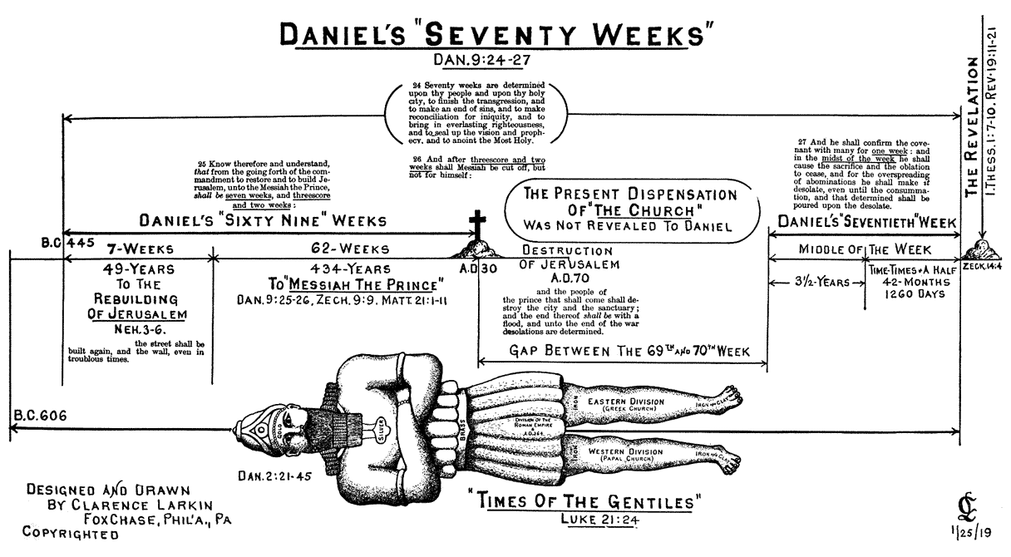

**Part 2: Daniel 9:24-27, The Seventy Weeks**

|  |  |
| --- | --- |
| [Daniel 8](javascript:%7b%7d) | [Daniel 9](javascript:%7b%7d) |
| The “little horn” (8:12-14, 22- 25) | The “prince who is to come” (v. 26) |
| Gabriel is the interpreter (v. 16) | Gabriel explains the vision (v. 21) |
| Concerns events of the end time(vv. 7,19,26) | Events bring matters to conclusion (v. 24) |
| Opposes the “Prince of princes” | Messiah the Prince will be cut off (vv. 25-26) |
| Removes regular sacrifice (v. 12) | Stops sacrifice and grain offering (v. 27) “People of prince” destroy Jerusalem and the sanctuary (v. 26) |
| Destroys many (vv. 24, 25) | Destruction, abominations, desolation (v. 27) |
| Horn broken without human agency 5) | Complete destruction poured out on him (v. 27) |

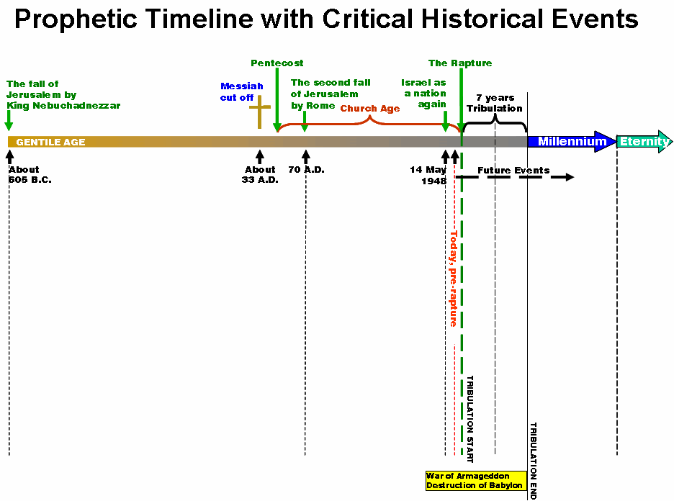

**Verse 24—The Scope Verse 25—The 69 Weeks Verse 26—Interval Verse 27—The 70th Week**

**Read Daniel 9: 24-27, “The Seventy Weeks” – 9B**

1. **The Seventy Weeks (70 X 7=490 years), is often compared to Jesus famous statement, “Seventy times Seven” in Matthew 18:21-22, about forgiveness.** Probably, this is a reference by Jesus to the “completeness of end times” referenced in this Daniel passage. Meaning—you should forgive your brother until the ages have passed, and the new world, void of sin, begins. **Seventy weeks are determined**: There is almost universal agreement among Bible scholars and commentators that this refers to **seventy** sets of seven years, or *weeks of years*.
2. **This is how the 70 weeks break down:**
3. **ZECHARIAH 9:9, “REJOICE GREATLY, O DAUGHTER OF ZION; SHOUT, O DAUGHTER OF JERUSALEM; BEHOLD THY KING COMETH UNTO THEE; HE IS JUST, AND HAVING SALVATION, LOWLY, AND RIDING UPON AN ASS, AND UPON A COLT THE FOAL OF AN ASS.”—JESUS PRESENTS HIMSELF AS A KING!**
4. **PSALM 118—“THIS IS THE DAY THE LORD HATH MADE..”—“Saying, blessed be the KING that cometh in the name of the Lord; peace in heaven, and gloring in the highest.’—LUKE 19:38, which is quoting Psalm 118. When the people are waving palm branches at the “The Triumphal Entry,” the people are quoting Psalm 118. Luke 19:39—“And some of the Pharisees from among the multitude said unto him, “Master, rebuke thy disciples.” (because they understood Psalm 118 was declaring that Jesus was the Messiah.)**
5. **Luke 19:40—“And He answered and said unto them, “I tell you that, if these should hold their peace, the stones would immediately cry out.”**
6. **Chronology of Jesus’ Ministry: Christ’s ministry began in fall 28 A.D., Tiberius appointed in 14 A.D.; August died in August 19, 14 A.D., within the 15th year of Tiberius, (Luke 3:1), 4th Passover: April 6, 32 A.D.**

|  |  |
| --- | --- |
| • | **The 7 weeks** - This 49 year period is the time where the 'commandment to restore and to build Jerusalem' was given. It would take 49 years to accomplish this, and it began in 445 BC. |
| • | **The 62 weeks** - From the end point on the rebuilding of the walls, until Messiah was to be revealed, it would be 62 weeks, or 434 years.  ++**+The Great Parenthesis** |
| • | **The last week** - This 7 year period is yet future because God stopped the time clock when Israel rejected the Messiah and He went to the cross. |

**This is around 539 B.C., when this prophecy came. Adding the 7 weeks, or 49 years, to the 62 weeks, or 434 years, brings us to a total of exactly 483 from the time that the commandment went forth to rebuild the walls unto the very day, April 2, 30 AD, that Jesus was paraded through the streets of Jerusalem just prior to going to the cross.. The last week, 7 years, is paused and deferred to a point in the future.**

**The 70 weeks starts with the Commandment to restore and rebuild Jerusalem (Decree of Artaxerxes Longimanus, March 14, 445 B.C., 69 times 7 times 360 =173,880 days (The Triumphal Entry, April 6, 32 A.D.—The Messiah the King)-- OR 7 WEEKS X 7 (49 YEARS) + 62 WEEKS X 7 (434 YEARS) = 483 YEARS**

**445 B.C.—32 A.D.—173,740 days**

**March 14-April 6: 24**

**Leap Years: 116**

**LUKE 19:41-42—“AND WHEN HE WAS COME NEAR, HE BEHELD THE CITY, AND WEPT OVER IT. SAYING, IF THOU HADST KNOWN, EVEN THOU, AT LEAST IN THIS THY DAY, THE THINGS WHICH BELONG UNTO THY PEACE BUT NOW THY ARE HID FROM THINE EYES.”—Paul tell us in Romans 11: 25,** “For I do not desire, brethren, that you should be ignorant of this mystery, lest you should be wise in your own opinion, that blindness in part has happened to Israel **until the fullness of the Gentiles has come in.”**

And further….Luke 19:43-44, “For days will come upon you when your enemies will build an embankment around you, surround you and close you in on every side, 44and level you, and your children within you, to the ground; and they will not leave in you one stone upon another, **because you did not know the time of your visitation**.” **38 years from the time Jesus said that, Titus Eustachio and the 5th, 10th, 12th, and 15th legions came into Jerusalem for 9 months and slaughtered over a million inhabitants, and another ½ million died from pestilence and famine when Jerusalem fell in 70 A.D., when the Romans laid siege to Jerusalem.**

1. **Verse 24 uses the term, “70 weeks.” What does the word “weeks” mean?** 
   1. **Name the different uses of the words “weeks” in the Bible.**
      1. **Week of days—Genesis 2:2 and Exodus 20:11.**
      2. **Feast of weeks—See Leviticus 23:15, 16**
      3. **Weeks of months—**Nisan to Tishri, **Exodus 12:2 and Leviticus 23:24.**
      4. **Sabbatical years—Sabbatical years for the land, Leviticus 25:1-22, 26:33-35, Deuteronomy 15, Exodus 23:10-11, and 2 Chronicles 36:19-21.** (The reason Israel was in captivity for 70 years was because they had not given God the land rest every 7 years).
   2. **Who are “thy people?”**
2. **Verse 24 is the scope of this prophecy of “the 70 weeks” explanation; the introduction--70 7’s on “thy people and the holy city.”** 
   1. **Finish transgression**
   2. **Make an end of sins**
   3. **Make reconciliation for iniquity….**maybe happened on the cross.
   4. **Bring in everlasting righteousness**
   5. **To seal up the vision and prophecy**
   6. **To anoint he most Holy Place (Holy of Holies)**
      1. **The scope of this is detailed, but not yet complete.**
3. **Verse 25—deals with 69 of the 70 weeks; the fulfilled part to the very day** 
   1. **Note that the “Weeks” are 7 years plus 62**
   2. **From what to what? (from the going forth of the commandment to rebuild Jerusalem unto the Messiah the King)**
   3. **The Holy Spirit’s footnote is added here for clarification….the last phrase of Verse 25. What does He say? “The street shall be built again and the wall, even in troublesome times.”**
   4. **The 69 Weeks=483 years (69 X 7 X 360 Days=173, 880 Days)**

|  |
| --- |
| **Commandment to Restore Jerusalem—(the trigger)** |

|  |
| --- |
| **The Messiah the King—(the target)** |

|  |  |  |
| --- | --- | --- |
| **Decree of Artaxerxes Longimanus on March 14, 445 B.C.** |  | **The Triumphal Entry on April 6, 32 A.D.** |

**(69 X 7 X 360 Days=173, 880 Days)—exactly what Gabriel foretold!**

1. **How long is a week?** 1. Days—Sabbath on the 7th Day (Gn. 2:2, Ex. 20:11) 2. Weeks—Feast of Weeks (Lev. 23:15-16) 3. Months—Nisan to Tishri (Ex. 12:2, Lev. 23:24) 4. Years—Sabbatical Years for the Land (Lev.25:1-22, 26:33-35, Deut. 15, Ex. 23: 10-11, 2 Chron. 36: 19-21) to clarify the meaning of the term '70 weeks'. It was not 70 calendar weeks, but rather it was 70 'weeks of years', figuring each day of the 70 weeks as one year. We know this for a variety of reasons. First, the word that was translated as 'weeks' is the word 'heptad', which means a 'group of sevens'. By the context that was given, we come to see that indeed it was meant as years and not days, as we shall soon see. Also note that Gabriel divides up the 70 weeks into 7 weeks, 62 weeks, and one week. If you miss that distinction, then you have missed the boat entirely. Gabriel's message to Daniel was simple and striking. 483 years - that is, 69 units of seven years - would pass from the time of the command recorded in [Nehemiah 2:1-8](http://www.studylight.org/desk/index.cgi?q1=Nehemiah+2:1-8&t1=en_nas) until the appearance of **Messiah the Prince**.
2. **Review the “Decrees to “Rebuild Jerusalem”” in the Bible.** Only the last of these four decrees was a **command to restore and build Jerusalem**. The first three each focused on the *temple*, not on **the street** or on **the wall**. Some say the 483 years were completed at the triumphal entry of Jesus (if dated at a.d. 32). Sir Robert Anderson's significant work *The Coming Prince* followed this argument in great detail. Anderson, using a 360-day year (which Israel used in Daniel's day), calculated 173,880 days from the decree to the triumphal entry, fulfilling the prophecy *to the day*. "It is customary for the Jews to have twelve months of 360 days each and then to insert a thirteenth month occasionally when necessary to correct the calendar."
   1. **Cyrus, 537 B.C., review Ezra 1:1-4, 5:**13-17. Cyrus made a decree giving Ezra and the Babylonian captives the right to return to Jerusalem and rebuild the temple in 538 b.c. ([Ezra 1:1-4](http://www.studylight.org/desk/index.cgi?q1=Ezra+1:1-4&t1=en_nas) and 5:13-17).
   2. **Darius, 517 B.C., read Ezra 6:1-5, 8, 12.** Darius made a decree giving Ezra the right to rebuild the temple in 517 b.c. ([Ezra 6:6-12](http://www.studylight.org/desk/index.cgi?q1=Ezra+6:6-12&t1=en_nas)).
   3. **Artaxerxes, 458 B.C., see Ezra 7:11-26.** Artaxerxes made a decree giving Ezra permission, safe passage, and supplies to return to Jerusalem to rebuild the temple in 458 b.c. ([Ezra 7:11-26](http://www.studylight.org/desk/index.cgi?q1=Ezra+7:11-26&t1=en_nas)).
   4. **Artaxerxes, 445 B.C., examine Neh. 2:1-8, 17,18**—the only one of the decrees that deals with the city of Jerusalem, the other ones deal with the temple—this decree rebuilds the city. Artaxerxes made a decree giving Nehemiah permission, safe passage and supplies to return to Jerusalem to rebuild the city and the walls in 445 b.c. ([Nehemiah 2:1-8](http://www.studylight.org/desk/index.cgi?q1=Nehemiah+2:1-8&t1=en_nas)).
3. **What kinds of years are mentioned in the Bible?** Nominal 360-day years or 12, 30-day months; about 701 B.C. they all change—long day of Joshua; conjecture that Mars and the Earth were on a near pass-bys and every 104 years there were resident orbits, and exchanged energy. Mars lost energy and earth gained it; exchange of energies. 701 B.C. energy stabilized; earth picked up 5 ¼ days. Confirmed scientifically, and mentioned in Joshua.
   1. **Genesis, Gen. 7:24, 8:3,4**
   2. **Daniel, Dan. 9:27, 12:6**
   3. **Revelation, Rev. 11:2,3; 13:5**
4. **Read Zechariah 9:9. How does this prophecy apply to the “until” in Verse 25? What does “thy king” and “riding upon an ass” mean? Who is He presenting Himself to?** Jesus is the king, and Jerusalem, the Jewish People is who He is coming for
   1. **Discuss Jesus’ 'Triumphal Entry,' recorded in each one of the Gospels and fulfilling** [**Zechariah 9:9**](http://www.studylight.org/desk/index.cgi?q1=Zechariah+9:9&t1=en_nas) **and** [**Psalm 118:26**](http://www.studylight.org/desk/index.cgi?q1=Psalm+118:26&t1=en_nas)**.**
   2. **Describe “On that day,” when Jesus *deliberately* arranged the event to present Himself as Messiah in** [**Mark 11:1-10**](http://www.studylight.org/desk/index.cgi?q1=Mark+11:1-10&t1=en_nas)**.**
   3. **Why “On that day” did Jesus welcome praise as described in** [**Luke 19:38-40**](http://www.studylight.org/desk/index.cgi?q1=Luke+19:38-40&t1=en_nas)**, instead of quieting it** [**in Luke 5:14**](http://www.studylight.org/desk/index.cgi?q1=Luke+5:14&t1=en_nas) **and 8:56?**
   4. **Talk about that “On that day, Jesus made special reference to the importance of that day” in** [**Luke 19:41-42**](http://www.studylight.org/desk/index.cgi?q1=Luke+19:41-42&t1=en_nas)**.**
5. **How does Psalm 118 apply to this?** 
   1. **Luke 19:38-40, the triumphant entry?**
   2. **In Luke 19: 41-42, what is Jesus’ emotion?**
   3. **What warning does He give Israel?--**the Pharisees are upset because that they understand that that Psalm was declaring Jesus the Messiah. They knew what Jesus was doing, and called Him blasphemous. Jesus answered that “the stones would cry out” if the people were quiet.
6. **Examine the “Chronology of Christ’s Ministry.” Discuss.** 
   1. **Began in fall of 28 A.D. (Tiberius appointed in 14 A.D., Augustus died August 19, 14 A.D., within the 15th year of Tiberius (Luke 3:1),**
   2. **4th Passover was April 6, 32 A.D.**
   3. **Explain the breakdown. (69 X 7 X 360 Days=173, 880 Days)**
   4. **Gabriel foretold the exact day that Jesus would reveal Himself**
   5. **See Luke 19: 41-42, why did Jesus chastise Israel?** 
      1. **What is hidden now from Israel? Until when? What does verse 43-44 foretell for Israel? 38 years later, Rome laid siege on Jerusalem and destroyed it in 70 A.D.—fall of Jerusalem.**
      2. **Luke 19:44. Jesus held the Jews accountable to know prophecy, and there was a great price to pay for not knowing….vs. 44**

|  |  |  |  |
| --- | --- | --- | --- |
| Verse 25 | | Verse 26 | Verse 27 |
| 7 wks | 62 Weeks | (Interval)  The Great Parenthesis | 70th Week |

1. **In Verse 26, an interval which occurs after 25, but before 27, (there are 7 weeks and 62 weeks, and one left) after 60th week, but before the 70th week. What does that imply? Clarence Larkin calls this “The Great Parenthesis.” Explain.**
   1. **A**ll 70 weeks are not contiguous, at least 38 years and now over 200.
   2. “Cut off”—“karat” means to cut off, eliminate, kill, or to execute. Jesus is to be executed, but not for Himself. Old Testament declares the Messiah will be killed.
   3. “The Prince that shall come”—antichrist, the final world leader. (His people shall destroy the sanctuary—70 A.D., the Roman legions under Titus Eustachian destroyed Jerusalem). The “people” are the Roman legions that destroyed the city and the sanctuary.
   4. Eastern leg of Roman Empire outlived the Western part of the Roman Empire by a thousand years, the Byzantine part. Culturally, the Middle East Isaiah 10, Micah 5—“the Assyrian.”
   5. At least 38 years, and over 1970 years +…
   6. It is Messianic, and the Messiah had to be executed before 70 A.D., and exit prior to 33 A.D.
2. **These four verses are centered on Israel. Explain how?**
   1. **This is 5/6 of the Bible**
   2. **Discuss Replacement Theology; how is that an unfortunate heresy?** Romans 9, 10, 11.
   3. **Read I Corinthians 10:32 where Paul deals with three types of people: Jews, Gentiles, and the church (neither Jew nor Gentile)…..explain the difference.**
   4. **Why is it important to understand this prophecy**? 404 Verses of Revelation, contain over 800 references to Israel….from Chapter 4 on in Revelation, the focus is on the Jew
   5. **The interval of Verse 26 is in Isaiah 61: 1-2. Review.** 
      1. **Compare Luke 4:18-20, where Jesus reads in the temple, and stops at the comma, leaving out……”And the day of vengeance of our God” is where He stopped……that interval is implied here.**
      2. **Interval also implied: Isa. 61: 1-2, Rev. 12:5-6, Isa. 54:7, Hos. 3:4-5, Amos 9:10-11, Acts 15:13-18, Micah 5:2-3, Zech 9:9-10, Luke 1:31-32, 21:24**
      3. **Interval Defined—Luke 19:42, Romans 11:25.** Also called “the church age.”
         1. **See Matthew 13:33-34, Ephesians 3:5-9, Colossians 1:16, I Corinthians 12:13, Acts 1:5, and 11:15-16.** this interval is the “church,” kept secret in the O.T. Matthew 13:33-34”hidden since the foundations of the world” Eph. 3:5-9 “privilege to reveal the mystery of the church.” Church was born at Pentecost…Col. 1:16, I Cor12:13, Acts 1:5, 11:15-16
   6. **Mystery Character of “The Church.” What is it? Read:**
      1. **The Body—Ephesians 3:3-5, 9**
      2. **Indwelling Every Believer—Colossains1:26-27**
      3. **Bride of Christ—Ephesians 5:22-32**
      4. **“Harpazo” or “Rapture”—I Corinthians 15: 50-58**
      5. **One “New Man”—Ephesians 2:15, Revelation 12:5.**
      6. **Distinguished from both the Jews and the Gentiles—I Corinthians 10:32.**

|  |  |
| --- | --- |
| • | **God turns to the Gentiles** - |
|  | "For I would not, brethren, that ye should be ignorant of this mystery, lest ye should be wise in your own conceits; that blindness in part is happened to Israel, until the fullness of the Gentiles be come in." [Romans 11: 25](javascript:;) |
|  | "But I say, did not Israel know? First Moses saith, I will provoke you to jealousy by [them that are] no people, [and] by a foolish nation I will anger you." [Romans 10: 19](javascript:;) |
|  | "Then Paul and Barnabas waxed bold, and said, It was necessary that the word of God should first have been spoken to you: but seeing ye put it from you, and judge yourselves unworthy of everlasting life, lo, we turn to the Gentiles." [Acts 13: 46](javascript:;) |
|  |  |
| • | **God turns His attention back to the Jews** - |
|  | "For if the casting away of them [be] the reconciling of the world, what [shall] the receiving [of them be], but life from the dead?" [Romans 11: 15](javascript:;) |
|  | "And so all Israel shall be saved: as it is written, There shall come out of Sion the Deliverer, and shall turn away ungodliness from Jacob: For this [is] my covenant unto them, when I shall take away their sins. " [Romans 11: 26](javascript:;) |
|  | "Saying, Hurt not the earth, neither the sea, nor the trees, till we have sealed the servants of our God in their foreheads. And I heard the number of them which were sealed: [and there were] sealed an hundred [and] forty [and] four thousand of all the tribes of the children of Israel."  [Revelation 7: 3,4](javascript:;) |
|  | And it shall come to pass in that day, [that] I will seek to destroy all the nations that come against Jerusalem. And I will pour upon the house of David, and upon the inhabitants of Jerusalem, the spirit of grace and of supplications: and they shall look upon me whom they have pierced, and they shall mourn for him, as one mourneth for [his] only [son], and shall be in bitterness for him, as one that is in bitterness for [his] firstborn. In that day shall there be a great mourning in Jerusalem, as the mourning of Hadadrimmon in the valley of Megiddo. " [Zechariah 12: 9-11](javascript:;) |

1. Jesus **declares corporate blindness for Israel until when? Read Luke 19:42 and Romans 11:25.** Jesus declares blindness for Israel until the fullness of the Gentiles be come in. Fullness of the Gentiles is a church phrase…..a complete number. **Synonymous with the Church Period.**
2. **Discuss “Shall destroy the city and the sanctuary.” Verse 26.**  After the Messiah was cut off, Jerusalem and her temple would be destroyed *again* by an overwhelming army (with a flood). Most all Bible scholars and commentators agree that this was fulfilled in the Roman destruction of Jerusalem in a.d. 70.
3. **Who are “The people of the prince who is to come?”** Verse 26. shall destroy: The destroying army is made up of the people of the prince who is to come. This *coming prince* is described more in [Daniel 9:26](http://www.studylight.org/desk/index.cgi?q1=Daniel+9:26&t1=en_nas).
4. **Discuss verse 27—the missing part, the 70th week.**

--Mentions “Wing of Abominations,” Hebrew word for “edge of a garment,” much like when the woman with the issue of blood touched the edge of Jesus’ garment and was healed….Luke 8:43-48…possibility that the edge of the anti-Christ’s garment has some kind of “blood” power to change DNA, like the edge of Jesus’ garment changed “the issue of blood” in Luke

1. **Seventieth Week is in two parts. Explain them.**  It begins with the covenant enforced by the coming world leader. Dan. 9:27
   1. **Who is “he?”**
      1. **What is the covenant? For how long?**
   2. **What starts the 70 week? Is there a temple standing at this point?** The starting of the covenant. In the middle of that week the antichrist erects the image of the holy of holies, “The Great Tribulation.” This is the last ½ of the 70th week.
      1. **Compare to Matthew 24:15, 21.**
   3. **What is one week? Sacrifice? Oblation?**
   4. **What happens in the middle of the covenant? How does this mimic Antiochus Epiphanes in 167 B.C.? The Abomination of Desolation?** God’s covenant with Israel was established in Genesis 15:1-6. This covenant in Genesis is the same word used in Daniel, vs. 27, meaning literally “to cut a deal.” **Abominations** translates an ancient Hebrew word (*shiqquwts*) that is connected to horrific idolatry ([Deuteronomy 29:17](http://www.studylight.org/desk/index.cgi?q1=Deuteronomy+29:17&t1=en_nas), [1](http://www.studylight.org/desk/index.cgi?q1=Deuteronomy+29:1&t1=en_nas) Kings 11:5-7, [2 Kings 23:13](http://www.studylight.org/desk/index.cgi?q1=2%20Kings+23:13&t1=en_nas)). The idea is that the coming prince breaks the covenant and brings an end to sacrifice and offering by desecrating the holy place of the temple with a horrific idolatry.
      1. **See Matthew 24:15 and 2 Thessalonians 2:3-4.** Jesus called this the *abomination of desolation* ([Matthew 24:15](http://www.studylight.org/desk/index.cgi?q1=Matthew+24:15&t1=en_nas)) and indicated that it would be a pivotal sign in the Great Tribulation. Paul referred to the idolatry of the coming prince in [2 Thessalonians 2:3-4](http://www.studylight.org/desk/index.cgi?q1=2%20Thessalonians+2:3-4&t1=en_nas).
   5. **Time, Times and ½ Time—explain. Refer to Daniel 7:25, 12:7, and Revelation 12:14**.—3 ½ years in Dan. 9:27, 12:7, 42 mos. in Rev. 11:2, 13:5, 1260 days in Rev. 11:3, Dan. 12:6, and ½ week in Dan. 9:27—most documented time in the entire Bible
   6. **Explain the “Abomination of Desolation.” See John 10:22, which refers to this.** Read it. (Hanukkah is in winter). Review who Antiochus Epiphanes was.
      1. **Read Matthew 24:15 and John 10:22.**
2. **When is “The Great Tribulation?” Read Matthew 24:21 and 22.** Jesus is actually quoting from Daniel 12:1, “At that time shall Michael stand up…..”Zech. 13:8-9, Jeremiah calls it “a time of Jacob’s trouble.”
3. **Who is the "he" Gabriel described is “the prince who is to come?”** If we know that the prince's *people* destroyed Jerusalem in a.d. 70, then we know this coming prince has his ancestral roots in the soil of the ancient Roman Empire.
4. **Read Hosea 5: 15. What does he mean by “go to my place?”** Jesus returns to heaven until the Jews pray for Him to return. Singular and specific. Jesus will return when the Jews acknowledge their offence. One of the prerequisites for Jesus’ return
5. **Compare Gen 1 and Gene 3:15, with the “prince that shall come.” Who is he?**
   1. **Give other names of him.**
6. **Give characteristics of the antichrist.** Intellectual—Daniel 7:20; Persuasive—Revelation 13:2; Shrewd Politician—Daniel 11:21; Financial Genius—Revelation 13:17; Forceful Military Leader—Daniel 8:24, Isa. 4:16; Powerful Organizer—Revelation 13:1,2; Unifying Religious Leader—2 Thessalonians 2:4.
7. **Revelation 13 has two “bad guys.” Who are they?** 
   1. **Read Revelation 13:1-2.** The leader cannot be revealed until after the Rapture. 2 Thess. 2:6-9
8. **Read Zechariah 11:17. What is the description given of the antichrist?** 
   1. **Who is the “idol shepherd?”** 
      1. **Describe his head wound.**
9. **The Second beast is explained in Revelation 13:11-12. Describe.**
10. **Revelation 13:16-17. Explain the mark of the beast.** Modern times speculation?
    1. **When does the 70th week begin?** Taking the description of what would be accomplished in the 70 Weeks from [Daniel 9:24](http://www.studylight.org/desk/index.cgi?q1=Daniel+9:24&t1=en_nas), we know that the 70 Weeks are not yet complete. Yet the events promised in the first 69 weeks *are* fulfilled, indicated that there is a lengthy "pause" in the 70 Weeks, between the 69th week and the 70th week. The 70th week will begin when the coming prince shall confirm a covenant with the Jewish people. These gaps or pauses in prophecy may seem strange to us, but they are common. Comparing [Isaiah 9:6](http://www.studylight.org/desk/index.cgi?q1=Isaiah+9:6&t1=en_nas) and [Luke 1:31-33](http://www.studylight.org/desk/index.cgi?q1=Luke+1:31-33&t1=en_nas) shows another significant pause or gap in prophecy regarding the coming of the Messiah. **Seventieth week starts with antichrist making a covenant with Israel. Rapture takes place before . Prior to the 70th Week of Daniel….An interval between the rapture and the rise of the Antichrist. Teaching of Immanency (Christ could come at any moment). Israel and the Church are not the same…Dan. 9:26. They are dealt with the differently.** 
       1. **See I Thessalonians 5:8-9 and Revelation 3:10.** We are promised not to experience God’s wrath.
       2. **How can the Bride come with Him if He hasn’t received her?**
11. **Read 2 Thessalonians 2….”that day shall not come” “restrainer removed”**
12. **How Revelation Correlates with Daniel 9. Where are the lamp stands? What is their identification? Read Rev. 1:20, and Rev. 4:5**
13. **Who are the 24 Elders in Rev. 5? Are they the redeemed? What is their song? Read. Revelation 5: 9-10.**
14. **Define the 70th Week of Daniel using Revelation 6-19.**

The Order of Events

**`**

**The Apostasy The Restrainer Removed**

**The Day of the Lord**

|  |  |  |
| --- | --- | --- |
| **69 Weeks=483 Years**  7 Weeks 62 Weeks  49 Years 434 Years  **Artaxerxes’ Decree**  **Messiah’s Death** | **The Church Age**  **(The Great Parenthesis)** | **1 Week=7 Years**  ½ Week ½ Year  3½ Weeks 3½ Years  **The Tribulation**  Vs. 27 |

**444 B.C. 33 A.D. ?? Rapture**

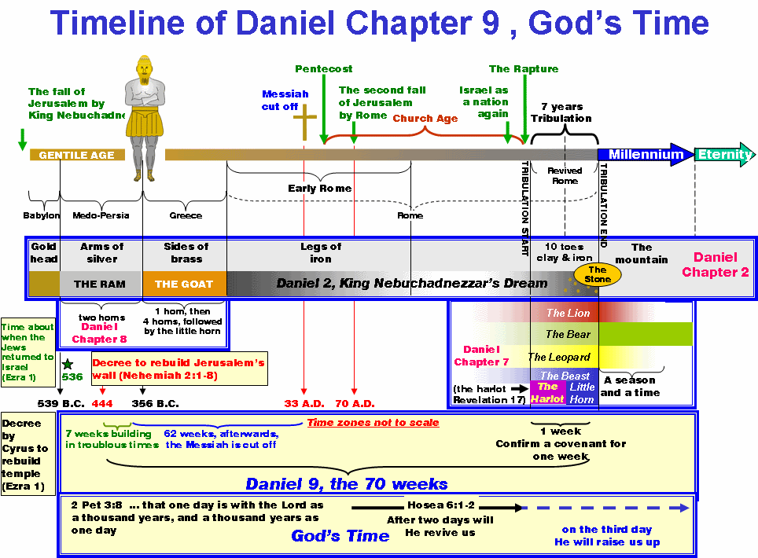

Study Notes

“Seventy Times Seven” reference—Matthew 18:21-22

Verse 24—Scope of the Prophecy

Thy People, and Thy Holy City—Jews and Jerusalem

I. To Finish Transgression—this is the transgression of Israel against God, and will not be finished until THEY, as a Nation, repent and turn to God. Remember, Daniel is not looking at the Gentiles, but the Jews.

II. To Make an End to Sin—“Sin” OF Israel is meant; a time will come when God “shall turn away ungodliness from Jacob, and take away from Israel all their sins.” But, not until the DELIVERER COMES—Romans 11:26-27—Paul

III. To Make Reconciliation for Iniquity—iniquity of Israel; wickedness and unrighteousness. Isaiah 53:6, Jews will look on Him whom they pierced…Rev. 1:7, at His Second Coming. Isaiah 66:8-- and the Jews shall be converted in one day. In that day, “The Day of the Lord”—a fountain will open up to “The House of David” and to Jerusalem—Zech. 13:1

IV. To Bring in Everlasting Righteousness—Millennial Kingdom can’t be set up until the “Transgressions of Israel” have come to an end and their sins “sealed up.” Then, Jesus will make a “New Covenant” with the “House of Israel.” Jer. 31:33-34

V. To Seal Up the Vision and Prophecy—for the Jews; Gold sealed up the prophecy to Israel and put blindness on them. Romans 11:25—blindness until the fullness of the Gentiles. When Israel is restored, transgressions have ceased, and there is no longer need for vision. I Cor. 13:8-10.

VI. To Anoint the Most Holy Place—this is a place—The Most Holy Place of the New Millennial Temple is the Holy of Holies. Ez. 41:1-42; 20; still in future

The “Shekinah Glory” was in the Exodus as the “Pillar of Clouds”/”Pillar of Fire”—Ex. 13:21-22; in the tabernacle, Ex. 40:34-35; in the Temple of Solomon, I Kings 8:10-11; Ezekiel saw it “leave the temple of God”—Ez. 9:3 and the City of Jerusalem—Ez. 11:23 to return to Heaven to return to the Millennial Temple, when it returns from the east, Ez. 43:1-6…the time space between the departure and the return of the Shekinah Glory marks the “Times of the Gentiles.´ Shekinah Glory—divine visitation of the dwelling of Jehovah God on Earth. Indwelling of Jehovah God.

Seventy Weeks—literally means “Seventy Sevens.” Seven is the perfect number.

Key—Numbers 14:34—tells us that these weeks are one day equals one year; seven days equal seven years; seventy weeks equal four hundred, ninety days, equal four hundred, ninety years—2 Chron. 36:19-21, Lev. 25.

**Verse 25—Detailed Prophecy of the 69 Weeks and Palm Sunday**

Verses describing Palm Sunday, the Triumphal Entry into Jerusalem, predicted by Gabriel over 500 years before--Zech 9:9,John 12:13, Matthew 21:1-3, Luke 19:29-48, Acts 13:46, Psalm 118:21-24 (what the people were singing as they waved palms on Palm Sunday), Luke 19:42 (Jesus invokes corporate blindness for Israel), John 1:10-11; Luke 19:40, even the stones would cry out.

Luke 19: 41-42—Jesus wept over the city; and told the Jews –announces judicial judgment on Israel; 44—because they didn’t know the day of His appearance

This verse starts at “the commandment to restore and build Jerusalem, the city UNTO the Messiah the Prince shall be 7 weeks plus 3 score weeks, 49 years plus 483 years=173,880 days, exactly the day that Daniel prophesied. (March 13, 445 B.C. UNTO April 6, 30 AD. See: John 12:13, Matthew 21:1-3, Luke 19:39-40, Zech 9:9

Bible Calendar-360 days

5/6 of the entire Bible focuses on Israel

**Verse 26—AND AFTER—(The Great Parentheses) or “The Church Age”**

Between 69th and 70th week

Parallel Passages to Daniel’s 70 Weeks—Jesus’ Olivet Discourse, Matthew 24 and John’s “Seal, Trumpets and Vials”—Rev. 6:1-18, 24…what Daniel discloses in one verse, Dan. 9:27, John explains in thirteen chapters

Jesus crucified or “cut off,” Jerusalem and Temple destroyed by Roman, and long period covered by wars.

Luke 21:14—the Times of the Gentiles

“The Prince that shall come” is one name for the antichrist. Roman legions under Titus destroyed Jerusalem and the temple

Isaiah 61:1-2—Jesus reads in the synagogue (Luke 4:21), and stops at the comma, leaving out “and the day of vengeance.” That comma, implied, or interval, has lasted almost 2000 years.

Till Rapture—I Thess. 4:13-18

The church was hidden in Old Testament—Eph. 3:5, 9; Matt 13: 34-35; Romans 11:25

The indwelling of the Holy Spirit was a special gift to the church—I Cor. 10:32

Luke 19:42, Jesus pronounces corporate blindness on Israel for not understanding His coming.

Hosea 5:15….Jesus returns home until the Jews petition Him to return

**Verse 27—Final Week, 70th Week**

“Prince that shall come,” antichrist, enforces covenant with Israel for seven years

7 year period divided into first and second half; starts with the enforcement of the covenant; but, by the middle of the week, antichrist goes back on his word and stops the sacrifices and prayers, which is a repeat of 167 B.C. when Antiochus Epiphanes does the same thing. Jesus refers to this in the Olivet Discourse.

Temple must be rebuilt in future

3 ½ years=42 months=1260 days=time, times, and ½ of time—Most documented period of time in the Bible

70th Week—defined as covenant being enforced and half-way through the covenant is broken marks the “Great Tribulation;” Jeremiah calls it “Time of Jacob’s Trouble”, Hosea 5:15 is the prerequisite for Jesus’ return, petitioning Him to return; 2 Thess. 2:6-7, I Thess. 5:9, Rev. 3:10

Matthew 24:21-22, last 3 ½ weeks; referred by Daniel 12:1

Zech. 11:17—only description of the antichrist in the Bible

1. **Contemplate this…..was Jesus “disfigured?” Refer to Isaiah 52:14, 53:2-10, 50:5-7, Rev. 5:11 and 13.**

**Ending Comments:** We can think of it in this way: God appointed 490 years of special focus on Israel in His redemptive plan. The years were caused by Israel's rejection of Jesus. Now there is no *special* focus on Israel in God's redemptive plan because this is the time of the church. God's focus will return to Israel when the church is taken away (at the rapture) and the last seven years of man's rule on this earth begins. "The 70th week will begin when the Jewish people are restored in unbelief to their land and city; and among them will be found a faithful remnant, owning their sin, and seeking Jehovah's face." (Henry Ironside writing in 1911). The Book of Revelation sees this seven year period with both its halves as yet future ([Revelation 12:6](http://www.studylight.org/desk/index.cgi?q1=Revelation+12:6&t1=en_nas), [13-14](http://www.studylight.org/desk/index.cgi?q1=Revelation+12:13-14&t1=en_nas); [13:5-9](http://www.studylight.org/desk/index.cgi?q1=Revelation+13:5-9&t1=en_nas), [14-15](http://www.studylight.org/desk/index.cgi?q1=Revelation+13:14-15&t1=en_nas)). The **middle of the week** and the **end of sacrifice** had not yet happened in 90 a.d.

Some Famous “Untils” in the Bible

Daniel 9:25….until Messiah the Prince

John 21:20-22…what if John remains until Jesus comes back?...

Matthew 5:17-19…the law….until heaven and earth are passed away…

Ephesians 4:10-14….we are called until we all are in unity…..

Matthew 11:11-13….John the Baptist

2 Thessalonians 2:3…..until the restrainer is removed….

Genesis 32:24…Jacob wrestled until…..

James 5:7…until the coming of the Lord…

2 Peter 1:19…until the Morning Star…

Hosea 5:15…..”I will return to my place until”

**The Seventy Weeks of Daniel as Understood by Sir Robert Anderson in “The Coming Prince….”**

[Daniel 9:24-25](http://www.studylight.org/desk/index.cgi?q1=Daniel+9:24-25&t1=en_nas) says that from the decree to rebuild Jerusalem to the coming of the Messiah there will be 483 years.

7 + 62 "weeks" = 69 groups of seven years. 7 x 69 = 483 years

Anderson understood a prophetic year as 360 days. This is based both on ancient history and on [Revelation 11:2](http://www.studylight.org/desk/index.cgi?q1=Revelation+11:2&t1=en_nas), [13](http://www.studylight.org/desk/index.cgi?q1=Revelation+11:13&t1=en_nas):5, 11:3, and 12:6 which indicate that 42 months - 3 years - are equal to 1,260 days.

Therefore, 483 years x 360 days = 173,880 days

Artaxerxes started his reign in 465 b.c. The decree to rebuild Jerusalem was given on the first day of Nisan, in the 20th year of Artaxerxes. In our calendar system (the Julian calendar) that date is March 14, 445 b.c. ([Nehemiah 2:1](http://www.studylight.org/desk/index.cgi?q1=Nehemiah+2:1&t1=en_nas))

Jesus started His ministry in the 15th year of Tiberius (see [Luke 3:1](http://www.studylight.org/desk/index.cgi?q1=Luke+3:1&t1=en_nas)). Tiberius started his reign in a.d. 14, so Jesus' ministry started in a.d. 29. Anderson believed that Jesus celebrated four Passovers during His ministry, one each in a.d. 29, 30, and 31. and His final Passover in a.d. 32. With the help of lunar charts, we can calculate the exact date of ancient Passovers, so it is possible to calculate the exact day of Jesus' triumphal entry into Jerusalem as April 6, a.d. 32.

From 445 b.c. to a.d. 32. there are 476 years on the Julian calendar

(Not 477 years, because there is no year zero).

476 years x 365 days = 173,740 days.

Adjusting for the difference between March 14 and April 6 adds 24 days.

Adjusting for leap years over a period of 476 years adds 116 days.

The total number of days from March 14, 445 b.c. to April 6, a.d. 32.

173,740 + 24 + 116 = 173,880 days.

According to his calendar, Daniel told us there would be 173,880 days between the decree and the arrival of Messiah the Prince. Jesus said to the Jews of this day: *If you had known, even you, especially in this your day, the things that make for your peace!* ([Luke 19:42](http://www.studylight.org/desk/index.cgi?q1=Luke+19:42&t1=en_nas)). David said of this day in [Psalm 118:24](http://www.studylight.org/desk/index.cgi?q1=Psalm+118:24&t1=en_nas): *This is the day which the Lord has made; we will rejoice and be glad in it*.