**The Destiny of Daniel—Chapter 7—Daniel’s Dream**

**This chapter is dated at** 553 B.C., 50 years after Chapter 2, in the 1st year of Belshazzar’s reign as co-regent with Nabonidus, fourteen years before Belshazzar’s feast, during Daniel’s “retirement” period in the court of Belshazzar**. This is the first chapter in Daniel’s prophetic section, and the last book written in Aramaic. Chapter 2—Outward splendor; dazzling, inanimate man; Chapter 7—True warlike and beastly character, more spiritual animate man.** This chapter treats the same subject as the second chapter. But there the four kingdoms, and Messiah's final kingdom, were regarded according to their external political aspect, but here according to the mind of God concerning them, and their moral features. The outward political history had been shown in its general features to the world ruler, whose position fitted him for receiving such a revelation. But God's prophet in Chapter 7 receives disclosures as to the characters of the powers of the world, in a religious point of view, suited to his position and receptivity. Thus, in the second chapter the images are taken from the inanimate sphere; in the seventh chapter they are taken from the animate. Chapter 7 is the last chapter in Aramaic and actually occurs, chronologically, after chapter 4. Chapter 8 follows in the time line, then Chapter 5, 9, 6 and 10-12, in that order. Chapters 2-6, and 7 are in Aramaic—Gentile history.

**(1) Daniel’s Dream, Chapter 7, verses 1-14**

* **The Four Beasts — verses 1-8**
* **The Ancient of Days — verses 9-12**
* **The Son of Man — verses 13-14**

**(2) The Divine Interpretation — verses 15-28**

* **Daniel’s distress — verse 15**
* **A General Interpretation — verses 16-18**
* **A Fuller Interpretation — verses 19-27**
* **Daniel’s Response — verse 28**

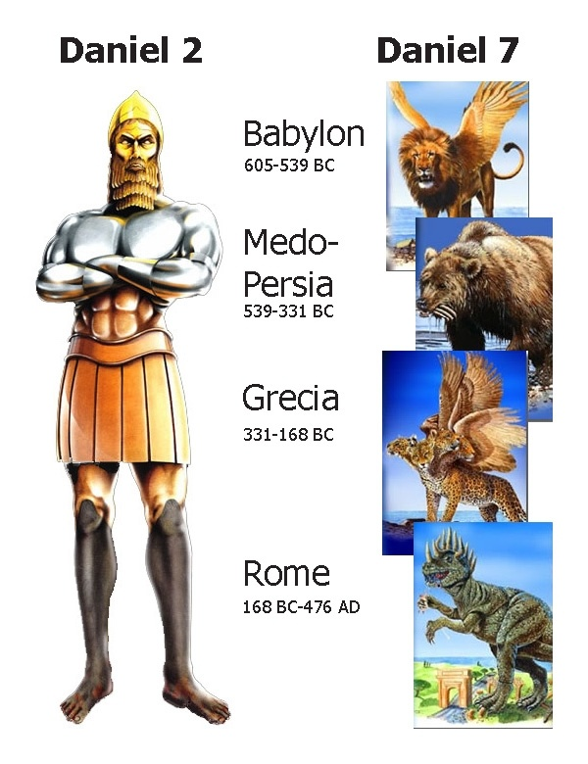

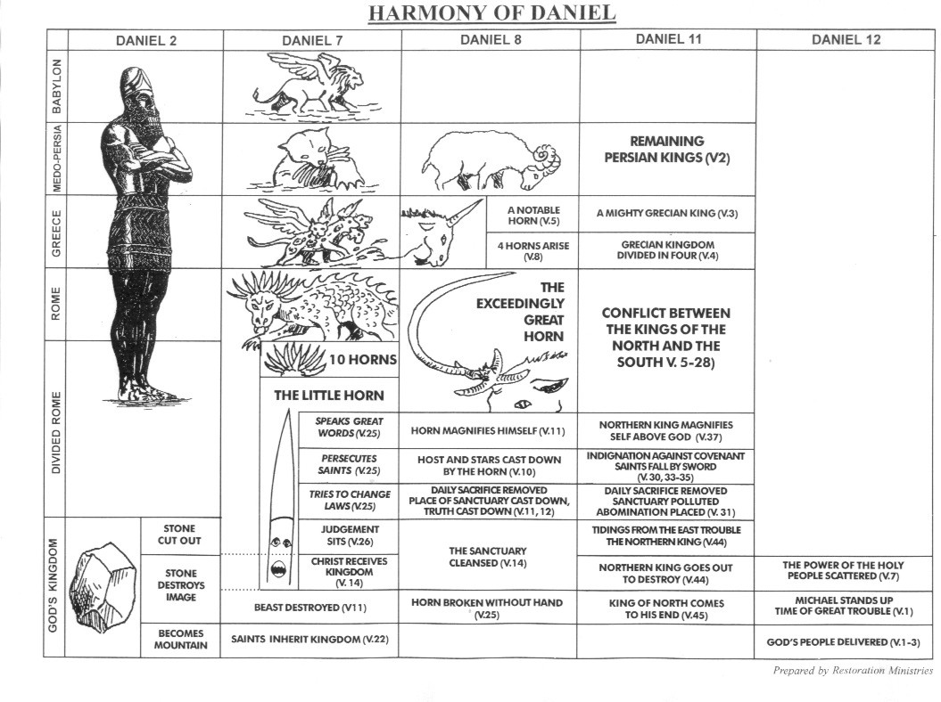

**Setting of the visions…around the Mediterranean Sea, which is where the epic drama will all unfold**

**Take note: In the first six chapters of Daniel, Daniel referred to himself in the third person; in the last six, he used the personal 1st person**

**Important Vocabulary for Bible Prophecy**

1. **Winds—Spirits; sovereign power of God; God’s own judgments “God often used the wind as a means to attain His ends.” Gen. 8:1, Ex. 10:13, 14:21, 15:10, Numbers 11:31, I Kings 18:45. Over half of the 120 references in Bible to “wind” (O.T. and N.T.) are related to events and ideas which reflect the sovereignty and power of God. In Daniel, it always means “sovereign power of God.”**
2. **Sea—People; multitudes; nations; tongues**
3. **Great Sea—Mediterranean Sea**
4. **Beasts—Kings, Kingdoms or political powers**
5. **Wings—Swiftness of movement, flight**
6. **Heads—Divisions or branches of government**
7. **Horns—Kingdoms or Kings; rulers, heads of state**
8. **Dragon—Satan**
9. **Stars—Angels**
10. **Fig Tree—Israel**
11. **Horn—Power or Authority**
12. **Earth Dwellers—Followers of the beast**

**Read Daniel 7:1-8—The Four Beasts**

1. **Review Luke 21:24….the times of the Gentiles……start with Nebuchadnezzar and ends with the Anti-Christ. (Fullness of the Gentiles is for the church, Romans 11:25).**
2. **Who actually had the dream in this chapter? Daniel**
   1. **Verse 2—why does Daniel shift to first person for the first time?**
3. **Compare this chapter with Daniel 2.** Nebuchadnezzar's colossal image represents mankind in its own strength, but only the outward man. Daniel sees man spiritually degraded to the beast level, led by blind impulses, through his alienation from God. It is only from above that the perfect Son of man comes, and in His kingdom man attains his true destiny. The animal with all its sagacity looks always to the ground, without consciousness of relation to God.
   1. **Parallel Psalm 8:1-9 with Genesis 1:26-28.**
   2. **See the bestiality in Psalm 32:9, 49:20, and 73:22.**
   3. **View heathen nations compared to bulls in Psalm 68:30.**
   4. **Egypt is likened to the dragon in the Nile in Isaiah 27:1, 51:9, and Ezekiel 29:3.**
   5. **View also** [**Hosea 13:7**](http://www.biblestudytools.com/hosea/13-7.html)**-8.**  **(**Would occur to him while viewing those ensigns of the world power). **Compare** [**Jeremiah 2:15**](http://www.biblestudytools.com/jeremiah/2-15.html) **and** [**4:7:5:6**](http://www.biblestudytools.com/passage/?q=Jeremiah+4:7;Jeremiah+4:5;Jeremiah+4:6).
4. **Place this chapter in the proper chronological order in Daniel. Who is the king?**
5. **The “Great Sea” designates the Mediterranean Sea. What, then, is the setting for this vision? Verse 2--** sea--The world powers rise out of the agitations of the political sea.
   1. **Compare** [**Jeremiah 46:7**](http://www.biblestudytools.com/jeremiah/46-7.html)**-8,** [**Luke 21:25**](http://www.biblestudytools.com/luke/21-25.html)**, and also** [**Revelation 13:1**](http://www.biblestudytools.com/revelation/13-1.html)**,** [**17:15**](http://www.biblestudytools.com/revelation/17-15.html)**, and** [**21:1**](http://www.biblestudytools.com/revelation/21-1.html)**.**
   2. **Where else in scripture does “The Great Sea" mean the Mediterranean? Examine Joshua 1:4, 9:1.** It isthe center territorially of the four kingdoms of the vision, which all border on it and have Jerusalem subject to them. Babylon did not border on the Mediterranean, nor rule Jerusalem, till Nebuchadnezzar's time, when both things took place simultaneously
6. **Describe who are, or what the “Four Winds of Heaven” are, See also in Zechariah 6:5 and also Revelation 7:1.** “These are the four spirits of heaven, going forth after standing before the Lord of all the earth.” Rev.7:1, “After this I saw four angels standing at the four corners of the earth, holding back the four winds of the earth.”
   1. **Who are the four winds?** spirits
7. **In Verse 4, what does “Plucked off” mean?** “Man’s Heart?” Remember….Daniel only knew of the Babylonian era at this point….the rest is pure prophecy.
8. **Who are the four beasts?** Beasts--not living animals, as the cherubic four in [Revelation 4:7](http://www.biblestudytools.com/revelation/4-7.html) (for the original is a different word from "beasts," and ought to be there translated, living animals). The cherubic living animals represent redeemed man, combining in himself the highest forms of animal life. But the "beasts" here represent the world powers, in their beast-like, groveling character. It is on the fundamental harmony between nature and spirit, between the three kingdoms of nature, history, and revelation that Scripture symbolism rests. The selection of symbols is not arbitrary, but based on the essence of things.
   1. **Describe and discuss the First Beast—Lion.** (verse 4) **See Jeremiah 4:7, 13, 48:40, Isaiah 46:11, Habakkuk 1:6, and Lamentations 4:19. Mythical beast that adorned Neb’s palace was called “griffins. ’Compare to the Gold Head in Daniel 2’s metal figure.** Lion--the symbol of strength and courage; chief among the kingdoms, as the lion among the beasts. Nebuchadnezzar is called "the lion,” eagle's wings--denoting a widespread and rapidly acquired,   
      plucked--Its ability for widespread conquests passed away under Evil-Merodach, rather, during Nebuchadnezzar's privation of his throne, while deranged. It was lifted up from the earth--that is, from its groveling bestiality.   
      Made stand. . . as a man--So long as Nebuchadnezzar, in haughty pride, relied on his own strength, he forfeited the true dignity of man, and was therefore degraded to be with the beasts. [**Daniel 4:16**](http://www.biblestudytools.com/daniel/4-16.html) **: "Let his heart be changed from man's, and let a beast's heart be given unto him." But after he learned by this sore discipline that "the Most High ruleth in the kingdom of men"** ([Daniel 4:35](http://www.biblestudytools.com/daniel/4-35.html) [Daniel 4:36](http://www.biblestudytools.com/daniel/4-36.html) ), the change took place in him, "a man's heart is given to him; instead of his former beast's heart, he attains man's true position, namely, to be consciously dependent on God."
      1. **Compare** [**Psalms 9:20**](http://www.biblestudytools.com/psalms/9-20.html)**.** The gates of Babylon have winged lions on their front.
      2. **Was this an allusion to Nebuchadnezzar’s heart being changed? See Daniel 4.**
   2. **Beast two—like a bear--describe and compare to the Silver Kingdom in Daniel 2; read Isaiah 13:17-20, Jeremiah 51:48, 56.** Bear--symbolizing the austere life of the Persians in their mountains, also their cruelty …Cambyses, Ochus, and other of the Persian princes were notoriously cruel; the Persian laws involved, for one man's offense, the whole kindred and neighborhood in destruction, [Daniel 6:24](http://www.biblestudytools.com/daniel/6-24.html) and rapacity. "A bear is an all-devouring animal". itself on one side--but the Hebrew, "It raised up one dominion." The Medes, an ancient people, and the Persians, a modern tribe, formed one united sovereignty in contrast to the third and fourth kingdoms, each originally one, afterwards divided. English Version is the result of a slight change of a Hebrew letter. The idea then would be, "It lay on one of its fore feet, and stood on the other"; a figure still to be seen on one of the stones of Babylon denoting a kingdom that had been at rest, but is now rousing itself for conquest. Media is the lower side, passiveness; Persia, the upper, active element. Xerxes was known to march 2 ½ million men in the army….very ponderous and powerful.
      1. **Why is it raised up on one side?**
      2. **What are the “Three Ribs?”** Three primary conquests established this kingdom. **See Isaiah 13:17.** Babylon, Egypt, Lydia… The three ribs in its mouth are Media, Lydia, and Babylon, brought under the Persian sway. Rather, Babylon, Lydia, and Egypt, not properly parts of its body, but seized by Medo-Persia. Called "ribs" because they strengthened the Medo-Persian Empire. "Between its teeth," as being much grinded by it.   
         Devoured much flesh--that is, subjugate many nations.
   3. **In Verse 6, who is the Third Beast-- leopard? Bronze?–**does this imply speed? **Four Heads—Four general who took over after Alexander--Cassandra**  (Macedonia and Greece)—conquered by Rome in 146 B.C., **Lysimachus** (Thrace, Bithynia, most of Asia Minor)—conquered by Rome in 133 B.C., **Seleucus** (Syria and east all the way to India)—conquered in 64 B.C., and **Ptolemy** (Egypt, Cyrene, Arabia Petraea)—conquered in 31 B.C. A leopard is smaller than the lion; swift ([Habakkuk 1:8](http://www.biblestudytools.com/habakkuk/1-8.html) ); cruel ([Isaiah 11:6](http://www.biblestudytools.com/isaiah/11-6.html) ), the opposite of tame; springing suddenly from its hiding place on its prey ([Hosea 13:7](http://www.biblestudytools.com/hosea/13-7.html) ); spotted. So Alexander, a small king, of a small kingdom, Macedon, attacked Darius at the head of the vast empire reaching from the Ægean Sea to the Indies. In twelve years he subjugated part of Europe, and all Asia from Illyricum and the Adriatic to the Ganges, not so much fighting as conquering [JEROME]. Whereas Babylon is represented with two wings, Macedon has four, so rapid were its conquests. The various spots denote the various nations incorporated into his empire; Or Alexander's own variation in character, at one time mild, at another cruel, now temperate, then drunken and licentious. Four heads--explained in [Daniel 8:8](http://www.biblestudytools.com/daniel/8-8.html) [Daniel 8:22](http://www.biblestudytools.com/daniel/8-22.html) ; the four kingdoms of the Diadochi or "successors" into which the Macedonian empire was divided at the death of Alexander, namely, **Macedon and Greece under Cassander, Thrace and Bithynia under Lysimachus, Egypt under PTOLEMY, and Syria under Seleucus’ dominion** . . . given to it--by God; not by Alexander's own might.
      1. **What are the four wings? Four heads?** Four generals after Alexander
   4. **Describe the fourth beast. The ten horns? 10 Horns=10 Toes… The little horn (vs. 8)?** Whereas the three former kingdoms were designated respectively, as a lion, bear, and leopard, no particular beast is specified as the image of the fourth; for Rome is so terrible as to be not describable by any one, but combines in itself all that we can imagine inexpressibly fierce in all beasts.
      1. **Why does Daniel repeat three times that this beast is different from all the others?** Refer to [**Daniel 7:7**](http://www.biblestudytools.com/daniel/7-7.html)[**Daniel 7:19**](http://www.biblestudytools.com/daniel/7-19.html)[**Daniel 7:23**](http://www.biblestudytools.com/daniel/7-23.html). It is repeated, that the fourth was "diverse from all" the others. The formula of introduction, "I saw in the night visions," occurs here, as at [Daniel 7:2](http://www.biblestudytools.com/daniel/7-2.html), and again at [Daniel 7:13](http://www.biblestudytools.com/daniel/7-13.html) , thus dividing the whole vision into three parts--the first embracing the three kingdoms, the second the fourth and its overthrow, the third Messiah's kingdom. The first three together take up a few centuries; the fourth, thousands of years. The whole lower half of the image in the second chapter is given to it. And whereas the other kingdoms consist of only one material, this consists of two, iron and clay (on which much stress is laid, [Daniel 2:41-43](http://www.biblestudytools.com/passage/?q=Daniel+2:41-43) ); the "iron teeth" here allude to one material in the fourth kingdom of the image.
      2. **What are the iron teeth?**
      3. **What are the ten horns? See also Revelation 13:1, 17:12 and Daniel 2:4.** Ten horns--It is with the crisis, rather than the course, of the fourth kingdom that this seventh chapter is mainly concerned. The ten kings, [Daniel 7:24](http://www.biblestudytools.com/daniel/7-24.html), the "horns" representing power, that is, kingdoms, into which Rome was divided on its incorporation with the Germanic and Slavonic tribes, and again at the Reformation, are thought by many to be here intended. The Western Roman Empire continued till A.D. 731, and the Eastern, till A.D. 1453. The ten kingdoms, therefore, prefigured by the ten "toes" ([Daniel 2:41](http://www.biblestudytools.com/daniel/2-41.html); compare [Revelation 13:1](http://www.biblestudytools.com/revelation/13-1.html) , [17:12](http://www.biblestudytools.com/revelation/17-12.html) ), are the ten kingdoms into which Rome shall be found finally divided when Antichrist shall appear.
      4. **Why does Daniel ask so many questions about the fourth Beast?**
      5. **Viewing verse 7 how was this beast diverse or different? Read Daniel 2:42-43, Gen. 6: 1-3.**
      6. **Discuss with modern-day implications**….transhumanism, DNA Altering
9. **In verse 7, what does “after this” mean?**
10. **In verse 8, we see the “11th” horn, the little horn. Discuss. In the Bible there are at least 33 references in the Old Testament and 13 in the New Testament to this “little Horn.” Here is a List of some. (“Mouth Speaking Pompous Words”—vs. 9). Add others…“The Man of the Earth”—Psalm 10:18, “The Bloody and Deceitful Man”-- Psalm 5:6, “The Wicked One”-- Psalm 10:3-4, “The Mighty Man”-- Psalm 52:1, “The Enemy”—Psalm 55:3, “The Adversary”—Psalm 74:10, “The Violent Man”—Psalm 140:1, “The Spoiler”—Isaiah 16:4, “The Profane and Wicked Prince”—Ezekiel 21:25, “The Little Horn”—Daniel 7:8, “The Prince That Shall Come”—Daniel 9:26, “The Vile Person”—Daniel 11:21, “The Willful King”—Daniel 11:36, “The Man of Sin”—2 Thess. 2:3, “The Son of Perdition”—2 Thess.2:3, “The Wicked”—2 Thess. 2-3-8, “The Lawless One”—2 Thess. 2:9, ”The Assyrian”—Isaiah 10:5-6, “The Antichrist”—I John 2:22, “The Beast”—Rev. 11:7,13:1-8**
    1. **Who are three horns “plucked up by the roots?”** verse 8. Horn was a symbol of power in ancient lands…and idiom for authority or power.
    2. **Talk about “a mouth speaking pompous things.”** A person, a leader
    3. **Compare to Revelation 13:3, where he receives a head wound.**

**Read Daniel 7:9-18**

**\*\*\*** Verse 11 returns to prose, as the scene shifts from the heavens to the earth**….**

1. **Compare the Judgment Scene in Daniel 7:9-10 to Revelation 19:20 and 20:4.**
2. **Who is the Ancient of Days? Describe him.** “White hair” means mature judgment.
3. **What are the “Thrones?” Examine Revelation 4:4, 4:10, and 19:4.—**alluded to here, but elders not mentioned because Daniel did not know about the church.
   1. **Why are “thrones” plural**? For the elders…...thrones placed 24 elders Revelation 1 and 4. Alluded to here, the church, but the mystery of the church was not known at this point.
      1. **Are these the “Thrones” that the Elders sit upon?**
   2. **See Matthew 13 and Ephesians 3, hidden from O**. T.—the church.
   3. **Where else is the “Throne” associated with Fire in the Bible? Read Ezekiel 1:26-28.**
   4. **Who is sitting on the thrones? Compare to** [**Matthew 19:28**](http://www.biblestudytools.com/matthew/19-28.html) **,** [**Luke 22:30**](http://www.biblestudytools.com/luke/22-30.html) **,** [**1 Corinthians 6:2**](http://www.biblestudytools.com/1-corinthians/6-2.html)[**1 Corinthians 6:3**](http://www.biblestudytools.com/1-corinthians/6-3.html) **,** [**1 Timothy 5:21**](http://www.biblestudytools.com/1-timothy/5-21.html) **,** [**Revelation 2:26**](http://www.biblestudytools.com/revelation/2-26.html)**, and** [**4:4**](http://www.biblestudytools.com/revelation/4-4.html)**.** For the saints and elect angels to whom "judgment is given" ([Daniel 7:22](http://www.biblestudytools.com/daniel/7-22.html) ), as assessors with the Judge. Compare [Daniel 7:10](http://www.biblestudytools.com/daniel/7-10.html), "thousand thousands ministered unto Him".
   5. **Describe the throne of the Ancient of Days.**
4. **Describe the “fire” around the thrones. See Ephesians 36-8, Matthew 13:10-17**--(revealed in N.T. to reveal the church) “Fiery Thrones”—Exodus 3:2--burning bush, Deuteronomy 4:24—a consuming fire, I Timothy 6:16—inapproachable light, Heb. 12:29—consuming fire, Revelation 1:14-15—God’s eyes a blazing fire. “Wheels” imply God can go anywhere
5. **Discuss the term “Ancient of Days.” See Isaiah 9:6 and Revelation 1:14.** The everlasting Father.” HE is the Judge here, as THE SON does not judge in His own cause, and it is His cause which is the one at issue with Antichrist.   
   White--The judicial purity of the Judge, and of all things round Him, is hereby expressed. Sit—the attitude of a judge about to pronounce judgment. **NOTE: the description of the beasts is written in prose, while the description of the heavenly court in verses 9-10 and of the Son of Man in verses 13-14 is written in poetry form. The beasts are hardly worthy of prose, but the court of heaven deserves a description of the finest words.**
   1. **What about the term “Wheels?**” **Refer to Ezekiel 1:15-16.** Wheels--as Oriental thrones move on wheels. Like the rapid flame, God's judgments are most swift in falling where He wills them. The judgment here is not the last judgment, for then there will be no beast, and heaven and earth shall have passed away; but it is that on Antichrist (the last development of the fourth kingdom), typical of the last judgment: Christ coming to substitute the millennial kingdom of glory for that of the cross ( [Revelation 17:12-14](http://www.biblestudytools.com/passage/?q=Revelation+17:12-14) , [19:15-21](http://www.biblestudytools.com/passage/?q=Revelation+19:15-21) , [11:15](http://www.biblestudytools.com/revelation/11-15.html) ).
6. **According to verse 11, who is thrown into the flame?**
7. **Who is the Son of Man?** (verse 13) **Why Does Jesus prefer this title for Himself?**
   1. **See Matthew 8:20, Luke 9:58, Matthew 16:30 and Matthew 11:19.** Jesus uses this title above all others; 31 times in Matthew alone.
   2. **Referring to verse 14—discuss His/Jesus’ dominion. Review Matthew 4:1-11, Luke 4:1-13, Mark 1:12, and 13**—Satan’s dominion**.** Jesus’ dominion is an everlasting dominion, above all others.
   3. **Refer to Numbers 23**:**19, Psalm 80:17, Daniel 7:13, 8:17** (Daniel actually uses this term, “Son of Man,” twice), Ezekiel 2:1, and is a reference to the human man and the Messiah.
8. **Why was Daniel troubled and grieved?** Verse 15
9. **In Verse 16, who is “one of them that stood by?” Parallel this to John’s experience “On the Lord’s Day?”—Revelation 1:10**
10. **Discuss the description and far-reaching implications of the “Beasts” given to Daniel?** Verse 17
    1. **Did they arise out of the earth? Why not the sea?**
    2. **Why does he ask specifically about the fourth beast?**  Verse 19, this beast was different from all of the others, teeth of iron, nails of brass, stamp with feet, ten horns, and the other horn with eyes and mouth. **Verse 18—“Saints” mentioned were not the N. T. Church because Daniel didn’t even know about them as they had not been revealed yet. These are the Jewish converts in the tribulation.**
11. **Does “Bronze” mean fierce** (verse 19) **as “refined in fire?” Compare with John’s description of Jesus’ feet in Revelation 1:14-15.**
    1. **What does the Bronze Represent?** (judgment) **Reference Micah 4:13, Dan.10:5-6, Ez.40:3, Rev. 2:18.**

**Read Daniel 7:19-28**

1. **Why did Daniel ask about the fourth Beast?** Vs. 19
2. **How was it diverse? Exceeding dreadful?**
3. **Who was “The Horn that had eyes?”** 
   1. **See also Ezekiel 1:18 and Genesis 3:5.** Eyes express intelligence ( [Ezekiel 1:18](http://www.biblestudytools.com/ezekiel/1-18.html) and [Genesis 3:5](http://www.biblestudytools.com/genesis/3-5.html)) **the serpent's promise was, man's "eyes should be opened,"** if he would but rebel against God
4. **What does “stout” mean?**
5. **In Verse 21, the Antichrist prevailed against the saints. See Matthew 16:17-19 says, “The gates of Hell shall not prevail, but in Rev. 13:7, “The antichrist overcomes the saints.” Explain the “seeming” discrepancy here. Does this point to the rapture of the church?** 
   1. **In Verse 21, when “Satan prevails against the “saints,” could this term point to different groups of “saints” in the Bible? Discuss the different saints**….The law and the prophets were **until John the Baptist—Luke 16:16**—Old Testament Saints; and we are “The Church”—N.T. Saints, and the **“Tribulation Saints**”/**Post Rapture Saints.** There is a distinction between the O.T. Saints and the N.T. Saint/church. THIS IS A PROOF THAT THE CHURCH DOES NOT GO THROUGH THE TRIBULATION!
      1. **N.T. saints—reference Ephesian 1:1, I Corinthians 1:2, and Colossians 1:2.**
   2. **When do the saints possess the kingdom?** Verse 22
6. **Who is the “Ancient of Days?” Review Daniel 7:13, Isaiah 9:6**. Ancient of days came--The title applied to the Father in [Daniel 7:13](http://www.biblestudytools.com/daniel/7-13.html) is here applied to the Son; who is called "the everlasting Father" ([Isaiah 9:6](http://www.biblestudytools.com/isaiah/9-6.html)). ***The Father is never said to "come"; it is the Son who comes.***
7. **In Verse 23, who is explaining this scene to Daniel?** –Flesh and Blood cannot inherit heaven.
   1. **Read I Corinthians 15:50.** Enoch? Elijah? The 24 Elders—cannot be because they haven’t been revealed to Daniel yet? Angel?
8. **In Verse 24 who are the Ten Kings who “shall arise”? Examine Revelation 13:1 and 17:12.** the ten come out of the answering of the ten toes, out of this kingdom--It is out of the fourth kingdom that ten others arise, whatever exterior territory any of them possess ([Revelation 13:1](http://www.biblestudytools.com/revelation/13-1.html), [17:12](http://www.biblestudytools.com/revelation/17-12.html)). Rise after them--yet contemporaneous with them; the ten are contemporaries. Antichrist rises after their rise, at first "little" ([Daniel 7:8](http://www.biblestudytools.com/daniel/7-8.html) ); but after destroying three of the ten, he becomes greater than them all ([Daniel 7:20](http://www.biblestudytools.com/daniel/7-20.html) [Daniel 7:21](http://www.biblestudytools.com/daniel/7-21.html)). The three being gone, he is the eighth (compare [Revelation 17:11](http://www.biblestudytools.com/revelation/17-11.html) ); a distinct head, and yet "of the seven." As the previous world kingdoms had their representative heads (Babylon, Nebuchadnezzar; Persia, Cyrus; Greece, Alexander), so the fourth kingdom and its Antichrists shall have their evil concentrated in the one final Antichrist.
   1. **Compare the “ten horns” to the “ten toes” in Daniel 2:41.**
   2. **“And another,” what does this represent?** 
      1. **Does the Anti-Christ come out of the first ten kings?**
9. **When will the antichrist be revealed? 2 Thess. 2:1-3 (church must be raptured first)** this is a precondition for the antichrist being revealed.
10. **In Verse 25, what does the Anti-Christ do? See Revelation 13:5-8.**
11. **Define “Time, Times, and Dividing of Times.”—**3 ½ years, 42 months, 1,260 days**--Occurs in Daniel 7:25, 12:7, Revelation 12:6, 14, and 11:2-3—**most documented interval of time in the entire Bible. Time. . Times, and. . Dividing of time--one year, two years, and half a year: 1260 days; forty-two months. That literally three and a half years are to be the term of Antichrist's persecution is favored by [Daniel 4:16](http://www.biblestudytools.com/daniel/4-16.html) [Daniel 4:23](http://www.biblestudytools.com/daniel/4-23.html)
12. **What is the court in verse 26? Judgment?** 
    1. **Compare this to the Stone in Daniel 2:44-45 and Revelations 21:3-4.**
13. **Daniel writes His attitude about this vision. Describe.**
    1. **Parallel to Daniel 2:1-45; Rev. 13: 1-7; and Zechariah 11:17.**
14. **Compare Jesus’ ministry of 3 ½ years to the antichrist’s reign in the great tribulation of 3 ½ years, as well.**
15. **Summing it up--Modern Day Implications--Is it possible that the ten horns are coming from the eastern leg of the Old Roman Empire, or the Arab/Muslim countries?** 
    1. **Discuss the possibility of a new, transhuman Osama Bin Laden or Sadam Hussein or Nimrod appearing?**
16. **What are the various “judgments” listed in the Bible?** **Read John 5:22**. “For the Father judgeth no man, but hath committed all judgment unto the Son.” Revelation 1 shows Christ as the judge.
    1. **Judgment Seat of Christ—before Millennium--2 Chronicles 5:10, 1 Corinthians 3: 11-15.**
    2. **Judgment of the Jews—Jacob’s Trouble—Jeremiah 30:47 and Daniel 12:1.**
    3. **Great White Throne Judgment—after Millennium—Revelation .20:11-15.**
    4. **Daniel 7’s Judgment of Gentile Nations.**
    5. Judgment of Nations, Sheep and Goats—Valley of Jehoshaphat. 21:31-46
17. **Who is the “Son of Perdition?”** **“Son of Perdition”—only used twice by Jesus, John 17:12, 2 Thessalonians 2:3, Acts 1:25 (Judas went to his own place—maybe abyss)…..the beast that was and is and shall ascend out of the bottomless pit (Rev. 17:8)…John 6:70-71, “one of you is the devil.”—no other person in Bible referred to as devil, except Satan.**
    1. **The word “antichrist” was used only thrice in the Bible--**[**1 John 2:18**](http://www.biblestudytools.com/1-john/2-18.html)[**1 John 2:22**](http://www.biblestudytools.com/1-john/2-22.html) **,** [**4:3**](http://www.biblestudytools.com/1-john/4-3.html)**. Discuss.**
18. Who is the “Satanic Trinity?”**Satan, Anti-Christ, and False Prophet—form a “Triumvirate Satanic Trinity…in ancient Rome, a group of three men who hold power**
19. **Review** [**John 18:36**](http://www.biblestudytools.com/john/18-36.html)**,** [**Romans 8:17**](http://www.biblestudytools.com/romans/8-17.html)**,** [**Colossians 3:2**](http://www.biblestudytools.com/colossians/3-2.html)**-3,** [**2 Timothy 2:11**](http://www.biblestudytools.com/2-timothy/2-11.html)**-12, and discuss the Kingdom of God being hidden until Jesus’ second coming.**
20. **The object of Christ’s Kingdom as compared to all the other worldly kingdom focuses on saving souls “out of this world,” rather than becoming part of it. See Romans 12:2, I Corinthians 1:20, 2:6,8, 3:18, 7:31, 2 Corinthians 4:4, Galatians 1:4, Ephesians 2:2, 2 Timothy 4:19, and Matthew 5:5.**
21. **Why was Daniel so troubled by this vision? Refer to I Peter1:11-12.**
    1. **Where else in Daniel do we see him distressed?** **See 8:17, 27; 9:20-21; 10:2-3, 7-10, 17; 12:8.**
22. **Compare this vision of Daniel with Revelation 13.** The scene of the four beasts arising from the sea, which Daniel saw in his night vision, is strikingly similar to the account found in the 13th chapter of **Revelation, 13:1-10**, “And I stood upon the sand of the sea, and saw a beast rise up out of the sea, having seven heads and ten horns, and upon his horns ten crowns, and upon his heads the name of blasphemy.2And the beast which I saw was like unto a leopard, and his feet were as the feet of a bear, and his mouth as the mouth of a lion: and the dragon gave him his power, and his seat, and great;’/ authority.3And I saw one of his heads as it were wounded to death; and his deadly wound was healed: and all the world wondered after the beast.4And they worshipped the dragon which gave power unto the beast: and they worshipped the beast, saying, Who is like unto the beast? who is able to make war with him?5And there was given unto him a mouth speaking great things and blasphemies; and power was given unto him to continue forty and two months.6And he opened his mouth in blasphemy against God, to blaspheme his name, and his tabernacle, and them that dwell in heaven.7And it was given unto him to make war with the saints, and to overcome them: and power was given him over all kindreds, and tongues, and nations.8And all that dwell upon the earth shall worship him, whose names are not written in the book of life of the Lamb slain from the foundation of the world.9If any man have an ear, let him hear.10He that leadeth into captivity shall go into captivity: he that killeth with the sword must be killed with the sword. Here is the patience and the faith of the saints.”
23. **Sum-up the central premise of Daniel 7. Is there an application for today?**

**\*\*Here’s a thought-provoking question—where are we in the statue?**

**The Promises…**

***[Colossians 1:16](https://www.biblegateway.com/passage/?search=Colossians+1%3A16&version=ESV), “****For by him all things were created, in heaven and on earth, visible and invisible, whether thrones or dominions or rulers or authorities—all things were created through him and for him.”*

[***1 Chronicles 29:11***](https://www.biblegateway.com/passage/?search=1+Chronicles+29%3A11&version=ESV)*,* ***“****Yours, O Lord, is the greatness and the power and the glory and the victory and the majesty, for all that is in the heavens and in the earth is yours. Yours is the kingdom, O Lord, and you are exalted as head above all.”*

