**“Insights into Isaiah”—Chapters 50-51**

**Chapter 50—The Messiah’s Obedience**

**The first 35 chapters are O.T., judgment/ dirge style, while chapters 36-39 offer a historical interlude very much like 2 Kings. From chapters 40-on there is a distinct change of style. This part is increasingly Messianic, which gets louder and louder, with the crescendo in Chapter 53, the holy of holies of the O.T. Chapters 50-52 are getting us ready for 53. John 12 quotes from both sections of Isaiah, the first and last, proving that Isaiah is written by one author, Isaiah.**

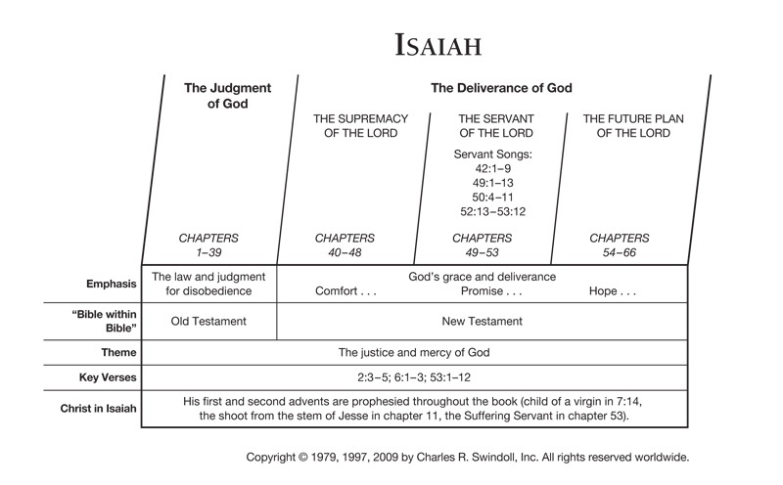

1. **Hosea 1:2, 3:1-4 and 4:15 also speaks of Israel as the adulterous wife of Jehovah, the unfaithful wife. Compare with Isaiah 50:1.** 
   1. **Is God justified in getting rid of Israel?** Where is the certificate of your mother’s divorce, whom I have put away?
   2. **Is God being facetious about the creditors?**
   3. **Why is Israel put away?**
   4. **Discuss the parable of verse 1, divorcing a wife and selling his children. Are the children of Israel accusing God of acting like this?** Behold, for your iniquities have caused this.
      1. **The cause of Israel’s trouble is her own sin. See Proverbs 19:3**……Israel is reaping what she has sown. This is because of their attitude against Jesus.
2. **Discuss the idiom of “sackcloth” in verse 3.** 
   1. **Relate this to the crucifixion scene. See Luke 24:44-48.**.. Spurgeon relates this to the crucifixion: The last miracle recorded here, namely, that of covering the heavens with sackcloth, was performed by our Lord even when he was in his death agony. We read that, at high noon, the sun was veiled, and there was darkness over all the land for three black hours. Wonder of wonders, he who hung bleeding there had wrought that mighty marvel! The sun had looked upon him hanging on the cross, and, as if in horror, had covered its face, and traveled on in tenfold night. The tears of Jesus quenched the light of the sun. Had he been wrathful, he might have put out its light for ever; but his love not only restored that light, but it has given to us a light a thousand times more precious, even the light of everlasting life and joy.
   2. **Refer to Jeremiah 4:28, Ezekiel 32:18, Joel 2:10, 3:50, Matthew 24:29, and Mark 13:24, Luke 21:25, and Revelation 6:12……**the Mark, Matthew and Luke are from the Olivet Discourse.
3. **What does it mean that “God has given Me the tongue of the learned?” Refer to Philip’s encounter with the Ethiopian eunuch in Acts 8:26-38**. Philip shows him the Messiah in Isaiah 53. \*\*\***SEE ADDITIONAL INFO AT THE END OF THIS CHAPTER..**
   1. **Discuss our preparedness for such an opportunity**??
   2. **Does this passage instruct us to study His Word**?
4. **Explain “word in season.”** verse 4.
5. **What does “morning by morning” mean? See Lamentation 3:23 and Psalm 5:3.** It is a Hebrew phrase meaning continually.
6. **Compare “bond slave” to “hearing.” See Exodus 21:5-6, Psalm 40:6, and Philippians 2:7.**
   1. **See also Exodus 21:5-6.** where a servant became a willing bond slave to his master.
   2. **“Piercing of the ear” refers to what?** **See Exodus 21:5-6, Psalm 40:6, and Philippians 2:7**. A bond-slave, bonded to the house. If, after the six years of servitude, a servant wished to make a life-long commitment to his master - in light of the master’s goodness and his blessings for the servant - he could, through this ceremony, make a life-long commitment to his master. This was a commitment not motivated by debt or obligation, only love for the master. In the ceremony, the servants ear would be pierced - opened - with an awl, in the presence of witnesses - then, *he shall serve him forever* also speaks of this ceremony taking place between the Father and the Son, where the **Psalmist speaks prophetically for the Messiah:** *Sacrifice and offering You did not desire; my ears You have opened.* Jesus was a perfect bond-slave to the Father ([Philippians 2:7](http://www.studylight.org/desk/index.cgi?q1=Philippians+2:7&t1=en_nas)). This also refers to when the Jubilee year falls.
      1. **Revelation 1:1 written to the “bond servant” of Jesus Christ. Discuss.**
         1. **Are you are bond servant of Jesus?**
7. **Isaiah 50:6 seems to hint at some unpleasantries about the crucifixion. Discuss Jesus’ abuse by the Romans and the hierarchy of the temple.** 
   1. **What detail in verse 6 that is not mentioned in the New Testament? Why? They ripped off His beard.** There is no specific mention in the gospels of those **who plucked out the beard** of Jesus as part of His pre-crucifixion suffering, but from this passage in Isaiah we know it happened. What terrible agony Jesus endured! It is even more than what the gospel writers explain to us! We have before us the language of prophecy, but it is as accurate as though it had been written at the moment of the event.
   2. **Relate Luke 24:13-36—the Road to Emmaus story--with Isaiah 50:6-9.** (the Emmaus Road experience, 7 mile walk)….
      1. **Discuss verse Luke 24:16, “eyes were restrained.”** verse 16 says that they cannot recognize Jesus as He walks with them.
      2. **Examine Mark 15:15, Luke 22:63-65, and Mark 15:19-20**. **I gave My back to those who struck Me, and My cheeks to those who plucked out the beard; I did not hide My face from shame and spitting**: This prophecy speaks in chilling detail of the sufferings of the Messiah. We know that Jesus was beaten on the back ([Mark 15:15](http://www.studylight.org/desk/index.cgi?q1=Mark+15:15&t1=en_nas)). We know Jesus was beaten on the face ([Luke 22:63-65](http://www.studylight.org/desk/index.cgi?q1=Luke+22:63-65&t1=en_nas)). We know that Jesus was mocked and spat upon ([Mark 15:19-20](http://www.studylight.org/desk/index.cgi?q1=Mark+15:19-20&t1=en_nas)).
   3. **Why did the disciples not recognize Jesus after the resurrection**? **See John 20:19.** Isaiah might have been one of the Evangelists, so exactly does he describe what our Savior endured.
   4. **Look up John 20:11-16. Why did Mary Magdalene not recognize who Jesus was? Take particular notice of verse 19** (where the disciples don’t recognize Jesus). Thomas’ unbelief in John 20:26-28.
   5. **See John 21:1-7 where Jesus stood on the shore and was not recognized.**
      1. **Pay particular attention to John 21:12.** The disciples were afraid to ask who it was.
   6. **Relate Isaiah 50:6 to the description of Jesus’ crucifixion.** Note that his beard is ripped off His face.
      1. **Why is this account left out of the N. T. recollections?**
   7. **See Zechariah 13:6. Explain. Could this be a reference to Thomas’ unbelief without seeing Him? Read John 20:25-29.** Zechariah writing 800 years before Jesus was born foretold of Thomas’ unbelief and doubt.
   8. **Revelation 5-6 describes a lamb “as it had been slain.” Could this be a picture of a scarred Christ? The only man-made thing in heaven is Christ’s scars.**
   9. **Re-read Psalm 22. Compare with this passage.**
8. **What does set “My face like a flint” represent? Reference Luke 9:51.** His **face** will be set as hard as **a flint**, and nothing will turn Him aside. This was exactly fulfilled in the life of Jesus, who was determined to go to Jerusalem, even knowing what waited for Him there. *Now it came to pass, when the time had come for Him to be received up, that He steadfastly set His face to go to Jerusalem.* ([Luke 9:51](http://www.studylight.org/desk/index.cgi?q1=Luke+9:51&t1=en_nas))
   1. **Parallel this passage with Romans 8:31**, “**He is near who justifies Me; who will contend with Me?** This is the Messiahs way of quoting [Romans 8:31](http://www.studylight.org/desk/index.cgi?q1=Romans+8:31&t1=en_nas): *If God is for us, who can be against us?* If it isn’t clear enough, He says it again: **Surely the Lord God will help Me; who is he who will condemn Me?** In fact, the reason why [Romans 8:31](http://www.studylight.org/desk/index.cgi?q1=Romans+8:31&t1=en_nas) applies to us is that it first applies to Jesus, and we are *in Christ*. If Jesus stands in this place of victory, then all those who are in Christ stand there also.
9. **Verses 10-12 sum-up this chapter. Re-cap.** Who among you fears the Lord? Who obeys the voice of His Servant? Who walks in darkness and has no light? Let him trust in the name of the Lord and rely upon his God. Look, all you who kindle a fire, who encircle yourselves with sparks: Walk in the light of your fire and in the sparks you have kindled; this you shall have from My hand: You shall lie down in torment.
   1. **Is the Messiah speaking to His people throughout all the generations**?
   2. **Is the Servant here, the Messiah Himself**?
   3. **The “fire” mentioned here is a reference to a profane fire as seen in Numbers 10:1.**
      1. **Discuss how the “fire” of one’s own beliefs, not Christ’s, can lead to eternal fire and brimstone.** Look, all you who kindle a fire: We might think that this fire is a *positive* thing, but in light of the entire verse, it isn’t positive. It is more like the *profane fire* of Nadab and Abihu described in [Numbers 10:1](http://www.studylight.org/desk/index.cgi?q1=Numbers+10:1&t1=en_nas).
10. **How would you summarize Chapter 50? What is its central theme?**
11. **Where do you see the Messiah in this passage?**

**\*\*\*\*ADDITIONAL INFO……..Philip and the Ethiopian Eunuch**

We are fascinated by missionary tales of "chance" encounters. Along a lonely road in the African bush, a man suddenly appears and asks a missionary traveler, "Can you tell me who Jesus is?" Luke's account of Philip's divinely guided encounter with the Ethiopian would have been just as fascinating to first-century Romans or Greeks, for in their view Ethiopians lived literally at the southern edge of the earth (Homer *Odyssey* 1.23--*eschatoi andron;* see Acts 1:8).

God is actively fulfilling his purposes for the scope of the church's mission (Lk 24:47; Acts 1:8). If it reaches an Ethiopian so soon after its beginning, Theophilus can know for sure that the gospel that is to be preached among all the nations is true. It *is* for him, and for us too.

This scene is a fitting climax to the Grecian Jewish Christians' mission thrust, for here they complete the geographical aspects of the Acts 1:8 commission: Jerusalem (6:8-8:3), Judea and Samaria (8:4-25) and the ends of the earth (8:26-40). Further, it is a harbinger of the full-fledged Gentile mission to come (Acts 13--28).An Evangelist Guided by God (8:26-31)

Through his angel, God takes the initiative and directs Philip to take the road *from Jerusalem to Gaza.* The phrase translated *south (kata mesembrian)* may also be taken temporally, "at noon" (so regularly in the LXX). This would make the command all the more unusual, for few travelers would be on the road in the harsh midday sun. *Desert road* might be better translated "wilderness road." This fits the topography of the northern route from Jerusalem to Gaza, which was paved (suitable for a carriage), was more direct and had abundant water at Ein Yael (Rapuano 1990:47; contrast Williams 1985:146).

In immediate obedience, with little information but complete trust in the God who guides, Philip sets out. For God to summon Philip from a thriving ministry in Samaria to the wilderness of the Judean hills is not an irrational move. God's goal is not only "quantity" but also "quality," in the sense of an ethnically diverse body of Christ (Rev 5:9). In a day when four of six billion have yet to hear the gospel within their own language and culture, we should not be surprised to see God calling our most effective evangelists to go to remote places. And like Philip, they should obey immediately and unquestioningly.

Philip encounters an Ethiopian eunuch and his retinue. He is at once exotic, powerful and pious. Greeks and Romans were particularly fascinated with dark-skinned Africans (Martin 1989:111; Diodorus Siculus *Library of History 3.8.2-3; Strabo Geography* 17.2.1-3). Although *Ethiopian* was used generally for anyone with these physical characteristics, here it refers to an inhabitant of the ancient kingdom of Meroe, which covered what is now northern Sudan south of Aswan to Khartoum (see NIV marginal note; compare Youngblood 1982:193; Crocker 1986). This man is powerful, the chief treasurer of a kingdom wealthy from its iron smelting, gold mining and trading position. It was a conduit for goods from the rest of the continent. *Candace, queen of the Ethiopians* (better "Queen Mother, ruling monarch of the Ethiopians," since *candace* is a title, not a proper name), cared for the duties of state. The king was regarded as a god, "child of the sun," too sacred to engage in administration. The candace in this instance was Amanitare (A.D. 25-41; Wead 1982:197; Crocker 1986:67).

Luke does not identify the eunuch as either a proselyte, a Gentile convert to Judaism, or a God-fearer, a Gentile adherent to the Jewish monotheism, ethic and piety (compare Acts 2:11; 6:5; 10:2; 13:26, 43; Levinskaya 1990). He presents him only as pious according to the Jewish faith. The eunuch is returning to Meroe after a pilgrimage to Jerusalem for one of the feasts, and he is *sitting in his chariot* reading Scripture. The chariot is probably a four-wheeled covered vehicle, like an oxcart, large enough to accommodate the eunuch, his driver, Philip and possibly another servant (who would be reading the manuscript aloud if the official is not doing so himself). The carriage is moving slowly enough to allow for reading and for Philip to approach it on foot. Reading aloud was the common practice in ancient times, and was especially necessary when words were strung together on a manuscript without spacing or punctuation (Bruce 1990:226).

Under the guidance of the Spirit (compare 10:19; 11:12; 13:2, 4; 16:6-7), Philip obediently overcomes any social reticence, approaches the wagon, walks briskly alongside and engages the eunuch in conversation about his reading. Luke consistently tells us that reading and understanding Scripture are not the same thing, especially for those who do not have the hermeneutical key (13:27; compare Lk 6:3; 10:26). Correct spiritual understanding is a gift (8:10; 10:22). The eunuch admits his need. His humble, teachable stance is the essential first step to achieving knowledge of salvation (compare Acts 17:11).

God in his mercy has provided not only the text but also the interpreter, a Spirit-filled teacher. The eunuch urgently, but politely, asks guidance (13:42; 16:9; contrast Lk 6:39). And today these two gifts are still present. Where are those of teachable spirit?Jesus Is Preached from the Scriptures (8:32-35)

Luke reports that the eunuch was reading the Septuagint of Isaiah 53:7-8 (Acts 8:32-33). Though the wording reflects "a gravely deviant translation" (Archer and Chirichigno 1983:123) at this point, the basic intention of Isaiah is not completely lost (Williams 1985:147). Luke is very interested in the content of this quote, introducing it with a phrase meaning the "content or wording of the passage" (compare v. 35; not *passage of Scripture* as the NIV). In it we have a description of the innocent, righteous sufferer, the objective basis for vicarious atonement. Luke has already portrayed Jesus in his passion in these terms: silent before authorities (Lk 23:9), deprived of justice, an innocent man condemned (Lk 23:4, 15, 22; 23:47; compare Acts 2:22-23; 3:14), his life taken (Lk 23:18; 22:2; 23:32; compare Acts 2:23; 10:39; 13:28).

The eunuch wants to know whether the prophet is talking about himself or someone else. For the Jew in the first century "someone else" was either the humiliated but vindicated "righteous sufferer" of the apocalyptic and wisdom traditions (Is 53:11; *1 Enoch* 46, 62, 63; Wisdom of Solomon 2:12-5:23; Sirach 11:13/Is 52:15; Decock 1981:114). Or, as the targum has it, wicked Gentile nations suffer at the hands of the victorious Messiah, who vindicates his people (*Targum of Isaiah* 53:7-8; note Israel suffers in *Targum of Isaiah* 52:14; 53:2, 4, 10, and the wicked Gentile nations in 53:3, 7-9, 11). The messianic interpretation is original with Jesus (Lk 22:37/Is 53:12; Longenecker 1981:364; Bruce 1988:176).

Philip "opened his mouth" (NIV omits this phrase; compare 10:34) and beginning from this passage (compare Lk 24:27) tells the eunuch the good news about Jesus. Christ is the salvific key to the Old Testament. Does Philip simply expound Isaiah 53 and then show the fulfillment in Jesus' life, vicarious death and victorious resurrection/exaltation (see E. F. Harrison 1986:152)? Does he continue a connected exposition through succeeding chapters of Isaiah, dealing with baptism at Isaiah 54:9-10 (compare 1 Pet 3:21) and the new day of salvation at 55:1, to 56:4-8, where a eunuch participates without hindrance in the people of God (Porter 1988)? Does he proceed from Isaiah 53 via early Christian testimonia on the suffering servant and righteous sufferer to show the Ethiopian how Christ and his salvation are preached in all the Scriptures (Is 42:1-44:5; 49:1-13; 50:4-11; Ps 22, 34, 69, 118; Longenecker 1981:365)?

Whatever the method, Philip both answers the eunuch's question and points to Jesus' saving significance. Just as a messenger fresh from the field of battle would "evangelize" the citizens with news of their army's triumph (2 Sam 18:19-20, 26, 31), Philip evangelizes the Ethiopian that Jesus, the righteous sufferer, crucified and risen again, has won the victory over sin and death, and now repentance and forgiveness of sins are available in his name (compare Lk 4:18/Is 61:1; Acts 13:38-39).

Do you want to understand the Old Testament? Stand in the empty tomb, under the shadow of an empty cross, within earshot of the teaching of Jesus and the preaching of the apostles, and *read!*Convert and Evangelist Sent on their Way (8:36-40)

When the carriage arrives at some water, the eunuch exclaims, "Behold water! What is hindering me from being baptized?" (NIV *Why shouldn't I be baptized?*). One of Luke's great concerns is that obstacles of age (Lk 18:16), religious tradition, old or new (Lk 9:49-50; 11:52), race or ethnic origin (Acts 10:47; 11:17), or physical condition (8:36, if the eunuch were one physically) must not keep people from hearing and applying to themselves the gospel of salvation. His ideal is found in the closing phrase, indeed the closing word, of Acts: "Boldly and *without hindrance* he preached the kingdom of God and taught about the Lord Jesus Christ" (28:31).

The eunuch is baptized as Philip stands with him in the water. Is it by immersion (Williams 1985:148) or pouring (Stott 1990:162)? The account will accommodate both understandings. The act's theological significance is cleansing for sin and incorporation into the fellowship of those who have experienced Christ's salvation blessings (Lk 24:47/Acts 2:38-39; 10:47-48; 16:31-33).

Though Philip is taken away *suddenly,* the eunuch goes on his way *rejoicing.* For Luke and us, joy is a manifestation of a person's salvation (8:8; Lk 6:23; 10:20), particularly of reception of the Holy Spirit (Acts 13:52).

The episode ends as it began, with divinely guided and empowered outreach. Miraculously transported over thirty miles to the seacoast town of Azotus (Old Testament Ashdod), Philip continues his witness on non-Jewish soil until he comes to Caesarea (compare 21:8).

The conversion of the Ethiopian eunuch graphically demonstrates the inclusiveness of the gospel. No apparent obstacle--whether physical defect, race or geographical remoteness--can place a person beyond the saving call of the good news. Athanasius, in his comments on Psalm 68:31, marvels that "by `Kushites' God indicates the end of the earth. . . . For how Kush ran to the preaching is possible to see from the believing Ethiopian. God shows that all the other nations also believe in Christ with their kings" (quoted in Martin 1989:116). For persons of black African lineage, the eunuch's conversion means the "inclusion of black Africans among the charter members of the faith . . . all of which symbolizes from the beginning the African involvement in the new faith that spread throughout the world" (C. E. Lincoln 1984:24).

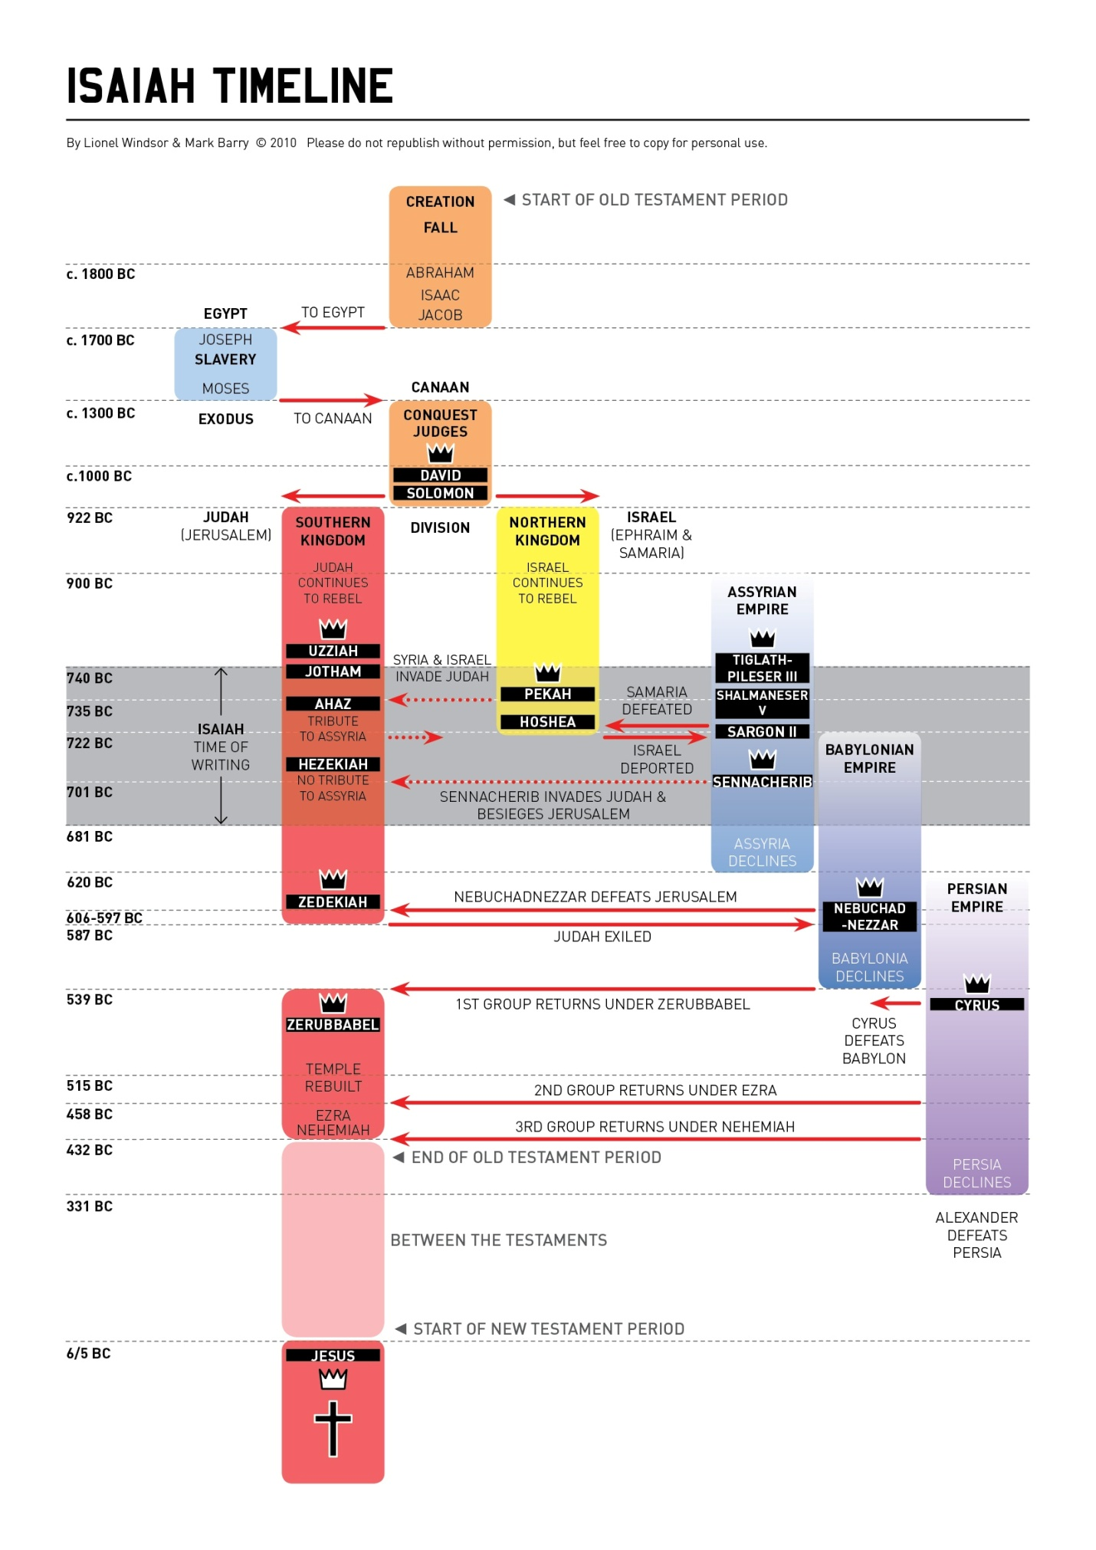

**Chapter 51—The Lord Comforts Zion**

1. **Note the command in the first verse. Why here?**
2. **Who is the “rock” referenced in the first verse?**
   1. **See also Psalm 78:35, 18:31, 2 Samuel 22:32, 23:3, Isaiah 30:29, and Mark 12:10.**
   2. **Why did God call Abraham? See Genesis 12:1-3.**
3. **Eden is referenced in verse 3. Discuss.** 
   1. **See Genesis 2:8-14, 13:10, and Ezekiel 31:9.**
4. **Some people say that verse 3 is the heart of this chapter, “For the Lord will comfort Zion.” Explain.**
5. **Why do you think God is issuing another command in verse 4?** When the Lord ultimately regathers, blesses, and saves Israel, He will also shine forth His **justice** to the entire world - to Israel (**My nation**) and to all the nations (**the peoples**).
6. **Discuss the Messianic theme in verses 1-5. Take note of the Millennial language.**
7. **Verse 6 seems to be foreshadowing the Tribulation period. Examine.**
   1. **Who are the “earth dwellers?” See also Revelation 3:10, 6:10, 8:13, 11:10, 13:8, 14:6, and 17:8.**
   2. **Where else do we see the imagery of smoke and “heavens vanishing?”**
      1. **Reference Revelation 8:4, 9:3, 14:11, and 18:18.**
      2. **Also examine Matthew 24:35, 2 Peter 3:7-10, and Revelation 6:12-17.**
8. **Verse 8 begins with a similar command. Discuss.** Listen to Me, you who know righteousness, you people in whose heart is My law: Do not fear the reproach of men, nor be afraid of their insults. For the moth will eat them up like a garment, and the worm will eat them like wool; but My righteousness will be forever, and My salvation from generation to generation.
   1. **Where do we see similar language? Look at Matthew 6:19-20.**
9. **Another command, verse 9, of “Awake, awake” seems to targeting believers, the faithful.**
   1. **Could this be good advice to today’s Christians? Explain.**
   2. **See also Psalm 121:4.**
10. **Are verses 9-16 a picture of the Millennium?** 
    1. **Who is the “arm that cut Rahab apart?”** Often in the Bible, Rahab is a synonym for Egypt; this would be referring to God delivering His nation from the Pharaoh’s evil grasp, cutting them off at the Red Sea. **Are You not the arm that cut Rahab apart, and wounded the serpent?** Among God’s great works remembered is His defeat of **Rahab**.
       1. **Rahab can be referring to Egypt.** **See Psalm 87:4, 89:10, and 74:13.** Rahab is used for Egypt in [Psalms 87:4](http://www.studylight.org/desk/index.cgi?q1=Psalms+87:4&t1=en_nas), and also in [Psalms 89:10](http://www.studylight.org/desk/index.cgi?q1=Psalms+89:10&t1=en_nas). Some versions render the Hebrew word as Dragon; but this also means Egypt ([Psalms 74:13](http://www.studylight.org/desk/index.cgi?q1=Psalms+74:13&t1=en_nas)).
    2. **Who is “the serpent?” Some versions translate serpent, “Leviathan.” See Isaiah 27:1, Job 41:1-34, Psalm 74:13-14, and Revelation 12:1-17.** 
       1. **See Genesis 3:1-6 and Psalm 89:10.** The name **Rahab** means *pride*, and ever since the Garden of Eden, the **serpent** has been associated with Satan ([Genesis 3:1-6](http://www.studylight.org/desk/index.cgi?q1=Genesis+3:1-6&t1=en_nas)). This speaks in poetic terms of God’s victory over Satan, as it does also in [Psalm 89:10](http://www.studylight.org/desk/index.cgi?q1=Psalm+89:10&t1=en_nas).
    3. **Verse 10 seems to point to the Exodus deliverance. Discuss.**
    4. **Compare verse 11 with Isaiah 35:10.** Note that verse 11 here is practically a verbatim quotation of [Isaiah 35:10](http://www.studylight.org/desk/index.cgi?q1=Isaiah+35:10&t1=en_nas)**.**
    5. **Talk about the double use of the first person pronoun in verse 12. What does “double emphasis” mean in the Bible?**
    6. **Where do we see the “Creator God” here mentioned? Verse 13, 16**
    7. **Verse 16’s, “I have covered you with the shadow of My hand,” may point back to Moses in Exodus 33:17--23.** The phrase **I have covered you with the shadow of My hand** reminds us of how God covered Moses with His hand, as Moses hid in the rock and the Lord made His glory to pass before Moses ([Exodus 33:17-23](http://www.studylight.org/desk/index.cgi?q1=Exodus+33:17-23&t1=en_nas)).
       1. **Discuss God’s protection and parallel here.**
11. **Why is God calling His people to awake? Verse 17.** This wakeup call is directed right at **Jerusalem**.
    1. **Parallel with Romans 13:11-12**. God’s people sometimes spiritually fall asleep and need to be awakened. [Romans 13:11-12](http://www.studylight.org/desk/index.cgi?q1=Romans+13:11-12&t1=en_nas) says, *And do this, knowing the time, that now it is high time to awake out of sleep; for now our salvation is nearer than when we first believed. The night is far spent, the day is at hand. Therefore let us cast off the works of darkness, and let us put on the armor of light.*
    2. **Why is God referring to “you who have drunk at the hand of the Lord?”** verse 17**…** If possible, the image is even strengthened: **You have drunk the dregs of the cup of trembling, and drained it out**. Not only did Jerusalem drink the cup, they **drained it** - drinking down to the **dregs** at the bottom of the cup. They had experienced **desolation and destruction, famine and sword**, and this was Gods cup for them.
       1. **Reference Jeremiah 25:15-17, 51:7, Psalm 75:8, Zechariah 12:2-3, and Revelation 14:10.**
       2. **Was this image shown at the Garden of Gethsemane?** **Read Luke 22:42.** This powerful image was in the mind of Jesus when He prayed in the Garden of Gethsemane on the night before His crucifixion. When He prayed, ***Father, if it is Your will, take this cup away from Me; nevertheless not My will, but Yours, be done* (**[**Luke 22:42**](http://www.studylight.org/desk/index.cgi?q1=Luke+22:42&t1=en_nas)**),** He had in mind the cup of God’s wrath He was about to drink - to the dregs - at the cross.
12. **Discuss the use of the word "Therefore" in** [**Isaiah 51:21**](http://www.studylight.org/desk/index.cgi?q1=Isaiah+51:21&t1=en_nas)**. Re-visit Isaiah 10:24, 27:9, and 30:18.** Here, as in [Isaiah 10:24](http://www.studylight.org/desk/index.cgi?q1=Isaiah+10:24&t1=en_nas); 27:9; and 30:18, the transition from threatening to promise is marked by the word `therefore'.
13. **Is there a lesson to be learned from Chapter 51?**
14. **Do we see the promise of the Millennial Kingdom for God’s people, Israel?**

**And, here are “The Promises”……**

**Romans 13:11-12, “And *do* this, knowing the time, that now *it is* high time to awake out of sleep; for now our salvation *is* nearer than when we *first* believed. 12The night is far spent, the day is at hand. Therefore let us cast off the works of darkness, and let us put on the armor of light.”**

**Isaiah 50:10,** **“Who among you fears the Lord? Who obeys the voice of His Servant? Who walks in darkness And has no light? Let him trust in the name of the Lord And rely upon his God.”**

**Isaiah 51:12b, “**For I am Jehovah thy God, who stirreth up the sea, so that the waves thereof roar: Jehovah of hosts is his name. And I have put my words in thy mouth, and have covered thee in the shadow of my hand, that I may plant the heavens, and lay the foundations of the earth, and say unto Zion, Thou art my people."