**“Insights into Isaiah”—Chapters 48-49**

**Chapter 48—Mercy for Judah**

***For the last eight chapters, Isaiah has been talking about deliverers, particularly Cyrus, who will come in 150 years to defeat the Babylonians and send Israel back to her homeland. Then, from chapters 49-58, God will “switch” deliverers, to the real Servant, the Messiah. This is the last chapter referencing the Medo/Persia deliverance by Cyrus. This is considered a “bridge passage,” and since Chapter 40 God has been teaching His people about their coming exile to Babylon, exposing their idolatry, and chiding them for being disinterested in serving Him. This is the climax of God’s indictment of Israel, by binding together Israel’s rebelliousness and the social consequence of that rebellion.***

1. **Explain how, in verses 1-2, the Lord sees the hypocrisy of Judah. Give details.** 
   1. **Comment on the imperative phrase, verse 1, “Hear this.”**
   2. **Who is “the house of Jacob?” House of Jacob, who are called by the name of Israel**: Judah should take notice at this opening statement. God identifies His people as the **house of Jacob** -
      1. **Define “Jacob.”** the name **Jacob** essentially meaning “deceiver, cheater” - and says they only have **the name of Israel**, not the character of **Israel**, which means “governed by God.”
   3. **Often we imply that Judah is a more “complimentary” name for Israel. But, is it? Who was Judah? Examine Genesis 37:26-27 and 38. And have come forth from the wellsprings of Judah**: The second statement of Isaiah 48 isn’t any more complimentary to the southern kingdom of Judah. God reminds them of their tribal ancestor, **Judah**, who was noted for his cruelty (Genesis 37:26-27) and immorality (Genesis 38). The Lord speaks to His people and says, “You come from your father **Judah**.” It’s hardly a compliment.
   4. **Note the imperatives in verse 1, 12, 14, 16…**…Verse 1—hear this, Verse 12—listen to me, O Jacob… Verse 14-assemble and listen…. Verse 16—draw near and hear this, hear this, listen
2. **Do verses 1-5 reference the fact that God had foretold what would happen to Israel? What was the warning?** Verses 1-5, God diagnoses the problem, His own people, who are inwardly not righteous…..only external religion.
   1. **The predictive prophecy statement of verse 3 seems to echo Isaiah 42:9, 44:7, 46:9-10, Psalm 139:4 and Daniel 2:28. Compare.** 
      1. **Because of the “foretold things of God,” is God saying that Judah “has no excuse?”**
3. **From verse 6, what are the “new things?”**
4. **Why another imperative in verse 6 to “see all this?”**
5. **What does “you were called a rebel from birth” mean?**
6. **Verses 6-8 are an explanation of Israel’s debauchery. Verse 8b explains God’s “foreknowledge” of their sins. Discuss.**
   1. **See also Romans 5:12.** It is a difficult concept for our human minds, but the Bible teaches that we are sinners **from the womb**, and that we inherited a sin nature because we descend from Adam and sinned in Adam (Romans 5:12). It isn’t our individual acts of sin that make us sinners; it is our descent from Adam. Our individual acts of sin merely prove that each of us is a **transgressor from the womb**.
7. **Verses 9-13 seem to state the reasoning behind God’s mercy for His people; what is the purpose?** For My name’s sake I will defer My anger, and for My praise I will restrain it from you, so that I do not cut you off.
8. **What is the “furnace of affliction?”** verse 10
   1. **What does the phrase, “refined but not as silver” reference?** When you refine silver, it becomes pure. This implies that Israel has not come out pure.
9. **The declaration, “I will not give my glory to another,” verse 11, centralizes the theme of this section. Comment**.
10. **The echo of verse 12, “I am the first, and the last” are reminiscent of Revelation 1:8, 22**:**13, Isaiah 41:4, and 44:6. Compare and contrast.** 
    1. **Verse 12 is the keynote of this section.** **Discuss.**
11. **Comment on “God’s creative power” in verse 13. Is this a recurring theme in Isaiah?**
12. **A second speaker appears in verses 14-19. Is it Jesus, the Servant, the Redeemer of Israel? Defend your answer.** 
    1. **What is the ultimate destruction of Babylon?** Verse 14
    2. **Note particularly at the end of verse 16 the reference to the trinity. “The Lord God and His spirit have sent Me.”**
    3. **In verses 14-16, God promises to deliverer His purpose. Discuss.**
    4. **Why does God use “I” four times in verse 15?**
    5. **Discuss the “lamenting of God,” “Oh that you had…” in verse 18.**  Oh, that you had heeded My commandments! In light of His power and love for Israel, God laments their unfulfilled potential, unfulfilled because of their disobedience. If only you’d listened to Me, things could have been different.
13. **Re-state the praise that “oozes forth” from verse 20, where God begins to speak prophetically**.……leave Babylon…….this prophecy is given 150 years before the captivity, then Israel is captive 70 years….
    1. **Review the captivity of Babylon and how God delivers His people through Cyrus.**
    2. **Discuss the redemption promised, covenant blessings, in verse 20.**
14. **Is verse 21 a reminder of God’s protective provision for His people? Explain.**
15. **Verse 22 is an interesting statement and is referencing a section that will come again in Isaiah 57:21... Discuss.** Verse 22 is a refrain that occurs again in 57:21, and both times it comes at the end of a nine-chapter section.”
    1. **Also refer to Ezekiel 13:10 and Jeremiah 6:14.**
    2. **Discuss the solemn benediction in verse 22. “There is no peace for the wicked.”**
    3. **Note: verse 16b introduces another speaker, the Servant. Refer back to Isaiah 42.**
16. **Chapter 48 ends the section about the deliverer, Cyrus. Is there a “far-off” reference to the “true deliverer,” Jesus also implied?**
17. **Parallel Isaiah 48 with Psalm 73. Is this the same message?**
18. **J. Vernon McGee calls Isaiah’s theme: “Last call to the house of Jacob; longing call of God to the remnant.” Comment.**
19. **Sum-up the central theme of this chapter. Apply it to today’s world.**

**Chapter 49—The Messiah**

*This chapter is full of our Lord Jesus Christ. The Messiah, the servant, will speak of His first and second coming. It begins the final section of Isaiah, and is separated by the words, “There is no peace unto the wicked.”* The broad section of Isaiah 40 through 48 focused on the promise of God’s deliverance of His people from their captivity in Babylon, and the specific prediction of the Gentile king who would deliver them, Cyrus. Through the section, God showed that His desire to deliver His people proves His love, His ability to deliver His people proves His power, and His prophetic knowledge of the deliverer proves His uniqueness among all gods. Starting with Isaiah chapter 49, there is no longer a mention of Cyrus, **now the focus is on the ultimate deliverer, the Messiah**. Though there is still reference to the deliverance from Babylon’s captivity, the real focus is on the ultimate deliverance the Messiah will bring for Jew and Gentile alike. And, according to J. Vernon McGee, “Israel was the servant of Jehovah, but as such Israel had failed. Now God speaks of another Servant, and that Servant is the Lord Jesus Christ. The prophetic scriptures spoke primarily of Israel as God’s servant; yet the final meaning is found in the Person of Christ.”

1. **First consult Hosea 11:1, where God calls Israel “my child” and Matthew 2:15, where we see the fulfillment of that promise in Jesus.**
2. **Verses 1-13 are often referred to as the second of the four “Servant Songs.” What is the heart of the message? “The call and the preparation of the Messiah.**
   1. **See also Isaiah 42:1-9, 50:4-11, and 52:13-53:12.**
   2. **In verse 1, who are the “coastlands?”** Gentiles, foreigners far-off
   3. **Was Jesus called “from the womb?” Refer to Micah 5:2, and Luke 1:31.** Actually before
3. **“He had made my mouth like a sword” is paralleled in Revelation 1:16, 19:15 , John 1:1, 14, Isaiah 11:4, Psalm 2:9, and John 7:46. Examine. “in the beginning was the word,” and “the word of God was made flesh.”**
4. **“He has hidden Me,” verse 2, may point to the Messiah. See Galatians 4:4-5.** The Messiah prophetically proclaims that He is like a carefully made and polished arrow in the service of the Lord, ready to be used at the right time. This probably has reference to the “hidden” years of Jesus, when He lived in obscurity, as **a polished shaft** waiting in the **quiver** of the Lord.
   1. **It was also “hidden” in the O.T. about the reconciliation to the Gentiles. Look at Colossians 1:27, Ephesians 3:5-10, Romans 11:11, 12:25-32, 15:9-12, and I Timothy 3:16.**
5. **In verse 3, God implies that “Israel” is a direct reference to the Messiah. Why would He use that terminology?** First, because the Messiah *comes from* Israel, and is a representative of the nation. Second, because the Messiah *fulfills the name Israel*, which means, “governed by God.”
   1. **Parallel with Isaiah 42:1, 49:6-7, 52:13, and 53:11.**
6. **How can verses 3-4, “labored in vain” passage be reconciled to Jesus? Compare with John 1:11.** “though He came to His own, His own received Him not.”
   1. **Also re-visit Jesus’ “Palm Sunday” entrance/words in Luke 13:34.**
7. **Verses 5-7 is called a “light to the Gentiles” and a “reconciliation to the Jews.”**
   1. **Review Matthew 10:5-6, 15:24, Romans 1:16, 26, 11:25-27.**

**Jesus will complete His reconciliation to Israel in His second coming. Read Zechariah 12:10-13:1 and Romans 11:26. To bring Jacob back to Him**: This shows that an important aspect of the Messiah’s mission was to bring Israel back to the Lord. This shows that ethnic Israel has an enduring place in God’s plan, and that plan will be fulfilled when *all Israel will be saved* (Romans 11:26).

* 1. **Discuss the Messiah being despised and rejected. Review Isaiah 53:3.**
  2. **Re-read Isaiah 49:6-7, often called one of the most “remarkable passages in the scripture.”**

1. **The promises of the Messiah in verses 8-12 foreshadowed the agony of the cross. Note God’s pledges to Jesus.** The Lord God extended His help and preservation to the Messiah all through His earthly ministry. Yet if there is any specific time that this promise was fulfilled, it was as Jesus died on the cross and trusted in the promise of resurrection.
   1. **Explain how Jesus, the Messiah, becomes the covenant for His people.** Jesus, the Messiah, doesn’t merely *bring* a covenant; He *is* a covenant to the people. It is beautiful to imagine Jesus comforting and strengthening His soul with these promises as He anticipated and endured the ordeal of the cross. He could *know*, based on this promise, that the Lord would hear, help, and preserve Him.
   2. **Verse 9 mentions freedom. Detail.**
      1. **Review Mark 5:1-15.**  Jesus set the demon possessed free from the bondage of chains and demonic torture.
      2. **See Luke 13:16.** Jesus set the sick and diseased free from the bondage of their infirmities.
      3. **Refer to Ephesians 4:8.** Jesus set the righteous dead captive in Hades free from their place.
      4. **Also examine John 8:33-36 and Galatians 3:22-23.** Jesus sets those in bondage to sin and the law free.
   3. **The Millennium is in view in verses 11-12. Take note of the details.**
   4. **Where is Sinim?** “‘Sinim’ is probably Aswan, near the southern border of Egypt . . . This assumes that ‘Sinim’ is derived from *sewenim* . . . If the Masoretic Text is correct, a long standing interpretation connects Sinim with China.” Grogan gives another perspective on **Sinim**: “It is most likely that Isaiah was being consciously obscure. Even unmapped places are known to God, and even from them he will gather his pilgrims.”
2. **The “song of praise,” verses 13-14, seems to point to a later time in the Millennium. Discuss.**
   1. **The writer calls for the creation itself to praise God. Detail.**

**In verse 14, “Zion” seems to lament and feel forsaken because of the captivity of Babylon. How does God answer this charge?** Zion believes, **“The Lord has forsaken me, and my Lord has forgotten me.”** The rest of Isaiah 49 and Isaiah 50 will answer this question. Because of their captivity in Babylon, Zion wonders “Does God really care about us?” God will answer, with strength and insight, this question that many have asked since.

1. **How does God prove that He cares and loves His people? (15-18)**
   1. **Verse 16 has one of the most beautiful descriptions of God’s love. Re-state.**  **See, I have inscribed you on the palms of My hands**: This has obvious and beautiful fulfillment in the nail-scarred hands of Jesus. As Jesus told Thomas in a post-resurrection appearance, *look at My hands* (John 20:27). When we see the nail-scarred hands of Jesus, we see how He has **inscribed** us on the **palms of** His **hands**. With such love, how could God ever forget His people?
      1. **Parallel this passage with John 20:27.**
      2. **What are the walls?** The **walls** refer to the walls of the city of Jerusalem, which figuratively speak of the health, the strength, the prosperity, and the security of God’s people. God is always mindful of the condition of His people, despite the objections of a doubting Zion.
2. **Verse 18 explains what will happen to the captives. Discuss. Your sons shall make haste . . . you shall surely clothe yourselves with them all as an ornament**: The Lord will bring back the exiled and captive sons of Zion to the Promised Land, and this will be **an ornament** for God’s people. The Lord’s love and faithfulness for Zion is also shown by His promise for their future. It isn’t just demonstrated by the past and the present, but also by His future plans for them. This promise was partially fulfilled in the return of the exiles from Babylon, but will be ultimately fulfilled in the regathering of Israel in the last days.
3. **Explain verses 19-26’s promise of care and blessing for His people.** As the Lord brings the sons of Zion back to the Israel, they will fill the land in a glorious way.
   1. **“Captives taken away,” verse 25, refers to the Babylonian captivity. Parallel with “spoiling Satan” in Luke 11:21-22.**
   2. **Re-state the warning from God in verses 25-26.**
4. **Re-think the central theme for this chapter. Where do you see Jesus?**

**And, here are “The Promises”……**

**Isaiah 48:6**, “Indeed He says, ‘It is too small a thing that You should be My Servant To raise up the tribes of Jacob, And to restore the preserved ones of Israel; I will also give You as a light to the Gentiles, That You should be My salvation to the ends of the earth.’”

**Isaiah 49:16-18**, “See, I have inscribed you on the palms *of My hands;* Your walls *are* continually before Me. 17Your sonsshall make haste; Your destroyers and those who laid you waste Shall go away from you.18Lift up your eyes, look around and see; All these gather together *and* come to you. *As* I live, says the Lord….”

**[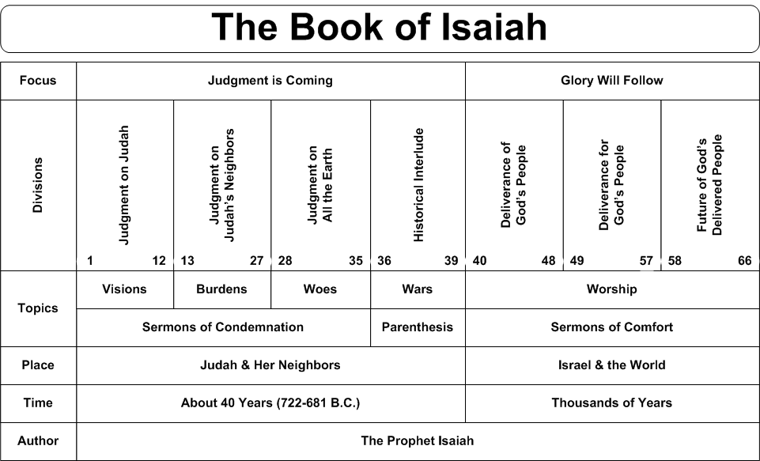](http://www.swartzentrover.com/cotor/bible/Bible/Bible%20Charts/Chart%20of%20Isaiah.gif)**