**The Destiny of Daniel—Chapter 5, “The Writing on the Wall,” The Fall of Babylon**

**This chapter takes place around 539 B.C., over 20 years after Nebuchadnezzar’s death (563/1 B.C.) Many common phrases we use today come from the book of Daniel: “Your number’s up,” “You’ve been found wanting,” “The idol has clay feet,” “The handwriting’s on the wall.” The first example of a “cryptologist” is in this chapter of the Bible, where Daniel deciphers code. This chapter is the beginning of the fall of Babylon. The first six chapters of Daniel are historical: Ch. 1—Deportation of a Teenager, Ch.2—Nebuchadnezzar’s Dream, Ch. 3—Bow or Burn, the Fiery Furnace, Ch.4—Nebuchadnezzar’s Letter to the World, Ch. 5—The Writing on the Wall, Ch. 6—The Lion’s Den. Chapters 2-7 are written in the Gentile Aramaic. The “Fall of Babylon” is not to be confused with the “Doom of Babylon,” which is prophesied in Isaiah 13-14, Jeremiah 50-51, and Revelation 17-18**. **Both Isaiah and Jeremiah predicted Babylon’s fall—Isaiah 13:17-22, 21:1-10, 47:1-5; and Jeremiah 51:33-58. Cyrus does declare “freedom for the Jews” after 70 year captivity in 536 B.C.**



1. **Who is Belshazzar? How is he related to Nebuchadnezzar?** Belshazzar was joint king with his father (called Minus in the inscriptions), but subordinate to him; XENOPHON'S description of Belshazzar accords with Daniel's; he calls him "impious," and illustrates his cruelty by mentioning that he killed one of his nobles, merely because, in hunting, the noble struck down the game before him; and unmanned a courtier, Gadates, at a banquet, because one of the king's concubines praised him as handsome. Daniel shows none of the sympathy for him which he had for Nebuchadnezzar. XENOPHON confirms Daniel as to Belshazzar's end. WINER explains the "shazzar" in the name as meaning "fire."
2. **Explain the opulence of the big feast. Is pride involved?** In this same time the Persian army is on the move, conquering lots of little territories, and Belshazzar is unmoved by this with his pride.
   1. **Is it “status quo” for the King to drink with his ‘lords?’ See Esther 1:3.** The fortifications and abundant provisions in the city made the king despise the besiegers. It was a festival day among the Babylonians [XENOPHON]. **drank . . . before the thousand**--The king, on this extraordinary occasion, departed from his usual way of feasting apart from his nobles (compare [Esther 1:3](http://www.biblestudytools.com/esther/1-3.html) )
3. **Review the lineage of Belshazzar…..his father Nebuchadnezzar**--that is, his forefather. So "Jesus. . . the son of David, the son of Abraham" ([Matthew 1:1](http://www.biblestudytools.com/matthew/1-1.html) ). Daniel does not say that the other kings mentioned in other writers did not reign between Belshazzar and Nebuchadnezzar, namely, Evil-Merodach ([Jeremiah 52:31](http://www.biblestudytools.com/jeremiah/52-31.html) ), Neriglasser, his brother-in-law, and Laborasoarchod (nine months). BEROSUS makes Nabonidus, the last king, to have been one of the people, raised to the throne by an insurrection. As the inscriptions show that Belshazzar was distinct from, and joint king with, him, this is not at variance with Daniel, whose statement that Belshazzar was son (grandson) of Nebuchadnezzar is corroborated by Jeremiah ( [Jeremiah 27:7](http://www.biblestudytools.com/jeremiah/27-7.html) ).. Evil-Merodach, son of Nebuchadnezzar (according to BEROSUS), reigned but a short time (one or two years), having, in consequence of his bad government, been dethroned by a plot of Neriglasser, his sister's husband; hence Daniel does not mention him. At the elevation of Nabonidus as supreme king, Belshazzar, the grandson of Nebuchadnezzar, was doubtless suffered to be subordinate king and successor.

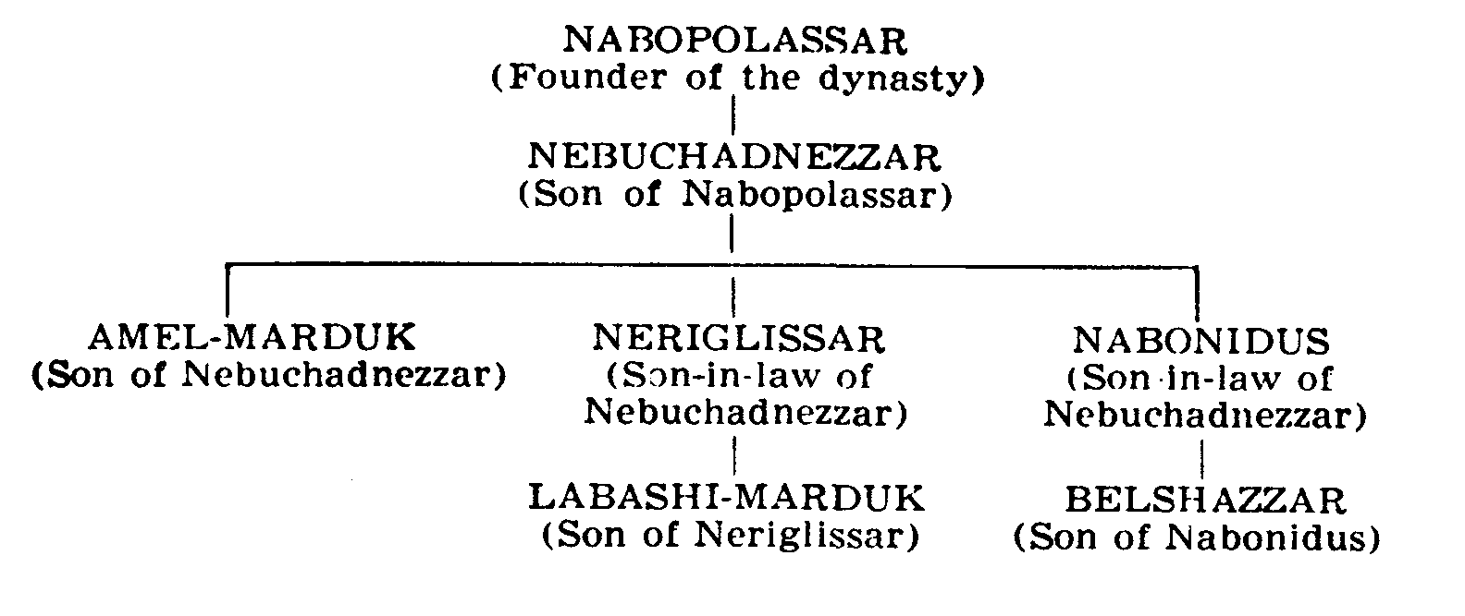***Dates:***

Amel-Markdul (562-560), aka “Evil-Merodach,” Neriglasser (560-556), (aka “Nergal-Sharezer”), Jeremiah 39:13, Labashi-Marduk (555), lasted only 9 months, Nabonidus 556-539), absented to N. Arabia, and was co-regent with his son, Belshazzar (553-539).

1. **Why were the vessels/utensils captured by Nebuchadnezzar important?**
   1. **Verse 2 shows Belshazzar making a BIG MISTAKE. Talk about him using the vessels from the temple for this feast.**
   2. **Compare to I Chronicles 28:9, Exodus 37:16-24, Jer. 27:16, 18, and Ezra 1:7**
2. **Verses 5-6 are supernatural. Elaborate.**
   1. **Proverbs 25:2 talks about codes in the Bible.**
   2. **“In the same Hour”—what is the significance to that first phrase in verse 5?**
   3. **Where else in the Bible do unique “fingers” write messages for men?**
      1. **Exodus 8:19—Egyptian magicians attribute the plague of gnat to the “finger of God.”**
      2. **Exodus 31:18—The writing of the Decalogue is said to be written by “the finger of God.”**
      3. **Psalm 8:3- David attributes the work of the heavens to God’s fingers.**
   4. **Compare to—Ps. 8:3, Ex. 31:18, Ex. 8:19, Luke 11:20, Dan. 5:5, 5:24-28, John 8: 2-6**
   5. **Look up: Job 12:10, Job 26:13**
   6. **Do these fingers belong to God? God has a body….not just in spirit…See Ez. 1:26-28, Is. 6:1, Dan. 7:9, Rev. 1:12-18,** 
      1. **See also….and we shall be like him—I Cor. 15:42-44, Phi. 13:21**
3. **In Verse 6, explain Belshazzar’s reaction to the appearance of the fingers.** Shaking knees, loosening of his loins—bowels
4. **Why did the king not call for Daniel to come and interpret the writing?** Verses 7-8
5. **Why is there a reward for “Third ruler” to the interpreter?** 
   1. **Who were rulers one and two?**
6. **Who is the queen in verse 10?** This could be the queen-mother; it is supposed that this queen was the widow of Evil-Merodach, or was that famous Nitocris whom Herodotus mentions as a woman of extraordinary prudence. She was not present at the feast, as the king’s *wives and concubines were* ([v. 2](http://www.biblestudytools.com/nkjv/daniel/5-2.html)); it was not agreeable to her age and gravity to keep a merry night. But, tidings of the fright which the king and his lords were put into being brought to her apartment, she came herself to the banqueting-house, to recommend to the king a physician for his melancholy. She would have had intimate knowledge of Daniel with Nebuchadnezzar. **queen**--the queen mother, or grandmother, Nitocris, had not been present till now. She was wife either of Nebuchadnezzar or of Evil Merodach; hence her acquaintance with the services of Daniel.
   1. **Read I Kings 15**:**13.** This accounts for the deference paid to her by Belshazzar. given to the queen mother among the Hebrews ([1 Kings 15:13](http://www.biblestudytools.com/1-kings/15-13.html) ).  **queen**--the queen mother, or grandmother, Nitocris, had not been present till now.
7. **In verse 11, why did Belshazzar not know or recognize Daniel?** 
   1. **How old would Daniel be at this point?** She recounts the story of Daniel to her grandson; Daniel has been in retirement, but has a great reputation. Daniel had been in charge of all of the soothsayers.
8. **Describe Daniel, according to the queen, in verse 12.**
   1. **What is the importance of a Good Reputation?** 
      1. **Discuss Daniel’s, and read Proverbs 22:1.**
9. **Why does Belshazzar finally consent to calling for Daniel?**
10. **What will be his reward for interpreting the writing?**
    1. **Verse 17 reveals Daniel’s heart for the king’s gifts. Explain.**
    2. **Verses 17-18 reveal Daniel’s answer about the rewards offered. Discuss.**
11. **Summarize the chastisement Daniel administers to the King (vs.22-24).**
    1. **Daniel shows very little mercy for Belshazzar. Why?**
12. **Talk about the speech Daniel makes in verses 17-18 about Nebuchadnezzar.** 
    1. **Can you sense a love of Nebuchadnezzar by Daniel in this soliloquy?**
    2. **In verses 19-20, re-visit the plight of Nebuchadnezzar from Chapter 4.**
    3. **Why does Daniel mention the vessels from the temple again, verse 23?**
13. **Explain the interpretation of the words that are written on the wall in verses 24-25.** 
    1. **Do we have any modern phrases that compare?** **Mene, Mene, Tekel, Upharsin (means ‘half shekel’)--literally, "numbered, weighed, and dividers/divided." The word "Peres" alludes to the similar word "Persia.” ALL REFER TO MEASURES OF WEIGHT.** 
       1. **Discuss the interpretation by Daniel.** Mene—NUMBERED, God hath numbered thy kingdom; Tekel—WEIGHED, Thou are weighed in the balances, and found wanting; Peres—BROKEN AND DIVIDED, Thy kingdom is divided, and given to the Medes and Persian.—THIS IS A PUN FOR THE PERSIANS
          1. **“Weighed in the Balance”-- weighed in the balances**--The Egyptians thought that Osiris weighed the actions of the dead in a literal balance. The Babylonians may have had the same notion, which would give a peculiar appropriateness to the image here used.   
             **found wanting**--too light before God, the weigher of actions ([1 Samuel 2:3](http://www.biblestudytools.com/1-samuel/2-3.html) , [Psalms 62:9](http://www.biblestudytools.com/psalms/62-9.html) ). Like spurious gold or silver ([Jeremiah 6:30](http://www.biblestudytools.com/jeremiah/6-30.html) ).
          2. **“Dividers”--Peres**--the explanation of "dividers" ([Daniel 5:25](http://www.biblestudytools.com/daniel/5-25.html) ), the active participle plural there being used for the passive participle singular, "dividers" for "divided." The word "Peres" alludes to the similar word "Persia."”
       2. **Compare this incident with** [**Proverbs 16:18**](http://www.biblestudytools.com/proverbs/16-18.html) **and** [**Acts 12:21-23**](http://www.biblestudytools.com/passage/?q=Acts+12:21-23)**.**
14. **How did Belshazzar react to Daniel’s interpretation?** Verses 29-31, Belshazzar commanded that Daniel get a new robe, chain of god, and made him third ruler in the kingdom
15. **What immediately happened after Daniel’s interpretation? See verse 30.** “In that night was Belshazzar the king of the Chaldeans slain**.´** 
    1. **Refer also to Isaiah 21:5, 44:7, Jeremiah 50:38-39, 51:36.** Cyrus diverted the Euphrates into a new channel and, guided by two deserters, marched by the dry bed into the city, while the Babylonians were carousing at an annual feast to the gods. See also [Isaiah 21:5](http://www.biblestudytools.com/isaiah/21-5.html) , [44:27](http://www.biblestudytools.com/isaiah/44-27.html) , [Jeremiah 50:38](http://www.biblestudytools.com/jeremiah/50-38.html) [Jeremiah 50:39](http://www.biblestudytools.com/jeremiah/50-39.html) , [51:36](http://www.biblestudytools.com/jeremiah/51-36.html)
    2. **Belshazzar is slain. See Isaiah 14:18-20, 21:2-9, Jeremiah 50:29-35, 51:57.**
16. **How did Darius the Mede take over the Babylonian Kingdom without a battle?** Vs.31
    1. **Read Isaiah 44:28, 45:1-4.** **Elaborate**. WRITTEN 175 YEARS BEFORE Babylon fell.
    2. **Isaiah and Jeremiah predicted Babylon’s Fall in Isaiah 13:17-22, 21:1-10, 47:1-5; and Jeremiah 51:33-35. Relate to Daniel 5.**
17. **Sum up Daniel 5, and parallel with Isaiah 64:8.** BELSHAZZAR'S IMPIOUS FEAST; THE HANDWRITING ON THE WALL INTERPRETED BY DANIEL OF THE DOOM OF BABYLON AND ITS KING. According to the Nabonidus Chronicle this occurred on the 16 of Tishri, or Oct. 12, 539 B.C. Herodotus and Xenophon state that the Medo-Persians were able to go under the city walls by diverting the Euphrates, and wading under the walls during a time of Babylonian feasting. A few hours later Belshazzar was executed.
    1. **See also Isaiah’s warning to Hezekiah in Isaiah 39:5-7.**
18. **Additional information. Review “The Kings of Babylon.”**
19. Nabopolassar—627-605 B.C.
20. Nebuchadnezzar—605-562 B.C
21. Evil-Merodach—562-560 B.C, (Son of Nebuchadnezzar; reigned two years; murdered by his brother-in-law, Neriglasser (he was married to Nebuchadnezzar’s daughter)
22. Neriglasser—560-556 B.C. (Married to Nebuchadnezzar’s daughter)
23. Labosoarchad or Labashi-Marduk –556 B.C. (Son of Neriglasser; imbecile child; murdered nine months after assuming kingship
24. Nabonidus—556-539 B.C.—son-in-law of Nebuchadnezzar
25. Belshazzar—553-539 B.C.—co-king with his father, Nabonidus
26. Cyrus conquered Babylonia in 539 B.C.
27. **Who is Darius the Median? Cyrus? See Daniel 6:28, Isaiah 13:17, 21:2, and Jeremiah 51:11, 28.** --that is Cyaxares II, the son and successor of Astyages, 569-536 B.C. Though Koresh, **or Cyrus,** was leader of the assault, **yet all was done in the name of Darius**; therefore, he alone is mentioned here; but [Daniel 6:28](http://www.biblestudytools.com/daniel/6-28.html) shows Daniel was not ignorant of Cyrus' share in the capture of Babylon. [Isaiah 13:17](http://www.biblestudytools.com/isaiah/13-17.html) , [21:2](http://www.biblestudytools.com/isaiah/21-2.html) , confirm Daniel in making the Medes the leading nation in destroying Babylon. So also [Jeremiah 51:11](http://www.biblestudytools.com/jeremiah/51-11.html) [Jeremiah 51:28](http://www.biblestudytools.com/jeremiah/51-28.html) . HERODOTUS, on the other hand, omits mentioning Darius, as that king, being weak and sensual, gave up all the authority to his energetic nephew, Cyrus [XENOPHON, Cyropædia, 1.5; 8.7]. **Threescore and two years old**--This agrees with XENOPHON [Cyropædia, 8.5, 19], as to Cyaxares II. DARIUS IS A TITLE OF HONOR IN THE PERSIAN EMPIRE, like Caesar in the Roman Empire, or Pharaoh in Egypt. Probably this is Cyrus. It could also be a famous general, Ugbaru or Gubaru, who Cyrus installed as Governor over Babylon.
    1. **Read Isaiah 44:27, 28--45:1-5. Discuss.** Written 150 years before.
       1. **How did Cyrus respond to this information?**
    2. **See also the mention of Cyrus in Ezra 1:2-3. Respond.**
    3. **What happens after Cyrus takes over Babylon?** His son, Cambyses is made ‘viceroy’ in Babylon in 538 B.C.; Babylon was peaceful until his death in 522 B.C. Darius II rises to power (521-486 B.C.), called himself ‘Nebuchadnezzar III or Nidintu-Bel. Alexander in 331 B.C. takes over Babylon.
28. **What is a “Trihagion?”** —the repetition of 3’s. The three dreams in Daniel, “Holy, holy, holy”—**Refer to Isaiah 6:3, Rev. 4:8, and Jeremiah 7:4, the temple of God.**
29. **In summation, contrast the actions of Nebuchadnezzar and his grandson, Belshazzar. Discuss God’s mercy and grace for Nebuchadnezzar to the immediate judgment on Belshazzar, the repentance of Nebuchadnezzar compared to Belshazzar’s rebellion, and “pride given up” by Nebuchadnezzar to “pride exemplified” by Belshazzar. And, parallel their eternal outcomes.**
    1. **What is to be learned from this story in our life today?**
30. 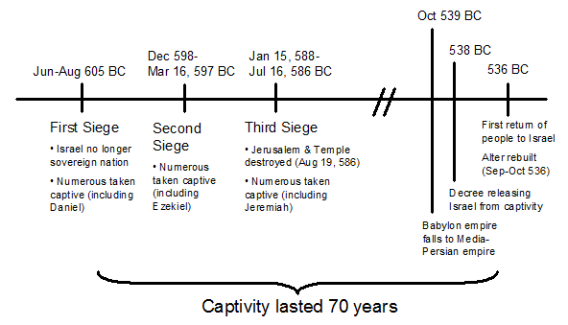

**The Promises**

**Daniel 5: 13-14, “Then Daniel was brought in before the king. The king spoke, and said to Daniel, “*Are* you that Daniel who is one of the captivesfrom Judah, whom my father the king brought from Judah? 14I have heard of you, that the Spirit of God *is* in you, and *that* light and understanding and excellent wisdom are found in you.”**

**Isaiah 3:10, “Say ye to the righteous, that it shall be well with him: for they shall eat the fruit of their doings.”  
  
Psalm 58:11, "Verily there is a reward for the righteous.”  
  
Psalm 5:12, "Thou, LORD, wilt bless the righteous; with favour wilt thou compass him as with a shield.”**

**Assignment for Next Week: Read in one sitting, Isaiah 13-14, Jeremiah 50-51, and Revelation 17-18**.