**The Destiny of Daniel—Chapter 4, “The Letter of a Gentile King”**

**Daniel is divided into two halves, the first six chapters are historical, and the last six are the prophetic. This is the longest chapter of the book, and it is an affidavit by the Gentile King of the world, Nebuchadnezzar. Daniel and his three friends are promoted by the King to high positions. This chapter is 10-20 years later than the “fiery furnace” exposition. Chapters 2-7 are written in Aramaic, because it is about the Gentile World, the Gentile language of that day. This is the only place in the Bible where a Gentile King authors.**

1. **Verses 1-3 begin the letter written by Nebuchadnezzar. Read and review.**
   1. **Is this a public declaration?**
   2. **Who is the letter addressed to?** The whole world
   3. **What does he mean “all the earth?”**
   4. **Who is “the Most High God?”**
   5. **Discuss the fact that this is a pagan ruler, talking to a pagan world.**
2. **In verse 3, there is an admission by Nebuchadnezzar about the importance of God. Re-state in your own words.**
3. **Verses 4-5 introduce Nebuchadnezzar’s second dream. Discuss.**
   1. **Why is he afraid?**
   2. **Who helped him understand the vision?**
   3. **Why did Nebuchadnezzar invite all of the “soothsayers” when they did such a miserable job in interpreting his other dream?**
      1. **Where was Daniel at first?** He was chief of the magicians, and probably on official business somewhere.
4. **In verses 7-8, why is Daniel called by his Hebrew name, “Daniel,” here?**
   1. **Why is Daniel the last advisor to be called?**
      1. **Write Nebuchadnezzar’s description of Daniel?** Chief of the magicians; Daniel was in charge of all of the advisors—chief of staff
5. **In verses 9-10, Nebuchadnezzar seems to understand the value of Daniel? Discuss.**
6. **What is the vision which Nebuchadnezzar sees?** Verses 11-14
   1. **Describe the dream.**
   2. **Who is the tree? Leaves? Fruit? Beasts?**
   3. **When did Nebuchadnezzar have this dream?**
7. **Who are the “watchers?”** in verse 14 and 23? A ‘holy one.’ According to the Book of Enoch the "watchers" were a group of angels God had commissioned to watch over the earth. Two hundred of these "watchers" rebelled against God and married the daughters of men. If interpreted literally, they produced half-breed humans called the Nephilim. The Nephilim were monstrous, gigantic evil-beings. We find several details of this story in Genesis chapter six. MANY COMMENTATORS BELIEVE THAT THE CREATION OF MAN MAY HAVE CAUSED THE FALL OF SATAN, WHO DID NOT WISH TO SERVE MAN.
   1. **See Deuteronomy 33:2**. *‘He said, "The LORD came from Sinai, And dawned on them from Seir; He shone forth from Mount Paran, And He came from the midst of* ***ten thousand holy ones****; At His right hand there was flashing lightning for them.’*
   2. **Review Psalm 89:7**. *‘A God greatly feared in* ***the council of the holy ones****, And awesome. A*
   3. **Read Hebrews 13:2.** “Do not neglect to show hospitality to strangers, for thereby some have entertained angels unawares.
   4. **Examine Ephesians 3:10-11.** “10to the intent that now the manifold wisdom of God might be made known by the church to the principalities and powers in the heavenly *places,* 11according to the eternal purpose which He accomplished in Christ Jesus our Lord.”Principalities, powers, are rankings of angels. God shows His angels His wisdom by the church. These angels are watching you!!
   5. **Scrutinize I Peter 1:12.** “To them it was revealed that, not to themselves, but to us they were ministering the things which now have been reported to you through those who have preached the gospel to you by the Holy Spirit sent from angels desire to look into.”
   6. **Look at Job 38:7.** “Where were you when I laid the foundations of the earth? Tell *Me,* if you have understanding. 5Who determined its measurements? Surely you know! Or who stretched the line upon it? 6To what were its foundations fastened? Or who laid its cornerstone, 7When the morning stars sang together, And all the sons of God shouted for joy?”
   7. **Re-visit Hebrews 1:7, 14.** “And of the angels he saith, Who maketh his angels spirits, and his ministers a flame of fire. …..Are they not all ministering spirits sent forth to minister for those who will inherit salvation?”
8. **Who is the ‘stump of his roots; in verse 15?**
9. **Explain verse 16, with the stump, roots, and changed heart?** 
   1. **In verse 15, the pronouns shift to “man” and not a tree. Why?**
   2. **What is “beast’s heart?”**
   3. **What is “times?”** time is one years, times is two years
10. **In verse 17, why do the “watchers” decree? Discuss their presence**.
    1. **Review their decrees in verses 15-16.**
    2. **What does the Most High declare**?  **Why?**
11. **What does Nebuchadnezzar see in verse 18? How does Daniel answer him?**
    1. **Does Daniel seem to care for Nebuchadnezzar?**
12. **In verse 19, there is a reference to “one hour.” Why?**
    1. **Describe Daniel’s mood?** Daniel was troubled by this
    2. **What is Daniel’s answer?**
    3. **How do we see Daniel’s heart in this passage?**
13. **Explain the dream in verses 20-25.**
    1. **Who are the leaves and the fruit?**
    2. **What was the watchers’ decree?**
    3. **What does “cut down,” portion with the beasts of the field, stump and root imply?**
    4. **Is Daniel implying that Nebuchadnezzar will become a beast and eat grass?**
14. **Did Daniel show courage in interpreting this dream?** Verses 26-27
15. **How does Nebuchadnezzar react to the honesty of Daniel?**
16. **What seems to be the point of this dream?** Verse 26-27
    1. **Does Daniel try to give Nebuchadnezzar a “way out” by repentance?**
17. **Where else in the scripture do we see the idiom of a “tree” used?** Often kings and kingdoms are referred to “as trees.”….nations—trees.
    1. **Fig tree--Matthew 24 and Luke 21:29**
    2. **A man--See Psalm 1:3, 37:35, 52:8, 92:12, Isaiah 56:3, and Jeremiah 17:8**
    3. **Assyrian and Egyptian Pharaoh are compared to the cedar of Lebanon—See Ezekiel 31:3**
    4. **Olive Tree, Israel—Romans 11:16-24, 2 Kings 14:9, Psalm 1:3, 37:35, 52:8, 92:12, and Ezekiel 17**
    5. **Transplanted shoot—Ezekiel 17:22, 22:24, 31.**
    6. **Stump—Isaiah 11:1**
    7. **The cross—I Corinthians 1:18**
    8. **Mustard tree—Matthew 7:17—parable, Matthew 13:32-32**
18. **How much time transpires between the dream and the actual happening?** Verse 28-20. 12 months
19. **Why is the King bragging in verse 29? What does God say about pride?** Babylon was the number 1 city of the world….considered impregnable. It is double walled and very substantial.
    1. **See the following verses about pride: Proverbs 11:2, 16:3, 29:23, 16:18, Galatians 6:3, James 4:6.**
    2. **See Proverbs 6:16-19; discuss what God hates.**
    3. **Use I Corinthians 4:6-7 as an example of God’s feeling about pride.**
    4. **Also review Proverbs 15:5; what is an abomination to the Lord?**
    5. **Contrast the pride of Nebuchadnezzar with the attitude of Jesus in Philippians 2:5-6.**
    6. **Decipher verse 30, and all of the “I’s” and “my’s.” Parallel those thoughts with your own life. Who gets credit for your successes?**
    7. **Why does God hate pride?** Because that is what caused Satan’s fall…
       1. **Study Isaiah 14:13-14 and Ezekiel 28.**
20. **How long until the dream is actually fulfilled? 1 year**
21. **What was the voice that fell from heaven in verse 21?**
22. **Explain the “beast of the field,” and eating “grass.”**
23. **Discuss the disease of Lycanthropy….from the Greek, ‘lykos,’ ”wolf,” and anthropos, “man.” Clinical lycanthropy** is defined as a rare [psychiatric](http://en.wikipedia.org/wiki/Psychiatric) syndrome that involves a [delusion](http://en.wikipedia.org/wiki/Delusion) that the affected person can transform into, has transformed into, or is a non-human [animal](http://en.wikipedia.org/wiki/Animal).[[1]](http://en.wikipedia.org/wiki/Clinical_lycanthropy#cite_note-Garlipp-1) Its name is connected to the [mythical](http://en.wikipedia.org/wiki/Mythology) condition of [lycanthropy](http://en.wikipedia.org/wiki/Werewolf), a [supernatural](http://en.wikipedia.org/wiki/Supernatural) affliction in which humans are said to physically [shape shift](http://en.wikipedia.org/wiki/Shapeshift) into [wolves](http://en.wikipedia.org/wiki/Werewolf).
    1. **Are werewolves from this same root word?** Men assume the form of a man, a psychic disorder. Folklore of the medieval period supports this. Mental disorder in which the patient believes he is a wolf or some other animal. Romans called this “versipellis,” or “turnskin.” Boanthropy was probably what Nebuchadnezzar had, where the person believes they are an ox. In 266 B.C., Abydenus, a Greek historian records aspects of Nebuchadnezzar’s insanity as being on top of the roof and other details. Josephus records that another Babylonian historian, Berosus, recorded that a Chaldean priest at the time of Alexander had this same condition. And, in 1946, in a British Mental Institution, a twenty-year-old was hospitalized for five years with this condition.

[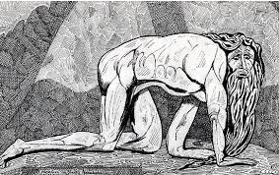](http://www.google.com/imgres?imgurl=http://images-1.redbubble.net/img/art/size:large/view:main/3261670-6-40-variation-on-william-blakes-nebuchadnezzar-dave-edwards-ink-1981.jpg&imgrefurl=http://www.redbubble.com/people/blythart/works/4520877-290-william-blake-dave-edwards-mixed-media-2010&h=347&w=550&tbnid=wIBH5NkKuzPkXM:&zoom=1&docid=2HWkI4GDh197iM&hl=en&ei=tipTVdbfGZKnyASJ_YGoCw&tbm=isch&ved=0CEoQMygjMCM)

* 1. **Describe Nebuchadnezzar’s physical condition.**
  2. **How many years? See verse 34.**
  3. **How does Nebuchadnezzar end this disease in verse 35?**
  4. **Does Nebuchadnezzar get cured? What are his words in verses 35-36?**
  5. **Who took care of Nebuchadnezzar for those seven years?** Daniel
  6. **Sum-up Nebuchadnezzar’s change in attitude in verse 37.** Issued throughout the land in 562 B.C., after he was restored he lived one year.
     1. **Discuss Nebuchadnezzar’s successor, his son, Evil-Merodach.**
        1. **See Jeremiah 9:23-24**

1. **Can you draw any kind of prophetic correlation to this story in Chapter 4 and the end times? Discuss the following parallels:**
   1. **A world religion has taken over the whole world, Babylon and end-times “Tribulation World,” both with Gentile power, to be overthrown by the One, True God.**
   2. **Seven years of insanity and confusion, both of Nebuchadnezzar and for the earth dwellers of the world in end times.**
   3. **Conversion took place for Nebuchadnezzar after seven years of chaos/madness, and will for the 1/3 remnant of the Jews during the seven years of the Tribulation.**
   4. **“The tree”/Nebuchadnezzar did not sprout again until after it had been cut down; Israel will not accept (or blossom) the Messiah until after it had been “cut down.”**
2. **See Acts 15:1-12, 19-21, Acts 16:4-5, Galatians 5:2-3, Romans 4:9, , and the council of Jerusalem** Peter and Paul argue about whether a Gentile has to become a Jew to be a Christian. James resolves the matter.
3. **Some people call Chapter 4 “Nebuchadnezzar’s Testimony.” Describe.**
4. **Compare this second dream, chapter 4, with his first dream, chapter 2.**
5. **What life lessons from Nebuchadnezzar are obvious for us today?**
   1. **Does it often take a tragedy or chaos to bring us to God?**
   2. **Sum-up Chapter 4 in your own words.**

**The Promises**

**Romans 2:4, “Or do you despise the riches of His goodness, forbearance, and longsuffering, not knowing that the goodness of God leads you to repentance?”**

**Ephesians 3: 1-7, “For this reason I, Paul, the prisoner of Christ Jesus for you Gentiles— 2if indeed you have heard of the dispensation of the grace of God which was given to me for you, 3how that by revelation He made known to me the mystery (as I have briefly written already, 4by which, when you read, you may understand my knowledge in the mystery of Christ), 5which in other ages was not made known to the sons of men, as it has now been revealed by the Spirit to His holy apostles and prophets: 6that the Gentiles should be fellow heirs, of the same body, and partakers of His promise in Christ through the gospel, 7of which I became a minister according to the gift of the grace of God given to me by the effective working of His power.”**

**Psalm 113:5-8, “Who is like unto the Lord our God, who dwelleth on high. Who humblest himself to behold the things that are in heaven, and in the earth! He raiseth up the poor out of the dust, and lifteth the needy out of the dunghill; that he may set him with princes, even with the princes of his people.”**

**Psalm 75:4-6, ““I said to the boastful, ‘Do not deal boastfully,’ and to the wicked, ‘Do not lift up the horn. 5do not lift up your horn on high; do *not* speak with a stiff neck.’” 6For exaltation *comes* neither from the east nor from the west nor from the south. 7But God *is* the Judge: He puts down one, and exalts another.”**

**James 4:10, “Humble yourselves in the sight of the Lord, and He will lift you up.”**

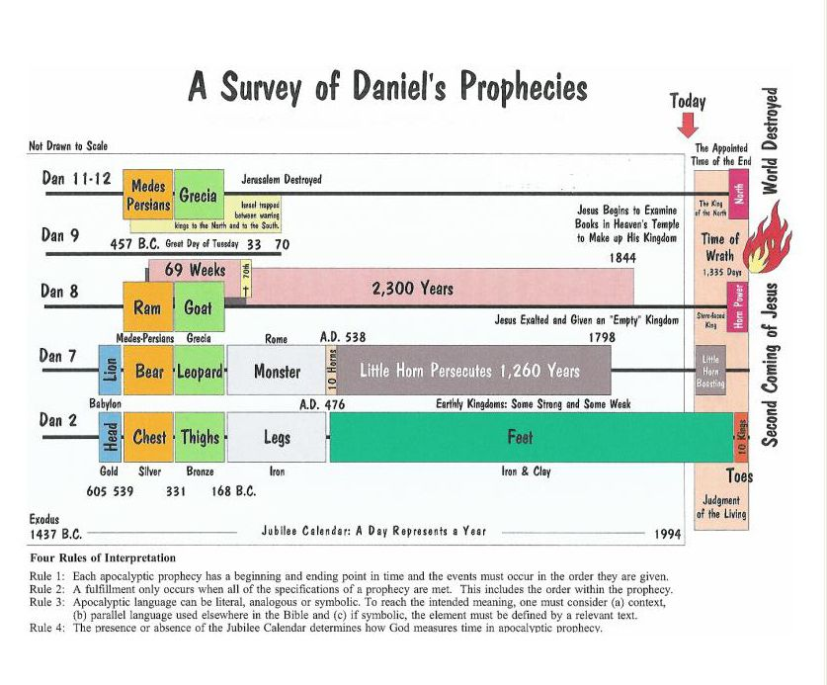

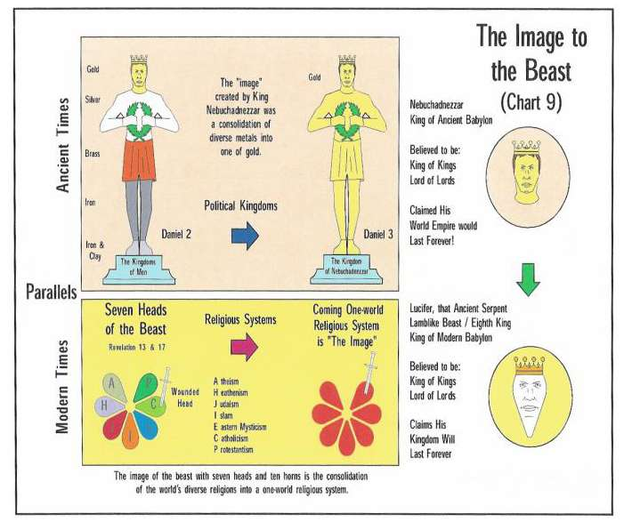

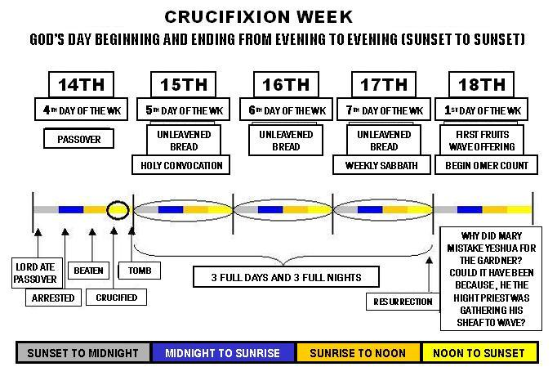

**Added Info: Boanthropy (bovine) , Therianthropy, Cynanthropy (dog), Lycanthropy (wolf or wild beast)**

From the "Pharmaceutical Journal": The metamorphosis of humans into animals is known as therianthropy (ability of human beings to metamorphosis into an animal by shape shifting), the best known form of which is lycanthropy — transformation into a wolf or werewolf. The term “cynanthropy” dates back to ancient Greece and is applied to shape shifters who alternate between human and dog form. A therianthrope, however, is a being that is part human, part animal. The best known examples are the animal-headed gods of ancient Egypt, such as Bast (with the head of a cat) or Anubis (with the head of a jackal). The word combines the Greek *therion*, wild animal, with *anthropos*, human being.

**Further, Nebuchadnezzar states that his hair grew long like eagle’s feathers and his nails like the claws of a bird. There is an illness called Boanthropy in which a man's mind sinks into insanity and he thinks that he is an animal and begins to live like one. Medically the disease of Boanthropy is a condition where the sufferer believes that they are an ox. The disease displays itself first by a tendency toward green vegetables and is therefore indistinguishable from vegetarianism, however the next stage (which occurs about five months after symptoms first appear) is unique to this particular mental condition, the sufferer will develop a liking for grass and some species of wild flowers at this stage the condition is irreversible. The third stage, characterized by mooing and snorting and the deep urge to plow fields, occurs only two months after symptoms first appear. This stage can last up to five years, but always results in coma and death, therefore it is not an affliction to be taken lightly. There have been documented cases where the sufferer has grown horns and taken to living in a stable.**