The **Destiny of Daniel—Chapter 3, “The Golden Image” and the “Fiery Furnace”**

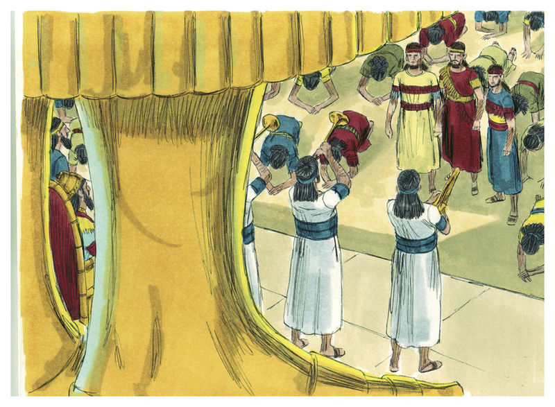

**Review……this chapter is a response to Chapter 2. The Book of Daniel focuses on Gentile history, from Nebuchadnezzar to the Anti-Christ. Chapter 1—the deportation of Daniel and several others of the royal line, and they were trained for service at court. This chapter could be ten-twenty-three years after Chapter 2. How does God speak; see Hosea 12:10, “**I have also spoken by the prophets, and I have multiplied visions, and used similitudes, by the ministry of the prophets.”—and this tells us different ways God speaks to us. Similitudes are parallelisms or analogies.

1. **Review what Nebuchadnezzar says after Daniel reveals the dream of Nebuchadnezzar in Daniel 2:47, “The king answered Daniel, and said, ‘Truly your God is the God of gods, the Lord of kings, and a revealer of secrets…”** 
   1. **Note the three names of God….God of gods, Lord of kings, and revealer of secrets. Could this be hinting at the Trinity?**
   2. **NOTE: THIS IS THE FIRST INDICATION OF NEBUCHADNEZZAR CALLING GOD, ‘GOD!’ Comment.**
2. **How many years have passed since the end of Daniel 2 and the beginning of Daniel 3? How do we know this?** About 10-23 years after Nebuchadnezzar’s dream.
3. **Give reasons that Nebuchadnezzar made an image of gold?**
   1. **Describe this statue. Height? Width?** 90 feet high, 9 ft. wide. This might be an obelisk, styled like a man. Or a man image on top of a pedestal.
   2. **Discuss the number “six.”** That is the number of man, of incompleteness**.**
   3. **Compare to the beast in Revelation 13:8 and 20:4.**
      1. **Discuss how the “bowing to the statue” parallels to the “bowing to the beast.”**
      2. **How much is a cubit?** About 18 inches. Tip of the finger to the elbow.
      3. **Does this statue echo the dream of Nebuchadnezzar from Daniel 2?**

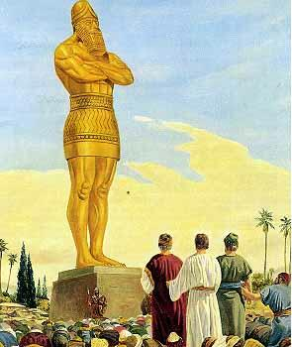

1. **Where is the Plain of Dura? Why did Nebuchadnezzar place the image there and not in Babylon?** Large plain in Shinar
2. **In verses 2-3, restate the “guest list” of participants in the statue’s dedication.** Princes, governors, captains, judges, treasurers, counselors, sheriffs and rulers of the provinces.
   1. **How many different entities were listed?** Seven…number of completeness
   2. **Discuss the word “all” in verse 3?**
3. **What did the heralds announce in verses 4-6?**
   1. **Note the phrase, “that at the time you hear the sound of the horn, flute, harp, lyre and psaltery, in symphony with all kinds of music, you shall fall down and worship the gold image,” is used four times. Discuss the number four.** One past the trinity, or the devil trying to put himself equal with God.
      1. **See John 19:23.—**Roman soldiers divided Jesus’ clothing into four parts.
      2. **Note the four kingdoms in Daniel 2.**
      3. **Read Ezekiel 14:21, and compare the four judgments Ezekiel warned about unrepentant rulers.**
   2. **What was the punishment for anyone who did not obey?**
   3. **What was the signal for worship of the idol?**
      1. **Why use musical instruments for this worship in verse 7?**
   4. **Compare the command for worship to the Anti-Christ’s command in Revelation 13:3-18.**
   5. **Review Romans 12:1-2 for a New Testament comparison about non-conformity.**
4. **In verse 8, who are the accusers? Could jealousy be involved?**
   1. **Note that this trial/test is the third test for Daniel and his friends. Discuss.** Daniel 1—food test, Daniel 2—dream test, Daniel 3—bow down test
5. **Who were the Chaldeans that accused the Three Jewish Youth of disobeying Nebuchadnezzar’s orders? What motive did they have?**
   1. **How did Nebuchadnezzar respond?**
6. **In verses 8-13, retell the story of what is happening with the king’s advisors and Nebuchadnezzar’s.**
   1. **Re-visit verse 13. Is this a normal reaction for Nebuchadnezzar?**
7. **Review the names (and their meanings) of the three Jewish captives:**
   1. **Shadrach, “illumed by the sun god,” Jewish name “Hananiah,” beloved of the Lord.**
   2. **Meshach, “who is like unto the moon god,” Jewish name “Mishael,” who is God.**
   3. **Abed-Nego, “servant of Nego” or “shining fire,” Jewish name “Azariah,” the Lord is my help.**
8. **What is Nebuchadnezzar doing in verse 14-15?** 
   1. **Is he giving these three Hebrews a second chance?**
   2. **Why weren’t they killed immediately like the edict said?**
   3. **Did Nebuchadnezzar offer the three Hebrews a second chance to bow down to the statue? Why?**
   4. **In verse 14, discuss Nebuchadnezzar’s question, “Is it true?”**
   5. **What was to be the consequence if they did not conform?**
9. **Nebuchadnezzar asks “the BIG QUESTION” at the end of verse 15: “And who is the god who will deliver you from my hands?” Is that an example of sarcasm by the Holy Spirit?**
10. **Discuss the answer of the Hebrews in verses 16-18.** 
    1. **Site examples of courage or a “holy rebellion.”**
    2. **Site examples of clarity of mission.**
    3. **Did the three Hebrews hesitate in their answer to the king? Defend your answer.**
    4. **Verse 18 has three important words….”but if not”—how vital is that phrase?**
    5. **Discuss I Peter 4: 1-5, “**Therefore, since Christ suffered for us[[a](https://www.biblegateway.com/passage/?search=1+Peter+4%3A1-5&version=NKJV#fen-NKJV-30448a)] in the flesh, arm yourselves also with the same mind, for he who has suffered in the flesh has ceased from sin, 2that he no longer should live the rest of *his* time in the flesh for the lusts of men, but for the will of God. 3For we *have spent* enough of our past lifetime[[b](https://www.biblegateway.com/passage/?search=1+Peter+4%3A1-5&version=NKJV#fen-NKJV-30450b)] in doing the will of the Gentiles—when we walked in lewdness, lusts, drunkenness, revelries, drinking parties, and abominable idolatries. 4In regard to these, they think it strange that you do not run with *them* in the same flood of dissipation, speaking evil of *you.* 5They will give an account to Him who is ready to judge the living and the dead.” **and talk about Peter’s correlation with standing against unrighteousness.** 
       1. **Does this mimic the three Hebrew young men in this chapter of Daniel?**
       2. **See also I John 2:15. “**Love not the world, neither the things that are in the world. If any man loves the world, the love of the Father is not in them.”
11. **How do we know that Nebuchadnezzar’s mood changed? Re-read verse 19.** 
    1. **Why is Nebuchadnezzar so furious?**
    2. **Discuss conformity and non-tolerance in Nebuchadnezzar’s mandate.** 
       1. **Do we see this in today’s world?**
12. **The fire was heated seven times greater than normal, according to verse 19. Re-tell the importance of the number seven in the Bible. See Lev. 26:18-28, Prov. 6:30-31, 24:16, Rev. 1:4, 10:7, and Gen. 2:1-3.**
13. **Who got hurt in the fiery furnace episode? Can you draw inference from that?**
    1. **In Verse 20, who were the ‘mighty men?’**
    2. **Describe the outfits of the three Hebrew men when they were thrown into the furnace?**
    3. **Were they bound?**
14. **Verse 24 describes Nebuchadnezzar as “astonished.” Why?**
    1. **What were his comments?**
    2. **Who was the fourth person in the fiery furnace?**
    3. **How did Nebuchadnezzar describe the fourth man?**
    4. **What did he say about the men who were suddenly unbound?** They were walking around loose.
15. **Describe the Hebrew youth when they came out of the fire?**
16. **In verse 26, what are Nebuchadnezzar’s words to the three Hebrews?**
    1. **Was Nebuchadnezzar serious about his praise of Almighty God?**
    2. **Have we seen that side of him before? If so, When? See Daniel 2:47.**
       1. **Describe this second incident of Nebuchadnezzar’s praise of God.**
       2. **Thirteen times in Daniel, Nebuchadnezzar calls God, “The Most High God.” Daniel, himself, uses that term twice. See Daniel 5:18, 21.**
17. **In verse 27, who witnessed the miraculous saving of the three Hebrews?**
18. **What was the outcome for the three Hebrews?**
19. **In verse 28, does Nebuchadnezzar explain what happened?** 
    1. **Who is he speaking to?**
    2. **Is the fourth person a Theophany? Explain your thoughts.**
    3. **Compare this story with Joshua 5’s appearance of Jesus in the O.T.**
20. **Discuss the decree in verse 29. Is Nebuchadnezzar changed at this point?**
21. **The last verse of Daniel 3 is very interesting, “**Then the king promoted Shadrach, Meshach, and Abed-Nego in the province of Babylon.” **Review and re-state for meaning.**
    1. **What did the king do for Mishael, Azariah, and Hananiah?** He promoted them.
22. **Who is absent in Chapter 3?** 
    1. **Where do you think he is?**
23. **Is there a symbolic reference to End Times/Tribulation in the story of Daniel 3?**
24. **Compare Daniel 3 with Revelation 13.** From an analogy or “type.”
    1. **Review “Forced worship of the image” in Revelation 13:2 and Matthew 24.**
    2. **Note: A single, forced religion; see Revelation 17, 2 Thessalonians 2:4**
    3. **Compare with the “Mark of the beast” in Revelation 13:18.**
    4. **What could the fiery furnace represent...**tribulation? **Review Isaiah 43:1-2.**
    5. **Who does Nebuchadnezzar seem to foreshadow?** Maybe the Anti-Christ
    6. **Could “The three youths” point to the 144,000 witnesses in Revelation 7 and 14? …**in the tribulation, but spared
    7. **Does “The fire” point to God?** –idiom of God’s presence, punishment, power and protection
    8. **With the absence of Daniel in this story, is Daniel picturing the rapture of the Church?** –perhaps represents the church, removed from the situation, probably out of the country for the King…..the New Testament church in the rapture.
25. **Sum-up the central theme of Daniel 3. Please note the application for today’s world.**

**And, here are the promises…**

**James 4:6, “**But He gives more grace. Therefore He says: “God resists the proud,   
but gives grace to the humble.”

**I Peter 3:15, “**15But sanctify the Lord God[[d](https://www.biblegateway.com/passage/?search=1+Peter+3&version=NKJV#fen-NKJV-30440d)] in your hearts, and always *be* ready to *give* a defense to everyone who asks you a reason for the hope that is in you, with meekness and fear; 16having a good conscience, that when they defame you as evildoers, those who revile your good conduct in Christ may be ashamed.”

**Daniel 3:16-18, “**Shadrach, Meshach, and Abed-Nego answered and said to the king, “O Nebuchadnezzar, we have no need to answer you in this matter. 17If that *is the case,* our God whom we serve is able to deliver us from the burning fiery furnace, and He will deliver *us* from your hand, O king. 18but if not, let it be known to you, O king, that we do not serve your gods, nor will we worship the gold image which you have set up.”

**Daniel 3:28-29, “**Nebuchadnezzar spoke, saying, “Blessed be the God of Shadrach, Meshach, and Abed-Nego, who sent His Angel[[b](https://www.biblegateway.com/passage/?search=Daniel+3&version=NKJV#fen-NKJV-21836b)] and delivered His servants who trusted in Him, and they have frustrated the king’s word, and yielded their bodies, that they should not serve nor worship any god except their own God! 29Therefore I make a decree that any people, nation, or language which speaks anything amiss against the God of Shadrach, Meshach, and Abed-Nego shall be cut in pieces, and their houses shall be made an ash heap; because there is no other God who can deliver like this.”

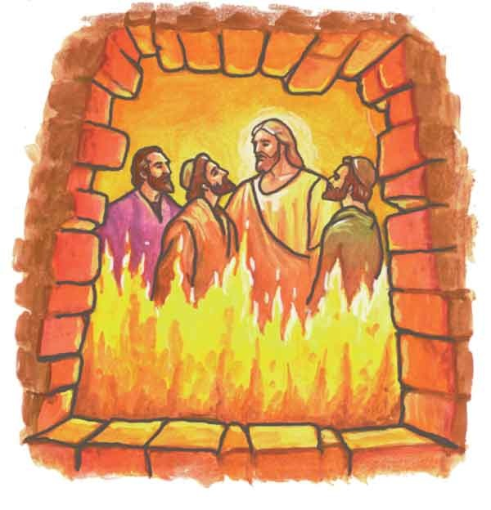

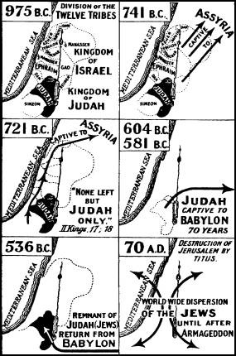**rde**