**The Destiny of Daniel—Chapter 2, “The Great Statue,” depicting a time line of the Gentiles, and the “Dream of a King”**

**ALSO CALLED: “The Alphabet of Prophecy” whose scope is: the nations of the world, Israel and the Messianic Kingdom, from 600 B.C. to the Millennium.**

**Review: Daniel, deported as a teenager to a foreign country, committed to be true to His God. This was the first of three deportations of Jews into Babylon, under Nebuchadnezzar; it took place in around 605 B.C. Jehoiakim was Judah’s king at this time (2 Kings 24:1-4). DANIEL REMAINED IN OFFICE UNTIL AROUN 538 B.C., when he was at least 85 years old. Historical background to this chapter: 612 B.C.—Nineveh, capital of Assyria, falls to Mede/Persia, 609 B.C.—Pharaoh Necho leads his army against Assyria, and at the same time Josiah comes up against Necho and is killed (2 Chronicles 35:20-24); most people believed that the Ark of the Covenant was being held by Egypt at this point, hence Josiah’s urgency to retrieve it, 606 B.C.—Battle of Carchemesh, where Nebuchadnezzar fights Pharaoh Necho on the west bank of the Euphrates and defeats them, establishing Babylon as a big deal in the world and during this battle Nebuchadnezzar’s dad, Nabopolassar, dies, in 605 B.C Jeremiah 46:1-6. Kings of Babylon: Nebapolazer—627-605 B.C., Nebuchadnezzar 605-562 B.C. History tells us that Nebuchadnezzar became King on September 7, 605 B.C., and his first official year began on the first of Nisan, 604 B.C., with his second year being counted from 603-602 B.C. DANIEL PROBABLY ARRIVED IN BABYLON AROUND 605 B. C. AND WAS SENT TO “COLLEGE” FOR THREE YEARS; THAT PLACED HIM IN FRONT OF NEBUCHADNEZZAR IN CHAPTER 2 AROUND 602 B.C., PROBABLY AT THE AGE OF 15-18. The Book of Daniel is divided into two parts, which are not in chronological order, where the language of Daniel changes to Aramaic (Gentile), and it speaks of Gentile history. 1. second year of . . . Nebuchadnezzar--** [**Daniel 1:5**](http://www.biblestudytools.com/daniel/1-5.html) **shows that "three years" had elapsed since Nebuchadnezzar had taken Jerusalem. The solution of this difficulty is: Nebuchadnezzar first ruled as subordinate to his father Nabopolassar, to which time the first chapter refers (**[**Daniel 1:1**](http://www.biblestudytools.com/daniel/1-1.html) **); whereas "the second year" in the second chapter is dated from his sole sovereignty. Chapters 2-7 are called “The Times of the Gentiles,” God’s program for the world. Isaiah writes from 760-700 B.C., Daniel from 605-538 B.C., and Nebuchadnezzar reigns from 605-562 B.C. The book of Daniel begins its Aramaic portion in Daniel 2:4b-7:28. *THIS ONE CHAPTER REVEALS THE BROADEST SWEEP OF WORLD HISTORY GIVEN TO ANY PROPHET!***

* 1. **Historical, narrative—Chapters 1-6**
     1. **Chapter 1—Daniel deported as a teenager--Hebrew**
     2. **Chapter 2—Nebuchadnezzar’s Dream, statue—Aramaic (Gentile language of that day)**
     3. **Chapter 3—The Fiery Furnace--Aramaic**
     4. **Chapter 4—Nebuchadnezzar’s Pride--Aramaic**
     5. **Chapter 5—Fall of Babylon--Aramaic**
     6. **Chapter 6—Revolt of the Magi, the Lion’s Den--Aramaic**
  2. **Prophetical—Visions of Daniel—Chapters 7-12**
     1. **Chapter 7—Daniel’s Vision of Four Beasts--Aramaic**
     2. **Chapter 8—The Ram and the He-Goat--Hebrew**
     3. **Chapter 9—The Seventy Weeks--Hebrew**
     4. **Chapter 10—A Glimpse of the Dark Side--Hebrew**
     5. **Chapter 11—The “Silent Years” in Advance--Hebrew**
     6. **Chapter 12—The Final Wrap-up of All Things—Hebrew**

1. **Re-visit Ezekiel 14:14, 20. How important is Daniel to God, according to these scriptures?**
2. **Chapter 2 begins the “Time of the Gentiles.” See Luke 21:24.”** And they will fall by the edge of the sword, and be led away captive into all nations. And Jerusalem will be trampled by Gentiles until the times of the Gentiles are fulfilled.” Began when Daniel was taken captive in 606 B.C., not when Jerusalem was destroyed in 70 A.D.
   1. **See also Hosea 3:4-5**
   2. **What is “the fullness of the Gentiles?” Acts 15:13-17 and Romans 11:25…Gentiles called out in the dispensation by the Holy Spirit as members of Christ’s Body—‘THE CHURCH,’ till they are complete.**
3. **Who is Nebuchadnezzar? According to verse 1, what year is this chapter starting?** Third year of Jehoiakim’s reign
   1. **Was he appointed by God? Why did God choose him? Read Jeremiah 27:4-8.**
   2. **Who was Nebuchadnezzar’s father?**
   3. **What position did Nebuchadnezzar hold?**
   4. **In what year was Daniel carried away as a captive to Babylon?**
4. **Verse 1 discusses Nebuchadnezzar’s dream. Why will this prove important to Daniel and his friends?**
   1. **Who did King Nebuchadnezzar call to interpret his dream?**
   2. **Review the following verses about dreams and visions: Acts 2:17, Amos 3:7, Joel 2:28, Genesis 15:1, 20:1-7, 28:10-12, 37:5-7, 40:1-8, 41:1-8, Job 33:14-17, I Kings 3:5, Luke 1:5-22, Matthew 1:20, 2:13, 27:17-19, Acts 10:9-13, Acts 16:9-10, and the entire book of Revelation is a vision John had while on the island of Patmos.**
      1. **i. Compare Nebuchadnezzar’s dream to that of Pharaoh’s in Genesis 41. Explain how Daniel is used in the same way as Joseph.**
   3. **List other Gentile “dreamers” in the Bible, and note their significance.**
      1. **See Pharaoh in Genesis 41:1-8, 12-14**
      2. **Ahasuerus/Artaxerxes in Esther 6:1-3.**
      3. **Abimelech, the king of Gerar who took Sarah from Abraham, in Genesis 20:3**
5. **According to verse 2, what kind of vessels/temple utensils were taken in this seizure? Review 2 Chronicles 36:7.**
6. **List the characters in verses 2-3 and note their “job descriptions.”**
   1. **Magicians—told fortunes**
   2. **Conjurer/ enchanters—communed with the dead**
   3. **Sorcerers—cast spells**
   4. **Chaldeans—the scientists/ astronomers who were a privileged caste by birth**
7. **Who are the youths taken captive, verse 3, or “the king’s seed?” Were they royals from Judah’s kingly bloodline?**
   1. **Why does this play an important role in this story?**
   2. **What position did Daniel hold in Nebuchadnezzar’s kingdom?**
8. **Why does verse 4 start the Gentile-language portion of this study?**
9. **In verse 5, the king had an interesting proposal to his “soothsayers.” What did he ask them to do to interpret his dream? How did they react? What was the consequence for inaction?**
   1. **Was this some sort of a “test” by Nebuchadnezzar? Why?**
10. **Re-state the conversation between the king and the fortune tellers in verses 4-11.**
    1. **What was the ultimate conclusion of the king?**
    2. **What was his mandate?**
11. **What was Daniel’s training? How many years? Who supervised this?**
12. **What is the difference between a dream and a vision?**
13. **Describe the jobs of the astrologers, magicians, sorcerers, and the Chaldeans? Which one was Daniel?**
    1. **Who were the Magi?** Chaldeans--here, a certain order of priest-magicians, who wore a peculiar dress, like that seen on the gods and deified men in the Assyrian sculptures. Probably they belonged exclusively to the Chaldeans, the original tribe of the Babylonian nation, just as the Magicians were properly Medes.
14. **In Verses 10-11, do you think Nebuchadnezzar actually forgot his dream? THIS IS THE ONLY EXAMPLE IN THE BIBLE OF A DREAM BEING INTERPRETED WITHOUT THE DREAM FIRST BEING REVEALED TO THE INTERPRETOR.**
15. **Was there a punishment for the soothsayers, etc., who could not tell the dream? Verses12-13.**
16. **Where is Daniel in verses 12-13?**
17. **Explain Nebuchadnezzar’s anger at his “learned” soothsayers. See also Genesis 40:2, 41:10 and Daniel 3:13, 19.**
18. **In verses 14-15, discuss Daniel’s response to the edict and prescribed punishment of Nebuchadnezzar.** Discretion and discernment.
19. **Compare Joseph‘s interpretation of Pharaoh’s dream to Daniel’s interpretation of Nebuchadnezzar’s dream. (Genesis 41: 1-45)**
20. **In verse 19, what did Daniel actually say about God?**
21. **Who is Arioch and how does God use him?** The captain of the executioners**.**
    1. **In verse 25, note how Arioch takes credit. Why?**
22. **In verses 20-23, describe Daniel’s “all night prayer meeting?” This is the first ever examples of corporate prayer in the Bible.** **Discuss the Bible references inside.** 
    1. **Parallel this with Philippians 4:6-7.**
23. **Daniel uses the phrase, “God of heaven” five times in this chapter, verses 18, 19, 28, 37, and 44. Why?**

**Daniel 2:20-23, NKJV, the Prayer/Blessing by Daniel**

**20Daniel answered and said:**

**“Blessed be the name of God forever and ever, (Ps. 113:2)   
for wisdom and might are His. (Job 12:13)  
21And He changes the times (Psalm 31:15, Esther 1:13) and the seasons;  
He removes kings and raises up kings; (Job 12:18; Psalm 75:6-7; Jer. 27:5)  
He gives wisdom to the wise (Jer. 32:19; I Kings 3:9-10, 4:29; Proverbs 3:21-22; James 1:5)  
And knowledge to those who have understanding.(Psalm 147:5)  
22He reveals deep and secret things; (Psalm 25:14; ; Jer. 23:24)  
He knows what *is* in the darkness, (Job 26:6; Job 12:22, Psalm 139:12; Isaiah 45:7; Hebrews 4:13)  
And light dwells with Him. (Ps. 36:9; I Timothy 6:16; I John 1:5; James 1:17)**

**23“I thank You and praise You,  
O God of my fathers;  
You have given me wisdom and might, (I Chronicles 29:11-12; Romans 11:33)   
And have now made known to me what we asked of You,  
For You have made known to us the king’s demand.” (Ps 21:2, 4; Dan. 5:11, 14)**

1. **Also consult** [**Matthew 18:19**](http://www.biblestudytools.com/matthew/18-19.html) **and…..** The same instrumentality rescued Peter from his peril…… [**Acts 12:5-12**](http://www.biblestudytools.com/passage/?q=Acts+12:5-12niv)**.**
2. **In verse 23, compare the prophecy with 2 Peter1:21.**
3. **Note in verse 24-30 that Daniel does not take credit for the interpretation of the dream. Where does he place his praise?** 
   1. **How does Daniel parallel with Joseph in Genesis 41:16?**
   2. **In verse 24, why did Daniel ask for all the “wise men” to be saved? Read Genesis 39:5, “**And it came to pass from the time that he had made him overseer in his house and over all that he had, that the Lord blessed the Egyptian’s house for Joseph’s sake; and the blessing of the Lord was upon all that he had in the house and in the field.”
      1. **Does it seem that the wicked were blessed because of the righteous? Explain.**
4. **In verse 28, the term “latter days/ end of days” appears. Compare that with Genesis 49:1.** 
   1. **Nebuchadnezzar’s dream for “HEREAFTER,” or “LATTER DAYS” was described in verses 26-30. When are the “latter days?” Give an explanation.**
   2. **This is often called “A History of the Gentiles.” Why?**
   3. **Verses 31-35 reveal the dream. Note the figure here, and discuss the accuracy of the Prophetical outline of the Gentile nations.** . The head and higher parts signify the earlier times; the lower, the later times. The metals become successively baser and baser, implying the growing degeneracy from worse to worse... The metals lessen in specific gravity, as they downwards; silver is not so heavy as gold, brass not so heavy as silver, and iron not so heavy as brass, the weight thus being arranged in the reverse of stability.. But the Persian king was so far dependent on others that he could not deliver Daniel from the princes ( [Daniel 6:14](http://www.biblestudytools.com/daniel/6-14.html) [Daniel 6:15](http://www.biblestudytools.com/daniel/6-15.html) ); contrast [Daniel 5:18](http://www.biblestudytools.com/daniel/5-18.html) [Daniel 5:19](http://www.biblestudytools.com/daniel/5-19.html) , as to Nebuchadnezzar's power from God, whom he would he slew, and whom he would he kept alive" (compare [Ezra 7:14](http://www.biblestudytools.com/ezra/7-14.html) , [Esther 1:13-16](http://www.biblestudytools.com/passage/?q=Esther+1:13-16niv) ).. Iron is stronger than brass, but inferior in other respects; so Rome hardy and strong to tread down the nations, but less kingly and showing its chief deterioration in its last state. Each successive kingdom incorporates its predecessor (compare [Daniel 5:28](http://www.biblestudytools.com/daniel/5-28.html) ).  As the two arms of silver denote the kings of the Medes and Persians [JOSEPHUS]; so the two legs of iron signify the two Roman consuls [NEWTON]. The clay, in [Daniel 2:41](http://www.biblestudytools.com/daniel/2-41.html) , "potter's clay," [Daniel 2:43](http://www.biblestudytools.com/daniel/2-43.html) , "miry clay," means "earthenware," hard but brittle (compare [Psalms 2:9](http://www.biblestudytools.com/psalms/2-9.html) , [Revelation 2:27](http://www.biblestudytools.com/revelation/2-27.html) , where the same image is used of the same event); the feet are stable while bearing only direct pressure, but easily "broken" to pieces by a blow ( [Daniel 2:34](http://www.biblestudytools.com/daniel/2-34.html) ), the iron intermixed not retarding, but hastening, such a result.
5. **How old was Daniel at the time of this dream?**
6. **Why do you suppose God gave Nebuchadnezzar the image of the Gentile world in the form of a statue?** Nebuchadnezzar would have seen giant stone monuments and statues while he was capturing Egypt and battling with his army there. Perhaps, those images influenced his dreams.
   1. **Read Daniel 4:29-30 to understand Nebuchadnezzar’s pride and mindset.**
   2. **Why did God use the idea of “different kinds of metals” in this massive image?**

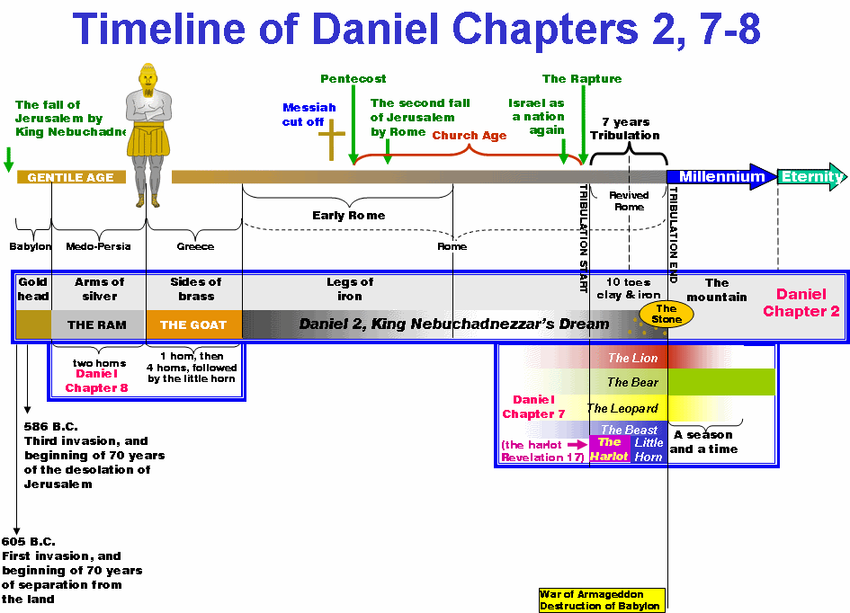

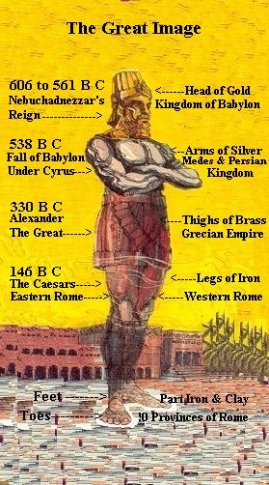

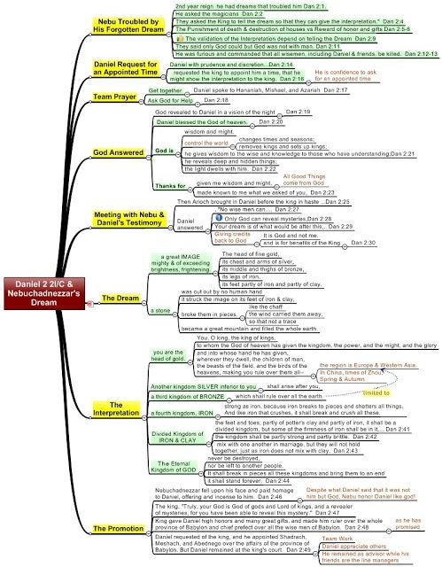

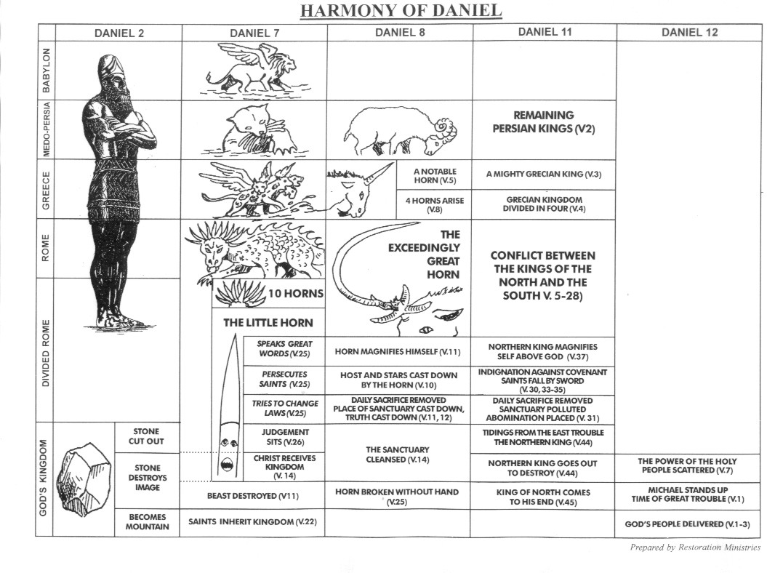

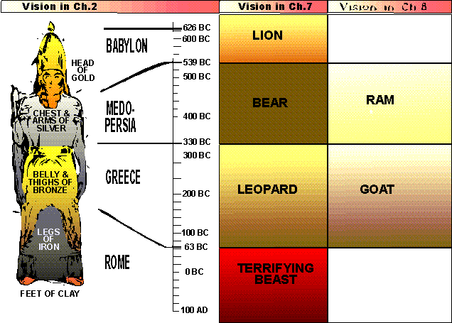

***Nebuchadnezzar’s Dream Statue***

**HEAD GOLD VALUABLE SOFT SELF-CONTAINED HEAVY SMALLEST LION**

**CHEST/ARMS SILVER LESS HARDER 1 UNIT, 2 PARTS LIGHTER LARGER BEAR**

**ABDOMEN/ THIGHS BRONZE EVEN LESS EVEN HARDER 1 UNIT, 2 DIFFERENT PTS EVEN LGHTR. EVEN LG. LEOPARD**

**LOWER LEGS IRON “ “ 2 PARTS “ “ iron BEAST**

**FEET/ TOES IRON/CLAY “ HARD & SOFT 2 PTS./10 SEGMENTS “ LGST. End times**

1. **Who is the head of Gold? Arms and breast of silver? Abdomen of brass? Legs of iron? Feet and toes of clay and iron?** **Gold—Babylon, 627-605 B.C.—88 years….**That **Silver—539-331 B.C., 208 Years…Medo-Persia** is the second kingdom appears from [Daniel 5:28](http://www.biblestudytools.com/daniel/5-28.html) and [Daniel 8:20](http://www.biblestudytools.com/daniel/8-20.html) . Compare[2 Chronicles 36:20](http://www.biblestudytools.com/2-chronicles/36-20.html) , [Isaiah 21:2](http://www.biblestudytools.com/isaiah/21-2.html) . Inferior--"The kings of Persia were the worst race of men that ever governed an empire" [PRIDEAUX]. Politically (which is the main point of view here) the power of the central government in which the nobles shared with the king, being weakened by the growing independence of the provinces, was inferior to that of Nebuchadnezzar, whose sole word was law throughout his empire. **Brass/Bronze, Greece, 331-31 B.C., 300 Years**--The Greeks (the third empire, [Daniel 8:21](http://www.biblestudytools.com/daniel/8-21.html) , [10:20](http://www.biblestudytools.com/daniel/10-20.html) , [11:2-4](http://www.biblestudytools.com/passage/?q=Daniel+11:2-4niv) ) were celebrated for the brazen armor of their warriors. JEROME fancifully thinks that the brass, as being a clear-sounding metal, refers to the eloquence for which Greece was famed. The "belly," in [Daniel 2:32](http://www.biblestudytools.com/daniel/2-32.html) may refer to the drunkenness of Alexander and the luxury of the Ptolemies [TIRINUS]. Over all the earth--Alexander commanded that he should be called "king of the entire world" [JUSTIN, 12. sec. 16.9; ARRIAN, Campaigns of Alexander, 7. sec. 15]. The four successors (diadochi) who divided Alexander's dominions at his death, of whom the **Seleucids in Syria and Asia** and **the Lagidæ/Ptolemy in Egypt were chief**, **Lysimachus in Trace or Asia Minor, Bulgaria and Antipater in Macedon and Greece**—generals of Alexander, held the same empire. Iron--This vision sets forth the character of the Roman power, rather than its territorial extent [TREGELLES]. Breaketh in pieces--So, in righteous retribution, itself will at last be broken in pieces ([Daniel 2:44](http://www.biblestudytools.com/daniel/2-44.html) ) by the kingdom of God ([Revelation 13:10](http://www.biblestudytools.com/revelation/13-10.html) ). Western Leg—Europe, Eastern Leg—Libyan. Roman Empire—31 B.C.-476 A.D.—western leg, Europe; 476-1453 A.D.—eastern leg, Muslims, and into today.
2. **Does the last part of the figure, verse 43, mixed clay and iron, correlate with Genesis Six?**
3. **In verses 48-49, who is the Stone? Give other Biblical references to “stone.”**The stone or “rock” is a frequent symbol of God and Jesus Christ in scripture. **Read Isaiah 41:15, 28:16, 30:29, Psalm 18:2, Psalm 78:35, Psalm 144:1, Hab. 1:12, I Pet. 2:6-8, Luke 20:18, 2 Samuel 22:32, 2 Samuel 23:3, Deut. 32:4,** [**1 Samuel 2:2**](http://www.kingjamesbibleonline.org/1-Samuel-2-2/) – “[There is] none holy as the LORD: for [there is] none beside thee: neither [is there] any rock like our God.” In Nebuchadnezzar’s dream, who, then, is the stone/rock that fills the whole earth? Give other examples of stones in the Bible….i.e., the tablets of Moses, the stone rolled away at the empty tomb, etc. 34. Stone--Messiah and His kingdom ([Genesis 49:24](http://www.biblestudytools.com/genesis/49-24.html) , [Psalms 118:22](http://www.biblestudytools.com/psalms/118-22.html) , [Isaiah 28:16](http://www.biblestudytools.com/isaiah/28-16.html) ). In its relations to Israel, it is a "stone of stumbling" ( [Isaiah 8:14](http://www.biblestudytools.com/isaiah/8-14.html) , [Acts 4:11](http://www.biblestudytools.com/acts/4-11.html) , [1 Peter 2:7](http://www.biblestudytools.com/1-peter/2-7.html) [1 Peter 2:8](http://www.biblestudytools.com/1-peter/2-8.html) ) on which both houses of Israel are broken, not destroyed ( [Matthew 21:32](http://www.biblestudytools.com/matthew/21-32.html) ). In its relation to the Church, the same stone which destroys the image is the foundation of the Church ([Ephesians 2:20](http://www.biblestudytools.com/ephesians/2-20.html) ). In its relation to the Gentile world power, the stone is its destroyer ([Daniel 2:35](http://www.biblestudytools.com/daniel/2-35.html) [Daniel 2:44](http://www.biblestudytools.com/daniel/2-44.html) ; compare [Zechariah 12:3](http://www.biblestudytools.com/zechariah/12-3.html) ). Christ saith ( [Matthew 21:44](http://www.biblestudytools.com/matthew/21-44.html) , referring to [Isaiah 8:14](http://www.biblestudytools.com/isaiah/8-14.html) [Isaiah 8:15](http://www.biblestudytools.com/isaiah/8-15.html) ), "Whosoever shall fall on this stone (that is, stumble, and be offended, at Him, as the Jews were, from whom, therefore, He says, 'The kingdom shall be taken') shall be broken; but (referring to [Daniel 2:34](http://www.biblestudytools.com/daniel/2-34.html) [Daniel 2:35](http://www.biblestudytools.com/daniel/2-35.html) ) on whomsoever it shall fall (referring to the world power which had been the instrument of breaking the Jews), it will (not merely break, but) grind him to powder" ( [1 Corinthians 15:24](http://www.biblestudytools.com/1-corinthians/15-24.html) ). The falling of the stone of the feet of the image cannot refer to Christ at His first advent, for the fourth kingdom was not then as yet divided--no toes were in cut out--namely, from "the mountain" ( [Daniel 2:45](http://www.biblestudytools.com/daniel/2-45.html) ); namely, Mount Zion ( [Isaiah 2:2](http://www.biblestudytools.com/isaiah/2-2.html) ), and antitypically, the heavenly mount of the Father's glory, from whom Christ came. Without hands--explained in [Daniel 2:44](http://www.biblestudytools.com/daniel/2-44.html) , "The God of heaven shall set up a kingdom," as contrasted with the image which was made with hands of man. Messiah not created by human agency, but conceived by the Holy Ghost ( [Matthew 1:20](http://www.biblestudytools.com/matthew/1-20.html) , [Luke 1:35](http://www.biblestudytools.com/luke/1-35.html) ; compare [Zechariah 4:6](http://www.biblestudytools.com/zechariah/4-6.html) , [14:58](http://www.biblestudytools.com/mark/14-58.html) , [Hebrews 9:11](http://www.biblestudytools.com/hebrews/9-11.html) [Hebrews 9:24](http://www.biblestudytools.com/hebrews/9-24.html) ). So "not made with hands," that is, heavenly, [2 Corinthians 5:1](http://www.biblestudytools.com/2-corinthians/5-1.html) ; spiritual, [Colossians 2:11](http://www.biblestudytools.com/colossians/2-11.html) . The world kingdoms were reared by human ambition: but this is the "kingdom of heaven"; "not of this world" ([John 18:36](http://www.biblestudytools.com/john/18-36.html) ).
   1. **Discuss Christ’s words, “cast the first stone,” in John 8:7.**
   2. **Read I Peter 2:6-8 and I Samuel 2:2.**
   3. **Remember also, David and his stone against Goliath, Jacob sleeping on a stone when He wrestle with an angel, and Moses hit the rock in the wilderness**
4. **Did Nebuchadnezzar have a change of heart? Defend your answer? (Vs. 46-48).—THIS IS THE FIRST TIME NEBUCHADNEZZAR CALLS DANIEL’S GOD, “GOD!”**
5. **What happened to Daniel, Shadrach, Meshach, and Abed-Nego because of the dream’s interpretation? Vs. 49.**
6. **Sump-up Daniel 2. Is its message pertinent to today’s believer?**

**Chapters 1-6…..History**

**Chapters 7-12… Prophecy**

**Chapters 2-7-- written in Aramaic, focusing on the Gentile World**

**Chapters 7-12—visions (not in chronological order)**

**Ch.7—The Times of the Gentiles**

**Ch. 8—The Ram and the Goat**

**Chapters 7 and 8 occur between Chapter 4 and 5**

**Ch. 9—Seventy Weeks--Occurs between Chapters 5 and 6**

**Ch.10—A Glimpse of the Dark Side**

**Ch.11—The “Silent Years” --between the Testaments written in advance**

**Ch. 12-The Consummation of all of history-**

***And, here are the “Promises!”***

**Daniel 2:17-18, NKJV**, “Then Daniel went to his house, and made the decision known to Hananiah, Mishael, and Azariah, his companions, 18that they might seek mercies from the God of heaven concerning this secret, so that Daniel and his companions might not perish with the rest of the wise *men* of Babylon

**Daniel 2:29-30, NKJV**,” As for you, O king, thoughts came *to* your *mind while* on your bed, *about* what would come to pass after this; and He who reveals secrets has made known to you what will be. 30But as for me, this secret has not been revealed to me because I have more wisdom than anyone living, but for *our* sakes who make known the interpretation to the king, and that you may know the thoughts of your heart.”

**Matthew 7:15-20, NKJV,** “Beware of false prophets, who come to you in sheep's clothing, but inwardly they are ravenous wolves. **16** You will know them by their fruits. Do men gather grapes from thorn bushes or figs from thistles? **17** Even so, every good tree bears good fruit, but a bad tree bears bad fruit. **18** A good tree cannot bear bad fruit, nor can a bad tree bear good fruit. **19** Every tree that does not bear good fruit is cut down and thrown into the fire. **20** Therefore by their fruits you will know them.”

**Philippians 2:8-11, NKJV**, “And being found in appearance as a man, He humbled Himself and became obedient to *the point of* death, even the death of the cross. 9Therefore God also has highly exalted Him and given Him the name which is above every name, 10that at the name of Jesus every knee should bow, of those in heaven, and of those on earth, and of those under the earth, 11and *that* every tongue should confess that Jesus Christ *is* Lord, to the glory of God the Father.”

***And, here is some additional info for you!***

1. **Additional Information about Babylonian Empire—605 B.C.-539 B.C.**
   1. **Nebuchadnezzar reigned 44 years, and died in 561 B.C.**
   2. **His son, Evil-Merodach, reigned for 2 years and was assassinated by his brother-in-law.**
   3. **Neriglasser who seized the throne from Evil-Merodach. He reigned four years and was killed in a battle in 556 B.C.**
   4. **Neriglasser’s son, Laboroso-arched, who was an imbecile child, reined for 9 months. He was beaten to death by another son-in-law of Nebuchadnezzar, Nabonidus.**
   5. **Nabonidus, who had married Neriglasser’s widow, seized the throne and reigned for 17 years. He disliked court life, and traveled extensively abroad, making his son, Belshazzar, co-king or co-regent most of the time.**
   6. **Belshazzar, thus became the second in command during the last of the Babylonian reign, with his father, Nabonidus known as first in commander. Daniel is noted to be “third” in command.**
2. **Additional Information about the Medo-Persian Empire—539 B.C.-330 B.C.**
   1. **Cyrus the first, King of Persia, defeated Babylon and reigned from 539-530 B.C.**
      1. **When entering Jerusalem, Daniel showed him the prophecy of Isaiah which named by Isaiah, by name in Isaiah 44:28, 45; 45:1-4, 175 years before his birth.**
      2. **In 538 B. C. he was named governor of the province. Ruled 7 years and then died**
   2. **He was followed by Darius the Mede, and Artaxerxes.**
      1. **In 536 B.C., Cambyses, father of Cyrus, died, making Cyrus king**
      2. **Cyrus’ son, Cambyses, followed him in reigning**
      3. **Eight monarchs, reigning from 7 months to 46 years followed him, until Darius Codomanus became the last of the long line of Persian kings.**
   3. **This dual kingdom had one side weaker than the other, left arm of the Medes weaker than the right arm, Persia.**
3. **Additional Information about the Third Empire, Greece—330 B.C.-168 B.C.**
   1. **Alexander only reigns 8 years, and dies at 33, 323 B.C.**
   2. **Leaves his kingdom his four generals:**
      1. **Lysimachus received Thrace (Bulgaria, n.e. Greece, and part of Turkey) and most of Asia Minor**
      2. **Cassander got Macedonia and Greece**
      3. **Ptolemy was given Egypt, Palestine, Cilicia, Petra and Cyprus**
      4. **Seleucus controlled the rest of Asia, Syria, Babylon, Persia and India**
4. **Additional Information about the fourth empire, Roman, 168 B.C.-476 A.D.**
   1. **In length, this is half of the image of Nebuchadnezzar’s statue and lasts longer than any of the other empires. Its legs imply two parts.**
   2. **Eastern Division, with Constantinople as the capital**
   3. **Western Division, with Rome as the capital**
5. **The prophetic books in the Bible.**
   1. **Major: Isaiah, Jeremiah, Lamentations, Ezekiel, Daniel**
   2. **Minor: Hosea, Joel, Amos, Obadiah, Jonah, Micah, Nahum, Habakkuk, Zechariah, Malachi**