**“Insights Into Isaiah”—Chapters 23-24**

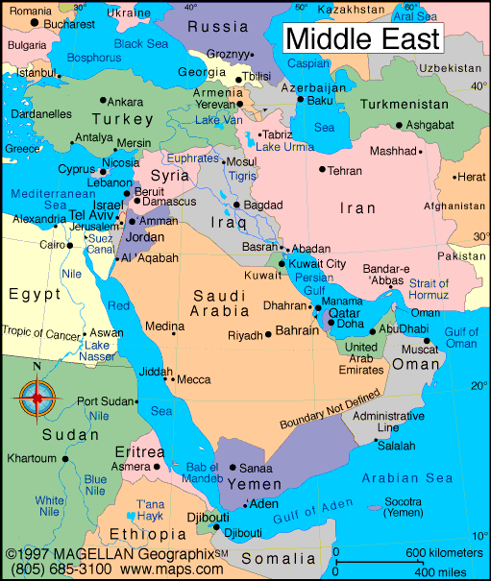

**Review: Isaiah means, “God is Salvation;” in Chapters 1-39, we see the Vision of Condemnation, and in Chapters 40-66, grace. Chapters 13-23 (oracles against Babylon, Philistia, Moab, Damascus, Egypt, Wilderness of the Sea/Babylon, Dumah/Edom, lower Jordan today, Arabia, Valley of Vision/Jerusalem, Tyre/Lebanon) are actually a mini-book, the burdens, woes, or “The Revelation to the Middle East,”— a total of nine countries bordering Israel--beyond the rivers of Cush in Arabian area and even Jerusalem.** With the pronouncement in Chapter 23, Isaiah concludes his judgments upon the nations surrounding Judah. It is a fitting conclusion. As Babylon, the great city in the east, began the subdivision, so **Tyre**, the famous sea-faring city in the west, closes it. This whole section is written in Hebrew poetry. The near historical prophecy against Tyre took place in several stages over 370 years. In the **first stage**, Sargon II (721 to 705 BC) and Sennacherib (704 to 681 BC) did not capture Judah over a period of fourteen years. But Sennacherib defeated 46 of her fortified cities and laid siege to Jerusalem before being turned away by **the Angel of the LORD** (When **An Angel of the LORD Put To Death a Hundred and Eighty Five Thousand Men in the Assyrian Camp**). **In the second stage,** Nebuchadnezzar captured and destroyed **Tyre** after thirteen years, although **ADONAI** would eventually restore her 70 years later. **In the third and last stage**, the final destruction of Tyre would be left to Alexander III, the Great, of Macedon. Alexander the Great accomplished the destruction of **Tyre** in 332 BC. During his campaign in Palestine he requested supplies from **Tyre**. When they refused to assist him, his army took the rubble that was left from the ancient city of **Tyre**, threw it into the sea to build a half-mile causeway, marched out to the island fortress, and defeated the city with the assistance of the navies of surrounding nations. The inhabitants paid dearly for trying Alexander’s patience. It is said that he crucified two thousand of the leaders and sold thirty thousand into slavery. Alexander did in seven months (taking down the inland city), what the Assyrian king Shalmenazer IV could not do in five years, or the Babylonian king Nebuchadnezzar did in thirteen years. Because it was time for **God’s** judgment, the city came crashing down. Nothing is left today. **Isaiah comes against Tyre, modern-day Lebanon, which was also the kingdom of ancient Canaan.** Today we call “**Isaiah’s** day” ancient history. Yet, from **Isaiah’s** point of view **Tyre**, which was already 240 years **old** at the time of his prophecy, was already ancient history even though it would not be destroyed until much later. **Tyre, the island city,**  was strong enough to withstand Alexander the Great for months. So from **Isaiah’s** standpoint **Tyre** would not ultimately be destroyed for another 365 years. **From Chapter 40 onward, Isaiah shifts his emphasis and his style of writing, becoming more Messianic. The first 35 chapters are fairly heavy, judgment sayings. Four chapters separate the two groups, 36-39, with historical applications, including Hezekiah and that period of history. Chapter 23 ends the “mini book,” the book of judgments.**

**Of particular note:** Today there is nothing of any significance on the ancient site of **Tyre**, 4th largest city of Lebanon, other than it is an excellent seaport. Established in 2750 B.C., it now hosts a population of 60,000-100,000. However, **the American archaeologist, Edward Robinson, 1794-1863, a Bible scholar and expert in Bible geography, discovered in the 1800’s** forty or fifty marble columns beneath the water along the shores of **Tyre**, which were obviously from Alexander’s engineering feat of building the causeway.

**Chapter 23—The Burden Against Tyre**

1. **What does “burden” mean in verse 1?** Judgment coming
2. **What is Tyre?** Modern Lebanon, **t**o the north of Israel, Tyre was the leading city of Phoenicia, the great maritime power of the ancient world. A conquering people, with their great maritime power, they would confiscate many goods through their pirating. Because it was such an important harbor and center for shipping, Tyre was synonymous with commerce and materialism A city-state with a coastal region in the ancient province of Phoenicia, it had a strategic island ½ -1 mile off its coast. Its walls were 150 feet tall. Tyre was the global super power in the 8th century B.C. It was very powerful globally and economically and was called the “Babylon of the Sea.” Because of her excellent harbor and seamanship, they established a commercial empire far greater than one would expect given their size and military power. Tyre was a city in two parts - an inland city and an island city. The inland city was conquered by the Assyrians and the Babylonians, just as Isaiah prophesied. The island city was conquered later by Alexander the Great in 332 b.c., by building a causeway between the island and the mainland from the rubble and debris left by the Babylonian war. Tyre and Sidon are sister cities in Phoenicia; they were incredibly skilled seaman. In their day, they had trafficked throughout the world in trading. A true alphabet was invented by the Phoenicians. Nebuchadnezzar laid siege to Tyre for 13 years, to no avail in 585-586 B.C., because they had an island 1 mile from shore. Alexander the Great made his name by conquering Tyre. He set his engineers to build a causeway, 1 mile out to the island, and he conquered Tyre in 532 B.C. It made Alexander a legend throughout the world because of this conquering. Edward Robinson in the 1800”s discovered that the “peninsula” of Tyre seemed to be manmade, confirming the engineering feat of Alexander the Great.

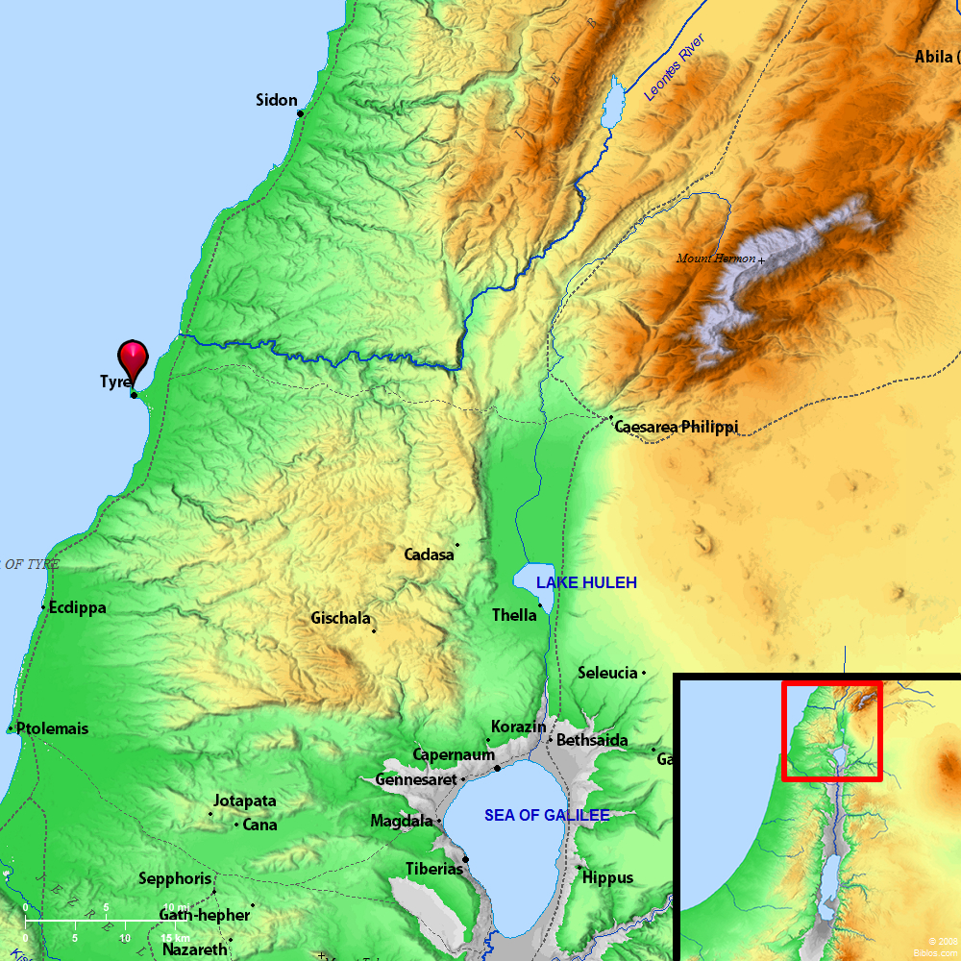

|  |
| --- |
| **Siege of Tyre (332 BC)** |
| Part of the [Wars of Alexander the Great](http://en.wikipedia.org/wiki/Wars_of_Alexander_the_Great) |
| [Siege tryre.gif](http://en.wikipedia.org/wiki/File:Siege_tryre.gif) The Siege of Tyre, courtesy of The Department of History, United States Military Academy |
| |  |  | | --- | --- | | **Date** | January–July 332 BC | | **Location** | [Tyre](http://en.wikipedia.org/wiki/Tyre,_Lebanon), [Phoenicia](http://en.wikipedia.org/wiki/Phoenicia) (now [Lebanon](http://en.wikipedia.org/wiki/Lebanon)) http://upload.wikimedia.org/wikipedia/commons/thumb/5/55/WMA_button2b.png/17px-WMA_button2b.png[33°16′15″N 35°11′46″E﻿ / ﻿33.27083°N 35.19611°E﻿ / 33.27083; 35.19611](http://tools.wmflabs.org/geohack/geohack.php?pagename=Siege_of_Tyre_%28332_BC%29&params=33_16_15_N_35_11_46_E_type:event) | | **Result** | [Macedonian](http://en.wikipedia.org/wiki/Macedon) victory | |  |  | |

* 1. **Read Ezekiel 26. Compare this to Isaiah 23.**
     1. **Ezekiel 26:1- 28:19 treats the subject of Tyre more fully than did any other prophet; discuss.** The space given to the prophecies against **Tyre** indicate the importance of the subject from **God’s** viewpoint. There are two important aspects from **Ezekiel’s** prophecy that help us to understand **God’s** judgment against **Tyre**.
        1. **Why did God pronounce judgment on Tyre**? **Review Ezekiel 26:2.** First, was the fact that she rejoiced over the fall of Jerusalem in 586 BC when she fell to the Babylonians. **Tyre** looked at Judah’s calamity as a chance to become even wealthier. Judah’s ruin would mean free passage of **Tyre’s** caravans and greater opportunity in trade. Taxes were doubtless levied by the Jews on caravans and when Judah was strong and had subjugated Edom, she controlled the caravan routes to the Red Sea, thus hindering the **Phoenician** traders from gaining all the profit they hoped for. So first and foremost, **Tyre** was motivated by commercial greed. But her sin was that she rejoiced at the calamity of **God’s** people.
  2. **What do other O.T. prophets have to say about Tyre?** 
     1. **Examine Amos 1:9-10.** Tells us that **Tyre** had **sold whole communities of** Jewish **captives to Edom, disregarding a treaty of brotherhood**.
     2. **See II Samuel 5:11**, who helped Solomon and him in their building of the Temple.
     3. **View I Kings 5:1-12; I Chronicles 14:1; II Chronicles 2:3, 11.** But in later years, they drifted apart. Unmindful of the history of friendly relations between herself and Israel, she had sold Jews as slaves to the Greeks and Edomites
     4. **Read Joel 3:4-8.** In addition, no king of Israel or Judah had ever made war upon **Tyre**. Arrogant people do not think of others; they merely make decisions based on what is best for themselves, and **Tyre** was arrogant and ungrateful.
     5. **Research Zechariah 9:3.** tells us that **Tyre** had **built herself a stronghold; she has heaped up silver like dust, and gold like the dirt of the streets.** The **Phoenicians** loved money. And the more money they made, the more money they wanted. To those who love money, things become more important than people. They become self-centered and egotistical. The love of money can really destroy us.

1. **Was Tyre consumed with her wealth? How was that her downfall?**
2. **Where is Tarshish?** Some say Spain, west of the Med. Some say Cyprus. It probably an island. Bring gold, silver, ivory and peacocks. Ezekiel—source of tin; some say it was Britain, which means “tin.” Sea, some say it could represent America. 8th century B.C. From Tarshish to Lebanon could be 6000 miles away. **Tarshish** was the city that was originally colonized by the **Phoenicians**. The ships of **Tarshish** learn of Tyre’s destruction while their ships are anchored at Cyprus. There was actually more than one **Tarshish**; one was on the African coast, south along the Red Sea route. A second **Tarshish** was on the southern coast of Spain. A third **Tarshish** was all the way up on the British coast. And now there is new evidence that there was a fourth **Tarshish** on the North African coast. It is believed that **Tarshish** was originally Carthage. It seems that when **Tarshish** established these colonies, they gave them all the same name (like McDonalds) because it was **Phoenicia’s** private colony.
   1. **Review Ezekiel 38:13’s reference to Tarshish**.
   2. **Discuss Solomon’s connection with Tarshish?** **Refer to 1** [**Kings 10:22**](http://tools.wmflabs.org/bibleversefinder/?book=1Kings&verse=10:22&src=)**, 22:48, 2 Chronicles 9:21, 20:37, and Psalm 48:7.**  notes that [King Solomon](http://en.wikipedia.org/wiki/King_Solomon) had "a fleet of ships of Tarshish" at sea with the fleet of his ally [King Hiram](http://en.wikipedia.org/wiki/King_Hiram) of [Tyre](http://en.wikipedia.org/wiki/Tyre,_Lebanon). And that "Once every three years the fleet of ships of Tarshish used to come bringing gold, silver, ivory, apes, and peacocks." Repeated while 1 Kings 22:48 states that "Jehoshaphat made ships of Tarshish to go to Ophir for gold, but they did not go, for the ships were wrecked at Ezion-geber." This is repeated in 2 Chronicles 20:37 preceded by the information that the ships were actually built at Ezion-geber, and emphasizing the prophecy of the otherwise unknown [Eliezer son of Dodavahu of Mareshah](http://en.wikipedia.org/wiki/Eliezer_son_of_Dodavahu_of_Mareshah) against [Jehoshaphat](http://en.wikipedia.org/wiki/Jehoshaphat) that "Because you have joined with Ahaziah, the Lord will destroy what you have made.” And the ships were wrecked and were not able to go to Tarshish. This may be referenced in Psalm 48:7 which records "By the east wind you shattered the ships of Tarshish." From these verses commentators consider that "Ships of Tarshish" was used to denote any large trading ships intended for long voyages whatever their destination.
      1. **Who was King Hiram**? **View 2 Samuel 5:11, I Kings 5:1-2, 7-8, 10-12, 9:11-12.** Tyre was a mixed bag for Israel. King Hiram of Tyre supplied David and Solomon great timbers for the building of the temple and other projects. Hiram gave Solomon sailors so Israel could build their commerce by sea. But later, Tyre gave Israel one of the worst rulers Israel ever had: Jezebel, the wife of King Ahab of Israel. During the reigns of David and Solomon, **Tyre** exercised a great influence on the commercial, political, and even religious life of Israel. Hiram, king of **Tyre**, was a devoted friend of David.
   3. **Why did Jonah, when he rebelled, choose to go to Tarshish?** **Read Jonah 1:3.** Jonah was trying to go as far as he could in that time.
   4. **Were the merchants and sailors of Tarshish renowned**? **See I Kings 10:22 and 2 Chronicles 9:21.** The best navigators in the world. Refer to Solomon and using the ships of Tarshish for his building materials.
3. **Review the Phoenician Queen, Jezebel, and the conflict between worshippers of Yahweh and Baal in** [**1 Kings 16:29-34, 18:17-40, 19:1-3**](http://www.womeninthebible.net/Jezebel_bible_text.htm)**.** The story of Jezebel, a Phoenician princess married to Ahab, king of the northern kingdom of Israel, is set in the turbulent period of the divided kingdoms, when various dynasties struggled for political power in Israel and Judah. There was open conflict between the followers of Yahweh and Baal. Jezebel supported the agricultural gods Baal and Anat. Elijah supported Yahweh. Jezebel's husband Ahab tried to steer a middle course, encouraging tolerance between the two belief systems.
4. **Is Tyre destroyed?** The world trade center of the ancient world is destroyed.
5. **How is God’s judgment displayed in verse one where there is “no house?”** All the people have been wicked against God, and so God took everything away.
6. **What is “The promise of coming judgment against Tyre?”**
7. **Discuss the nations involved in verses 1-3.** Tarshish, Tyre, Cyprus.
8. **In verse 2, do we see “sorrow of the world,” rather than Godly sorrow? See 2 Cor. 7:10 and Psalm 38:18.**
9. **In verse 2-3, who is Sidon?** **See Joshua 13:3, I Chronicles 13:5 and Jeremiah 2:18.** Sister City of Tyre, Phoenician city. Sidon was one of the oldest and the most important Phoenician city. The Phoenicians greatly benefited by the goods they received in international trade, and in turn, Phoenician trade enriched those other countries, like the island of Cyprus.
10. **In verse 3, where is Shihor?** **Look at Joshua 13:3. I Chronicles 13:5 and Jeremiah 2:18.** On the sea came the grain of the Shihor, a branch of the Nile River; for the harvest of the Nile was the revenue of Tyre and she became the marketplace of the nations, an exciting and cosmopolitan city (23:3). It is the best quality in the world, transported on their massive ships. Imported grain from Egypt….the harvest of the Nile River, which was known for its excellence. Grain from Egypt was one of the most important products transported through the Phoenician trading centers of Tyre and Sidon.
11. **Why does God command,”Be Still” in verse 2?**
12. **Compare Tyre, verse 3, to modern day Wal-Mart.** The distribution center of the world. The global economy is operating through this little area. This will affect the entire globe.
13. **In verse 4, why the use of the term “shame?”**
14. **In verse 4, the interesting phrase, “the sea has spoken” implies what?** God is going to judge this area. There will be no prosperity. The sea won’t save them. Some people believe that this island city had walls 150 feet tall, surrounding the island, ½ mile from the coast of Phoenicia. Assyria tried in 701 B.C., and Nebuchadnezzar tried in 587 B.C. for 13 years and failed. Alexander the Great in 332 B.C. build a causeway from the Phoenician coast, after he tore down all the houses and used this material to the island of Tyre. Eventually, Tyre was captured and destroyed by Alexander, 2000 people were crucified on the beach.
15. **Why is Egypt upset about this report in verse 5**? It sold its grain/wheat to be transported on the ships from Tyre.
16. **What do verses 6-7 describe as the outcome of Tyre?**
17. **How old was Tyre?** Herodotus said it was founded in 2700 B.C. When Isaiah was prophesying, Tyre had been around for 2000 years. This was the number one economy in the world.
18. **In verses 8-9, who took counsel against Tyre?**
    1. **How are their merchants described?**
    2. **Who are the honorable of the earth?** The most powerful men on earth at that time.
19. **Was this God’s purpose? See verses 9-10.**
    1. **Discuss: To bring to dishonor the pride of all glory. How?** These men were taking glory in their wealth, trophies, accumulations and control.
    2. **Re-think: To bring into contempt all of the honorable of the earth. Why**? Everyone who was renowned and unrepentant would be brought down.
    3. **Consider: Who are “The men of the earth” in verse 8?**
       1. **See Rev. 6:16-17, 13:12-14, 11:10), and compare to the earth dwellers in Revelation.**
20. **Who is the daughter of Tarshish in verse 10? Why has protection been removed?** Tyre is called the daughter of Tarshish because of their close economic ties and many of its inhabitants would flee to Tarshish to escape the wrath.
21. **Discuss the power of God’s hand, as seen in verse 11.**
22. **In verses 10-14, we see God’s commandment for judgment. Explain.**
23. **What were the sins of Tyre? Refer to Ezekiel 26:1-2** to **28:19** …she rejoiced over the fall of Jerusalem in 586 BC when she fell to the Babylonians. **Tyre** looked at Judah’s calamity as a chance to become even wealthier. Judah’s ruin would mean free passage of **Tyre’s** caravans and greater opportunity in trade. Taxes were doubtless levied by the Jews on caravans and when Judah was strong and had subjugated Edom, she controlled the caravan routes to the Red Sea, thus hindering the **Phoenician** traders from gaining all the profit they hoped for. So first and foremost, **Tyre** was motivated by commercial greed. But her sin was that she rejoiced at the calamity of **God’s** people.
24. **Who are the Chaldeans referred to in verse 13?** The Chaldeans—southern Babylonians. The mainland city of Tyre was defeated by both the Assyrians and the Babylonians. They were used by God to bring the city to ruin.
25. **Explain the deep mourning in verse 14?**
26. **Verses 15-17 are sometimes called, “The Ballad of Tyre.” Review**. God calls Tyre “The Forgotten Harlot.” Sennacherib came and took over the coastal lands of Tyre in 701-631 B.C. was taken over by Assyria.
    1. **Verse 16 could be described as “The Dirge of the Forgotten Prostitute.” Think about this strange imagery.**
    2. **“Seventy years” in verse 17 could be compared to the 70 years of Israel in captivity by Nebuchadnezzar. Relate to Jeremiah 29:10 and Daniel 9:1-2.** Seventy years are often linked to the “life span of a king.”
       1. **Does Tyre change/repent? See Proverbs 26:11 and John 8:11.**
27. **Compare Tyre’s warning to God’s warning to the Israelites…”when you have houses you didn’t build, when you come into a land you did not plan.” Review Deuteronomy 6:10-11 and Joshua 24:13.**
28. **Compare Tyre to the merchants moaning over the loss of Babylon in Revelation 18:11-20. Why the imagery of merchants and selling?**
29. **Restate in your own words what verse 18 explains. Will the meek inherit the earth**? **See Matthew 5:5.** …..the wicked will eventually loose and their bounty given to God’s people in eternity, robes of righteousness…eating from the tree of life,
30. **Relate the promises in John 15:4, 7, 10, 12 as a summation of this chapter**. Tyre, after its destruction by Nebuchadnezzar, recovered, as it is here foretold, its ancient trade, wealth, and grandeur; as it did likewise after a second destruction by Alexander. It became Christian early with the rest of the neighboring countries. St. Paul himself found many Christian there, Acts 21:4. It suffered much in the Diocletian persecution. It was an archbishopric under the patriarchate of Jerusalem, with fourteen bishoprics under its jurisdiction. It continued Christian till it was taken by the Saracens in 639; was recovered by the Christians in 1124; but in 1280 was conquered by the Mamelukes and afterwards taken from them by the Turks in 1517. Since that time it has sunk into utter decay; is now a mere ruin, a bare rock, ‘a place to spread nets upon,’ as the Prophet Ezekiel foretold it should be, chapter 26:14.” (Clarke)
31. **Sum up the “corporate idea” of Tyre in the Millennium, not turning back to God**. **Use Psalm 45:12 and Psalm 87:4 to support your conclusion.**
32. **How does this section of the “burdens against nations” end? Draw inferences to the near future and far future concerning the nations targeted for judgment? Use Zechariah 9:4.** Wail your ships of Tarshish; your fortress is destroyed (23:14). The oracle concerning Tyre ends on the same note that it began (23:1a). Zechariah tells us: But the LORD will take away her possessions and destroy her power on the sea, and she will be consumed with fire (Zechariah 9:4).
33. **As a final reflection on the “burdens” section of Isaiah, chapters 13-23, could you speculate what would have happened if any of the nations studied would have repented? Read Jonah 3:9-10. Defend your answer.**

***Noteworthy ending of Chapters 13-23: “So in the final analysis, if the glory of the nations is nothing (Chapters 13-14), if the scheming of the nations is nothing (Chapters 14 and 18), if the wisdom of the nations is nothing (Chapters 18-19), if the vision of the nation is nothing (Chapters 21-22), and if the wealth of the nations is nothing (Chapter 23), then the questions is: Why trust the nations? The answer is clear. There is no reason to do so.”***

**Chapter 24—The Scope of God’s Judgment**

**Chapters 24-27 are called by some scholars, “The Little Apocalypse.” Isaiah changes his style, because in Chapters 13-23, Isaiah has been discussing nation by nation. In Chapter 24, you will discover that Isaiah talks about the whole world “turned upside down.” Isaiah shifts to the far future, and alters his style and scope now to the whole world.**

1. **Review the rapture scriptures in I Thessalonians 4:15-17,** “…for the Lord Himself shall….”**Isaiah 26:19-21,** …..thy dead man shall live…..my dead body…until the indignation has passed. **“**Come”—linked to **Revelation 4:1, John 14:2, Romans 11:25. I Thess. 5:1-5, Rev. 3:20. Zephaniah 2:3.** The *connection* between these chapters and the preceding ones appear to be as follows: the judgments pronounced upon the various countries and nations in those chapters are drawn together here into a focal point. The specific divine judgments described there become here the general judgment upon the nations, which will take place when the Lord Jesus Christ with His Church will return to this earth.” (Bultema) As stated previously, the structure of the book of **Revelation** is based upon **Isaiah 24:1** to **27:13**. In **Revelation Chapter 6**, **John** spells out a series of judgments against humanity, known as the Seal Judgments. In **Revelation Chapter 7**, he breaks away from judgment. Then in **Revelation Chapters 8** and **9** he continues with another series of judgments known as Trumpet Judgments. Between the Seal Judgments and the Trumpet Judgments there is the worldwide preaching of the 144,000 Jews and all those saved by their ministry. The structure there is the structure here. In the midst of judgment passages, there is a small segment where a glorification of **God’s** name is made by the 144,000 and those Jews and Gentiles saved by their preaching. Therefore, we are told here that in spite of the pollution of the earth by humanity that brings about the judgments in **24:1-13**, there is a small believing remnant who is glorifying **God’s** name and **majesty**.
2. **When is this scene happening? Review Matthew 24:21-22, 29-30**. Behold, the Lord makes the earth empty: Isaiah invites us to behold, to look upon the scene of God’s judgment. The principles revealed here apply universally to the judgment of the Lord, but the ultimate fulfillment of this will be in the ultimate period of judgment, the time of the Great Tribulation (Matthew 24:21-22), which will immediately precede the second coming of Jesus Christ (Matthew 24:29-30).
3. **What does “turneth the world upside down” mean? Has this been fulfilled?**
4. **Explain Isaiah’s vision in verses 1-2.**
5. **Discuss, verse 3, the use of the word, “completely.” Is this the Tribulation Period?**
6. **In verse 4, why does the earth “mourn?” See Revelation 8:7-13.** The earth mourns and fades away: Why does the earth mourn? Because in the Great Tribulation, the earth will be terribly afflicted by the judgments of the Lord. Revelation 8:7-13 describes the terrible effect of the judgments of the Lord upon the earth.
7. **What does “transgressed the laws” in verse 5 imply? See Genesis 6:1-6 and Daniel 7:25.**
8. **Verse 5 highlights an “everlasting covenant.” Which covenant is Isaiah talking about?** Probably the Noah covenant. **Re-visit God’s covenants.**
   1. **Review Genesis 9:16.** The covenant God made with mankind after the flood, never to judge the world again by water is called an *everlasting covenant*.
   2. **See Genesis 17:7, 13, 19.** The covenant God made with Abraham and his descendants is called an *everlasting covenant*.
   3. **Read Leviticus 24:8.** The covenant God made with Israel and the priesthood is called an *everlasting covenant*.
   4. **Look up 2 Samuel 23:5.** The covenant God made with David, to bring the Messiah from his line, is called an *everlasting covenant*.
   5. **Review “The New Covenant,” which is called an *everlasting covenant*, both prophetically in Jeremiah 32:40 and after its establishment in Hebrews 13:20.**
   6. **See also Romans 1:18-32.**
9. **In verse 6, what curse is seen? Examine Revelation 9:15-21.** The inhabitants of the earth are burned. In the seal judgments in Revelation, ¼ of the earth’s inhabitants are destroyed in war, and 1/3 are destroyed by scorpions that come up from the Abyss. In modern numbers, that will be almost 3 billion inhabitants destroyed during this period, the Great Tribulation.
10. **From verses 6-12, what is the outcome of the wrath of God on the earth?**
11. **Verses 7-13 seem to be the scene of judgment. Elaborate on this.**
12. **What happens to all the merriment on the earth?** 
    1. **Look also at Matthew 24:38.** All the merry-hearted sigh: When the Lord brings the judgment of the Great Tribulation, there will be no more “partying as usual.” The days for *eating and drinking, marrying and giving in marriage* are for before the Great Tribulation. When the Great Tribulation comes, the noise of the jubilant ends, the joy of the harp ceases
13. **The “olive tree” reference, verse 13, is pointing to whom? See Psalm 52:8, Revelation 11:4, and Jeremiah 11:16.**
14. **When God deals with sin, he uses fire. See Zechariah 2:5 and 13:9.**
15. **Refer to Romans 8:19-20.** The whole earth is groaning.
16. **Is Isaiah’s “heavy” “language style” similar to John’s in Revelation 4-19. Give examples.**
17. **In verse 14, there seems to be a shift in moods. What is Isaiah alluding to with the picture of “singing?”**  **Review Revelation 7:9-14.** Even in the midst of great judgment, God has His own that praise Him. Before the Great Tribulation, God will remove all His people; but many come to trust in Jesus during the Great Tribulation, and these will praise Him in the midst of judgment.
    1. **Who are the earth dwellers seen also in Revelation 3:10, 6:10, 11:10, 13:6,12, 13:14, and Ephesians 2:6?** The Book of Revelation, writing of this time of Great Tribulation, makes constant reference to *those who dwell on the earth* (This is in contrast to *those who dwell in heaven* (Revelation 13:6), who are seated with Jesus in the heavenly places.
18. **Why is Isaiah so distraught in verse 16? Do we see the same attitude by Daniel, in Daniel 7:28, 8:27? But, I say, I’m wasting away, I am wasting away! Woe to me!** It is as if **Isaiah** is saying, “I understand what is going to happen in the future, but what happens now?” **Daniel** was similarly affected when he saw his visions into the future **(Daniel 7:28, 8:27)**.
19. **Phrases like “treacherous dealers deal treacherously” used twice, seem redundant. Comment.**
20. **In verse 17, we see Isaiah’s focus shift. Also review I John 2:15-17.** But then his focus changes. He projects the destruction of Jerusalem in the days of **Jeremiah** into **the far eschatological future**. Again, with a pounding mantra, **Isaiah** drives home the fate of those who put their trust in **the world (First John 2:15-17)**. As if he could talk to them in the last days, he declares: **Terror and pit and snare await you, O people of the earth (24:17).** There is no reliability in the people of the earth, only treachery. As a result, they would know only **terror**, the **terror** of knowing that life is a series of traps from which there is no final escape. ***Pit and snare Rev. 9…the bottomless pit…the Abyss….center of the earth…Rev. 13, two beasts come out the pit***
21. **Comment on verses 18-20, where we witness catastrophic changes in the earth.**
    1. **Read Genesis 6-8, especially “**windows of heaven opened, fountains of the deep” **Genesis 7:11.**
    2. **View Revelation 6:13-14 and 16:18.** The earth is violently broken, the earth is split open: The Bible describes some of this judgment during the Great Tribulation (Revelation 6:13-14), and specifically mentions *a mighty and great earthquake as had not occurred since men were on the earth* (Revelation 16:18). No wonder Isaiah says,
    3. **Reflect on the phrase, “the earth shall reel to and fro like a drunkard**.**” Has this happened yet?**
    4. **The phrase in verse 18, “windows from on high are open and the foundations of the earth do shake” are reminiscent of the language of Genesis 7:11 and 8:2. Discuss.** The phrase **the floodgates of the heavens are opened, and the foundations of the earth shake**, has similar language to the passages concerning the Noahic Flood **(Genesis 7:11** and **8:2)**. This is why we should take the **everlasting covenant** of **24:5** to be the Noahic Covenant because of the context of the Noahic judgment. The judgment in the days of Noah and the judgment at the end of the Great Tribulation are different, because one is by water and one is by fire, but the totality of destruction around the world is similar.
22. **“Booths” are suggestive of the feast of booths, a temporary structure. Why does Isaiah use this particular imagery? See Leviticus 23:33-34 and Deuteronomy 16:13.**
23. **“God takes no pleasure in the destruction” is in the book of Ezekiel. What is Isaiah’s heart in all the desolation he sees?** He is broken
24. **Describe the destruction of the earth in verses 19-20. Review Amos 5:2.**
25. **Reflecting on the phrase in verse 21, “in that day,” who are the hosts of the high ones?** 
    1. **Compare with Ephesians 6:11-17.**
    2. **See also Revelation 20:1-10.** **Are these “hosts of exalted ones” angelic beings?** But Isaiah is probably speaking of something even higher than the exalted ones of this earth. The phrase the host of exalted ones refers to rebellious angels that are judged at the end of the age, and imprisoned in the pit until the final rebellion at the end of the Millennium.
    3. **View 2 Peter 2:4, “**for if God spared not the angels that sinned.” **and relate to this passage.**
    4. **Parallel with Jude 6.**
    5. **Are the “locust demons” in Revelation 9:2-5 alluded to here?**
26. **All of the kings of the earth take up war against Jesus. What causes all of them do this?** 
    1. **Where else do we see this image? Look at Psalm 2, Revelation 17:12-14, and Acts 4:26-27.**
27. **In verse 23, explain in your own words “moon shall be confounded, sun ashamed.” Reference the “Battle of Joshua” in Joshua 10:12-13.**
    1. **Look also at Joel 2:31, 3:15, Matthew 24:29, and Revelation 6:12.**
    2. **Who are “his ancients?” Review the 24 elders in Revelation 4:4, 10, 5:8, 14.**
       1. **Could this be His raptured church?** Resurrection of the just.. "before his ancients;" the ancient patriarchs both before the flood, as Adam, Abel and after the flood, as Abraham, Isaac, Jacob, and others; the old Jewish church, the prophets and saints of the Old Testament dispensation; the apostles and elders of the Gospel churches under the New; the four and twenty elders, the representatives of the Gospel churches, so often spoken of in the book of the Revelation; very probably with reference to this text; and all the saints, in all ages, who will now be raised from the dead, and live and reign with Him; these are His ancients, who are loved with an everlasting love, chosen in Him before the foundation of the world, with whom a covenant was made in Him, and grace given to them in Him, before the world began; in the midst and presence of these He will reign, and they shall behold His glory; yea, these shall appear in glory; for so the words may be construed, "before his ancients", who are "glory", or "in glory,” for they shall appear with Him in glory, both in soul and body, having the glory of God upon them.
28. **When does this chapter happen?** Starts locally and then toggles to the Tribulation and the Millennium at the end.
29. **The finish of this chapter describes “the Lord of hosts shall reign in Mount Zion.” Elaborate on this.**
    1. **Is this in the Millennial Kingdom?**
    2. **What does the term “gloriously” mean? Or, “in His glory,” both as God and man, and mediator….and in His Father’s glory, and in the glory of His holy angels, in which He will come and appear, and therefore His appearance is called “the glorious appearing.” View Luke 9:26 and Titus 2:13.**
30. **In your own words, re-think the message of Isaiah 24 and its warnings, views, and promises. Think past “now” and into the eternal kingdom.**
31. **The Bible never mentions the kingdom of Tyre in the Millennial Kingdom. However, salvation is not corporate, but individual. See Ezekiel 18:1-29.** 
    1. **What does this say about evil, selfish nations? Look up the “sheep and goat” judgments in Matthew 25:31-46.**
    2. **Individual salvation is promised in Romans 10:9. Is this suggestive of Isaiah’s emphasis on the redemptive power of God?**
32. **In summary, using Isaiah’s thoughts, how would you characterize Isaiah’s description of end times in connection with John’s vision in the Revelation? Are they similar? Are they the same story?**

**The Promises**

**Isaiah 55:11, *“So shall my word be that goeth forth out of my mouth: it shall not return unto me void, but it shall accomplish that which I please, and it shall prosper in the thing whereto I sent it.”***

**Isaiah 55:6, *“Seek ye the LORD while he may be found, call ye upon him while he is near.”***

**Jeremiah 33:3, *“Call unto Me, and I will answer thee, and show thee great and mighty things, which thou knowest not.”***

.