**“Insights Into Isaiah”—Chapters 17-19—The Burden Against Syria, Israel, Ethiopia, and Egypt**

**Chapters 17—The Burden Against Syria and Israel**

***The idiom of “Damascus” stands for all of Syria, and it was an ally of the northern kingdom that went into slavery, the enemy of Judah. Syria, Ephraim, and Manasseh form an uncomfortable alliance; to no avail. Info about the temple: experts believe that the Dome of the Rock Mosque (a.k.a. Mosque of Omar) will be left standing, and the northern section will allow a place to build a fence and a temple for Judah on the north, the actual site of Solomon’s Temple.***

1. **Restate the warning for Damascus, Syria, in verses 1-6?** Damascus is the capital of Syria. Syria was an ally of the northern kingdom, the enemy of Judah.
   1. **Describe the way Damascus will look after its destruction.**
2. **In verse 3, who is Ephraim? Refer to 2 Kings 15:29 and 16:9.** The northern kingdom of Israel. At this time, Israel and Syria were closely aligned against Judah. Since they are such close friends, God will announce His judgment against. The northern kingdom and Damascus, Syria were in alliance against Assyria. God did not honor this coalition.
   1. **Why did God not honor this coalition?** He wanted them to depend on Him. They began to look to themselves for help, rather than from God.
3. **Where is Aroer in verse 2?**
4. **In verse 7, how does the text shift? View closely verse 7.** shifts to the tribulation period
5. **In verse 8, discuss the foreign religion and the idolatry of Israel. Is this why God allows “this event” to shake Israel into repentance?** 
   1. **Notice the parallelism to this idolatrous nation and modern America. Comment.**
   2. **“In that day,” the tribulation, how will Israel react to the worship of her foreign gods?** Verse 8
      1. **Is God’s purpose fulfilled in this section?**
   3. **What are the altars? What are the things “that his fingers have made?” Is this a form of idol-worship?** we make altars/idols of the things we make….secular humanism
   4. **Describe how the Israelites were a “stiff-necked” people.**
   5. **According to verse 9, what is the “plant image” pointing to?**
      1. **Compare this “forsaken uppermost branch” in verse 9 to the righteous branch of Jesus. See Isaiah 11:1 and Jeremiah 23:5-6.**
6. **Talk about the “cause” or the “because” of this punishment in verse 10-11.**
   1. **What kind of harvest is alluded to?** Verse 11 **Verses 10-11 describe the devastation of the labors of Syria. Link this to Haggai 1:6,** “You have sown much, and bring in little; you eat, but do not have enough; you drink, but you are not filled with drink; you clothe yourselves, but no one is warm; and he who earns wages, earns wages to put into a bag with holes,” **and Luke 5:1-10.**
7. **Verse 13 announces another “woe.” Who are verses 12-13 referring to?**
8. **Talk about the removal of the trees in verses 9-11.** Totally removed in the Turkish empire
9. **Beginning in verse 12, God pronounces judgment on the nation of Assyria. Why? How have they been an instrument against Israel?**
10. **Review the N. T. verse, Hebrews 12:6, “whom the Lord loves he chastens.” Examine Hebrews 12:6, Proverbs 3:12, Job 5:17-18 and Revelation 3:19. Does that theme apply here? Elaborate.**
11. **Why did the Lord bring this judgment on Israel**? Because you have forgotten the God of your salvation. In one way, this does not seem like a “great” sin. After all, why does God need us to remember Him? Why can’t we just leave Him alone, and He leave us alone? It is a sin to forget the God of your salvation because He created you, and because He is the God of your salvation. If you forget Him, you can forget about your salvation.
12. **Will God destroy the nation that brings the doom upon Syria and Israel in verses 12-13?** Woe to the multitude of many people *who* make a noise like the roar of the seas, and to the rushing of nations *that* make a rushing like the rushing of mighty waters! The nations will rush like the rushing of many waters. **The nations will rush like the rushing of many waters**: God will use other nations to bring judgment against Syria and Israel. They will come against them like a flash flood that can’t be stopped.
13. **What does “rushing of many waters” and “even tide” point to in verses 13-14?** God’s judgment against the nations that rush against Israel. When God brings the rush of nations against Israel, it doesn’t mean that the nations He uses to judge will be walking right with Him and exempt from judgment. Instead, **God will rebuke them and they will flee far away**. God can use one sinner to judge another, and then judge the sinner He just used!
14. **Talk about why “The wicked/Gentiles” are described as “troubled waters and troubled sea.” Refer to Isaiah 57:20-21**
15. **What comforting principle to we see arise in the end of this chapter?** This is a comforting principle: Even in the midst of judgment, God shows mercy. As bad as it was going to be for Israel, it could have been worse. Instead, God will allow it for a time, and then He would **rebuke** those attacking Israel. Israel was not at the mercy of circumstances or their enemies; they were at the mercy of God.

**Chapters 18—Proclamation Against Ethiopia**

**“To us, this brief, 7 verse chapters is the most difficult one of all the sixty-six chapters of Isaiah.” (Bultema) “Although the prophecy is a short one, it probably ranks as the most obscure chapter in this entire section.” (Wolf) “This is one of the most obscure prophecies in the whole Book of Isaiah.” (Clarke) This small chapter is only seven verses, and is very controversial in its true scope. If this is “beyond Ethiopia,” where is this land?**

1. **Who is the proclamation against in verses 1-4? “Cush” is Ethiopia.** In the days of Isaiah, Ethiopia was a major world power, ruling Egypt and a chief rival to Assyria. Since Judah was caught in the middle between this conflict, it might make sense for Judah to align herself with Ethiopia against Assyria. In 715 b.c. an Ethiopian named Shabako gained control of Egypt as founder of the twenty-fifth dynasty. Ethiopian domination continued until 633 b.c. when a native Egyptian regained the throne.” (Wolf) Go, swift messengers, to a nation tall and smooth of skin: As the Ethiopian ambassadors invite Judah to rebel against the Assyrians, they ask Judah to send swift messengers back to Ethiopia (to a nation tall and smooth of skin . . . a nation powerful), and the Ethiopians would hope to hear that Judah has rebelled against Assyria and aligned itself with Ethiopia and Egypt.
2. **What does “beyond the land of Ethiopia” refer to in verse 2? Is this Ethiopia or not?**
3. **What are “buzzing wings” in verse 1?** Ethiopia had a strong armada of ships. The Nile Valley is famous for its many whirring insects and birds.
4. **Are the “waters” in verse three The Nile River?** ..which sends ambassadors by sea: The scene pictures Ethiopian ambassadors who come to make an alliance with Judah and the other nations of the region against Assyria. ”: The Lord God rejects the alliance with Ethiopia, because He is more than able to deal with the Assyrians Himself. He can *take His rest* without the help of the Ethiopians. If God wanted to muster an army against Assyria, He would have raised a banner or sounded a trumpet. He is fully able to do it, and would do it when the time is right.
5. **How does Ethiopia send its ambassadors to Israel in Acts 8?** He comes in a chariot. Ethiopia is land connected. Acts 8
   1. **Take a side trip into the Ethiopian that Philip witnessed to.** **Examine Acts 8:26-40.**
6. **What do bulrushes mean? Vessels?** On the sea ….a nation that is stretched out, “peeled,” independent….a nation that is developed and independent…”peeled,” means independent.
7. **What does “terrible” mean?** “Terrible” means never defeated**. Explain.** Because of those phrases, some commentators try to make this nation the United States. United States has an incredible river-water way system. However, this does not make sense because America is going to be judged.
   1. **How can this description apply to America?**
8. **Restate Verse 3-4. What does “dew in harvest” speak to?—**dew in the spring is wonderful, in harvest is awful; damaging to crops. Talking about judgment. Dew in the heat of harvest is damaging, and not good as an idiom.
   1. **When does the “near future” shift to the “far future?” See verse 7.** This may have been fulfilled in some way close to Isaiah’s time. But we know it was fulfilled in Acts 8:26-40, when an Ethiopian came to worship the Lord at Jerusalem, and then trusted in Jesus at the preaching of Philip. It was also fulfilled in the strong Ethiopian church the first few centuries and the enduring Ethiopian church today.
   2. **In New Testament time, do we see a reference to the Ethiopians in Acts 8:26-40?**
   3. **In “far future” do we see a glimpse of the Millennium? Explain your reasoning.**
9. **Discuss the judgment in this section in verse 7.** Verse 7 is a “wrap up,” recap verse…the judgment. Verse 2 is the intro, in-between is the judgment, then verse 7 is the wrap up...
10. **What were the actions of the Assyrians as an army?** They were so brutal, many cities committed suicide before they arrived. Jonah was so mad about going to Nineveh, because they were such a brutal people. He really wanted them punished by God, and not forgiven.

## Chapters 19—The Burden Against Egypt

**At the time of Isaiah’s writing, Egypt was in a loose alliance with Judah, the northern Israelis were with Syria. Egypt falls apart with civil war and becomes broken into separate states. But they are reunited by a cruel overlord named, Psammetichus, the governor of one of the states, who made himself master of all of them. This may be who is referenced in verse 4.**

1. **Describe the Lord and what He is riding upon?** Egypt was one of the great powers of the ancient world, and being situated immediately to the south of Israel, it was an empire that Israel constantly had to reckon with. Many times Egypt had been the enemy of Israel, at times Egypt had been a refuge for Israel, and sometimes Egypt offered a tempting but ungodly alliance to Israel. In this chapter, the Lord presents both a prophecy *against* and *for* Egypt. Egypt is mentioned seven times in the first part of this chapter. Egypt was in alliance with Judah when Isaiah wrote; before they fall apart in Civil War. They are Polytheistic.
   1. **Does this imply a judgment? Check out Psalm 18:10, 11; 104:3; Daniel 7:13.**
   2. **Check out Psalm 18:9 and 104:3.**
   3. **Compare with the idols of Egypt in Numbers 33:4.**
2. **Talk about the civil war implied here.** Egypt is mentioned seven times as this chapter begins.
3. **What happens to the idols of Egypt?** The Lord strikes Egypt by giving them over to civil war and submission to a cruel master.
   1. **Refer back to another O.T. story about the idol Dagon falling down before the Ark of the Covenant. Read I Samuel 4:1-7:1.**
   2. **Compare this passage with the plagues of Egypt being purposefully addressed to each of Egypt’s idols.**
      1. **The god Khnum, guardian of the Nile.** At the time of the Exodus, when the Pharaoh of Egypt would not release the children of Israel from their captivity, the Lord also made **the idols of Egypt** to **totter at His presence**. He directed each of the plagues against a particular idol of Egypt. He knocked over the god *Khnum*, the guardian of the Nile,
      2. **The god *Hapi*, the spirit of the Nile. Nile turned to blood. And, the god *Osiris* (who had the Nile as his bloodstream), when the waters were turned to blood.**
      3. **He knocked over the goddess *Heqt*, or Heket, the frog-goddess of fertility, with the plague of frogs.**
      4. **He knocked over the goddess Amon, *Hathor*, a cow-like mother goddess, with the plague on livestock.**
      5. **He knocked over the god *Imhotep*, god of healing, and Sekhmet, goddess of healing, the god of medicine, with the plague of boils.**
      6. **He knocked over the god *Nut*, the sky goddess, with the plague of hail.**
      7. **He knocked over the god Kepher, beetle god, with lice and swarms of insects/gnats. Beelzebub means “flies.”**
      8. **He knocked over the god *Seth*, thought to be the protector of crops, with the plague of locusts.**
      9. **He knocked over the god *Ra*, thought to be the sun god, with the plague of darkness.**
      10. **He knocked over *Osiris*, the Egyptian god thought to be the giver of life, and the supposed deity of Pharaoh himself, with the plague against the firstborn. God made all the idols of Egypt to totter at His presence before and Isaiah tells us He will do it again!**
4. **Describe the fighting within the border of Egypt; verse 2.** Civil war happens within its borders. I will set Egyptians against Egyptians: Isaiah prophesies a coming civil war in Egypt, which was indirectly the hand of God’s judgment against them. “Not many years after this time it was divided into twelve several kingdoms, between whom there were many and cruel wars, as related by the historians of those times.”
   1. **Discuss the modern implications of this Civil War. Is it happening before our eyes today?**
5. **In verse three, why are Egypt’s soothsayers and counselors degraded? View I Kings 4:30.**
6. **Who is the cruel hand in verse 4? Is this “far future?” Could this be today and the anti-Christ?** When it was taken over by the Ottoman Empire was taxed into poverty.
7. **Discuss the Gog/Magog War and why Egypt is not in this confederacy? Review Ezekiel 38-39.**

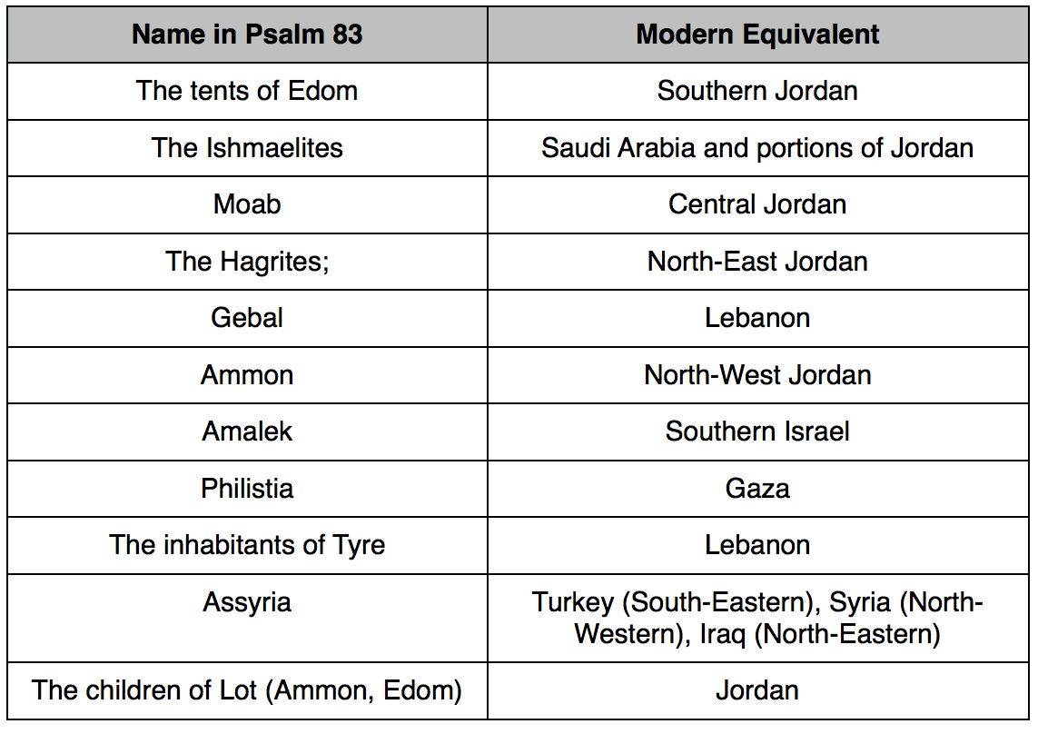

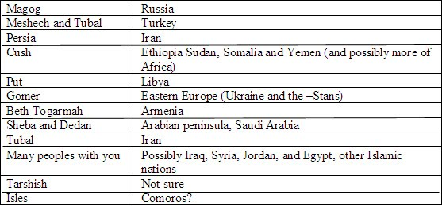

1. **What is the river symbolism in verse 5**? The river will be damned us, in the 1970’s the Aswan Dam was built. In the 1960’s this dam was created to put the Nile under control; took ten years to build. Assisted by Soviet Union. The results of this were devastating. Began in 1960, and finished in 1070.
   1. **Do verses 5-10 describe how Egypt’s commerce and industry are ruined by the drying up of the Nile River?** The Aswan Dam. The problem is that now the nutrients that used to be brought down by the flooding Nile, has stopped bring food down for the fish. Now, snails that used to be washed away by the flooding Nile are increasing are killing the textiles that were necessary to grow there for the flax crops.
2. **Since Egypt’s economic prosperity came from the Nile River, re-state verse 6-10. Is the Aswan Dam the cause of this?** Before the dams were built, the Nile River [flooded](http://en.m.wikipedia.org/wiki/Flooding_of_the_Nile) every year during late summer, when water flowed down the valley from its [East African](http://en.m.wikipedia.org/wiki/East_Africa) [drainage basin](http://en.m.wikipedia.org/wiki/Drainage_basin). These floods brought high water and natural [nutrients](http://en.m.wikipedia.org/wiki/Nutrient) and [minerals](http://en.m.wikipedia.org/wiki/Mineral) that annually enriched the fertile [soil](http://en.m.wikipedia.org/wiki/Soil) along the [floodplain](http://en.m.wikipedia.org/wiki/Floodplain) and [delta](http://en.m.wikipedia.org/wiki/Nile_delta); this had made the Nile valley ideal for farming since [ancient times](http://en.m.wikipedia.org/wiki/Ancient_Egypt). Because floods vary, in high-water years the whole [crop](http://en.m.wikipedia.org/wiki/Crop) might be wiped out, while in low-water years widespread [drought](http://en.m.wikipedia.org/wiki/Drought) and [famine](http://en.m.wikipedia.org/wiki/Famine) occasionally occurred. As [Egypt's population](http://en.m.wikipedia.org/wiki/Demographics_of_Egypt#Population) grew and conditions changed, both a desire and ability developed to control the floods, and thus both protect and support [farmland](http://en.m.wikipedia.org/wiki/Arable_land) and the economically important [cotton](http://en.m.wikipedia.org/wiki/Cotton)crop. With the [reservoir](http://en.m.wikipedia.org/wiki/Reservoir) storage provided by the Aswan dams, the floods could be lessened and the water stored for later release.
3. **Where is Zoan? Why is it mentioned? See Numbers 13:22, Psalm 78:12, 43, Isaiah 30:4, Ezekiel 30:14.**N.E. Border of Egypt, Tannus. Raiders of the Lost Ark—hidden in Tannus, the Ark, theory. Verse 11 A major city of northern Egypt. a city of Egypt in the eastern [Nile delta](http://en.wikipedia.org/wiki/Nile_delta). Numbers 13:22 says that it was built seven years after [Hebron](http://en.wikipedia.org/wiki/Hebron) was built. **Psalm 78:12, 43 identifies the "field of Zoan" as where Moses performed miracles before Pharaoh to persuade him to release Israel from his service**. The city is also mentioned in Isaiah 19:11, 13, Isaiah 30:4 and Ezekiel 30:14.
4. **Explain how verses 11-15 show the foolishness of Egypt’s counselors. Compare these with those to Pharaoh in Exodus 9-12**. 11-13, seem to involve the stupidness of Russia who helped build that dam.
   1. **Also see 2 Samuel 15:31, 1 Corinthians 1:20, James 3:15**
5. **In verse 12, what does “where are your wise men” mean? Compare with Proverbs 9:10.**
6. **What is “Noph” in verse 13?** Noph means “Memphis,” which was the capital city of northern Egypt at one time.
7. **What does “perverse spirit” imply?** Verse 14**. Compare to the evil spirit sent on Saul in I Samuel 16:14.**
8. **Using verse 15, describe the poverty that is prevailing in Egypt.**
9. **Do verses 16-25; look forward in the tribulation period? Defend your answer.**
   1. **Does the description, “like women,” imply there is frailty in Egypt? Discuss.**
10. **What does verse 16’s, “in that day” point to?** tribulation
11. **The verses in Chapter 19 will bring the nation of Egypt to its knees. How?** these verses show that God is going to break through the lie of Islam.
12. **In verse 18-22, Egypt turns to God. When is this?** The Millennium
    1. **What does “five cities” represent?** The number 5 symbolizes God's grace, goodness and favor toward humans and is mentioned 318 times in Scripture. Five is the number of grace, and multiplied by itself, which is 25, is 'grace upon grace' (John 1:16). The Ten Commandments contains two sets of 5 commandments. The first five commandments are related to our treatment and relationship with God, and the last five concern our relationship with others humans. There are five primary types of offerings God commanded Israel to bring to him. They are the Burnt Offering (Leviticus 1; 8:18 - 21; 16:24), Sin (Leviticus 4; 16:3 - 22), Trespass (Leviticus 5:14 - 19; 6:1 - 7; 7:1 - 6), Grain (Leviticus 2) and Peace Offering (Leviticus 3; 7:11- 34). The Book of Psalms is divided into five major sections. Section 1 (Psalm 1 to 41) refers to the Passover, Israel's beginning, and the start of the God's plan of salvation that centers on Christ. Section 2 (42 to 72) sings about a unified Israel in the land and pictures the creation of the New Testament Church. Section 3 (73 to 89) bemoans the destruction of both God's Temple and Jerusalem. This section also hints at prophecies regarding the End Time Great Tribulation. Section 4 (90 to 106) rejoices over the 1,000 reign of Jesus and shows Israel gathered again. Section 5 (107 to 150) pictures a time when Judah (representing all Israel) shall again be delivered. There are five books of God's Law (Genesis, Exodus, Leviticus, Numbers and Deuteronomy) commonly referred to as the Pentateuch ('Penta' means five). The 4 Gospels plus Acts equals five books which, as a set, can be designated as "the New Testament Pentateuch." They reveal Jesus' teachings concerning the Law and the Prophets. The apostle John wrote 5 books centered on the grace of God and eternal life (the gospel of John, 1John, 2John, 3John and Revelation). Jesus multiplied five loaves of barely to feed 5,000 (Matthew 14:17). There are five books in the Bible that contain only one chapter (2John, 3John, Philemon, Jude and Obadiah). Moses wrote five books, the most of any Old Testament writer. In the New Testament, the apostle Paul wrote fourteen books. Babylon's King Nebuchadnezzar was given, by God, a dream where he saw a giant statue of a man. This statue, according to the interpretation given by the Eternal to Daniel, represented 5 periods of world-ruling empires. The statue's head of gold represented Babylon (Daniel 2:32, 38) The Chest and Arms of Silver symbolized the Persian Empire (Daniel 2:32, 39) The Belly and Thighs of Bronze (brass) represented the Macedonian Empire under Alexander the Great. Two Legs of Iron symbolized Rome's Empire (Daniel 2:33, 40 - 43) The Ten Toes of Iron mixed with Clay are the successors to the Roman Empire (Daniel 2:41-**44).**
    2. **Using verse 18, describe the “city of destruction;”** City of Sin, Heliopolis, supposed home of the Egyptian Sun god, Osiris; **examine Jeremiah 43:12=13/**
13. **Examine verses 19-20; what is an “altar?” Explain “Pillar at the border to God.”**
    1. **Does verse 19 refer to the Millennium?** Pillar meansMonument…..altar and the monument are the same thing, The Hebrew language says the same thing two different ways so that there is understanding. Something at the middle and at the border are the same place. Egypt traditionally was two countries, upper and lower. The Pharaoh always represented Upper and Lower Egypt….the border between those two runs right through Giza…..the Nile Delta is the radius. Giza, in Arabic means, border. Manetho, an early priestly scribe, says it was built by a group of people called the “Hyksos,” who took over the country by mind control, without a battle. They supposedly built all the pyramids and shrines and then left. Josephus called them “Shepherd Kings.” In Hebrew, if you take the numeric value of verses 19-20, you will get the number 5449, which is the exact height of the pyramid in pyramid inches and the length of the descending passages. Angle up and down--26 degrees, 18 min., 9.7 seconds--is called the Christ Angle and is the angle from the pyramid to Bethlehem. Probably built 2000-3000 years ago.
    2. **Is this description, as sitting in the middle and at the border, complementary? Discuss**
    3. **Egypt used to be in two parts…upper and lower; the Pharaoh of Egypt always had two colors, upper and lower Egypt. Where was this border?** Right through Giza, this means border. **What is located at that point?** The great pyramid. **Where is this border now?**
       1. **Could this refer to the Great Pyramid? What was it used for?** Sits on 13 acres.
       2. **Review theories about the Great Pyramid.** Early studies show that the great pyramid is not Egyptian**.** But, by a group of people that came, the **Hyksos,** who took over the country without a battle. They destroyed all the altars to strange gods. This pyramid is not set up as a tomb. It is filled with angles and areas. Covers 13 acres, 6 ½ million tons of stones, precision-cut, passageways are precise, lined up with the meridians and cardinal points of the earth, and it speaks of the number pi in math, mathematical model of our solar system; some believe that the internal passages lay out the gospel of Christ, the Exodus of Egypt, the birth of Christ, etc. A Pyramid inch—5,449 Pyramid inches height, Isaiah 19:19, the numerical value if 5,449. Stonehenge in England, build 3500 years ago, point to the Great Pyramid of Egypt….believe that these were built by the same architect. Perhaps by Shem, the son of Noah. It appears that on Mars that there are monuments, similar to these. Appears to be a carefully crafted human face, 1 mile long, on Mars, 500,000 years old. Ancient Egyptians start at a high level, they just appear……like Mesopotamia. City of Cairo—means “Mars,” Baal—means “Mars.” Built 2000-3000 years before Christ.
       3. **Who built the pyramids?** Seth, Shem, Enoch, Job….
       4. **Is there a “Face on Mars?”** About 1 mile across, symmetrical,
       5. **Is there a “Pyramid on Mars?”** Leonardo di Vinci uses the same proportions as this pyramid…Cydonai region of Mars.
    4. **Examine Jer.32:20. What signs and wonders are seen in Egypt?**God has set signs and wondersin the land of Egypt, even to this day.
    5. **What does Josephus write in “The Antiquities of the Jews 1.2.3?”** They also were the inventors of that peculiar sort of wisdom which is concerned with the heavenly bodies, and their order. And that their inventions might not be lost before they were sufficiently known, upon Adam's prediction that the world was to be destroyed at one time by the force of fire, and at another time by the violence and quantity of water, they made two pillars; the one of brick, the other of stone: they inscribed their discoveries on them both, that in case the pillar of brick should be destroyed by the flood, the pillar of stone might remain, and exhibit those discoveries to mankind; and also inform them that there was another pillar of brick erected by them. Now this remains in the
14. **Review evil King Manasseh’s reign, especially 2 Kings 21:3, where he reinstates idol worship.** The “high places” were in reverence to Mars and the name “Baal” means Mars, all Egyptian ‘gods’ refers to “one who watches,”…..when Mars used to pass close to the earth, could the monuments and faces be seen?
    1. **Remind yourself of 2 Thessalonian 2:11.** Bible Verse—strong delusion.
15. **Why, in verse 20, does Egypt call to the Lord?**
16. **Is verse 21 referring to the Millennium? Defend your answer.** the Lord will be known to Egypt! God is going to lift the veil of Egypt.
17. **What does the phrase “five cities” point to in verse 18? Swear by the Lord of hosts?** First five books of the Bible prepare you for Israel's story throughout the rest of the Bible. The five wise virgins were prepared. David, in preparing for Goliath, took up five smooth stones.
    1. **Parallel to Ephesians 4:11-12.** To prepare and perfect the saints for ministry, some are called to be apostles, prophets, evangelists, pastors or teachers (Ephesians 4:11-12). Through these five outlets goes forth the gospel of Jesus Christ. Surely, you are prepared to fit into one of these five because of God's grace.
18. **How does the reference to “healing Egypt,” in verse 22, apply to the Millennium?—**heal Egypt….Assyria is modern day Iraq…….Egypt, Assyria (Iraq) and Israel will all worship God. See Zechariah, verse where they come and celebrate the feasts of tabernacles.
19. **Explain the amazing peace between three former, hostile enemies as seen in verses 23-25. Israel will be one of three with Egypt and Assyria**: God promises the day will come when there will be peace between Israel, Egypt, and Assyria. There will be trade and travel between the three nations (**a highway from Egypt to Assyria**). In that day, the Lord will bless all three nations **Israel will be one of three with Egypt and Assyria**: God promises the day will come when there will be peace between Israel, Egypt, and Assyria. There will be trade and travel between the three nations (**a highway from Egypt to Assyria**). In that day, the Lord will bless all three nations.
20. **Discuss the highway mentioned in verse 23?**
21. **Is God’s grace evident in the fact that Egypt and Assyria become “God’s people?” Comment.**
    1. **Is this millennial peace?**
22. **Why is Israel always God’s inheritance? Review Ephesians 1:18.** From this passage regarding the conversion of Egypt, Spurgeon draws these points: 1. God’s grace often comes to the very worst of men. 2. God’s grace sends a Savior. 3. Grace changes men’s language. 4. God’s grace sets men on holy service. 5. God’s grace teaches men to pray. 6. God’s grace instructs men. 7. Grace makes even trouble a blessing to a man. 8. God’s grace changes the relations of men to each other. 9. God’s grace makes men to be blessed, and to be a blessing to others. (*The Fruits of Grace*)
23. **Summarize Chapters 17-19.**
24. **Note of interest-- When Mars and the Earth were close?**

**Note: When Mars and the Earth were close—**

**After Noah's flood it appears** [**there were 360 days in an Earth year till**](http://www.greenheart.com/billh/360.html) **701 BC.** [**After 701 BC there were 365 and 1/4 days in an Earth year.**](http://www.greenheart.com/billh/eighth.html) **It also**

**seems Mars used to pass very close to the Earth every**

**few years during this time. Around 1400 BC the Earth**

**experienced the long day of Joshua. Around 701 BC**

**The shadow of the sundial turned backward [10 "mallah"](http://sunnyokanagan.com/joshua/index.html)**

**[Or 100 degrees](http://sunnyokanagan.com/joshua/index.html), the Earth's year lengthened to 365.25**

**days and Mars moved quite a bit further away from**

**the Sun. In order for the Earth and Mars to have an increase**

**in the number of days in their years they would have had to**

**move further away from the Sun. In order for the Earth system**

**and Mars to move further away from the Sun they would have**

**to of gained a specific amount of angular momentum while**

**another massive enough planet that passed within the Earth's**

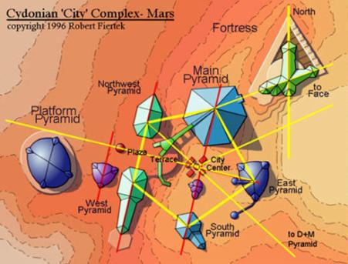

**Favorite Verses in Isaiah**

**Isaiah 17: 7-8, “**In that day a man will look to his Maker, And his eyes will have respect for the Holy One of Israel.8He will not look to the altars,  
The work of his hands; He will not respect what his fingers have made.”

**Isaiah 19: 19-22, “**In that day there will be an altar to the Lord in the midst of the land of Egypt, and a pillar to the Lord at its border. 20And it will be for a sign and for a witness to the Lord of hosts in the land of Egypt; for they will cry to the Lord because of the oppressors, and He will send them a Savior and a Mighty One, and He will deliver them. 21Then the Lord will be known to Egypt, and the Egyptians will know the Lord in that day, and will make sacrifice and offering; yes, they will make a vow to the Lord and perform *it.* 22And the Lord will strike Egypt, He will strike and heal *it;* they will return to the Lord, and He will be entreated by them and heal them.

***The promises....***

***\*\*2 Thessalonians 2 is probably the most important prophecy book in the N. T.*** –

**-2 Thess. 2:1-5,** “Now we beseech you, brethren, by the coming of our Lord Jesus Christ, and by our gathering together unto him, 2That ye be not soon shaken in mind, or be troubled, neither by spirit, nor by word, nor by letter as from us, as that the day of Christ is at hand.3Let no man deceive you by any means: for that day shall not come, except there come a falling away first, and that man of sin be revealed, the son of perdition;4Who opposeth and exalteth himself above all that is called God, or that is worshipped; so that he as God sitteth in the temple of God, shewing himself that he is God.5Remember ye not, that, when I was yet with you, I told you these things? **Paul only spent a few weeks in Thessalonica (Acts 17:2) and it seems he wished he could have taught them more. He decided to teach them more in a written letter, and many believe that 1 Thessalonians was his first letter written to a congregation. (*In Acts 17:1-4--*Paul preaches in Thessalonica over three Sabbaths.)**

**John 8:44,”You are of your father the devil, and the desires of your father you want to do. He was a murderer from the beginning, and does not stand in the truth, because there is no truth in him. When he speaks a lie, he speaks from his own resources, for he is a liar and the father of it.”**