**“Insights Into Isaiah”—Chapters 15-16—The Burden Against Moab**

**Chapters 15—The Burden Against Moab**

Isaiah was written over 2700 years ago. Isaiah saw God “high and lifted up!” Chapters 13-23 is a “book within a book,” the book of burdens. God is judging the nations that have come against Israel and Judah. Note: near fulfillment, local context, and far **fulfillment, specifically end times. Chapter 15 is toggling between the three years when Isaiah is writing and 2700 years. Moab, Ammon, and Edom are ancient Jordan. Historically, Moab, king was Balaak, tried to get Balaam to prophecy against the Israelites…Numbers 22-23, 31. Balaam. Moab, a region east of the Dead Sea, pretended to be a friend of Israel, and then turned on Israel.**

1. **Who is Moab? Read Genesis 19:30-38. Read Jeremiah 48.** Moab is adjacent to Israel, modern-day Jordan, southeast of Jerusalem. The founder of the people of Moab was the son born of the incestuous relationship between Lot and one of his daughters, when his daughters made Lot drunk, after the destruction of Sodom and Gomorrah ([Genesis 19:30-38](http://www.studylight.org/desk/index.cgi?q1=Genesis+19:30-38&t1=en_nas)). The Moabites settled in the plains to the south-east of Israel, in what is modern-day Jordan. At the same time, there was a Moabite connection with Israel. First, they were related to Israel because Lot was Abraham’s nephew. Because of this, God told Israel in [Deuteronomy 2:9](http://www.studylight.org/desk/index.cgi?q1=Deuteronomy+2:9&t1=en_nas) that they were not to destroy Moab and take their land. As well, David, Israel’s greatest king, was one-quarter Moabite. His paternal
   1. **Who is the father of the Moabites? From the eldest daughter of Lot with Lot; Ammon, the youngest daughter. Inspect Genesis 19:37.**
   2. **Why is God so mad at Moab? See Zephaniah 2:8-9, Jeremiah 48:1-2, 26, 36, Numbers 21:29, and Exodus 15:15. Also, Psalm 60:8**
   3. **What is God’s warning to Moab? Read Ezekiel 25:11 and Jeremiah 48:20, 42.**
   4. **Re-read I Samuel 22:2-4, and note David’s lineage to Moab. When David flees Saul, he took his parents and sent them to Moab…..David is a descendant of Moab…Ruth.** and David entrusted his father and mother to the protection of the king of Moab when he was a fugitive from Saul ([1 Samuel 22:3-4](http://www.studylight.org/desk/index.cgi?q1=1%20Samuel+22:3-4&t1=en_nas)).
2. **Discuss Israelites trek through the Promised Land; Who would not let them pass through on their journey? Refer to Judges 11:17, 2 Chronicles 20:10, Jeremiah 48:46**
   1. **Why did God warn Israel not to fight Moab? Look at Deuteronomy 2:9.**
3. **Who is Ruth? Read Ruth 1:4. Naomi and her sons….sons take Moabite daughters-in-law. Ruth refuses to leave….Discuss her family lineage**. Key to understanding Revelation 5….Gentile bride that shows up in the lineage of Jesus.
4. **Who was Balaak and Balaam**? **See Joshua 24:9. Read Numbers 22:24.** On their way to the Promised Land, the Israelites were opposed by Balaak, who hired Balaam to curse them. King of Moab. Gentile prophet, Balaam. See Numbers 22-23, 31. Balaam is rebuked by his own donkey.Tells Balaak to have his women mix with the Israelies, and it did happen that God did turn on them. . At times, the Moabites were great enemies of Israel. It was the Balak, king of Moab, who hired Balaam the prophet, hoping that he could curse Israel (Numbers 22-25).
   1. **Examine Numbers 25:**1. How does the intermarriage with the pagan Moabites corrupt the Israelites?
5. **Who was Eglon, king of Moab, and how did he oppress Israel in the days of the Judges? Review** [**Judges 3:12-30**](http://www.studylight.org/desk/index.cgi?q1=Judges+3:12-30&t1=en_nas)**.** During the period of the Judges, Eglon, king of Moab, attacked Israel, capturing Jericho and holding Israel in subjection for 18 years, Judges 3:12.
6. **Who were Israel’s enemies? See I Samuel 14:47.**
7. **In verse 2, where is Nebo and Medeba?** “Most of these sites were originally part of Israel’s territory when Moses and Joshua defeated Sihon, King of the Amorites. All the cities north of the Arnon River . . . once belonged to the tribe of Reuben. Throughout the years, however, the Moabites had persistently pushed the Israelites out of these regions.” **Nebo—Moses is buried Numbers 32-33, Medeba, Joshua 13…east of the dead sea**
   1. **Refer to Deuteronomy 34:1 for Mt. Nebo. Great mountain, 12 miles east of the mouth of the Jordan River**
   2. **Where did Moses die? See Deuteronomy 34:5.**
   3. **Where was he buried? Deuteronomy 34:6.**
   4. **Medeba--** waters of quiet, an ancient Moabite town (Num. 21:30). It was assigned to the tribe of Reuben (Josh. 13:16). Here was fought the great battle in which Joab defeated the Ammonites and their allies (1 Chr. 19:7-15; comp. 2 Sam. 10:6-14). In the time of Isaiah (15:2) the Moabites regained possession of it from the Ammonites. (See [HANUN](http://dictionary.reference.com/browse/HANUN).) The ruins of this important city, now Madeba or Madiyabah, are seen about 8 miles south-west of Heshbon, and 14 east of the Dead Sea. Among these are the ruins of what must have been a large temple, and of three cisterns of considerable extent, which are now dry. These cisterns may have originated the name Medeba, "waters of quiet."
   5. **Bajith—a temple of one of Moab’s false gods**
   6. **Jahaz—a town where Sihon (Moabites) was defeated and came into the possession of Israel.**
   7. **Heshbon—fish pools mentioned in Song of Solomon 7:4.**
   8. **Elealeh—built by the Reubenites in Numbers 32:3, 37.**
   9. **Eglaim—northern edge of the Dead Sea.**
8. **Note the church of Pergamum in Rev. 2:12-17. Tie it to Isaiah 15’s rejection of Moab.** .….the tone of the Balaam/Balaak story.
   1. **Refer also to Numbers 24:17. “**I shall see Him, but not now; I shall behold Him, but not nigh. There shall come a Star out of Jacob, and a Scepter shall rise out of Israel, and shall smite the corners of Moab and destroy all the children of Sheth.
9. **Who are the gods of the Moabites?**
   1. **Molech, abominable……the death of the children…Judges 10:6.**
      1. **Discuss the burning of their children.**
   2. **Chemosh—I Kings 11:7, 2 Kings 23:13,** Chemosh seems to have also had a taste for blood.  In 2 Kings 3:27 we find [that human sacrifice](http://ancienthistory.about.com/od/deathafterlife/f/012801hmnsacrfc.htm) was part of the rites of Chemosh.Chemosh was the national deity of the Moabites..**Numbers 21:29; Jeremiah 47:7, 13, 46 and** **in Judges 11:24.** he also appears as the god of the Ammonites.  Solomon introduced, and Josiah abolished, the worship of Chemosh at Jerusalem **(1 Kings 11:7; 2 Kings 23:13).**
10. **Read Jeremiah 48 and compare this with Isaiah 15.** It was written 100 years after Isaiah saw this story
11. **Where is Dibon (verse 2) and why is it important?** Baeth, temple of Baal…In Dibon, they discovered the Moabite stone, first recorded alphabet, and the records are supportive of the Bible…archaeology…Dibon held high places of worship, temples and idolatrous worship.

[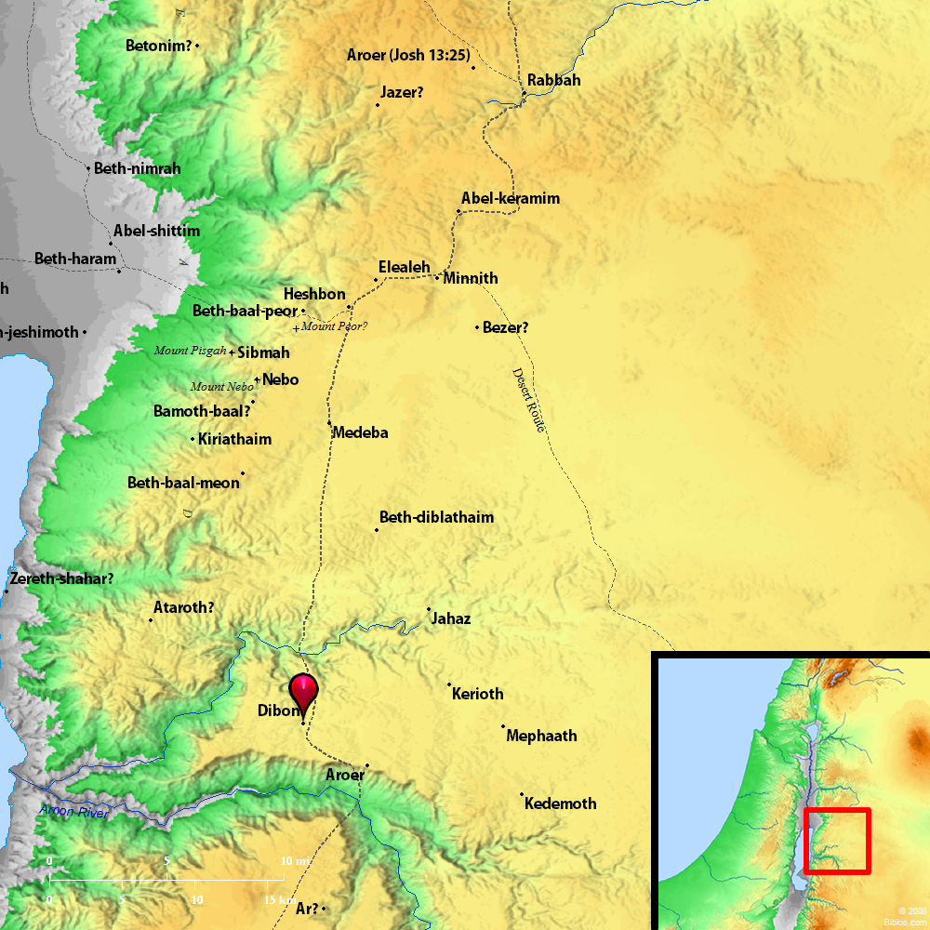](http://bibleatlas.org/region/dibon.jpg)

1. **What does shaving and baldness represent? …mourning in that culture**
   1. **In verse 3, discuss sackcloth? Wailing? Mourning?**
   2. **What does “shaving in the Bible” imply? Discuss these references: Leviticus 21:5, 2 Samuel 10:4-5, and I Corinthians 11:5-6.** The Old Testament law forbade priests from shaving their heads or beards ([Leviticus 21:5](http://biblia.com/bible/esv/Leviticus%2021.5)). In the ancient Hebrew culture, men usually had long beards. In fact, it was considered a disgrace for an adult man not to have a beard ([2 Samuel 10:4-5](http://biblia.com/bible/esv/2%20Samuel%2010.4-5)). Men taking the Nazarite vow were not to cut their hair until the vow was completed, at which time they were to shave their heads. Regarding women shaving, Scripture says that it is disgraceful for a woman to shave her head ([1 Corinthians 11:5-6](http://biblia.com/bible/esv/1%20Corinthians%2011.5-6)) and that her hair “is a glory to her” (v. 15 KJV). Other than the hair and beard, the Bible nowhere directly mentions shaving any other part of the body.
   3. **What does baldness mean? Isaiah 3:24, Micah 1:16, Isaiah 22:12, and** [**Leviticus 21:5**](https://www.biblegateway.com/passage/?search=Leviticus+21%3A5&version=ESV)**.**
2. **Where is Heshbon, as referred to in verse 4?** Heshbon also appears in the [Song of Solomon](http://en.wikipedia.org/wiki/Song_of_Solomon) where the poet likens his love's eyes to "the pools of Heshbon", which refers to the magnificent fish-pools of Heshbon. Ancient Heshbon was beyond the Jordan. Heshbon was taken by the Israelites on their entry to the [Promised Land](http://en.wikipedia.org/wiki/Promised_Land), and was assigned to the tribe of [Reuben](http://en.wikipedia.org/wiki/Tribe_of_Reuben);[[1]](http://en.wikipedia.org/wiki/Heshbon#cite_note-1) afterwards it was given to the [Tribe of Gad](http://en.wikipedia.org/wiki/Tribe_of_Gad).The reference in the [Tanakh](http://en.wikipedia.org/wiki/Tanakh) to **Heshbon** is found in the [Book of Deuteronomy](http://en.wikipedia.org/wiki/Book_of_Deuteronomy)where it is mentioned as the capital of [Amorite](http://en.wikipedia.org/wiki/Amorite) king, [Sihon](http://en.wikipedia.org/wiki/Sihon) (also known as Sehon). It is also mentioned in [Numbers](http://en.wikipedia.org/wiki/Book_of_Numbers),[[4]](http://en.wikipedia.org/wiki/Heshbon#cite_note-4) which tells the story of the [Israelite](http://en.wikipedia.org/wiki/Israelite) victory over [Sihon](http://en.wikipedia.org/wiki/Sihon) the [Amorite](http://en.wikipedia.org/wiki/Amorite) during the time of [The Exodus](http://en.wikipedia.org/wiki/The_Exodus) under [Moses](http://en.wikipedia.org/wiki/Moses). **20 miles**

[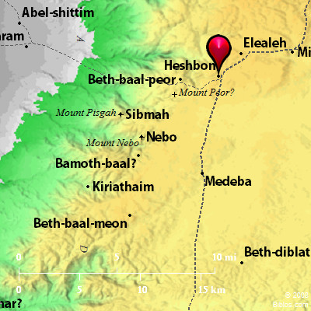](http://bibleatlas.org/full/heshbon.htm)

1. **What is the significance of Zoar in verse 5;** city spared at the pleading of Lot, one little city, **see Genesis 19:20-23.** The connection is interesting, because Zoar was the city Lot and his daughters escaped from, hiding in the mountains, before Lot’s daughters committed incest with their father, and brought forth the child *Moab*, the father of the Moabites. Zoar: “This town is called *an heifer of three years old*, apparently to indicate that it had never been under the yoke of strangers.”
2. **Who is the King of Moab? Discuss his wailing and distress in verse 2**
3. **In verse 4, discuss the reaction of the soldiers? Parallel this to Jeremiah 48:41.**
4. **In verse 5, what is Isaiah’s reaction to this destruction of Moab?** Isaiah’s heart is broken and he is sorrowful over this destruction. God does not take pleasure in the destruction of the wicked. Isaiah’s heart is shown here.
5. **Today in this territory there are two extremes: West of the Jordan River—Israel, with lush fields and crops and east is desolation (Moab). How do we see this set up in Isaiah 15?**
   1. **Why is the grass withered in verse 6?**
6. **In verse 9, “lions” represent what**? Moab is symbolic of sin….there is no escape from sin. **Check out the following verses**:
   1. [**Proverbs 28:1**](http://www.kingjamesbibleonline.org/Proverbs-28-1/) - The wicked flee when no man pursueth: but the righteous are bold as a lion.
   2. [**1 Peter 5:8**](http://www.kingjamesbibleonline.org/1-Peter-5-8/) - Be sober, be vigilant; because your adversary the devil, as a roaring lion, walketh about, seeking whom he may devour:
   3. [**Proverbs 19:12**](http://www.kingjamesbibleonline.org/Proverbs-19-12/) - The king's wrath [is] as the roaring of a lion; but his favour [is] as dew upon the grass.
   4. [**Hosea 11:10**](http://www.kingjamesbibleonline.org/Hosea-11-10/) - They shall walk after the LORD: he shall roar like a lion: when he shall roar, then the children shall tremble from the west.
   5. [**Hosea 5:14**](http://www.kingjamesbibleonline.org/Hosea-5-14/) - For I [will be] unto Ephraim as a lion, and as a young lion to the house of Judah: I, [even] I, will tear and go away; I will take away, and none shall rescue [him].
   6. [**2 Timothy 4:17**](http://www.kingjamesbibleonline.org/2-Timothy-4-17/) - Notwithstanding the Lord stood with me, and strengthened me; that by me the preaching might be fully known, and [that] all the Gentiles might hear: and I was delivered out of the mouth of the lion.
7. **Refer to Moab, Ammon and Edom in Daniel 11:41; why do they escape the antichrist the tribulation?**

**Chapters 16—The Burden Against Moab--continued**

Verses 1-5….future….time during the great tribulation

1. **What does “Send the lamb” mean? Refer to 2 Kings 3:4-5, 2 Chronicles 20:1-24 and 2 Samuel 8:2.—**Moab had to supply lambs and wool to Israel in tribute, tax, to Israel; see under David and Solomon, 100,100 lambs and wool of 100,000 rams; Moab is rebelling 2 Kings 3:4, 2 Chronicles 20….joining with the Ammonites. The idea behind **send the lamb to the ruler of the land** is that Moab should resume their bringing of tribute to Jerusalem, thereby submitting themselves to God again. This kind of tribute is described in [2 Kings 3:4-5](http://www.studylight.org/desk/index.cgi?q1=2%20Kings+3:4-5&t1=en_nas), where Mesha, King of Moab, who once paid tribute to Israel, stopped doing so when King Ahab of Israel died. Here, Isaiah counsels Moab to resume this payment of tribute. Northern boundary of Moab—Ar, and south of Ar is Kir. The tribute consisted of sheep and goats.
   1. **Jehoshaphat defeats Ammon, Moab, and Mount Seir in 2 Chronicles 20:**1-24. Ammon, the descendant of Lot’s second daughter and Lot….child’s name, Ben-Ammi.
   2. During the time of Saul and David, Israel established a firm control over Moab, but later kings of Israel were not always able to keep them under Israeli dominance.
   3. In 2 Kings 3:5 why does the rebellion of the King of Moab matter? He began to resent the tax placed on Moab by David and Solomon.
   4. When was the tribute established? See 2 Samuel 8:2, Judges 3:28-30, and I Chronicles 18:2.
2. **What is Sela?** Petra/Bozrah Daniel 8…..escape …rocky parts of Moab
3. **Who is “him” in the “betray not him?”—**refuge for Israel
   1. **What is Moab’s final outcome? See Jeremiah 48:47.**
4. **Who is “the spoiler” in verse 4?** —him who takes spoil--antichrist….Hosea 5, 6….Israel will flee to this area. And, when the antichrist tries to shift his fight, Matthew 24 Hosea 5:15, Israel petitions Jesus to come back and save them. “I will go and return to my place until……” Matthew 12, “a wicked and adulterous generation…..Jonah….Jesus resurrected in 3 days.” Also, refers to the perquisite to Israel’s petition for them to come back….interrupts the antichrist at Petra.
   1. **When will Jesus return? Read Hosea 5:15.**
   2. **Compare what Jesus said Matthew 24:15-16 and the end times.**
   3. **Discuss “the sign of Jonah” in Matthew** **12:38-45**
5. **Verse 4’s “hide the outcasts” has a local context and “far-reaching” meaning, as well. Discuss.** 
   1. **What is “the local?”** Here, in the compassion of his prophecy, Isaiah pleads with the rulers of Judah to **hide the outcasts** of Moab. Again, his great sympathies are probably due to the connection between Moab and the royal house of David.**Do not betray him who escapes**: Isaiah wanted Judah to be a place of refuge and protection for Moab under judgment. This is exactly what the church should be, when people are under the strong hand of the LORD in the world. We should be a place that will **hide the outcasts** and receive **him who escapes**, never to **betray** them.
   2. **Compare the “far-distant future” described in verses 3-5 with Revelation 12:6 and 13-14**. protect Israel in Petra during the tribulation period. This is a sudden and curious change of focus. In [Isaiah 16:3](http://www.studylight.org/desk/index.cgi?q1=Isaiah+16:3&t1=en_nas), Judah was counseled to receive the outcasts of Moab. Now, Moab is asked to receive the outcasts of Judah. [Isaiah 16:4-5](http://www.studylight.org/desk/index.cgi?q1=Isaiah+16:4-5&t1=en_nas) is an end-times prophecy of how Moab will be a place of refuge for Jews escaping the fury of the Antichrist after the abomination of desolation. **Let My outcasts dwell with you, O Moab**: b. Israel, fleeing from the fury of the Antichrist, will find refuge in places like Moab ([Revelation 12:6](http://www.studylight.org/desk/index.cgi?q1=Revelation+12:6&t1=en_nas); [Rev_12:13-14](http://www.studylight.org/desk/index.cgi?q1=Rev+12:13-14&t1=en_nas)). They will be protected **from the face of the spoiler** until **devastation ceases** and **the oppressors are consumed out of the land**. Moab, the rock city, Petra exists……built in 5th century B.C., “the rose city,” where Israel goes for refuge. Possibly this is Mt. Hor, scene of Aaron’s death. Can house as many as 100,000-200,000 people. Johann Burckhart in 1812 went to the Jordanians and asked to see Petra.
6. **Describe the Millennium in verse 5.—**Millennium--Tabernacle of David---Acts 15—Paul argues that a new convert does not have to be a Jew……
   1. **In Acts. 15:13, explain why a Christian does not have to be a Jew.…..**God, will first take out a people for His name, the Gentiles, after this—Jesus said I will return and set the Jews…..Acts 15: 1. A Christian does not have to become a Jew, 2. Israel will be restored.
7. **See Daniel 9:24-27 and how it is a key to understanding prophecy. Explain.** The vision of Daniel’s 70 weeks. The angel Gabriel came to explain this vision
   1. 70 weeks (a period of 7)—years—490 years
   2. Nation of Israel—and Jerusalem
   3. Vs.25—to build Jerusalem, Artexerxes sent Nehemiah (445 B. C.) to Jerusalem, starts the command.. Neh. 1
   4. 490-7equals 483 x 360 day calendar equals 173,880 days—Gabriel declares
   5. Palm Sunday, before the crucifixion making the proclamation, “Hosanna, Hosanna, blessed is He that comes in the name of the Lord” Zech.
   6. Leaves the 7 year period left between the 62 weeks, one week where we are, and then the 7 year tribulation
   7. Verse 27—antichrist—prince that is to come—confirms covenant with Israel
   8. Matthew 24: 15—speaking to believing Jews during the tribulation period, “When you see the……..flea to the mountains….great tribulation.
   9. Revelation 12:13 …..a dragon, a woman, and a child…….3 ½ years into the tribulation……woman flies to the wilderness and is saved for 3 ½ years and saved from the antichrist. A place in the wilderness where the earth helps the woman….Petra..near southern part of Israel….Isaiah 16
   10. In Isaiah 16:1—the lamb, Israel, to Selah/rock/Petra…..hide the outcasts, dwell with you, O Moab
8. **Time Line Charts of the 70 Weeks of Daniel**

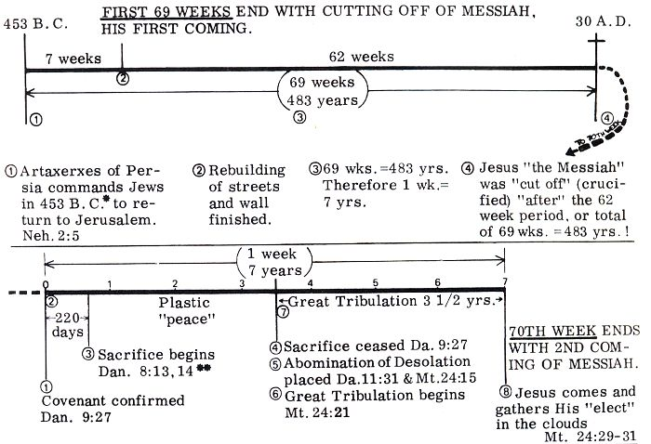

1. **In verse 6, what does “the pride of Moab” mean? What is Moab known for?** **We have heard of the pride of Moab**: Here is the only place where the sin of Moab is detailed. It is significant that Moab’s sin was **pride**, because they were a fairly small and insignificant nation.
   1. **Why does God hate pride? Scrutinize Jeremiah 48:1-13, 18, 29; also Proverb 16:5.**
2. **Is Moab wiped out in God’s wrath? Why is it spared. Scrutinize Daniel 11:41.**
3. **What does Isaiah’s heart feel for this people? Verse 9**
   1. **Compare Isaiah’s sadness about Moab’s punishment with Jesus’ feeling over a disobedient Jerusalem—Matthew 23:37-39**. This was the same attitude Jesus had when He wept for Jerusalem: O Jerusalem, Jerusalem, the one who kills the prophets and stones those who are sent to her! How often I wanted to gather your children together, as a hen gathers her chicks under her wings, but you were not willing! See! Your house is left to you desolate; for I say to you, you shall see Me no more till you say, “Blessed is He who comes in the name of the LORD!” ([Matthew 23:37-39](http://www.studylight.org/desk/index.cgi?q1=Matthew+23:37-39&t1=en_nas)) When Jesus saw the desolation to come upon the city that rejected Him, He did not rejoice. Jesus also knew that in the midst of their calamity, they would turn to themselves instead of the LORD.
4. **In verse 13, what is the word against Moab? How many years?** Three years from this prophecy, Moab was destroyed. “Apparently King Sargon of Assyria conducted a major operation against the Arabians in 715 B.C., and he may have devastated Moab en route to encountering those tribes.” Attack by Sennacherib on Moab….it will require three years, like a contract, that Moab will be destroyed