**“Insights Into Isaiah”—Chapters 9-10**

**Chapter 9…**

1. **What does verse 1-2 say? See the link to Matthew 4:12,** where Jesus is tempted by the devil and this is around the Sea of Galilee, seacoast, to fulfill what Isaiah had prophesied. Nahum and Jonah came out of this area, too. Their emphasis was to the Gentiles, Nineveh. Nevertheless - The calamity of this land and its inhabitants shall be great, yet not such as that which was brought upon it by the king of Assyria, who at first indeed dealt more gently with them, but afterwards rooted them out. He - God. Zebulun - These parts are particularly mentioned, because this storm fell most heavily upon them; but under them the other parts of the land are understood. Afterward - By Shalmaneser, who took Samaria, and carried Israel into captivity, [17:5](http://www.biblestudytools.com/commentaries/wesleys-explanatory-notes/isaiah/default.aspx?reference=2ki+17:5) ,6. Of which calamity, though yet to come, he speaks as if it were past, as the manner of the prophet is. The sea - In that part of the land which borders upon the sea, the lake Genesareth, upon which the portions of Zebulun and Naphtali bordered. Galilee - Or, Galilee of the Gentiles, namely, the upper Galilee, so called because it bordered upon the Gentiles. **The gloom carries over from Isaiah 8:22, “Then they will look to the earth, and see trouble and darkness, gloom of anguish; and they will be driven into darkness.” The northern regions of the Promised Land, especially Zebulun and Naphtali, around the Sea of Galilee (Gentiles), were most severely damaged when the Assyrians came in from the north. The promise is that this land will see the Messiah, the great light in the future.**
2. **Restate verse 2. Why is this verse so important?** 
   1. **Who is the light? See Matthew 4:13-16.** Galilee, first to be taken captive by the Assyrians will be privileged to host the Messiah!
3. **In verse 3, we see the Abrahamic covenant re-visited. Refer to Genesis 22:17.** Thou hast - Thou hast made good thy promise to Abraham concerning the multiplication of his seed, by gathering in the Gentiles to the Jews. Before thee - In thy presence, and in the place of thy worship.
   1. **Discuss the joy in the Messiah’s deliverance and victory. Refer to Matthew 9:14-15.**
4. **What is “rod of oppressor?”** task master(verse 4) **Compare with the Egyptian captivity in Exodus 6:6.** The yoke - His burdensome yoke. The staff - The staff or staves by which he was forced to carry burdens upon his shoulders. The rod - Wherewith he beat him. Oppressor - Of all his oppressors, but especially of sin and the devil. As - When God destroyed the Midianites in so admirable a manner by three hundred men.
   1. **Read Judges 7:1-25 and review the story of Gideon with the Midianites.**
5. **Verse 5’s reference to burning weapons with fire seems to parallel Ezekiel 39:9. Discuss.** Noise - With the triumphant exclamations of the conqueror, and the bitter lamentations of the conquered, and the different cries of the same persons. Blood - With great difficulty and slaughter.
   1. **Compare this section to the Battle of Armageddon in Revelation 16:14, Zechariah14:13, and Rev. 14:20.** 
      1. **List the three elements to these battles in verse 5.** This signifies the end of the battle; this is what the victor did.
         1. **Burnt the enemies’ sandals. How does Ephesians 6:**15, “feet shod with the preparation of the gospel of peace,” relate to this?
         2. **Battle confused with noise, Isaiah 66:6.**
         3. **Garments rolled with blood, Isaiah 63:1-4, Rev. 14:20.**
         4. **With burning and used for fuel of fire, Joel 2:3.**
6. **Notice two of the most elegant verses in the O.T. in verse 6-7. Comment. Compare with Psalm 2 and Philippians 2:7.**
   1. **Why do these familiar verses oft get overlooked?**
   2. **What are the two ideas in the very first phrases?** 
      1. **Does “child” speak to Jesus’ humanity?**
      2. **Does “son” refer to his Deity? Is ‘given?’ See John 3:16.**
      3. **How does this echo Isaiah 7:14?**
   3. **“Government on His shoulder” seems to imply future. See Luke 1:32-33. Explain.** When Gabriel talks to Mary, he tells Mary that God shall give Jesus the throne of His father, David, and reign over the house of Jacob.
      1. **Refer to Revelation 20:4-6, Zechariah 14:6-21, and Psalm 72.**
   4. **See Romans 11:24. Talk about the ‘fullness of the Gentiles.’**
   5. **Discuss the titles for Jesus--“Wonderful, Counselor, Mighty God, Almighty Father, Prince of Peace.” Why five different titles?** 
      1. **Wonderful--See Judges 13:8-11** (I am—verse 11—theophany)—verse 18—word “Wonderful” for secret.—state of awe; Jewish for Deity--
      2. **Counselor—**[**Colossians 2:3**](http://www.biblestudytools.com/commentaries/wesleys-explanatory-notes/isaiah/default.aspx?reference=col+2:3)**, Proverbs 8……..extols wisdom, and personifies it**
      3. **Mighty God—el—See Isaiah 7:14**…Immanuel-el; applied to Jesus in Revelation 1:8. Isaiah 10:21, Jeremiah 17:5
      4. **Everlasting Father—Father of eternity, Ex. 20:11, no time for God, He is in eternity, timeless, See Eph. 1:4.**
      5. **Prince of Peace—Examine Romans 5:1, Luke 2:14**
7. **Restate why verses 6-7** (vs. 6—first coming, vs. 7—second coming) **are the “overview of Christ’s plan” for all mankind? Us** - Unto us **Jews**, of whom Christ was born, and to whom he was primarily sent. Shoulders - Upon him, or in his hands. He mentions shoulders, because great burdens are commonly laid upon men's shoulders...Mighty God - This title can agree to no man but Christ, who was God as well as man, to whom the title of God or Jehovah is given, both in the Old and New Testament. And it is a true observation, that this Hebrew word El is never used in the singular number, of any creature, but only of the almighty Child—humanity; Son—Deity.
8. **The “Second Coming” is in view in verse 7. Re-state why “the zeal of the Lord of hosts will perform this.” What is the “sanctified jealousy” that is hinted at here? Parallel with 2 Cor. 11:2.**
9. **The local setting reappears here. In verse 8, why does God use both “Jacob” and “Israel**?” When he was in the flesh he is called “Jacob,” in the spirit—“Israel”. Samaria - the strongest place and the seat of the king and court.
10. **Is Ephraim a synonym for the northern Kingdom**?
    1. **Who is Rezin**? King of Syria
11. **Verses 10-11 pronounce judgment on whom?** 
    1. **Discuss how this portion of scripture has been linked the American’s 9-11 tragedy.** The northern kingdom did not recognize God’s chastening, but hardened their hearts and vowed to rebuild better, just like America did.
       1. **Examine Hebrews 12:6.**—whom the Lord loves, He chastens.
12. **In verse 12, God’s anger toward Israel surfaces. His use of, “His hand is stretch out still,” does not reflect mercy, but rather judgment. Where else do we see this same phrase used by Isaiah?** Verse 12, 17, 21, chapter 10:4.
13. **Why does God bring such strict judgment on Israel? See verses 13-14.**
    1. **What does “cut off head and tail” mean? See verses 15-16.**
       1. **In verse 15, who are the idioms?** Ancient prophets who teach truth is head, and lies are the tails
    2. **What are the Palm branch and bulrush symbolizing?** This is the same thing as head and tail. A branch grows upward and thus refers to the high and important people, while the rush grows down in the swampy marshes and refers to the lowest elements of the population.
14. **In verses 16-17, what happens to unrighteous leaders?**
    1. **Refer to Luke 17:1-2.**
    2. **The use of “Hand is stretched out still” implies what?** Anger of God
15. **Verses 18-21 detail God’s wrath. Explain.** Manasseh - Though more near and dear to one another than any other tribe, being both sons of Joseph.
    1. **See Genesis 6:3, and correlate with God’s displeasure for unrighteousness.**”And the Lord said, My spirit shall not always strive with man, for that he also is flesh; yet his days shall be an hundred and twenty years.”
    2. **Why is the picture of “fire” used?**
    3. **Do the tribes turn against each other?**

**Chapter 10…**

***(From Isaiah 7:1-10:4, the Lord revealed that He would use Assyria as an instrument of judgment against Syria, Israel, and Judah.)***

1. **Verses 1-4 are often linked with Chapter 9. List those being targeted by God for judgment and explain each woe.…..”Woe” to those who:**
   1. **Decree unrighteous decrees**
   2. **Write misfortune**
   3. **Rob the needy of justice and take from the poor**
   4. **Prey on widows**
   5. **Rob from the fatherless**
      1. **Describe the punishment.**
      2. **Compare this use of “evil nations” for chastisement, with God using Babylon to inflict judgment on Judah in Habakkuk 2:6-17 and Isaiah 14:5.** First, God raised up Babylon to inflict divine judgment on Judah, and then, He announced judgment on them.
2. **The last phrase is repeated again…….why?**
3. **Why does Isaiah begin predicting judgment on ancient Assyria?** It endured for as an important entity for seven hundred years. God used it to judge the northern kingdom.
4. **In verse 5, God calls Assyria what?** The rod of My anger….
   1. **Discuss the use of “rod and staff” in this verse.** The rod and the staff were sticks used by shepherds to guide and correct their sheep. God is equating Assyria as a stick in His hand, which He uses to correct Syria, Israel, and Judah. **See also Psalm 23:4.**
   2. **Is the antichrist called the Assyrian? How is the appropriate in today’s world?**
   3. **The Pharaoh against Moses was Assyrian. Why is that an interesting link?**
   4. **Re-visit what the wrath of God entails? See Psalms 76:10.**
5. **In verse 5-6, we see that the Assyrians will take “spoil and prey.” Where else is that description found?** 
   1. **See Ezekiel 38:12. Compare the two passages.** One is God punishing the northern kingdom, one is why the Gog/Magog squirmish happens –enemies want a spoil and a prey.
   2. **Link the “to take a spoil and take a prey” passage to the name of Isaiah’s second son in Isaiah 8:3.** Maher-Shalal-Hash-Baz, “spoil quickly, plunder speedily,”
      1. **Was this what Isaiah’s son’s name prophesied about?**
6. **Isaiah 10:7-14 displays the arrogance of Assyria. Do verses 7-8 imply that the Assyrian princes were also called kings as rulers?** Because in the Hebrew language Assyrian princes were called ‘kings,’ that makes the head of the Assyrian rulership the ‘king of kings,’ a direct slam to Jesus who is the real King of King. The Assyrians were sooo inflated about themselves.
   1. **Note the conceit in verse 8 of the Assyrian ruler.**
   2. **In verses 9-10, discuss the import of the cities mentioned.** They came under Assyrian control between 740 and 721 B. C., and none of their ‘gods’ had helped them!
7. **Who are Calno and Carchemish?”** Calno was in the lower Mesopotamia, city of Nimrod, mentioned in Genesis 10, tower of Babylon; Carchemish n.cap of Hittites (606 B.C.) is the battle where Neb. establishes Babylon as a world ruler. Hamath, Canaanite city, and Arpad, reduced by Assyrian king Tiglamipilea.
8. **What is the reference to Samaria and Damascus**? Damascus is capital of Syria; Fallen Cities…Samaria is the capital of the northern tribes.
9. **The brag of the Assyrians comes to naught against Judah**. **Why does God mention the idolatry in this kingdom in verse 10-11?**
10. **What is the punishment for the arrogant pride of the Assyrians**? Verse 12 symbol for sin is leaven, Exodus 12:15; Gal. 5:9. God hates pride, corrupts by puffing up.
    1. **Discuss God’s disgust over pride and “haughty look**s.” **Examine Proverbs 21:4, Psalms 101:5, and Psalms 18:27**.
11. **Re-state the brag of the Assyrian conquerors in verses 13-14.** Head - High and low. Branch - The goodly branches of tall trees, the mighty and noble. Rush - The bulrush, the weakest and meanest persons. One day - All together, one as well as another.
    1. **Associate the mention of the “nest” in this section to the “bird” in Matthew 13:4, 19**….bird is not good, parable of the four soils….bird is not good.
    2. **See Proverbs 22:28.**
12. **Are the Assyrians as an instrument of God in verse 15? Why the ax? See The saw? The rod?**
    1. **See I Chronicles 20:3, Isaiah 10:15, 2 Samuel 12:31, Ezekiel 26:9.**
13. **Note the double name of the God in verse 16? Why?**
    1. **Is “fire” or “burning” a common descriptor for God? Defend your answer.**
14. **Talk about “light” and “Holy One for a flame?” Refer to John 1:9**
    1. **Examine the use of the terms “thorns” and “briers.”**
    2. **The second coming happens in one day, verse 17**.
15. **Discuss the desolation of verses 18-19.**
16. **Talk about the remnant of Israel in verses 20-23**.
17. **What is the warning in verses 24-26? Why is the parallel drawn to the Egyptian exodus saga?**
    1. **In verse 26, what is the slaughter of Midian? At the rock of Oreb?**  **Re-visit Joshua 7:25 and Gideon’s “300” in 2 Kings 19.**—destroy of Sennarachib Stir up - Shall send a destroying angel. Midian - Whom God slew suddenly and unexpectedly, in the night. Oreb - Upon which one of their chief princes was slain, and nigh unto which the Midianites were destroyed. The sea - To divide it, and make way for thy deliverance, and for the destruction of the Egyptians
    2. **Compare this with Exodus 4 and 14:16—rod and sea --rod of Moses and rod of Aaron.**
    3. **According to 2 Kings 19:36-37, what ultimately happens to the King of Assyria after he attacks Israel?** He is murdered by his own sons as he worshipped in the pagan temple of Nisroch, his god.
18. **Who is the anointed one, verse 33? And, why the double reference to Him? See Hezekiah 2 Sam. 19, Lam. 4:22?**
19. **Explain the significance of the locations listed in verses 28-34**…..The approach of Sennacherib….Isaiah is predicting the Assyrian attack by analyzing it in real time, like a TV announcement, a play-by-play……fast paced—a geographical down play. The listing of these cities flows from north to south, describing the course of the Assyrian invasion. The bough - The top - bough, Sennacherib, with a most terrible stroke.
    1. **Aiath, Joshua 8 30 miles n.e. of Jerusalem, 3 miles south of Bethel**
    2. **Migron, I Sam. 14….30 miles north—Gibea of Benjamin**
    3. **Michmash—7 ½ miles n or Jerusalem—Jonathan against the Philistines, in I Sam. 14, tough terrain**
    4. **Geba—6 miles n. I Sam. 13**
    5. **Ramah—6 miles n or Jerusalem**
    6. **Bibeath of Saul—4**
    7. **Gallim—birthplace of Saul’s daughter, close to Laish, n. of Jerusalem**
    8. **Laish—Danites settle there in Judges 18, 1 mile n.e. of Jerusalem**
    9. **Anathoth—city of Refuge, Jeremiah’s birthplace, 3**
    10. **Madmenah—1-2 miles north**
    11. **Gebim’—1-2 miles north**
    12. **Nob—is right on the outskirts of Jerusalem**, (Saul kills the priests of Nob in I Sam. 22)…This is as far as the army of the Assyrians came against Judah. They were stopped here when the Lord killed 185,000 Assyrian soldiers in one night. **See 2 Kings 19:35-37,** when Hezekiah was king. Destruction of Sennacherib and **2 Chronicles 32:21, and. Isaiah 37:36.** God interferes and does not allow the Assyrians to get Jerusalem, Nebuchadnezzar does.

[**Isaiah 10**](http://bibletribes.org/bible#13.10.brb)**:28-32,** “He has come to Aiath; he has passed Migron; at Micmash he has laid up his supplies; 29they have gone over the passage of Geba to Beth Bethan; Ramah is afraid; Gibeah of Saul has fled. 30Lift up your voice, daughter of Gallim; give ear, Laishah; answer me, Anathoth. 31Madmenah has been removed; the inhabitants of Gebin are resisting. 32As yet, he will remain at Nob that day; he will shake his hand against the mount of the daughter of Zion and against the hill of Jerusalem.”

|  |  |
| --- | --- |
| **Tribe** | **Town** |
| Judah | Aiath |
| Reuben | Migron |
| Gad | Micmash |
| Asher | Geba |
| Naphtali | Beth Bethan |
| Manasseh | Ramah |
| Simeon | Gibeah of Saul |
| Levi | Gallim |
| Issachar | Laishah |
| Zebulun | Anathoth |
| Joseph | Madmenah |
| Benjamin | Gebin |
| Dan | Nob |

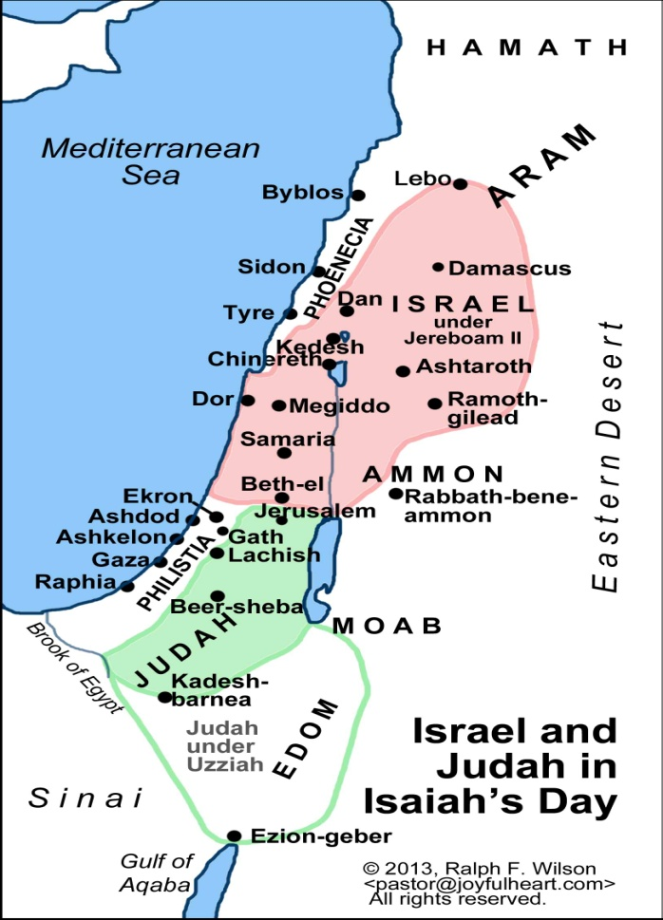

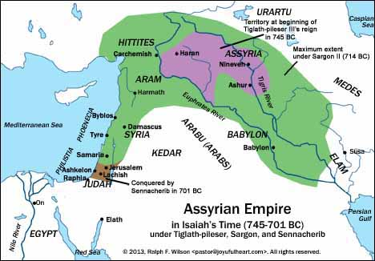

1. **Verses 33-34 sum up the judgments. Why would God bring down the Jews with such force? Validate your answer.**
   1. **What does Lebanon refer to?** The largest trees in the area are in Lebanon. The biggest “tree” in the forest, falls the hardest….an idiom.
   2. **What does the forest idiom imply?** Forest seems invincible and the picture shows that it will be leveled to stumps.
2. **Is there justice and righteousness in Chapter 10? *Chapter 10 is a chronicle of the punishment of Israel.***
3. **Where do we see Jesus in this chapter?**

**The Promises for Today:**

***Isaiah 10:20-22,”*** And it shall come to pass in that day, that the remnant of Israel, and such as are escaped of the house of Jacob, shall no more again stay upon him that smote them; but shall stay upon the Lord, the Holy One of Israel, in truth.21The remnant shall return, even the remnant of Jacob, unto the mighty God.22For though thy people Israel be as the sand of the sea, yet a remnant of them shall return: the consumption decreed shall overflow with righteousness”

***Favorite Isaiah verses from this session:***

***Isaiah 9:2, “****The people that walked in darkness have seen a great light: they that dwell in the land of the shadow of death, upon them hath the light shined.*

***Isaiah 9:6-7, “****For unto us a child is born, unto us a son is given: and the government shall be upon his shoulder: and his name shall be called Wonderful, Counselor, The mighty God, The everlasting Father, the Prince of Peace.” Of the increase of his government and peace there shall be no end, upon the throne of David, and upon his kingdom, to order it, and to establish it with judgment and with justice from henceforth even forever. The zeal of the Lord of hosts will perform this”*

***Isaiah 9:10-11, “****The bricks are fallen down, but we will build with hewn stones: the sycamores are cut down, but we will change them into cedars.11Therefore the Lord shall set up the adversaries of Rezin against him, and join his enemies together.”*

***Things you should know from “The Fifth Gospel!”***

***Names of God:***

1. LORD = *Yahweh* (many times)
2. God = *'el* (many times)
3. God of Israel (22 times in all), God of Jacob (5 times)
4. God of all the earth (54:5)
5. Sovereign Lord (NIV), Lord God (NRSV, KJV) = *'Ādôn Yahweh* (40:10 and 18 times in all)
6. LORD Almighty (NIV), LORD of hosts (NRSV, KJV) (9:7 and 62 times in all)
7. LORD your God (9 times)
8. Shepherd (40:11)
9. Potter (29:16; 41:25; 64:8)
10. Holy One / Holy One of Israel/Jacob (40:25, 33 times in all)
11. Everlasting God (40:28)
12. Creator (27:11; 40:28; 41:15)
13. Redeemer (41:14, 13 times in all)
14. King (6:5; 32:22; 41:21; 43:15; 44:6)
15. Savior (17:10; 43:3; 45:15, 21; 49:26)
16. First and the Last (43:6)
17. Rock (17:10; 44:8), Rock Eternal (26:4)
18. Maker (27:11; 30:29; 45:11; 51:13; 54:5)
19. Spirit (48:16)
20. Mighty One (33:21; 42:13; 49:26; 60:16)
21. Husband (54:5)
22. Father (63:16; 64:8)
23. Light of Israel (10:17; cf. 60:19)
24. Most High (14:14)
25. Righteous One (24:16), Upright/Just One (26:7)
26. Glorious Crown (28:5)
27. Spirit of Justice (28:6)
28. Judge (32:22)
29. Lawgiver (32:22)
30. Warrior (42:13)

***Names of Jesus:***

1. Branch (11:1; 4:2)
2. Child (9:6)
3. Everlasting Father (9:6)
4. King (32:1)
5. Mighty God (9:6)
6. Prince of Peace (9:6)
7. Righteous One (53:11)
8. Root of Jesse (11:10)
9. Servant (52:12)
10. Shoot (11:1)
11. Son (9:6)
12. Wonderful Counselor (9:6)