**“Insights into Isaiah”—Chapters 2-**4

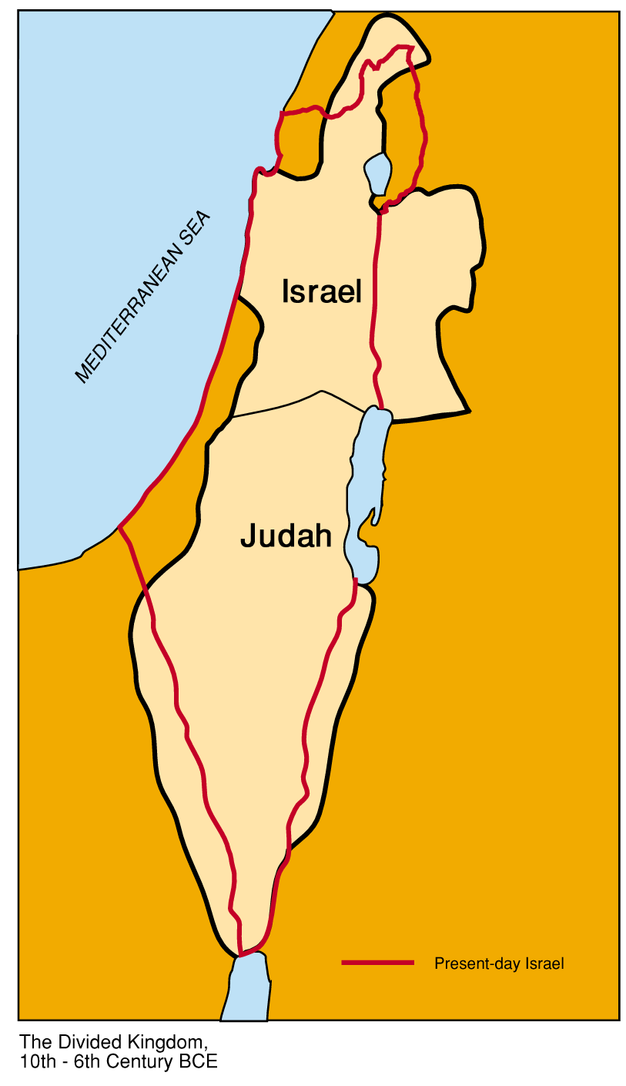

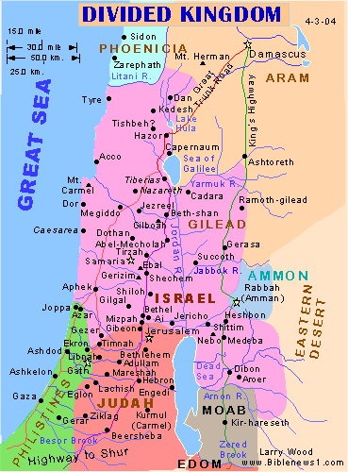

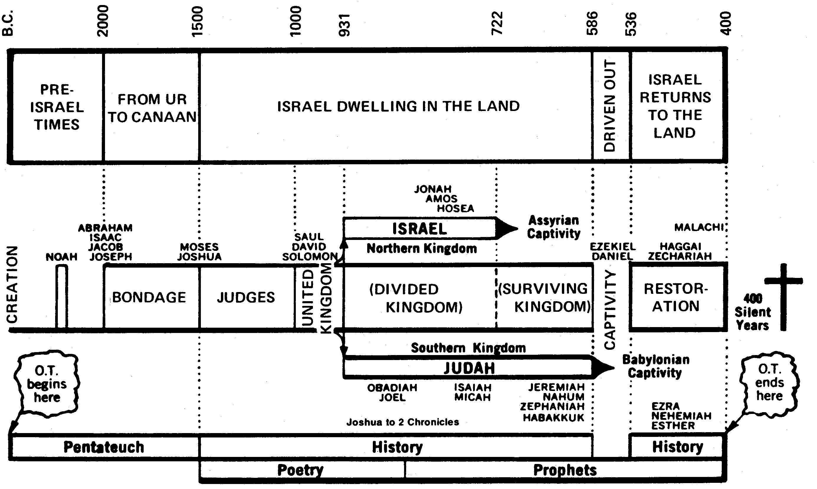

**Isaiah--Chapter 2**

**Review Chapter 1:21-26. Discuss how this small “unit within the large content” is the theme of all of Isaiah? Why is this small section sometimes referred to the “tale of two cities?”** He likes to order his material into units, with bookends—faithful city, Jerusalem bookend by the unfaithful city, the harlot Jerusalem. This is a small unit which houses the whole agenda of Isaiah…how is the faithless city to become the faithful city? This highlights throughout the whole book of Isaiah. Verse 24 is the key verse…..the Lord of Hosts will avenge His foes. Vs. 25 –Jerusalem become the enemy of God, but He then promises that He will bring Jerusalem back as a purified entity….righteous. Reminder of the Kings Isaiah served under: Uzziah (790-739 B.C.), Ahaz (731-715 B.C.), Jotham (739-731 B.C.), and Hezekiah (715-686 B.C.) Chapter 1—indictment of Israel, 2 tribes in the south—10 tribes in the north; then in Chapter 2—revelation that is 2,800 year time gap from proclamation of chapter 1 to chapter 2, way out into the future and speaks about the coming government of God….Government God’s Way for Judah and Jerusalem in the “latter days”—last time frame of man’s age, tribulation.

1. **Chapters 2-4 forms a separate unit within Isaiah, complete with beginning and ending ‘bookends.’ Read Chapter 2:1-5 as the beginning bookend of this section and the ending bookend is Chapter 4:2-6.** The passage in between is about the disparate position of Jerusalem in Isaiah’s day.
2. **What is Isaiah’s focus in the Book of Isaiah?** Judah and Jerusalem
   1. **List some of Isaiah’s 30 different titles for the city of Jerusalem. 1:21, “faithful city,”** Hill of Jerusalem (Isaiah 10:32), Nevermore shall you be called “Forsaken,” Nor shall your land be called “Desolate”; But you shall be called “I delight in her,” And your land “Espoused—*Isaiah 62*
3. **What was the promise of Gabriel to Mary?** **See Luke 1:26-33.** Gabriel made two promises to Mary. First, that she would be the mother of a holy child—that has been fulfilled. Second, the child would sit on the throne of his father David—this has not been fulfilled.
   1. **What is the “House of David?” The Mountain of Zion?** The new Temple; God’s place….the temple mount….the physical returning of Jesus’ second coming. **T**he Millennial Kingdom…
   2. **Isaiah 2 happens in correspondence to these verses about the Second Coming. Read Isaiah 62:1, 63:3-4—For Zion’s sake and Revelation 19:12—Micah 2:12,-13, Matthew 24:27, 29-30, Zechariah 12:9-10, second coming! And, Isaiah 63:1 (sheep pen, Bozrah, Selah, Petra)**
   3. **Discuss the temples in the Bible**—1st is Solomon’s, 2nd is Zerubbabel’s/Herod’s, and the 3rd has yet to be built—antichrist will desecrate, 4th temple Millennial
4. **In verse one, explain what “the word that Isaiah the son of Amoz, saw” means.**
   1. **Could this have double meaning? See John 1:1-3 and Col. 1:15-17. Who is the word? See also Genesis 1:3, 6 where “The Word” spoke the world into existence.**
   2. **Is this spoken or visual? Defend your answer.**
   3. **Is this word future predictions? A present-day revelation?**
5. **Summarize the bookend section, Isaiah 2:1-5. Compare Micah 4:1-3’s prophecy.**
   1. **Discuss our relationship with God and with others.**
   2. **Does this section parallel the Ten Commandments? Read Exodus 20:1-17.….**first five deal with our relationship to God, the last five our relationship with man. Future perfect city will focus on God.
   3. **Why does Isaiah say that the Lord’s house shall be “established on the top of the mountains?”** Micah and Isaiah show that Jerusalem will be the center of worship during the millennial period, with all peoples coming to Mt. Zion.
   4. **Do all the nations worship at Zion in the Millennium? Vs. 2**
      1. **Using Vs. 2, compare this with idol worship by Israel on hills.**
   5. **In verse 3, discuss “many” and not “all.”** Teaching is the attraction; the knowledge of God will reflect the character of God.
      1. **What is “the mountain of the Lord’s house in verse 3?”** This reference is to Mt. Zion, the location of the temple in Jerusalem. **Has this happened yet? Is this the Millennium Kingdom?**
         1. **Compare this with Jesus’ Sermon on the Mount in Matthew 5-7…..**it was no accident that Jesus used the “mountain” for His discourse.
         2. **See also John 8:12.**
   6. **What are “latter days?”** Millennium….highest of the mountains.
   7. **In verse 4, who judges between the nations?**
   8. **Why is the imagery of “beating swords into plow shares” necessary here in verse 4? Is this a permanent situation? Remind yourself of the end war of Gog/ Magog in Revelation 20:8.**
   9. **In Verse 5 discuss the “light of the Lord.”** 
      1. **How can Isaiah 2:5 be applicable to us today**? He will teach us His ways so that we may walk in His paths. This is a vision of something that is going to happen.
      2. **What, then, is the challenge for us today, using verse five as our guide**?
      3. **Will the gospel spread using verse 5**? Defend your answer. Compare the completion of this in the eternal kingdom.
6. **The section 2:6-3:26 gives a detailed list of the causes of the darkness in Judah. List some of these.** 
   1. **What does Isaiah 2:6-8 say about the degradation of Judah? What are the sins? List them.**
   2. **Why is Jerusalem a faithless city?**
   3. **Why has God rejected this people?**
   4. **Does verse 6 hint a pedophilia?** Children of strangers
7. **In verses 7-8, detail the atrocities of Judah. Are they wealthy? Are they idol worshipers?** Full of silver and gold, no end to treasures, full of horses and chariots.
   1. **Verse 7 references “horses and chariots.” Compare with Psalm 20:7, I Chronicles 18:4, 19:18, Deut. 17:16, 20:1, idols of the Gentiles—2 Kings 23:11. And, 2 Chronicles 32:8. See also Psalm 33:17.**
   2. **What is the root of evil in verse 8?** Idols
      1. **What is the work of their hands?**
8. **Who is the “mean man” in verse 9? The “great man?”**
9. **In the section, verses 6-9, think about “The Day of the Lord” and its implications.** 
   1. **What are the “customs from the east?” The soothsayers? The idols?**
      1. **What does the Bible say about these? See Deut. 18:9-12, Lev. 19:16, I John 4:1.** Likely they are ‘cloud diviners,’ **See Chronicles 26:6,** Uzziah’s conquests brought Judah into contact with the Philistines and the oracles at Ekron and elsewhere, **2 Kings 1:2, and I Samuel 6:2.**
      2. **Discuss the strangers or foreigners are seen in I Samuel 6:2.**
      3. **Also, consider Psalm 103:12….”east from west.” Do we see a picture of ‘eastern idolatries’ here?** Septuagint defines ‘east’, as ‘of old,’ or ancient religions…..probably back to the fall of Satan, the times of the Arabians, Persians, and Chaldeans, where astrology abounded…Nimrod. This could mean as separated as the ancient pagan religions—east, from the west—Christianity and the new life in Christ.
      4. **Matthew 24:24, reminds us about the deception of the “day of the Lord.” Paraphrase.**
   2. **Does this exclude America of today**?
   3. **What are “the works of our fingers?”**
10. **What is God’s demeanor of forgiveness in verse 9?** Therefore do not forgive them.
11. **Verse 10 has an allusion to John’s Revelation scenario in Revelation 6:16, the sixth seal.**
    1. **Contrast this also to the “white stone” given in Revelation 2:17-19 which is a reward for the faithful servant.**
12. **Read verses 11-22. Detail the atrocities and sins that God enumerates.**
    1. **Lofty looks and pride, verses 11-12.**
    2. **In verse 12, the phrase “The Day of the Lord,” is referring to the tribulation.** That term appears 19 times in the O. T. **See Obad. 15, Joel 1:15, Amos 5:18-20, Zeph. 1:7.**
    3. **Worship of trees and high places, verses 13-15**
    4. **Ships and pleasant pictures, verse 16**
    5. **What is man’s outcome in verse 17?** Shall be brought low
13. **What happens to the idols and wrongful sacrifices in verses 18-20?**
14. **Compare evil man’s outcome in verse 21 to Revelation 6:16.**
15. **Examine Acts 15:14, where the famous Council of Jerusalem takes place. How does this apply to what Isaiah is describing in Isaiah 2?….**does a Gentile have to be a Jew to be saved…some 15 years after Jesus…Judaizers believed that believers had to become Jews first; Peter and James defend the idea that a Gentile does not have to become a Jew to be saved.
    1. **What is to become of Israel?**
    2. **Re-visit James soliloquy?**
    3. **What is “after this?’ After I call out a people of my name**
    4. **Tabernacle of David?**
    5. **Read also Romans 9-11**
16. **The root of all sin is pride. How does this show up in Isaiah? See Isaiah 14:11 and the pride and fall of Satan.**
17. **In verses 20-22 is the summation of judgment of God. What does He promise the evildoers?** 
    1. **In verse 20, what does “to the moles and the bats” mean?** Blind, work in the dark, unclean animals (Leviticus 11:29-30), secretive, live underground or in caves **….into “the rat holes”; mole-rat or weasel.**
    2. **“Shake Terribly,”—compare this with Revelation 6.**
18. **Contrast the difference in the uplifting verse, Isaiah 2:5, with the chastisement of Isaiah 2:22. Why such a stark difference? Is God giving us a glimpse of the debase nature of man, especially His chosen people? Comment.** Stop putting faith in humans, and the idols in your life. Man has no hope without God.
19. **In your own words, give a summation of Isaiah 2.**

**Isaiah--Chapter 3**

1. **Comment on Chapter 3’s theme of social disintegration that follows idolatry.**
2. **In verse one-three, what is God removing from Jerusalem and Judah? Why?**
   1. **Who are The mighty men? The man of war? The captain of fifty?**
   2. **Who are the judge, prophet, prudent, ancient, honourable man, councelor, cunning artificer, and eloquent orator?**
   3. **What kind of punishment is this from God?**
3. **Describe the men who are being disparaged in this section? Why are children running things here?**
4. **In Verse 5, discuss the idiom of the children. This is upside down, no respect,**
   1. **Compare this with today’s rebellion of our children**
5. **In Verse 6-8, examine the ruin of Jerusalem and Judah and the consequences.**
   1. **Compare Jerusalem to Sodom**
   2. **Discuss the famine and desolation that is implied, the lack of clothing, food, shelter and leadership.**
6. **What is the final outcome of Judah and Jerusalem in verse 8? Why?**
   1. **What does the phrase “to provoke the eyes of His glory” refer to?** This is a Hebrew expression to denote “his glorious eyes,” to excite to anger, flashing eyes, to excite him to punish them, “To provoke His glorious Majesty before His eyes: **Compare to Isaiah 49:5 and Hab. 1:13.**
7. **In Verse 11-28, detail “The woe section” of Chapter 3, God’s judgments for Judah’s sins.**
   1. **Verse 11—the reward of his hands given to him**
   2. **Verse 12—children shall oppress them**
   3. **Verse 12--Why “women ruling over them?”**
   4. **Verse 13-15—the Lord judges the people**
      1. **What does “ancients of his people” imply?**
      2. **Explain “eaten up the vineyard,” and “grind the faces of the poor?” See Isaiah 5:1-7.**
   5. **Verses 16-24 –consequences to the daughters of Zion**
      1. **Describe the apparel and appearance of these wayward women.**
      2. **Verse 17—Does the phrase, “secret parts” refers to harlotry?**
      3. **Compare them to modern women.**
      4. **See Hosea 6:10. Talk about Israel’s deep sin; and Jeremiah 5:30.**
      5. **Verse 18—are the crescents referring to “moon worship” or Muslim idolatry?**
      6. **Verse 24—what is their outcome? Baldness? Hair in the Bible represents strength. See the Nazarite vow in Judges 13: 3-5. See the description of God’s hair in Daniel 7:9 and Revelation 1:13-14.**
         1. **Warnings in Isaiah 7:20 and Ezekiel 5:1-4.**
      7. **Does this section imply harlotry?**
   6. **Verses 24-66 describe what happens to the sinful men. Explain the “and so it shall be.”**
   7. **Discuss the judgment of the Lord in verse 26. What does “sit upon the ground” denote?** Jerusalem would be leveled with the ground; which is represented under the idea of a desolate female seated upon the earth. And when the Romans had destroyed Jerusalem, they struck a medal, on which was represented a woman sitting on the ground in a posture of grief. If sin be harbored within the walls, lamentation and mourning are near the gates.
   8. **Sum up the “judgment on Judah and Jerusalem” as set forth in Chapter 3.**

**Isaiah--Chapter 4**

1. **How is Isaiah related to the King and the prophets? Is he related to the King? Is he the court preacher? Focus on Judah and Jerusalem…..eloquent and wordy**
2. **What is Isaiah’s “big theme?”** If we stay faithful, God will keep us secure. But, fallen humans try to do this independently of God…our churches, our homes, our own cities, etc. to be our own salvation, without reference to God. The ‘I DO IT!”
3. **What does “in that day” imply? Verse 2.** 
   1. **Who is “the fruit of the Land?”**
4. **In verse one, are the “Seven women sharing one man” referring to John’s Revelation’s seven churches?** 
   1. **Does this imply to the seven kingdom parables?**
   2. **Is the inference here to Sardis, Christian in name only, instead of eating the bread of life and not putting on His name?**…they will wear His own apparel…echoes of Sardis, and not putting on His righteousness
   3. **What does Matthew say about “wearing your own apparel?” Is this attitude of defiance referenced in Matthew 22:10-12?** Wedding guest who brought his own apparel…. Still want to be called by His name
   4. **What does “take away our reproach” mean?**
5. “**In that day” implies when?** Tribulation and millennium
6. **In verse 2, discuss the Messianic title, “The Branch.”** A family tree metaphor.. Meaning the Messiah…..also derivative “The Nazarene.”That is an allusion to the Messiah of Israel. **See Jeremiah 23:5, 33:15, Zech. 3:8, 6:12.**
   1. “**Who are the escaped?”** The remnant….that will not be deceived by the coming leader
      1. **Talk about the remnant of Israel that will accept the Messiah. Daniel 12:1-3, Micah 7:18, Haggai 1:12.**
      2. **See also Micah 2:12-13, Isaiah 63 and Revelation 12.**
   2. **See John 5:43 in reference to the deception by the antichrist to the Jews. Is he Jewish?**
   3. **How is “the branch” portrayed in scripture?**
      1. **Like Jeremiah 23:5-6 and 33:15-17, Matthew 24:32, shows Christ, the Branch, as *King*.** **"Behold, the days are coming," says the Lord, "that I will raise to David a Branch of righteousness; a King shall reign and prosper, and execute judgment and righteousness in the earth. In His days Judah will be saved, and Israel will dwell safely; now this is His name by which He will be called: THE LORD OUR RIGHTEOUSNESS."»** **"In those days and at that time I will cause to grow up to David a Branch of righteousness; He shall execute judgment and righteousness in the earth. In those days Judah will be saved, and Jerusalem will dwell safely. And this is the name by which she [Jerusalem] will be called: THE LORD OUR RIGHTEOUSNESS." For thus says the Lord, "David shall never lack a man to sit on the throne of the house of Israel."**
      2. **Like Zechariah 3:8-9, Mark 13:28 shows Christ, the Branch, as *Servant* of God and man**. **"Hear, O Joshua, the high priest, you and your companions who sit before you, for they are a wondrous sign; for behold, I am bringing forth My Servant the BRANCH. For behold, the stone that I have laid before Joshua: Upon the stone are seven eyes. Behold, I will engrave its inscription," says the Lord of hosts, "And I will remove the iniquity of that land in one day."**
         1. **See Philippians 2:7, "But [Christ Jesus] made Himself of no reputation, taking the form of a servant. . . ."** Here the Branch is called God's *Servant*, taking away iniquity in one day. This is exactly what Christ did, and is reminiscent of Paul's description.
      3. **Like Zechariah 6:12-13, Luke14:19 and I Timothy 2:5-6. shows Christ, the Branch, as *Man*, whose job is to build the church and become the perfect Mediator between God and man**. Just a few chapters later, Zechariah provides another angle on the Branch: Behold, the Man whose name is the BRANCH! From His place He shall branch out, and He shall build the temple of the Lord; yes, He shall build the temple of the Lord. He shall bear the glory, and shall sit and rule on His throne; so He shall be a priest on His throne, and the counsel of peace shall be between them both. Here He is highlighted as a *Man* whose job is to build the Temple, be glorified, rule as King and function as priest without any controversy between the two offices, thus bringing peace. The Branch is shown as the one Man who fulfills all things perfectly. He is the perfect man. In this vein, Paul writes, "For there is one [God](http://www.cgg.org/index.cfm/fuseaction/library.topic/ID/1036/Nature-God.htm), and one Mediator between God and men, the Man Christ Jesus; who gave Himself a ransom for all, to be testified in due time" ([I Timothy 2:5-6](http://www.bibletools.org/index.cfm/fuseaction/bible.show/sVerseID/29722/eVerseID/29723)).
      4. **Like Isaiah 4:2 and 11:1, John15:2-5o shows Christ, the Branch, as *God* in the flesh.**
      5. **Luke 1:78 in Greek Septuagint language calls the word “dayspring” “branch.”**…**same word as Isaiah 4:2, “branch.”** hidden in modern views. And you, child [[John the Baptist](http://www.cgg.org/index.cfm/fuseaction/Library.sr/CT/PERSONAL/k/868/Elijah-John-Baptist.htm)], will be called the prophet of the Highest; for you will go before the face of the Lord to prepare His ways, to give knowledge of [salvation](http://www.cgg.org/index.cfm/fuseaction/Library.topic/ID/91/Salvation.htm) to His people by the remission of their sins, through the tender [mercy](http://www.cgg.org/index.cfm/fuseaction/Library.topic/ID/93/Mercy.htm) of our God, with which the **Dayspring** from on high has visited us; to give light to those who sit in darkness and the shadow of death, to guide our feet into the way of peace. ([Luke 1:76-79](http://www.bibletools.org/index.cfm/fuseaction/bible.show/sVerseID/24970/eVerseID/24973))
7. **In verses 3-6, we see the picture of the new earth in the Millennium.**
   1. **Describe who remains true to Jehovah?** Holy, filth washed away, purged by the spirit of judgment
   2. **What is the purging that takes place?**
   3. **Does the remnant remain in Jerusalem? Among the living?**
   4. **How does God purge and make justice? Burning, see Isaiah 1:25, 6:6-7.**
   5. **Who is holy? Refer to Isaiah 3:10-11.**
   6. **The verb “create” in verse 5, is the same verb as the creation of the earth. Compare.**
   7. **The “canopy” described in verse 5 is actually a “wedding chamber.”** That is the picture of the bride and the groom. This city is the bride of Christ. An eternal relationship
   8. **What is the cloud and the smoke by day, fire by night…**the Shekinah glory….called out of Egypt….made a new nation…first seen then, pillar of fire by night, cloud by day…this recalls Ezekiel’s prophecy of **the return of the Shekinah glory to God’s temple in Ezekiel 43:2-5.**
      1. **When did the Shekinah glory leave Solomon’s temple (it originally dwelt between the cherubim of the tabernacle)? Ezekiel 1-10.** sometime around the first 2 or 3 years in Zedekiah's reign and the beginning years of the Captivity of Israel in Babylon. which falls right along with Ezekiel's writing of Chapters 1-10 which dates to about 595-593 B.C. So around those years the Shekinah Glory left the Temple, because in Chapter 11 we're shown that the two wicked men were in council, Peletia and Jaazaniah. That happens because if Ezekiel saw his vision of the wickedness in Jerusalem after He saw the first vision of the glory, then since Ezekiel's prophecies are recorded in chronological order, it would be safe to say that the Shekinah Glory left before the wickedness. In 2 Kings it records that Hananiah was also the Son of Azur. Ezekiel says it left Solomon’s temple and did not inhabit the temple of Herod.
      2. **In Exodus 13:20-22 and I Corinthians 10:1, discuss the same typology of cloud and pillar of fire.**
8. **In conclusion of this section, sum-up what the millennial kingdom will look like for believers, with Mt. Zion, God’s Shekinah glory, and a faithful Jerusalem in view.**
   1. **Compare** **with** **Matthew 16:27-28/**
9. **What is the “take away” for modern believers from Isaiah 2-4? List at least five similarities to today’s faithful and faithless.**

***Favorite Isaiah verses from this session:***

***Isaiah 2:5, “O house of Jacob, come ye, and let us walk in the light of the Lord.”***

***Isaiah 4:2, “In that day the Branch of the Lord shall be beautiful and glorious; and the fruit of the earth shall be excellent and appealing  
for those of Israel who have escaped.”***

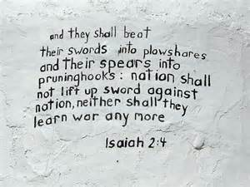



|  |  |  |
| --- | --- | --- |
| ***Reference*** | ***Fulfilled Literally*** | ***Fulfilled Typically*** |
| **7:14** | The Virgin birth of Christ (Matthew 1:23). |  |
| **8:14,15** |  | A stone of stumbling and a rock of offense (Rom. 9:33; 1Pet.2:8). |
| **8:17** |  | Christ's hope and trust in God (Heb.2:13a). |
| **8:18** |  | The Son of God and the sons of God  (Heb. 2:13b). |
| **9:1-2** |  | The arrival of Jesus in the area of Zebulun and Naphtali  (Matt. 4:12-16). |
| **9:6** | The birth of Immanuel  (Matt. 1:23; Luke 1:31-33; 2:7, 11). |  |
| **11:1** | Revival of the Davidic dynasty  (Matt 1:6, 16; Acts 13:23; Rev. 5:5, 22:16). |  |
| **12:3** |  | Water from the wells of salvation  (John 4:10, 14). |
| **25:8** |  | The swallowing up of death  (1 Cor. 15:54). |
| **28:11** |  | The gift of tongues as an authenticating sign of God's messengers  (1 Cor. 14:21, 21). |
| **28:16** | Incarnation of Jesus Christ (Matthew 21:42). |  |
| **29:18; 35:5** |  | Jesus' healing of the physically deaf and blind (Matt.11-5). |
| **40:3-5** | Preaching of John the Baptist  (Matt. 3:3; Mark 1:3; Luke 3:4-6; John 1:23). |  |
| **42:1a,2,3** | Christ at His baptism (Matt. 3:16,17) and transfiguration Matt.17:5) and His general demeanor throughout His first advent |  |
| **42:6** |  | Christ extended the benefits of the New Covenant to the church  (Hebrew 8:6, 10-12). |
| **42:7** |  | Jesus healed physical blindness and provided liberty for the spiritual captives  (Matthew 11:5; Luke 4:18). |
| **42:7** |  | Jesus removes spiritual darkness at His first coming (Matthew 4:16). |
| **50:6** | Jesus beaten and spat upon  (Matthew 26:67; Mark 14:64; Luke 22:63; John 18:22). |  |
| **50:7** | Jesus resolutely setting His face to go to Jerusalem  (Luke 9:51). |  |
| **53:1** | Israel failed to recognize her Messiah (John 12:38). |  |
| **53:4** |  | Jesus healed sick people as a symbol of His bearing of sin (Matthew. 8:16, 17). |
| **53:7-8** | Philip identifies Jesus as the one whom the prophet wrote  (Acts 8:32-35). |  |
| **53:7** | Jesus remained silent at all phases of His trial (Matthew 26:63; 27:12-14; Mark 14:61; 15:5; Luke 23:9; John 19:9; 1 Peter 2:23). |  |
| **53:7** | Jesus was the Lamb of God who takes away the sin of the world  (John 1:29; 1 Peter 1:18-19; Revelation 5:6). |  |
| **53:9** | Jesus was completely innocent of all charges against Him  (1 Peter 2:22). |  |
| **53:12** | Jesus saw the need to be crucified between two criminals  (Luke 22:37). |  |
| **54:13** |  | Jesus saw those who came to Him at His first advent as taught by God (John 6:45). |
| **55:3** | Chris's resurrection was prerequisite to His someday occupying David's throne on earth  (Acts 13:34). |  |
| **61:1,2a** |  | Jesus saw His first-advent ministry as a spiritual counterpart of His second-advent deliverance of Israel (Luke 4:18, 19). |
| **62:11** | Jesus fulfilled the call to the daughter of Zion in His  [Triumphal Entry](http://jewishroots.net/library/prophecy/zechariah/triumphal-entry-first-coming-2.html) (Matthew 21:5). |  |

**Source: The MacArthur Study Bible p.965**