**Seeking God’s Secrets—Week 4, Secret Societies and the Masons**

Intro.: Freemasonry, a historic mystery, is widely accepted as the largest and most influential occult body existing throughout the world today, and has inherited its imagery, known as esoteric (or occult) symbolism, directly from the fountainhead of the pagan ancient mysteries. The most authoritative Masonic writer ever, was held to be Albert Pike (1809-1891); he wrote “Morals and Dogma.” He rose to Sovereign Grand Commander of the Supreme Council of the thirty-third degree (Mother council of the World) and Supreme Pontiff of Universal Freemasonry. From Albert Pike, ““Fictions are necessary for the people, and the Truth becomes deadly to those who are not strong enough to contemplate it in all its brilliance. In fact, what can there be in common between the vile multitude and sublime wisdom? The Truth must be kept secret, and the masses need a teaching proportioned to their imperfect reason.” Masonry compares itself to Solomon’s temple of old and “builds its temple in the hearts of man” and strives for mankind to enter the next stage of evolution, a divine race. **George Washington was a Mason, along with** [**13 other presidents**](http://www.usnews.com/listings/freemasons/2-presidents) **(14 or our 43 presidents) and** [**numerous Supreme Court Justices**](http://www.usnews.com/listings/freemasons/6-supreme-court-justices)**. Benjamin Franklin published a book about Freemasonry on his own printing press. Nine signers of the Declaration of Independence were Freemasons, including the man with the biggest signature: John Hancock." OATH OF MASONS:** "*I do most solemnly and sincerely promise and swear...*

* **To have my throat cut across...**
* **My tongue torn out by the roots...**
* **And my body buried in the rough sands of the sea at low water mark, where the tide ebbs and flows in twenty-four hours...**

"*...should I ever knowingly or willingly violate this solemn oath or obligation as an Entered Apprentice Mason? So help me God."*

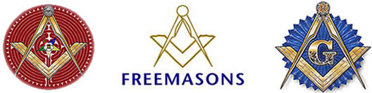

1. What is the secret of the “Secret Societies” from ages past? Read Jeremiah 33:3. **“Call unto me, and I will answer thee, and show thee great and mighty things, which thou knowest not.”**
2. **What is the “secret” that Satan is trying to achieve? Read Genesis 3:5. Discuss this in relationship to “the evolution of mankind.”**
   1. **Read Daniel 2:42-43. What does it mean “They shall mingle themselves with the seed of men; but they shall not cleave one to another?”**
   2. **What does God say about changing man’s DNA? See I Cor. 3:16-17, “Know ye not that ye are the temple of God, and that the Spirit of God dwelleth in you? If any man defile the temple of God, him shall God destroy; for the temple of God is holy, which temple ye are.” Also I Corinthians 6:19, “What? Know ye not that your body is the temple of the Holy Ghost which is in you, which ye have of God, and ye are not your own?”Masons talk about rebuilding “the temple,” which is the human body.**
   3. **The temple is the human body. What does Hosea, the Old Testament prophet, warn about in the last days? See Hosea 9:6, “For, lo, they are gone because of destruction: Egypt shall gather them up, Memphis shall bury them: the pleasant places for their silver, nettles shall possess them; thorns shall be in their tabernacles,” and discuss how the human body might be corrupted in the end days.**
3. **God warns His people against corrupt, occultic practices.** 
   1. **Read Deuteronomy 18:9, “**[When thou art come into the land which the LORD thy God giveth thee, thou shalt not learn to do after the abominations of those nations.](http://www.kingjamesbibleonline.org/Deuteronomy-18-9/)10 [There shall not be found among you [any one] that maketh his son or his daughter to pass through the fire, [or] that useth divination, [or] an observer of times, or an enchanter, or a witch,](http://www.kingjamesbibleonline.org/Deuteronomy-18-10/)11 [Or a charmer, or a consulter with familiar spirits, or a wizard, or a necromancer.](http://www.kingjamesbibleonline.org/Deuteronomy-18-11/)12 [For all that do these things [are] an abomination unto the LORD: and because of these abominations the LORD thy God doth drive them out from before thee.](http://www.kingjamesbibleonline.org/Deuteronomy-18-12/)
   2. **Examine** [**2 Kings 21:6**](http://www.kingjamesbibleonline.org/2-Kings-21-6/), And he made his son pass through the fire, and observed times, and used enchantments, and dealt with familiar spirits and wizards: he wrought much wickedness in the sight of the LORD, to provoke [him] to anger, [**Leviticus 19:31**](http://www.kingjamesbibleonline.org/Leviticus-19-31/), Regard not them that have familiar spirits, neither seek after wizards, to be defiled by them: I [am] the LORD your God. [**Isaiah 8:19**](http://www.kingjamesbibleonline.org/Isaiah-8-19/), and when they shall say unto you, Seek unto them that have familiar spirits, and unto wizards that peep, and that mutter: should not a people seek unto their God? For the living to the dead? [**2 Kings 17:17**](http://www.kingjamesbibleonline.org/2-Kings-17-17/) - And they caused their sons and their daughters to pass through the fire, and used divination and enchantments, and sold themselves to do evil in the sight of the LORD, to provoke him to anger. [**Acts 8:9**](http://www.kingjamesbibleonline.org/Acts-8-9/) - But there was a certain man, called Simon, which beforetime in the same city used sorcery, and bewitched the people of Samaria, giving out that himself was some great one, [**Micah 5:12**](http://www.kingjamesbibleonline.org/Micah-5-12/) - And I will cut off witchcrafts out of thine hand; and thou shalt have no [more] soothsayers:, [**2 Chronicles 33:6**](http://www.kingjamesbibleonline.org/2-Chronicles-33-6/) - And he caused his children to pass through the fire in the valley of the son of Hinnom: also he observed times, and used enchantments, and used witchcraft, and dealt with a familiar spirit, and with wizards: he wrought much evil in the sight of the LORD, to provoke him to anger, [**Deuteronomy 18:10**](http://www.kingjamesbibleonline.org/Deuteronomy-18-10/) - There shall not be found among you [any one] that maketh his son or his daughter to pass through the fire, [or] that useth divination, [or] an observer of times, or an enchanter, or a witch, [**Deuteronomy 4:19**](http://www.kingjamesbibleonline.org/Deuteronomy-4-19/) - And lest thou lift up thine eyes unto heaven, and when thou seest the sun, and the moon, and the stars, [even] all the host of heaven, shouldest be driven to worship them, and serve them, which the LORD thy God hath divided unto all nations under the whole heaven, [**Acts 19:19**](http://www.kingjamesbibleonline.org/Acts-19-19/) - Many of them also which used curious arts brought their books together, and burned them before all [men]: and they counted the price of them, and found [it] fifty thousand [pieces] of silver, [**2 Kings 9:22**](http://www.kingjamesbibleonline.org/2-Kings-9-22/) - And it came to pass, when Joram saw Jehu, that he said, [Is it] peace, Jehu? And he answered, What peace, so long as the whoredoms of thy mother Jezebel and her witchcrafts [are so] many, [**Deuteronomy 18:9-12**](http://www.kingjamesbibleonline.org/Deuteronomy-18-9_18-12/) - When thou art come into the land which the LORD thy God giveth thee, thou shalt not learn to do after the abominations of those nations, [**Leviticus 20:27**](http://www.kingjamesbibleonline.org/Leviticus-20-27/) - A man also or woman that hath a familiar spirit, or that is a wizard, shall surely be put to death: they shall stone them with stones: their blood [shall be] upon them, [**Revelation 22:15**](http://www.kingjamesbibleonline.org/Revelation-22-15/) - For without [are] dogs, and sorcerers, and whoremongers, and murderers, and idolaters, and whosoever loveth and maketh a lie, [**Colossians 2:8-10**](http://www.kingjamesbibleonline.org/Colossians-2-8_2-10/) - Beware lest any man spoil you through philosophy and vain deceit, after the tradition of men, after the rudiments of the world, and not after Christ, [**Galatians 5:20**](http://www.kingjamesbibleonline.org/Galatians-5-20/) - Idolatry, witchcraft, hatred, variance, emulations, wrath, strife, seditions, heresies,
   3. **What does God say about Pagan worship? See Romans 1:25.** The book of Romans gives us a perfect definition of the word "Pagan."  A Pagan is someone, "who changed the truth of God into a lie, and worshipped and served the creature more than the Creator, who is blessed forever. Amen."  [Romans 1:25]
   4. **Discuss Psalm 2, the conspiracy**. What does “bands” represent? How is the current push for gay marriage hinted at in the break-down of spiritual pureness in modern America? Can this destroy the basis of Christianity and the church?
      1. Who is Baphomet? God of Freemasons, male and female in one body, symbolizes “alchemy,” turn humans into gods
4. **Discuss the symbolism within Masonry**. As occultist Benjamin Creme states, "in Freemasonry is embedded the core or the secret heart of the occult mysteries, wrapped up on number, metaphor, and symbol"...

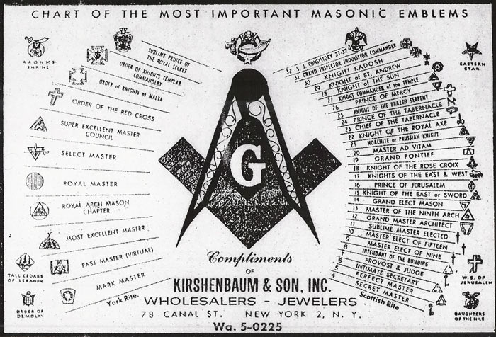

* 1. **Examine the “Square and the Compass,” the Masonic Symbol**, and Illuminati symbol.

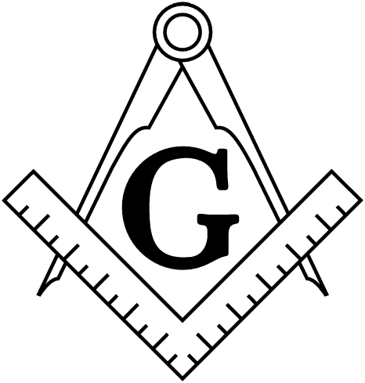 Female—earthly realm Male—heavenly realm gods—new creations/transhumanism

Albert Pike states within Morals and Dogma [page 631-32] that the Monad [#1] is male, and the Duad [#2] is female.  Their sexual union produces the Triad [#3], which is "represented by the letter 'G', the generative principle."  This term, "generative principle," is code for the sex act. This is representative of Genesis 6, the sons of god that came unto the daughters of men.

* + 1. **Does this symbol represent sex between fallen angels and humans?** The letter "G" is displayed quite often in Masonic symbols.   The initiate is told that this letter stands for "God" and for "Geometry," which the Supreme Architect of the Universe used to design the universe. However, Arthur Waite, Occultist and 33rd Degree Mason quotes Eliphas Levi who is also a 33rd Degree, tells us that the letter "G" stands for Venus, and that Venus' symbol is a lingam, a stylized phallus. [Masonic author, Arthur Edward Waite, The Mysteries of Magic: A Digest of the Writings of Eliphas Levi , Chicago, , DeLaurence, Scott, and Company, 1909, p. 217]Albert Pike states within Morals and Dogma [page 631-32] that the Monad [#1] is male, and the Duad [#2] is female.  Their sexual union produces the Triad [#3], which is "represented by the letter 'G', the generative principle."  This term, "generative principle," is code for the sex act
  1. **What about secrets?** In his book 'Morals and Dogma' *(accepted universally as 'the bible' of Freemasonry)* Pike admits: "Masonry like all religions, all the Mysteries, Hermeticism and Alchemy, ***conceals its secrets from all except the Adepts and Sages***, or the Elect and uses false explanations and misinterpretations f its symbols to mislead those who deserve to be misled; to conceal the Truth which it calls Light, from them, and to draw them away from it.”The Blue Degrees are but the outer court or portico of the Temple. Part of the symbols is displayed there to the Initiate, but he is intentionally misled by false interpretations. It is not intended that he shall understand them, but it is intended that he shall imagine he understands them" ('Final Notice' by Barry Smith pp. 328-329). “
     1. **Compare Deut.** 29:29, Psalm 139:15, Eccles., and Proverbs 3:32, Ezekiel 7:22, Leviticus 11:42-44, Jude 1:4.
     2. **Contrast the Bible, Mark 16:15, “**And he said unto them, Go you into all the world, and preach the gospel to every creature,” **and Deuteronomy 13:6-9**, “ **If thy brother, the son of thy mother, or thy son, or thy daughter, or the wife of thy bosom, or thy friend, which is as thine own soul, entice thee secretly, saying , Let us go and serve other gods, which thou hast not known , thou, nor thy fathers;** 7 **Namely, of the gods of the people which are round about you, nigh unto thee, or far off from thee, from the one end of the earth even unto the other end of the earth;** 8 **Thou shalt not consent unto him, nor hearken unto him; neither shall thine eye pity him, neither shalt thou spare , neither shalt thou conceal him:** 9 **But thou shalt surely kill him; thine hand shall be first upon him to put him to death , and afterwards the hand of all the people.”**
     3. **Examine also 2 Kings 17:9, Job 13:10, Psalm 17:12, Revelation 17:5, Proverbs 5:6, and Proverbs 7:7-10.**
     4. **The Bible holds the secret. See Matthew 10:27,**
     5. What does Albert Pike say? “We shall unleash the nihilists and the atheists and we shall provoke a great social cataclysm which in all its horror will show clearly to all nations the effect of absolute atheism; the origins of savagery and of most bloody turmoil. Then everywhere, the people will be forced to defend themselves against the world minority of the world revolutionaries and will exterminate those destroyers of civilization and the multitudes disillusioned with Christianity whose spirits will be from that moment without direction and leadership and anxious for an ideal, but without knowledge where to send its adoration, will receive the true light through the universal manifestation of the pure doctrine of Lucifer brought finally out into public view. A manifestation which will result from a general reactionary movement which will follow the destruction of Christianity and Atheism; both conquered and exterminated at the same time.”
     6. Manly P. Hall, “The Secret Teachings of All Ages, ““The true Mason is not creed-bound. He realizes with the divine illumination of his lodge that as Mason his religion must be universal: Christ, Buddha or Mohammed, the name means little, for he recognizes only the light and not the bearer. He worships at every shrine, bows before every altar, whether in temple, mosque or cathedral, realizing with his truer understanding the oneness of all spiritual truth. All true Masons know that they only are heathen who, having great ideals, do not live up to them. They know that all religions are but one story told in divers ways for peoples whose ideals differ but whose great purpose is in harmony with Masonic ideals. North, east, south and west stretch the diversities of human thought, and while the ideals of man apparently differ, when all is said and the crystallization of form with its false concepts is swept away, one basic truth remains: all existing things are Temple Builders, laboring for a single end. No true Mason can be narrow, for his Lodge is the divine expression of all broadness. There is no place for little minds in a great work.”
  2. Discuss the pillars in Masonry. Read I Kings 7:21. Discuss Jachin and Boaz.
     1. Compare these with the pillars or our DNA.—pillars have 23 chromosomes each. The “book” God wrote is our 46 chromosome, similar to the columns seen in each Masonic Lodge. Read Genesis 3: 1-6, “The devil speaks 46 words to eve to corrupt man’s DNA.  Now the serpent was more subtle than any beast of the field which the Lord God had made. And he said unto the woman, Yea, hath God said, Ye shall not eat of every tree of the garden?2And the woman said unto the serpent, We may eat of the fruit of the trees of the garden:3But of the fruit of the tree which is in the midst of the garden, God hath said, Ye shall not eat of it, neither shall ye touch it, lest ye die.4And the serpent said unto the woman, Ye shall not surely die:5For God doth know that in the day ye eat thereof, then your eyes shall be opened, and ye shall be as gods, knowing good and evil.6And when the woman saw that the tree was good for food, and that it was pleasant to the eyes, and a tree to be desired to make one wise, she took of the fruit thereof, and did eat, and gave also unto her husband with her; and he did eat. Also Deut 12:2 and 2 Kings17:10.
        1. “X” represents the X Chromosome, DNA…see “X Men,” transhumanism, Nexxus—2 things that combine, German Swastika, Swastika, 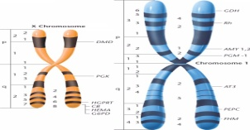, X Chromosome
        2. Genesis 3:14-15, against “serpent seed,” also called sons of Belial
        3. I Samuel 2:12, 2 Samuel 23:6, Deut. 13:13, Judges 19:22,20:13, I Kings 21:13, Matthew 23:33, Acts 13:10
        4. Deut. 22:9—don’t mix the seed
        5. Freemasons have stairways up and down with 23 stairs….Led Zeppelin’s “Stairway to Heaven” was written under a trance.
     2. See I Corinthians 6:19, “What? Know you not that your body is the temple of the Holy Spirit who is in you, whom you have of God, and you are not your own?”
     3. 2 Thessalonians 2:3-4, “3Let no man deceive you by any means: for that day shall not come, except there come a falling away first, and that man of sin be revealed, the son of perdition; 4Who opposeth and exalteth himself above all that is called God, or that is worshipped; so that he as God sitteth in the temple of God, showing himself that he is God.”
     4. **Examine Acts 17:24-25**, “24God that made the world and all things therein, seeing that he is Lord of heaven and earth, dwelleth not in temples made with hands;25Neither is worshipped with men's hands, as though he needed anything, seeing he giveth to all life, and breath, and all things;
     5. **Discuss Kundalini…..third strand, serpent that goes up the back bone to open up the ‘eye of the brain.’ The human backbone has 33 bones.**
     6. **Name the “46” words that the devil says to eve.**
  3. **Discuss “the ladder” in Freemasonry. 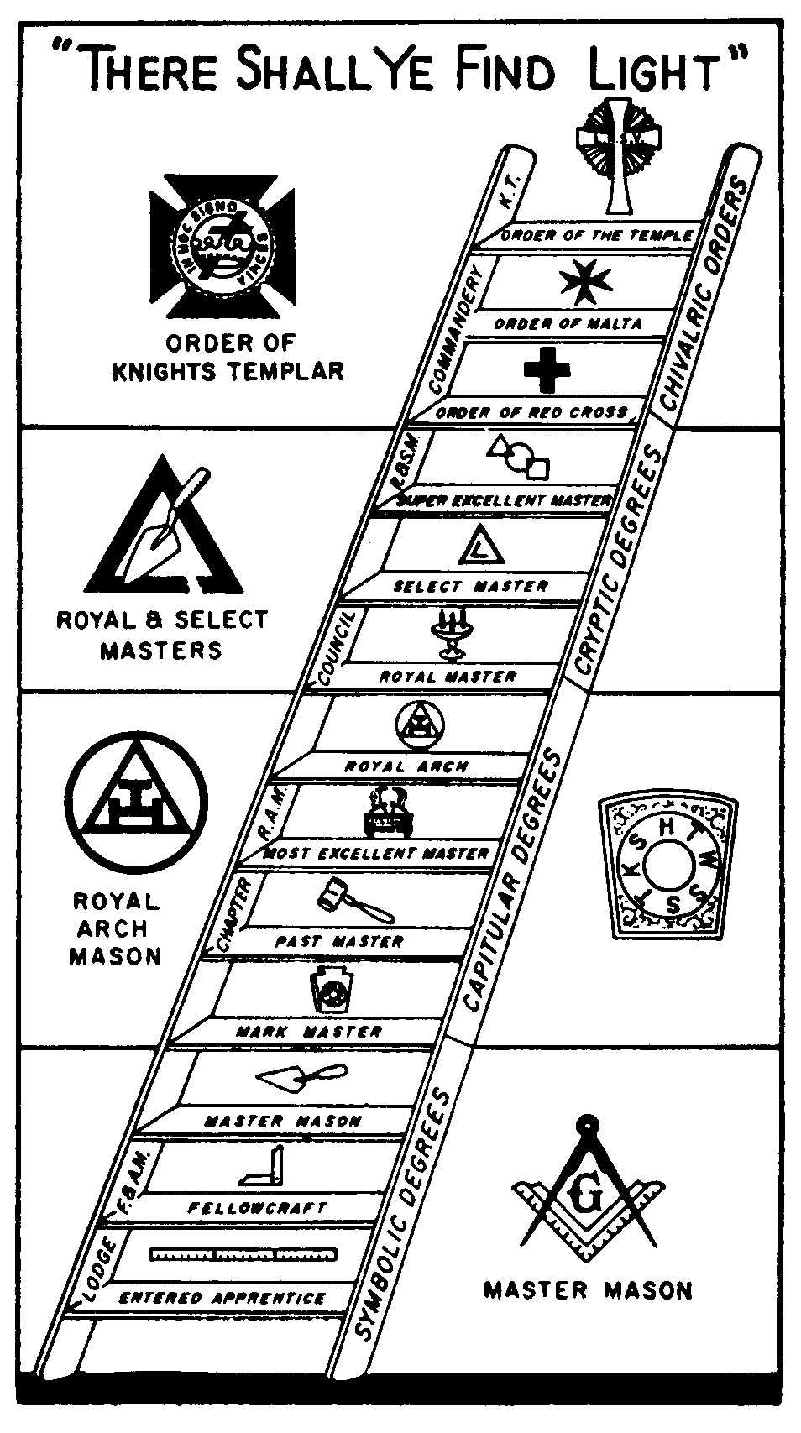Examine Genesis 28:10-15.** The ladder is a symbol that appears frequently in religious and esoteric contexts since ancient times.  It features prominently in the Tracing Board of the First Degree (Jacob’s ladder), and it is also an important symbol both in the Second Degree (the spiral staircase).  
     From remote antiquity, the ladder was taken as a paradigm of spiritual ascent.  In a bas-relief from the 3rd Dynasty of Ur, dated c. 2070-1960 B.C., there appears a seven-rung ladder ‘suggesting initiation leading from lower to higher realms of consciousness; above the initiate is the conjunction of a crescent moon and sun, symbolizing the union of masculine and feminine principles.  
     We find here the core of an explanation for the use of the ladder as a symbol in the First Degree of   
     The source of the connection made in Freemasonry between the ladder and the moral virtues can be traced back to the Greek philosophers: ‘Man’s arduous ascent to God is represented by a ladder.  John Klimakos (died c. 600andwhose name means John of the Ladder) laid the foundation for this graduated conception, rooted in neo-Platonism.  The starting point of this “ascent to Paradise” is Jacob’s dream’.
     1. **Compare the “ladder” symbolism in Masonry with “the winding staircase.” Read I Kings 6:8, “The door for the middle chamber was in the right side of the house; and they went up the winding stairs into the middle chamber, and out of the middle into the third.” The path to illuminations….urging mankind to seek God in himself.**
  4. **Explore the use of “lightness” and “darkness” in Freemasonry.** In the initiation of an Entered Apprentice, the "Worshipful Master" (Mat. 23:10) asks: "In your present condition, what do you most desire?" The candidate responds: "Light." The "Master" later informs the candidate that he is "yet in darkness." Then for the Second Degree (Fellow Craft) the candidate is required to ask for "more light." According to God's word, Jesus Christ is the LIGHT (John 1:9; 8:12) and God's word is LIGHT (Psa. 119:105, 130). If you are saved, then it is an outright BLASPHEMY for you to agree that you are "yet in darkness" and to ask for "more light." Please note: "This then is the message which we have heard of him, and declare unto you, that God is light, and in him is no darkness at all. If we say that we have fellowship with him, and walk in darkness, we lie, and do not the truth: But if we walk in the light, as he is in the light, we have fellowship one with another, and the blood of Jesus Christ his Son cleanseth us from all sin." (I John 1:5-7) So all Masons have DENIED Jesus Christ and have asked for another light being offered to them through Masonry. "And no marvel; for Satan himself is transformed into an angel of light." (II Cor. 11:14) The "God" of Masonry is not the God of the Bible! The Masonic god is the god of this world (II Cor. 4:4), which is BLINDING Masons from the true God of the Bible. Now the member is ready to climb the ladder of the Lodge and encounter some of the most ungodly practices known to man.
  5. Discuss the triangular symbol. **Masonic author, R.H. MacKenzie, states that "among Egyptians, the base [of the triangle] represented Osiris, or the Male Principle; the perpendicular, Isis, or the Female Principle; and the hypotenuse, Horus, their son ..." [Kenneth R.H. MacKenzie, The Royal Masonic Cyclopaedia of History, Rites, Symbolism, and Biography , New York, J.W. Bouton, 1877, p. 743] Thus, you can see that the hypotenuse was conceived as a result of the sexual union of the base and the perpendicular. Within Masonic symbolism, the sex act is portrayed as the union of the perpendicular and the base.** 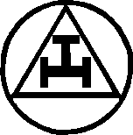
  6. **What about “The All-Seeing Eye?”** 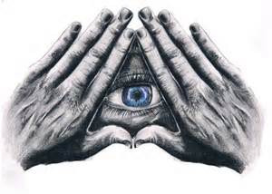 Freemasonry employs a mystical eye in its imagery known throughout the occult world as "the all-seeing eye." This symbol which is shared with most false religions, cults and occult bodies today has always been used as a symbol of 'deity'. Occultist Fredrick Goodman explains that, "The eye plays a most important part in occult symbolism and probably owes its origin in western magical designs to the Eye of Horus, which was one of the most frequently used of Egyptian magical symbols" (Magical Symbols p. 101).The Masonic third degree lecture teaches that the "All-Seeing Eye whom the Sun Moon and Stars obey, and under whose watchful care even comets perform their stupendous revolutions, beholds the innermost recesses of the human heart, and will reward us according to our works" (Beyond The Light' p. 136).
  7. **Discuss “The Obelisk.” The Egyptian God, Osiris:**  The Egyptians represented Osiris, their chief deity, by the symbol of an open eye and placed this hieroglyphic of him in all their temples. His symbolic name, on the monuments was represented by the eye accompanying a throne to which was sometimes added an abbreviated figure of the god and sometimes what has been called a hatchet, but which may as correctly be supposed to be a representation of a square.
  8. **What about the Masonic Apron, a symbol of defiance? 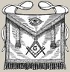Almost in symbolic defiance to God, new Masons are given aprons and told it is the most precious symbol of Masonry.  Remember, in the Garden of Eden (Genesis 3:7) once they realized they were naked Adam and Eve sewed together an apron of fig leaves.  God was displeased with this and gave them coats made from skin.  In the 3rd degree many Masons get a silver serpent emblem for his apron.**
  9. **What about “Salvation through good works and upright character?**” Freemasonry once again outlines its erroneous teaching of 'salvation through an upright character and good works'. This is in complete violation of Scripture which teaches: "Knowing that a man is not justified by the works of the law, but by the faith of Jesus Christ, even we have believed in Jesus Christ, that we might be justified by the faith of Christ, and not by the works of the law: for by the works of the law shall no flesh be justified" (Galatians 2:16).
     1. **Portrayed their leaders as gods, for instance, George Washington.** The **Apotheosis of Washington** is actually the huge fresco painted on the inside of the main dome of the U.S. Capitol Building. The tendency to make the first president into a god shows how easily people can get twisted by power.
  10. **Worship of the sun and moon.** The book of Acts tells us how the disobedient children of Israel brought such imagery into the camp and how God dealt with it: "Then God turned, and gave them up to worship the host of heaven; as it is written in the book of the prophets, O ye house of Israel, have ye offered to me slain beasts and sacrifices by the space of forty years in the wilderness? Yea, ye took up the tabernacle of Moloch, and the star of your god Remphan, figures which ye made to worship them: and I will carry you away beyond Babylon" (Acts 7:42-43).
  11. **What is “The Five-Pointed Star?”….**The five-pointed star, known as the pentagram, is probably the most blatant occult symbol in use today. 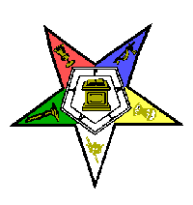This symbol is one of the most prominent emblems within Freemasonry, though its significance, like every symbol inherited from the occult, is ***concealed*** behind a smokescreen of secret society ambiguity. The five-pointed star is found on most Masonic memorabilia and represents the blasphemous resurrection rite of the five points of fellowship, each point mystically symbolizing a part of the resurrection act. First - Foot to foot. Second - Knee to knee. Third - Hand in hand. Fourth - Breast to breast. Fifth and last - Left hand behind back.
  12. **Why are the columns important in the symbolism?** The broken column is utilized by the Eastern Star and Freemasonry.  It contains many levels of meanings.  The initiate is told that the broken column signifies an early death. The Mason learns later on that columns represent gods. [ Joseph Fort Newton, The Builders: A Story and Study of Masonry , Cedar Rapids, Iowa, The Torch Press, 1914,  p. 9]A different hidden meaning for the broken column is learned later on by the Mason.  "In Egyptian Mythology, Isis is sometimes pictured weeping over the broken column, which conceals the body of her husband, Osiris, while behind her stands Horus, or Time, pouring ambrosia over her hair." Isis was both virgin and mother, so the 'beautiful virgin is Isis weeping. The broken column is the missing member of Osiris, the Phallus. [Short Talk Bulletin, "The Broken Column," Feb, 1956, p. 6-7; also Edmond Ronayne, The Master's Carpet (Mah-Hah-Bone), 1879, p. 387-88, and several other Masonic authors]Horus is another name for Satan.    Isis is the consort of Lucifer.  Isis just lost her husband (Osiris) that is the reason why she is weeping.  Osiris' body was dismembered, including his penis, which had been cut into many sections.   Isis and Osiris were written about by Albert Pike, saying they were "the Active and Passive Principles of the Universe ... commonly symbolized by the generative parts of man and woman ..." [Morals and Dogma, p. 401] you must focus on the bottom of the broken column and not the top.  The bottom of the column shows the phallic upright column inserted into the circular base, which is the symbol of the female vulva. The column is broken; of course, to symbolize the belief that Osiris' penis had been cut into many sections. But Albert Mackey, 33 Degree Masonic author, states that the regular column is a phallus symbol. "The Phallus was an imitation of the male generative organ. It was represented usually by a column, was surrounded by a circle at the base." [Mackey, a Manual of the Lodge, 1870, p. 56. Mackey also stated this in The Symbolism of Freemasonry , p. 60]
      1. **Do the columns represent DNA? Read Daniel 2:18-19, 43.**
      2. The number 33. Thirty-three is a very important number – in ancient mysticism. There's a reason that Jesus Christ was said to be 33. There is a reason that there are 33 vertebrae in our spine and that much of Freemasonry has to do with the concept of the body as a temple. Thirty-three repeats throughout the Masonic house of the temple. There are 33 columns or pillars, each one 33 feet tall. The cap on the Washington Monument weighs 3300 lbs.
  13. **Lies that abound. This is what the Freemason, Manly P. Hall,** who Masons highly regard as a modern day Masonic philosopher revealed about Masonry's deception “Freemasonry is a fraternity within a fraternity - an outer organization concealing an inner brotherhood of the elect. Freemasonry is a hidden fraternal order, and defined by them as a system of morality. The first three steps are the Blue Lodge. The first degree is called Entered Apprentice. The second degree is called Fellow Craft. The Third degree is called Master Mason. Most men only go to the third degree, but if one chooses, he may advance either through the York Rite or the Scottish rite. The Scottish rite has thirty-two degrees. In each degree, the Mason pledges himself to a different Egyptian deity. There is a thirty-third degree that is largely honorary, but the thirty-two degrees give you access to becoming a Shriner. As a Shriner you will place your hand on the pagan Muslim Qur'an (Koran) and pledge yourself to the [pagan "god" Allah](http://www.bibleprobe.com/muhammad.htm); who by the way lies that Jesus did not even die on a cross, and that God has no Son.  This pagan 'Allah' never once shows that it knows the real name of God (Jesus/Yeshiva/Yahweh/I am).
  14. **What about the “G?”** Ex-33 degree Mason Jim Shaw says; "The Blue Lodge Mason is taught that the "G" in the basic Masonic symbol represents God.  Later on, he is told that it represents "deity".  Later still, he is told that it represents "geometry". In reality, this letter represents the "generative principle," the Sun-god and, thus, the worshipped phallus, the male "generative principle..." In its position (along with the square and compass) on the east wall over the chair (throne) of the Worshipful Master, it is the representation of the Sun, thus of the Sun-god, Osiris.  Its earthly meaning, then, is of the sacred phallus; its cosmic meaning is of the Sun, worshipped since antiquity by pagans while facing the East.  *Reference, book: The Deadly Deception", page 144*
  15. **The Conclusion.** **The ultimate object of secret societies**, even back to the days of Hermes, who many know as the 'father of the occult' - has been to take a new recruit with a belief in a personal God - and to ultimately, over time, change that recruit's belief to believe that there is no God, and that the recruit is his own God. It's just like Satan thinking before his fall, that he (Lucifer) is like God. Usually it is preferable and easier if that new recruit has a belief in God. Masonry requires a belief in ANY God, even a cow or a monkey.   
        
      The 'secret society process' is that the recruit indoctrinates himself with the secret society's spiritual and mystical teachings, until at last this society's teachings actually become the all-consuming focus of his life. Masonry keeps this deprogramming process quiet from the public, and also quiet to the first several levels of Masonry. Hermes was one of the earliest intellectuals to believe that he was his own authority and that it was that old belief in a personal God and all that went with it (sorrow for sin, sorrow for greed, sorrow for not loving his neighbor, etc.) that kept him back in life. Thomas Paine, one of our most famous founders, like Benjamin Franklin, was a Deist.  He believed in one God, but rejected all religions, saying:  "My own mind is my own church." He also maintained an interested in Freemasonry. His pamphlet, Origin of Free-Masonry, proposed that Masonry's embodiment of the sun worship of ancient Druidism was a legitimate alternative to Christianity. He notes that **Freemasonry's god, "...Osiris and Isis**, theologically represented the Supreme Being and universal Nature..." Paine wrote in his famous "The Age of Reason": "I do not believe in the creed professed by the Jewish church, by the Roman church, by the Greek Church, by the Protestant church, nor by any church that I know of.  My own mind is my church. Karl Marx, Lenin and Trotsky, were all Freemasons.

|  |
| --- |
| The lie... “…salvation by faith and the vicarious atonement were not taught as now interpreted, by Jesus, nor are these doctrines taught in the esoteric scriptures.  They are later and ignorant perversions of the original doctrines.” (J. D. Buck, “Mystic Masonry,” p.57)  "Acacian: a term signifying a Mason who by living in strict obedience to obligations and precepts of the fraternity is free from sin." (A. Mackey, "Lexicon of Freemasonry, page 16). Strict obedience includes not witnessing about Jesus or even mentioning His name in the Lodge. |
| **The truth... “**For God so loved the world, that he gave his only begotten Son, that whosoever believeth in him should not perish, but have everlasting life.**”** (John 3:16)  "Verily, verily, I say unto you, He that believeth on me hath everlasting life." (John 6:47)   “**For by grace are ye saved through faith**; and that not of yourselves: it is the gift of God: Not of works, lest any man should boast.” (Ephesians 2:8-9) |

**At the Heart of Masonry is Lucifer:**

**High level Masons believe that Lucifer never fell to earth and that Lucifer is really God, and refer to Yahweh by the name of ‘Adonay.’**

**Masons say that it is Yahweh that is the god of evil**, because he forces men to be subservient to his repressive dictates.Masonic books given to handpicked members of the 32nd and 33rd Degrees, say that Jesus was an impostor, and that Lucifer is the true God… **Manly Palmer Hall, a great authority on Masonry, writes, "When the Mason ... has learned the mystery of his Craft, the seething energies of Lucifer are in his hands. ..."**

In his most famous book, "[*Morals and Dogma*](http://www.freemasonrywatch.org/moralsanddogma.html)". Albert Pike said that "... Masonry is identical with the Ancient Mysteries ..." (On Page 624, 28th Degree). As you read this Masonic book and others, you will be amazed at how many stories of the gods and goddesses from the many Ancient Religions are written in full detail, as instructions to Freemasons!

Truth Revealed in the highest 33rd degree of Masonry:

"The highest degree of the Scottish Rite of Freemasonry, the Meritorious Degree, the Degree of the Illuminati, whose motto is **"Ordo Ab Chao" or "Out of Chaos Comes Order".** This literally means if Masons break down the existing structure and cause the population to cry out for order, they will emerge as the rulers and will have the world that they seek.

Is it possible a global government controlled by illuminati and Masons can happen -- begun by bankrupting the United States and the U. S. Catholic Church, and using homosexuals as dupes?