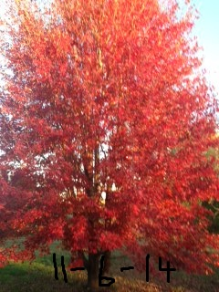

Figure Maple Tree 2014

**Thoughts on my maple tree...**

**The wonder and beauty of autumn are best displayed right outside my bathroom window.  Erupting before my view is a raucous array of crimson, flame orange, and butterscotch gold. Delightful, rich, strong-warm, exquisite colors!  Yeah, fall! Yeah, change of seasons in Kansas!   
   
Not that that scene was entirely unexpected, not that that picturesque beauty was unique, not that that horizon-filled, smash-box of painter's-like splotches were foreign to my skyline, but, it was, this year more than most, greatly anticipated and thoroughly, completely appreciated!**

**After an extremely brutal, ghastly, record-exploding, non-relenting, 'beyond-the-blast-of-an-oven' summer, I longed for a whisper of fall, a hint of relief, a glimpse of help, and wondered if the horrible, grueling "season of heat" would ever end.  I yearned for the "stability and 'sureness'" of autumn's normalcy!  I actually craved "the changing of the seasons." I found it... this morning in the sight of my own, personal, singing-of-God's-promises, gorgeous maple tree, in the "I told you cooler weather would come" dictates of His watch-care over me!  And, like most life-lessons from my Lord, I went to my knees in great gratitude for the rock solid, forever 'real and sure,' steadiness of God, who, by allowing that beautiful kaleidoscope outside my panes, once-again re-emphasizes that He never forsakes me and ALWAYS STAYS STEADY, even when the "heat is excruciating!"  This breath-taking morning, I am drawn to His Word, His grounded, "I  
 am more than you will ever need" promises:   
Malachi 3:6, "For I am the Lord, I do not change." and  Hebrews 13:8, " Jesus Christ is the same yesterday, today, and forever."   
   
And so, as I take in the spectacularly, splendidly-colored, slide show just beyond my perimeters, I, FOR SURE, will be "shouting loud" in joyous praise to my exquisitely beautiful Lord and Savior who gives me ginormous grace and such beauty to behold!  Happy Autumn's Morning!  Thank You, precious Creator, for wielding Your exquisite paint brush, right before my very eyes!**  
   
It is always, Because of Him, Lindi