**Revelation Chapter 15—(shortest chapter. In Revelation)**

**Precedes the Bowl Judgments**

**Now in Chapters 15 and 16 we see the final outpouring of God's wrath before Christ's return. That wrath is expressed by the effects of the seventh trumpet which was opened in chapter 11, verse 15. Chapter 15 is very short and begins the introduction to those last seven judgments,**

# Revelation, Chapter 15

Revelation chapter 15 begins the preparation for the last seven vials. The wrath of God began with the seven seals in chapter 6 and will be finished with the last seven vials. Chapter 15 is an introduction to these last seven and final plaques on mankind.

Throughout history God has poured out his wrath in judgment on early sinners. Adam's sin in the Garden of Eden brought the entire human race under judgment.

By Noah's days, people had turned so wicked, that God sent the judgment of the flood to destroy the entire world except eight people. Noah, his three sons and their wives.

Centuries of disobedience and wickedness by the Jewish people eventually led to their judgment and captivity. First the northern 10-1/2 tribes in 722 B.C. by the Assyrian Empire, then the southern kingdom of Judah in 586 B.C. by the Babylonian Empire.

Cities named Sodom and Gomorrah was completely destroyed by God with fire and brimstone.

Now in Chapters 15 and 16 we see the final outpouring of God's wrath before Christ's return. That wrath is expressed by the effects of the seventh trumpet which was opened in chapter 11, verse 15. Chapter 15 is very short and begins the introduction to those last seven judgments.

**Chapter 15**

**15:1 "And I saw another sign in heaven, great and marvelous, seven angels having the seven last plagues; for in them is filled up the wrath of God."**

This chapter in the book of Revelation sets the stage for the last seven vial judgments that cover the last three and one-half years of the tribulation which are described in Revelation chapter 16.

The seven angels prepare to administer the last seven Tribulation judgments of Christ: the seven vials). Vials are actually shallow bowls (these are called the bowl judgments), used for pouring libations (5:8; 1 Chronicles 28:17; Jeremiah 52:18; Zech. 9:15; 14:20). The bowls are full of the wrath of God (2 Thess. 1:7 - 9). God has the right to judge, because He is the Eternal incense that filled the Holy of Holies in the tabernacle. Until the seven plagues are finished, no one is able to enter into the temple. The time for intercession is past; God's judgment will now be completed.

This "seven" just means this is the end. The only good thing about these plagues is that the Christians are in heaven when this occurs. The wrath of the devil is bad, but to fall into the hands of Almighty God and have His wrath fall on unbelievers is the very worst thing that could happen.

These plagues will conclude with the wrath of God on sinful mankind for rejecting His Son, the Lord Jesus Christ.

The last seven plagues indicate that these are in order and this finishes the 21 total plagues on mankind before the end of time.

**15:2 "And I saw as it were a sea of glass mingled with fire: and them that had gotten the victory over the beast, and over his image, and over his mark, [and] over the number of his name, stand on the sea of glass, having the harps of God."**

The sea of glass was before God's throne in Rev. 4:6. "*And before the throne [there was] a sea of glass like unto crystal: and in the midst of the throne, and round about the throne, [were] four beasts full of eyes before and behind*."

John was seeing the same crystal platform, but now it was mixed with the fire of God's judgment.

The victory over the beast has been won through faith in Christ and refusal to submit to the Antichrist. These are the Tribulation Martyrs who are rejoicing over the victory they have won. The harps indicate they are rejoicing and singing praise to God. These believers are rejoicing because their prayers for God's vengeance on their persecutors are about to be answered.

**Revelation 15:3 "And they sing the song of Moses the servant of God, and the song of the Lamb, saying, Great and marvelous [are] thy works, Lord God Almighty; just and true [are] thy ways, thou King of saints."**

This "they" are the believers in Christ. The "song of Moses" and the "song of the Lamb" are the same. This is the song of redemption. God used Moses to redeem His people from bondage in Egypt. Moses leads the people out of the land of Egypt to the Promised Land prefiguring now Jesus is leading the Saints to that Promised Land we call heaven.

Who purchased this for us?  Who did all the work Himself? Jesus. His works are "marvelous". It is beyond our imagination to see a beautiful snow-capped mountain and realize that the One, who created that, also loved us enough that He climbed on the cross and suffered for us. He has every right to be our King. Remember in all of this, He is not just a loving God, but a "just and true" God as well.

The exclamation, "just and true" reflects the Old Testament truth that all of God's works are true and His ways just Dan. 4 v.37; Deut. 32 v.4; and Hosea 14 verse 9.

"Lord God Almighty" celebrates God's omnipotence, essential to the triumphant power of the last judgments and appears frequently in Revelation. This name just tells us of His overwhelming power.

**Revelation 15:4 "Who shall not fear thee, O Lord, and glorify thy name? For [thou] only [art] holy: for all nations shall come and worship before thee; for thy judgments are made manifest."**

In Proverbs 9:10 we read "The fear of the LORD [is] the beginning of wisdom: and the knowledge of the holy [is] understanding."

We are not to fear the world or its people. We are "to fear" (Reverence) God.

This "all nations shall come and worship", is speaking of the time when Jesus will sit on a throne in Jerusalem and rule the world. There will be a yearly pilgrimage by everyone to worship. We see Jesus is the only Holy one.

 A Philippians 2 verse 10 -11 says”That at the name of Jesus every knee should bow, of things in heaven and things under the earth; And that every tongue should confess that Jesus Christ is Lord, to the glory of God, the Father."

After God's righteous acts of judgment have been made manifested or revealed, the time of Isaiah will come: "And it shall come to pass, [that] from one new moon to another, and from one Sabbath to another, shall all flesh come to worship before me, saith the LORD."

**Revelation 15:5 "And after that I looked, and, behold, the temple of the tabernacle of the testimony in heaven was opened:"**

This "tabernacle" is the original tabernacle in heaven that the one on the earth was patterned by. Moses was given instruction by God how to build the earthly one.  The tabernacle was opened by Jesus, as the temple curtain which was in front of the Holy of Holies, was torn from the top to the bottom, when Jesus died on the cross.

In an earlier vision given John, God's throne room was opened so the faithful could see in. We see here that it "was opened" (past tensed). Now the heavenly tabernacle, which the earthly tabernacle was a copy, was opened to reveal the most severe earthly judgment ever on the unrepentant.

The tabernacle was sometimes referred to as the tabernacle of the testimony, so named as it contained the testimony. The two stone tablets which God had written the Ten Commandments on.

**Revelation 15:6 "And the seven angels came out of the temple, having the seven plagues, clothed in pure and white linen, and having their breasts girded with golden girdles."**

Seven golden vials full of the wrath of God. These are the "plagues" that will strike the earth in the last three and one-half years to punish those who have chosen to serve the Antichrist, doing his bidding to persecute the saints for their faith in Christ.

So many people in this current, new wave of believers think that all punishment comes from the devil and no bad thing comes from God. They better take another look at this Scripture right here. These "angels" are operating under God's orders. They have just come "out of the temple" (which shows the origination). They are clothed in white (which shows they are good angels and not demons). The gold of their breasts show that they have been in the presence of God.

**Revelation 15:7 "And one of the four beasts gave unto the seven angels seven golden vials full of the wrath of God, who liveth forever and ever."**

Here, again, we see these "vials" are from God, because they are gold. These "sevens" just show the completeness of it all.

And again, we see the eternity of God in the forever and ever. They are ready to pour the wrath out on the inhabitants of the earth. God has the power to put an end to sin so that it can never exist again in His holy presence.

**Revelation 15:8 "And the temple was filled with smoke from the glory of God, and from his power; and no man was able to enter into the temple, till the seven plagues of the seven angels were fulfilled."**

As soon as the angels in verse 6 come out of the Temple, great smoke from the glory of the presence of God and His power and wrath fills the Temple so that neither angels nor human beings can go back into worship until "the seven plagues of the seven angels are completed."

We know that in the tabernacle in the wilderness, no one could go inside. God is a consuming fire as we read in Hebrews 12:29 "For our God is a consuming fire."

During this time no created human being will have access to the presence of God on His throne until the end of the Tribulation, for He will not be dealing with people in mercy, as is His usual custom. During the latter three and one half years of the Tribulation, He will deal with human beings in judgment.

This glory cloud will remain in the heavenly temple until the earth is completely purged, cleansed and prepared for the King and His kingdom that is coming.

This "smoke" is from the Majesty of God. The children of Israel were led by God Himself. We read that a fire led them by night and a cloud by day, Exodus 13:21.  This is the very same presence we read of here. No mere man can enter this holy place. Jesus enters here for us and takes us with Him after we are covered by His (Jesus) blood.

God sees Jesus' shed blood, instead of us, when we enter (after we are a believer); and that shed blood is what keeps us from being burned up in God the Father's presence.

God's anger is kindled at those on the earth who have caused such sorrow to the church and the true believers, and His fury has come in His face. These plagues, as we said before, are from God. What a terrible thing it is to fall into the hands of the Living God and be judged by Him guilty and deserving of His wrath.

In Hebrews 10:30-31, we read about just how terrible it is for the sinner to fall into His hands.

Hebrews 10:30-31 "For we know him that hath said, Vengeance [belongeth] unto me, I will recompense, saith the Lord. And again, The Lord shall judge his people." "[It is] a fearful thing to fall into the hands of the living God."

**Seals/Trumpets/Bowls Compared**

|  |  |  |  |
| --- | --- | --- | --- |
|  | **Seal** | **Trumpet** | **Bowl** |
| ***1*** | white horse  conquering—arrival of antichrist  (political change) | **to the earth**  hail & fire w/ blood  1/3 earth burned,  1/3 trees burned,  1/3 grass burned | **on earth**  loathsome and malignant sores (on mark of beast) |
| ***2*** | red horse  takes peace from earth  (sociological change) | **to the sea**  mountain burning with fire thrown into sea  1/3 sea becomes blood | **on sea**  sea became blood |
| ***3*** | black horse  w/ scales and money  (economic change) | **to the rivers & springs**  star burning like torch fell  1/3 waters become wormwood | **rivers**  became blood |
| ***4*** | ashen horse  kill w/ sword, famine, pestilence, & beasts  (ecological/demographical change) | 1/3 sun struck  1/3 mood struck  1/3 stars struck  (shine 1/3 less) | **sun**  scorch men w/ fire |
| ***5*** | martyrs cry out for vengeance  given white robes while wait for more of them | locusts released from bottomless pit, tormented non-believers for 5 months, sting like scorpions | **throne of beast**  kingdom darkened (gnawed tongues) |
| ***6*** | great earthquake, sun blackened, moon like blood, stars fell to earth, kings of earth hid | Kill 1/3 mankind with plagues: fire, smoke, brimstone | **the great river**  Euphrates dries up |
| ***7*** | prayers of saints go up to God, 7 trumpets given to 7 angels | Lightning, thunder, earthquake, great hailstorm. | **the air**  earthquake, leveling planet, 100 lb hail |

1. **Verse one says, “Another sign” in heaven. Where do we see this same terminology evidenced? Read Revelation 12:1 and Revelation 12:3. What are the other two signs? The woman clothed with the sun, and the red dragon. Revelation 12-13, the woman clothed in the sun, and moon under her feet.** When John claims that *I saw in heaven another great and marvelous sign,* he recalls for us the "great and wondrous sign" in heaven in 12:1 ("a woman clothed with the sun") and "another sign . . . in heaven" in 12:3 ("an enormous red dragon"). The third sign, so long in coming, consists of *seven angels with the seven last plagues--last, because with them God's wrath is completed* (v. 1).
2. **What does “great and marvelous” describe in verse 1?**
3. **What is the “sign in heaven?” 7 angels with the 7 last plagues complete the wrath of God.**
4. **Who are the 7 angels? Read Revelation 8:2 and Revelation 21:9.** 7 angels to 7 churches; read Revelation 2-3. The seven angels prepare to administer the last seven Tribulation judgments of Christ: the seven vials). Vials are actually shallow bowls (these are called the bowl judgments), used for pouring libations (5:8; 1 Chronicles 28:17; Jeremiah 52:18; Zech. 9:15; 14:20). The bowls are full of the wrath of God (2 Thess. 1:7 - 9).
5. **Define the wrath of God; revisit Revelation 14:19b. Discuss retributive justice?**
6. **In verse 2, what is the “sea of glass?” These occupants came out of the Great Tribulation. In heaven, the martyrs from the peoples, multitudes, nations, and languages, who will stand before God. Mingled with “fire?” Is always judgment. Read Revelation 4:6, Revelation 14:2, these are the harpers from this chapter, and Revelation 17:15. The victory over the beast has been won through faith in Christ and refusal to submit to the Antichrist. These are the Tribulation Martyrs who are rejoicing over the victory they have won. The harps indicate they are rejoicing and singing praise to God. These believers are rejoicing because their prayers for God's vengeance on their persecutors are about to be answered.**
7. **How does John define “victory” in verse 2? Over the beast, his image, his mark, and the number of his name.**
8. **What does “playing on harps” indicated? Read I Samuel 16:23; I Chronicles 15:16; Psalm 33:2; Psalm 98:5; Ezekiel 26:13.**
9. **What “Song of Moses” does verse 3 describe? Discuss Exodus 15 and Deuteronomy 32 and the rescue of the Israelites from Egypt. Compare it with the “Song of the Lamb” in Revelation 5:6-10.**
10. **The words “great and marvelous” are used in verse 3 just like in verse 1. Discuss. The truth of the revelation of Chapter 15—God always blesses obedience, when sin is put down, and John sees that the future for those that forsake sin are given great promises. When righteousness finally wins, it is great and marvelous.**
11. **“Who shall fear God?” Verse 4 infers about the decline of reverence to God in our times by the human race.. Read Proverbs 9:10 and Philippians 2:10-11. Deliberate.** In Proverbs 9:10 we read "The fear of the LORD [is] the beginning of wisdom: and the knowledge of the holy [is] understanding." Philippians 2 verses 10 -11 says  "That at the name of Jesus every knee should bow, of things in heaven and things under the earth; And that every tongue should confess that Jesus Christ is Lord, to the glory of God, the Father."
12. **What is the temple mentioned in verse 8? Read Hebrews 12:29 and Revelation 15:8. This is the temple in heaven. The temple is mentioned 15 times in Revelation, but not until after verse 4 when the church is raptured.** The tabernacle, ark, etc., are replicas of those in heaven. "And the temple was filled with smoke from the glory of God, and from his power; and no man was able to enter into the temple, till the seven plagues of the seven angels were fulfilled."As soon as the angels in verse 6 come out of the Temple, great smoke from the glory of the presence of God and His power and wrath fills the Temple so that neither angels nor human beings can go back into worship until "the seven plagues of the seven angels are completed."We know that in the tabernacle in the wilderness, no one could go inside. God is a consuming fire as we read in Hebrews 12:29 "For our God is a consuming fire."During this time no created human being will have access to the presence of God on His throne until the end of the Tribulation, for He will not be dealing with people in mercy, as is His usual custom. During the latter three and one half years of the Tribulation, He will deal with human beings in judgment. This glory cloud will remain in the heavenly temple until the earth is completely purged, cleansed and prepared for the King and His kingdom that is coming. This "smoke" is from the Majesty of God. The children of Israel were led by God Himself. We read that a fire led them by night and a cloud by day, Exodus 13:21.  This is the very same presence we read of here. No mere man can enter this holy place. Jesus enters here for us and takes us with Him after we are covered by His (Jesus) blood. God sees Jesus' shed blood, instead of us, when we enter (after we are a believer); and that shed blood is what keeps us from being burned up in God the Father's presence. God's anger is kindled at those on the earth who have caused such sorrow to the church and the true believers, and His fury has come in His face. These plagues, as we said before, are from God. What a terrible thing it is to fall into the hands of the Living God and be judged by Him guilty and deserving of His wrath. In Hebrews 10:30-31, we read about just how terrible it is for the sinner to fall into His hands. .Hebrews 10:30-31 "For we know him that hath said, Vengeance [belongeth] unto me, I will recompense, saith the Lord. And again, The Lord shall judge his people." "[It is] a fearful thing to fall into the hands of the living God."
13. **In verse 6-7, describe the angels that exit the heavenly temple. Who gives the golden bowls full of the “wrath of God” to the angels? Why? This verse ends the preamble to the bowl judgments. From here on, it gets very rough. Heaven ceases its intercession to disperse the final judgments. Mercy is finished.**
14. **The word “bowl” is also the same as “vial.” Describe. Shallow bowl, more like a censor.**
15. **Define “smoke” and fire in the temple. Refer to the smoke in Solomon’s temple. Read 2 Chronicles 7:1, Exodus 91:18, and Leviticus 9:23-24, I Kings 18:38, and Exodus 40:35.**
16. **Where do these judgments come from? God, not the devil….the wrath of God.**
17. **What is the purpose of chapter 15? Does it describe the heavenly activities that preempt the final judgment of God? Give details. Wrath will be finalized and poured out on sin….we are headed to a new heaven and a new earth, a re-creation of the whole earth.** [**Revelation 15**](javascript:na_open_window('win',%20'scripture_files/rev_15.htm',%200,%200,%20300,%20400,%200,%200,%200,%201,%201)) is the beginning of the end for the tribulation period.  This chapter provides the preparation for the final set of seven judgments which will end the tribulation and establish the Lord's millennial reign.  As a result, the following chart shows a single event as a red dot and a vertical bar with text explaining what is happening, at the top of the chart in the second half of the tribulation.
18. **Summarize Chapter 15, noting the foreboding tone of its ominous warnings. Site, for example, the similarities with the seal and trumpet judgments, compared to the plagues of Egypt (see below chart), and look ahead in Chapter 16 to the trumpet judgments which are coming. Note the differences and parallels.**

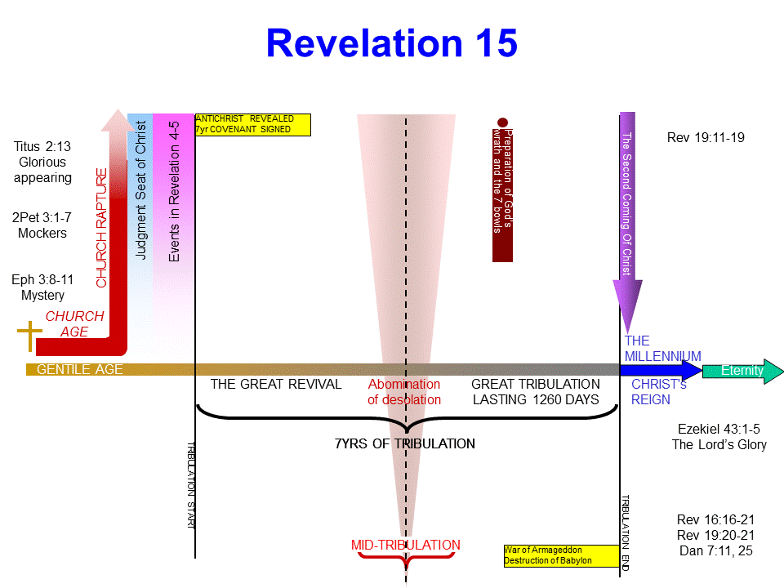

1. The events described in [**Revelation 15**](javascript:na_open_window('win',%20'scripture_files/rev_15.htm',%200,%200,%20300,%20400,%200,%200,%200,%201,%201)) are shown in the following graph with the red dot and bar.  Again, this is the final preparation for the end of the tribulation.

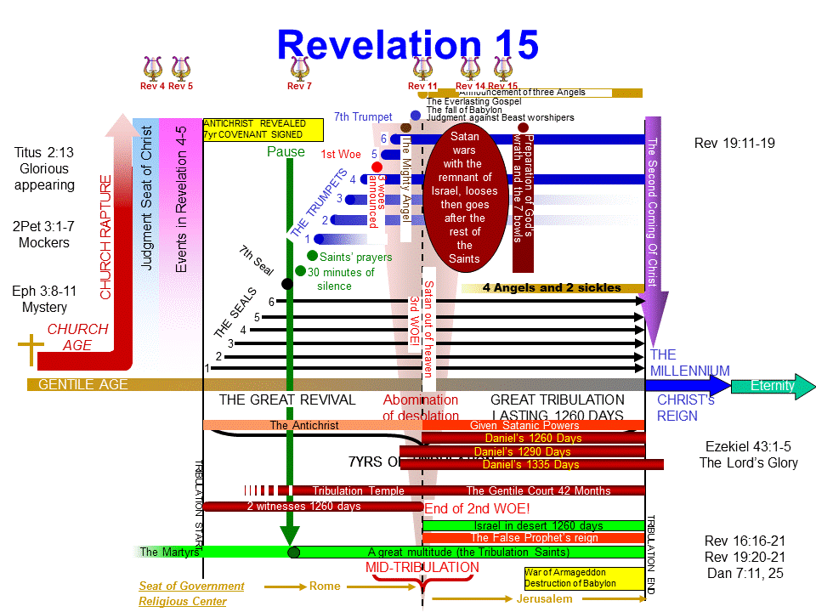

**Here’s the promise:**

**Isaiah 30:29,** “You shall have a song as in the night when a holy feast is kept, and gladness of heart, as when one sets out to the sound of the flute to go to the mountain of the Lord, to the Rock of Israel.”

**Revelation 19:11-14**, “11 [And I saw heaven opened, and behold a white horse; and he that sat upon him was called Faithful and True, and in righteousness he doth judge and make war.](http://www.kingjamesbibleonline.org/Revelation-19-11/)12 [His eyes were as a flame of fire, and on his head were many crowns; and he had a name written, that no man knew, but he himself.](http://www.kingjamesbibleonline.org/Revelation-19-12/)13 [And he was clothed with a vesture dipped in blood: and his name is called The Word of God.](http://www.kingjamesbibleonline.org/Revelation-19-13/)14 [**And the armies which were in heaven followed him upon white horses**, clothed in fine linen, white and clean.](http://www.kingjamesbibleonline.org/Revelation-19-14/)”

**Here’s the preview for the next chapter, “The beginning of the end”**

