**Revelation 12: 1-6, NKJV, “Now a great sign appeared in heaven: a woman clothed with the sun, with the moon under her feet, and on her head a garland of twelve stars. 2Then being with child, she cried out in labor and in pain to give birth.3And another sign appeared in heaven: behold, a great, fiery red dragon having seven heads and ten horns, and seven diadems on his heads. 4His tail drew a third of the stars of heaven and threw them to the earth. And the dragon stood before the woman who was ready to give birth, to devour her Child as soon as it was born. 5She bore a male Child who was to rule all nations with a rod of iron. And her Child was caught up to God and His throne. 6Then the woman fled into the wilderness, where she has a place prepared by God, that they should feed her there one thousand two hundred and sixty days.”**

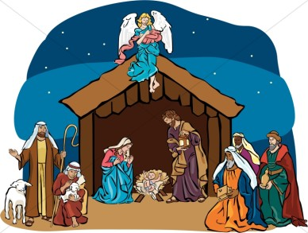 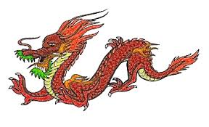

**Dear Enders**, here is the picture you should have received from our study in Revelation 12.  I wanted to make sure that  I highlighted the “Christmas Story” in Revelation 12 clearly to you!  When you set up your nativity set EACH YEAR, you should also include “the fiery red dragon” that makes an appearance to try to “foil” the salvation story.  Of course, we know he doesn’t succeed, and when you re-read Revelation 12, you will see that the devil, once again, loses.  Doesn’t this make your idea of the “Christmas Story” seem more real?  Doesn’t it make more and more sense about what was really going on?  But, never forget what Isaiah told us, centuries before Jesus’ birth….**Isaiah 9:6, “For unto us a child is born, unto us a son is given: and the government shall be upon his shoulder: and his name shall be called Wonderful, Counselor, The mighty God, The everlasting Father, The Prince of Peace.”  Isaiah knew it; the devil knew it, too!**

**And, while Revelation 12 points to the “Christmas Baby,” it also reveals the real foe who would engage Him until the final triumph in Revelation 19. Heads up, my friends, for we battle against the fiery dragon who seeks to destroy, all the while understanding that the Messiah Himself will call us “cloud-ward” with a shout! Heads up eastward, my dear friends!  Christmas triumphed that long ago day, despite the red dragon’s attempt; Christ will do the same. May you understand the Christmas story with the intensity that surrounded it, because of your new and true knowledge that your study of Revelation reveals!  We read on and study harder!  Thank you for your dedication and diligence!**

**It is always and always and always because of Him, Lindi**

**MERRY CHRISTMAS! Indeed!**