**Revelation Review**

Revelation is an Apocalypse, a Prophecy, and an Epistle (or Letter). Authored by John, the beloved of Jesus and an apostle, while he was a prisoner on the Island of Patmos, approximately 85-95 A.D., the purpose of Revelation is to give encouragement and hope for all Christians to continue watching for the return and triumph of the Lord Jesus Christ. It also is to warn of the Final Judgment that nonbelievers will endure on that Last Day.

**•    In chapters 1-3**, John describes the details of the setting as he received this revelation (unveiling of truth). John was elderly and imprisoned on the Island of Patmos when he received an apocalyptic vision from an angel. With this vision he was instructed to write to seven churches about what he had seen. He describes of the seven churches their qualities and/or their weaknesses and failings (such as Sardis and Laodicea).

**•    In chapters 4-20,** John depicts what he sees in his vision about the Spiritual Realm. He describes Jesus Christ as the *“Slain Lamb”* who is the only one able to open the book with 7 seals. Aside from the 5th seal, each will bring a judgment upon the populace of the Earth.

**Chapter 1—The Throne in Heaven**

John wrote about a blessing to the reader, *“Blessed is he who reads and those who hear the words of the prophecy, and heed the things which are written in it; for the time is near”* (1:3).

***The Outline of Revelation:* Revelation 1:19, describes a basic outline of the entire letter written by John, *“Therefore write the things which you have seen,* Jesus Christ, (1:12- )*, and the things which are,* Churches, (2-3), *and the things which will take place after these things,* The Tribulation and Millennium (4-22)*”* this is the pattern that is followed by John**….

**Rev. 4:1 is a “tie up” to one more ‘loose string’/question ‘hanging’ in the Bible…**The answer to Matthew16:28,** “Verily I say unto you, There be some standing here, which shall not taste of death, till they see the Son of man coming in his kingdom,” is John’s being “called up” to heaven in Rev. 4:1. Thus, John was permitted to live until, in vision, he saw the Return of the Lord.

**Chapter 2-3—The Churches**

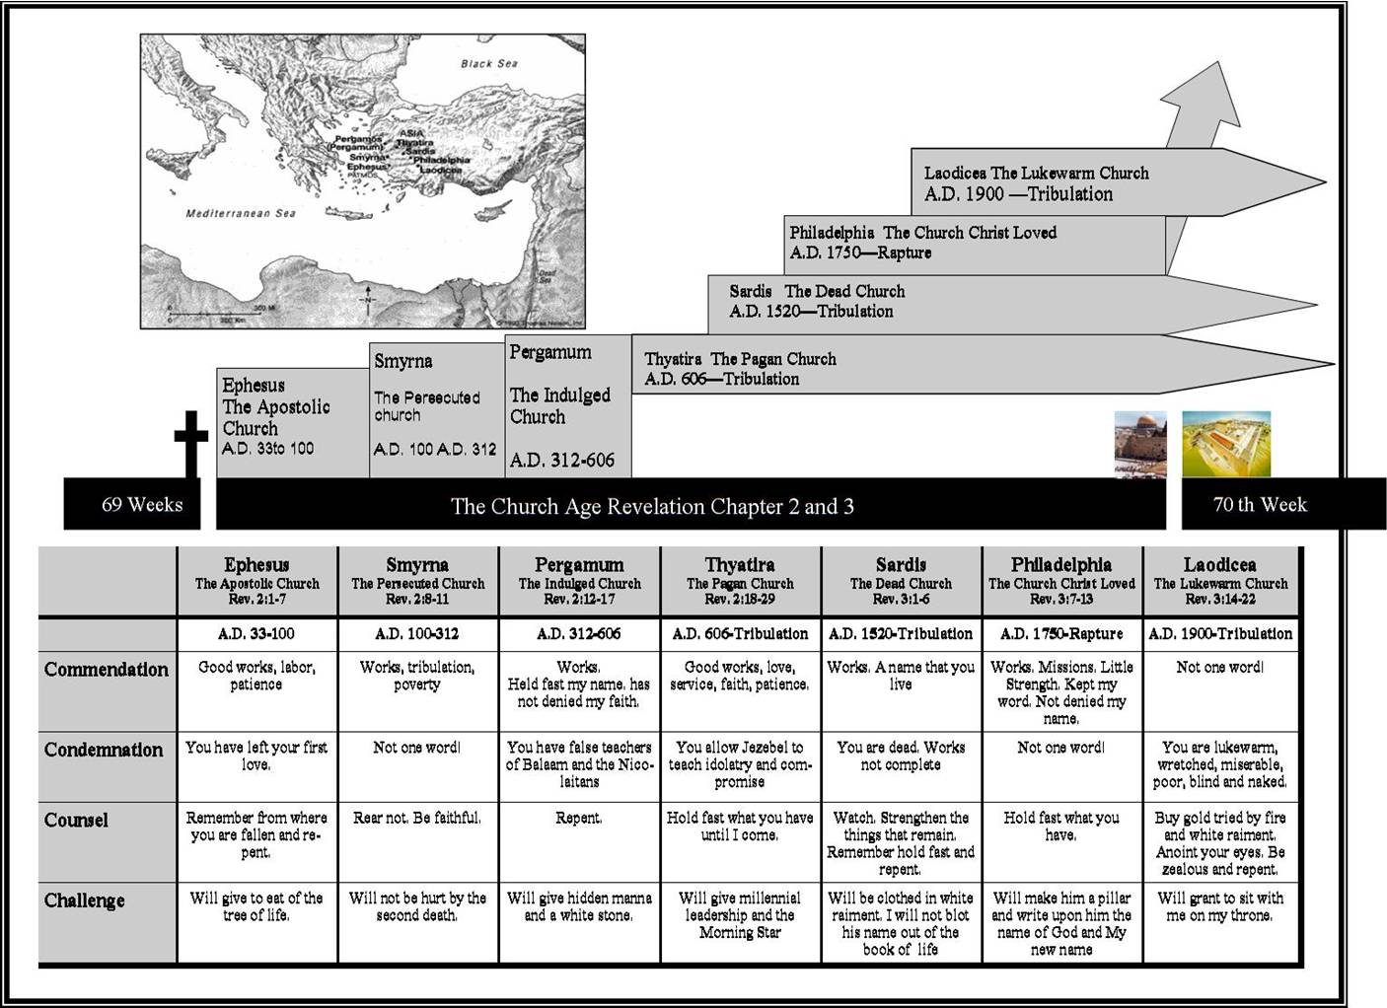

**Chapter 4—the Throne Room**

1. **When does mention of the church seem to disappear in Revelation?**
2. **Who are the twenty-four elders in Revelation 4?**
3. **What was the Seven-Sealed Scroll? Explain why it was “the Title Deed to Earth.”**

**John called up; the rapture; the throne room; the elders***Things to know:**

**Rev. 4:1-Rapture**

**John 14:1-3, I Cor. 15:51-52, I Thess. 4:16-17, 2 Thess. 2:6-8, Rev. 3:10, I Thess. 5:9, Luke 21:36, I Thess. 1:10**

1. **What crowns are promised the believer?**
   1. **Crown of life, for those who have suffered for His sake, James 1:12, Rev.2:10, 2.**
   2. **Crown of Righteousness, for those who loved His appearing, 2 Tim. 4:8, 3.**
   3. **Crown of Glory, for those who fed the flock, 1 Peter 5:4, 4.**
   4. **Crown Incorruptible, for those who press on steadfastly, I Cor. 9:25, 5.**
   5. **Crown of Rejoicing, for those who win souls, I Thess. 2:19.**
2. **Four Faces/living creatures surrounding the throne……ox/calf, man, eagle, lion**

**Chapter 5—The Lamb and the Scroll**

**The lamb and the scroll**

**Describe the lamb and the scroll, title deed**

**Chapter 6—The Seals**

### COMPARISON OF CHRIST'S "OLIVET DISCOURSE" AND REVELATION SIX"

By Clarence Larkin, MATT. 24:1-3

**Seal One—White Horse, antichrist, Seal Two—red horse, war, Seal Three—Black horse, famine, scales, Seal Four—Pale Horse, death and Hades, Seal Five—Souls of the martyrs under the throne—seen in Chapter 7 with the palm leaves—their prayers are answered here, Seal Six—great earthquake**

|  |  |  |  |  |  |
| --- | --- | --- | --- | --- | --- |
| **THE SEVEN SEALS OF THE REVELATION** | | | | | |
| **Seal** | **Text** | **WHAT THE PROPHET JOHN SAW** | | **THE MEANING** |
| [**1**](http://avoiceinthewilderness.org/prophecy/revbook/seals1-4.html) | **Rev. 6:2** | **A WHITE HORSE** | **Its rider carried a bow and went forth conquering and to conquer.** | **This seal portrays the going forth of Yahweh's Warning Truth concerning COUNTERFEIT: Baptisms, Sabbath Days, Messiahs and Bibles. Beware!** |
| [**2**](http://avoiceinthewilderness.org/prophecy/revbook/seals1-4.html#secondSeal) | **Rev. 6:3-4** | **A RED HORSE** | **Its rider was given a great sword and proceeded to take peace from the earth.** | **This seal tells of wars, revolutions and bloodshed on an unparalleled scale. The great sword symbolizes world wars involving many nations.** |
| [**3**](http://avoiceinthewilderness.org/prophecy/revbook/seals1-4.html#thirdSeal) | **Rev. 6:5-6** | **A BLACK HORSE** | **Its rider held a pair of scales and weighed out food at extremely high prices. (E.g. a whole day's wages for two measures of wheat).** | **This seal brings to view world-wide famines when prices for even the barest of life's necessities will spiral out of control. (A whole day's wages for two measures of wheat).** |
| [**4**](http://avoiceinthewilderness.org/prophecy/revbook/seals1-4.html#fourthSeal) | **Rev. 6:7-8** | **A PALE, SICKLY, greenish HORSE** | **Its rider's name was Death and Hell followed him.** | **This seal symbolizes pestilence and disease epidemics of various kinds which will lay low millions of people.** |
| [**5**](http://avoiceinthewilderness.org/prophecy/revbook/seals5-6.html) | **Rev. 6:9-11** | **SOULS UNDER THE ALTAR** | **Souls were heard crying for justice. They were told to wait for a while till a further martyrdom took place.** | **This seal reveals a further persecution of God's people, a persecution as intense as any which occurred in the past.** |
| [**6**](http://avoiceinthewilderness.org/prophecy/revbook/seals5-6.html#sixthSeal) | **Rev. 6:12-17** | **CELESTIAL SIGNS** | 1. **A great earthquake.** 2. **The sun turned black.** 3. **The moon turned blood-red.** 4. **The stars (meteorites) fell.** 5. **The sky was rolled back as a scroll.** 6. **Earth's population was terrified.** | **These are literal signs in the physical universe. When they occur blind panic will overtake the inhabitants of the world.**  **Note: The Messiah does not return to earth during this seal.** |
|  | |  |  |  |
|  |  |  |  |  |
|  |  |  |  |
|  |  |  |  |

**2. Rev. 6:2-Antichrist appears,**

**3. Rev. 6:17-Tribulation begins.**

**In Chapter 6, what is the final question asked?** Who can stand? Chapter 7 answers this question.

**Chapter 7—first parenthesis chapter—between 6th and 7th seal**

**The144,000 witnesses—discuss missing tribes of Dan and Manasseh**

**The multitude with palms, saved during the tribulation—this answers the cry of the martyrs in Seal Five, Chapter 6**

1. **In Luke 21:36, Jesus says, “Pray always that you will be able to escape.” “Escape” what? John never asks a question in the entire book of Revelation.**
2. **Here are the “Pause Sections”/ parenthetical parts in Revelation: Rev. 7:1-17, Rev. 10:1-11, Rev. 11:1-14, Rev. 12, Rev. 13, and Rev. 14. Why do you think John chooses to pause in strategic locations? The first pause answers the question in Rev.6:7, “Who can stand?”**
3. **There are two divisions in the Chapter 7: Sealed Servants (1-8) Saved Servants (9-17)**
4. **Contrast the Tribulation Saints with the 24 Elders (The Church):**

**Not Crowned Crowned**

**Palms in hands Harps in hands, no palms**

**Saved “out of “tribulation “Kept out of” tribulation-- Rev. 3:10**

**Stand before thrones Sit on thrones—I Cor. 6:2-3**

**Serve Him day and night Reign as kings and priests**

**Not recognized by John (I Cor. 6:2-3, I Pet. 2:9, Rev. 1:6)**

1. **In the Book of Revelation who explains to John about heaven? The elders. The earth? The angels**
2. **What are the first four seals on the scroll? The four horseman**
3. **How are the fifth and sixth seal different than the first four seals?**
4. **Who are martyrs under the throne?**
5. **In Chapter 6, what is the final question asked?** Who can stand? Chapter 7 answers this question.
6. **Read Daniel 12:4. How does “knowledge being increased” apply to our study of Revelation?**

**Chapter 8—The Seventh Seal, Trumpet 1-4**

The 7th seal introduces 7 angels who each possess 7 trumpets, another series of daunting judgments.

|  |  |  |  |
| --- | --- | --- | --- |
| **Revelation chapter 7 is inserted between Seals 6 & 7**  **The 7th Seal is Silence in Heaven, Rev. 8:1 and introduces the 7 trumpets** | [**THE SEALING OF YAHWEH'S SERVANTS**](http://avoiceinthewilderness.org/prophecy/revbook/sealing.html) | **By divine authority the devastation of the earth, the sea and the trees was delayed till the servants of God were sealed in their foreheads and right hands. 144,000 Israelites were sealed.** | **The Signature of Yahweh the God of Israel is the Sabbath days in the sacred calendar. These are the seventh day of the week (Saturday) and the seven annual Sabbaths as specified in Lev. chapter 23. Each one is a sacred memorial of a divine achievement in the plan of Salvation. In short, Yahweh seals his people with obedience.** |

**7th Seal—Silence in Heaven for ½ hour—silence before wrath, 7 days in ark before flood, Joshua’s army marching around 6 days silent, then the wrath.**

|  |  |  |  |
| --- | --- | --- | --- |
| **Rev. 8:7** | **Trumpet** [**1**](http://avoiceinthewilderness.org/prophecy/revbook/trump1-5.html#firstTrumpet) | **A third of the earth, a third of the trees and all the green grass were burned. Hail and fire mixed with blood** | **This damaging of the earth, the sea and the trees will only take place after the sealing work is completed (Rev. 7:3). The Trumpets, in other words, cannot even commence their destruction till all 144,000 Israelites are sealed.  When the Trumpets eventually do sound, a time of great devastation will begin on earth.  The terms earth, sea, trees, grass, fish, ships etc. may have symbolic as well as literal meanings. But it must be remembered that ONE THIRD OF MANKIND are slain at Trumpet No. 6, so it is most unlikely that these terms also represent mankind.** |
| **Rev. 8:8-9** | **Trumpet** [**2**](http://avoiceinthewilderness.org/prophecy/revbook/trump1-5.html#secondTrumpet) | **A third of the sea became like the blood of a dead man. A third of the fish perished and a third of the ships sank. Mt. falling into the sea. Volcano.** |
| **Rev. 8:10-11** | **Trumpet** [**3**](http://avoiceinthewilderness.org/prophecy/revbook/trump1-5.html#thirdTrumpet) | **A third of the rivers of water were made bitter and many people died. Star fell, Wormwood, into the waters.** |
| **Rev. 8:12** | **Trumpet** [**4**](http://avoiceinthewilderness.org/prophecy/revbook/trump1-5.html#fourthTrumpet) | **The sun, moon and the stars were then darkened by a third.** |
| **Angel flying through heaven** |  | **Woe, woe, woe!** | **Announces the 3 woes** |
|  |  |  |  |

**Chapter 9—Trumpet 5-6**

|  |  |  |  |
| --- | --- | --- | --- |
| **Rev. 9:1-12** | **Trumpet** [**5**](http://avoiceinthewilderness.org/prophecy/revbook/trump1-5.html#fifthTrumpet)**FIRST WOE!** | **The Bottomless Pit (Abyss) was then opened and an evil host of locusts led by Abaddon the King of the Abyss came forth. They proceeded to torture all mankind for five months - all except those who had received Yahweh's Seal at the time of the sealing. These believers were supernaturally protected from Abaddon's power.** | **The Abyss is a place - or condition - in which God has imprisoned a host of evil angels. Abaddon, the King of the Abyss, is a demon of great depravity. At this Trumpet, he is given leave to torture and brutalize mankind for 5 months: that is, all except the servants of the Most High who accepted the Seal of God in their foreheads and right hands (minds and actions) at the time of the sealing.** |
| **Rev. 9:13 to Rev. 11:14** | **Trumpet** [**6**](http://avoiceinthewilderness.org/prophecy/revbook/trump6.html)**SECOND WOE!** | **Four mighty angels were then loosed from the Great River Euphrates. Aided by a force of 200,000,000 they killed ONE THIRD OF MANKIND. At this time the holy city is trampled underfoot for a period of 42 months (3½ years).  Nephilim creatures.** | **During this seal, ONE THIRD OF MANKIND will be slain.  The Beast, who we are told also rises from the Abyss, could well be Abaddon the Destroyer, the Lawless One, the Son of Hell, the Exterminator from the Bottomless Pit. His Mark is the age-old** |
|  |  |  |  |

Incredibly, after the 6th trumpet in which 1/3 of the Earth’s population is killed, John claims, *“The rest of mankind, who were not killed by these plagues, DID NOT REPENT’* (9:20).

**Chapter10—2nd parenthesis chapter, between 6th and 7th trumpet**

The third woe is revealed after the seventh trumpet judgment. This woe is parallel to the trumpet that sounds in [Joel 2](http://biblia.com/bible/esv/Joel%202) and signals the consummation of God’s plan for the entire world. This third woe marks the finishing of God’s judgment on sin; it occupies the book of Revelation through the 19th chapter, when Christ’s Kingdom is established on earth. Incorporated within this third and final woe is the seven “bowls” of God’s wrath, described in [Revelation 16:1-21](http://biblia.com/bible/esv/Revelation%2016.1-21). This series of judgments is the greatest horror the citizens of earth have ever seen. Jesus said, “If those days had not been cut short, no one would survive” ([Matthew 24:22](http://biblia.com/bible/esv/Matthew%2024.22)).

**The Mighty Angel, Jesus, the little book, and John eating it…..John’s charge to prophesy.**

**And, here’s our promise…..Romans 8:21-25, NKJV, “….**because the creation itself also will be delivered from the bondage of corruption into the glorious liberty of the children of God. For we know that the whole creation groans and labors with birth pangs together until now. 23Not only *that,* but we also who have the first fruits of the Spirit, even we ourselves groan within ourselves, eagerly waiting for the adoption, the redemption of our body. 24**For we were saved in this hope**, but hope that is seen is not hope; for why does one still hope for what he sees? 25But if we hope for what we do not see, **we eagerly wait for *it* with perseverance.”**

**Chapter 11……the Two Witnesses**