|  |  |  |  |  |  |  |
| --- | --- | --- | --- | --- | --- | --- |
| |  | | --- | | **Name of Church** |   Title of Christ | **Strengths/**  **Commendation** | **Failures/**  **Criticism** | | **Instruction** | **Promise To Faithful** |
| Loveless  **EPHESUS**  (Rev. 2:1-7) |  |  | |  |  |
| Suffering  **SMYRNA**  (Rev. 2:8-11) |  |  | |  |  |
| Worldly  **PERGAMUM**  (Pergamos)  (Rev. 2:12-17) |  |  | |  |  |
| Wrong  Doctrine  **THYATIRA**  (Rev. 2:18-29) |  |  | |  |  |
| Spiritually  Dead  **SARDIS**  (Rev. 3:1-6) |  |  | |  |  |
| Spiritually Alive  **PHILADELPHIA**  (Rev. 3:7-13) |  |  | | . |  |
| Complacent  **LAODICEA**  (Rev. 3:14-22  **Closing Phrase--“He that hath an ear” appears for all churches.** |  |  |  | |  |

**Revelation Chapter 2**

**Ch.2—The Work of Churches to Do**

**Acrostic for 7 Churches—“Every Saved Person Truly Seeks a Perfected Life”**

**Isaiah 46:9-10, NKJV, “Remember the former things of old: for I am God, and there is none else; I am God, and there is none like me,Declaring the end from the beginning, and from ancient times the things that are not yet done, saying, My counsel shall stand, and I will do all my pleasure.”**

1. 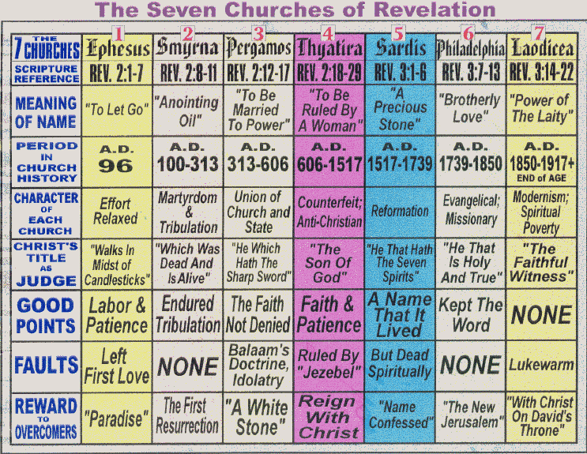
2. **According to the Bible, define “church.” The “church age” started fifty days after Jesus was raised from the dead on Pentecost, the Feast of Weeks, and is divided into seven periods. The “church age” is the period of time that the “church” is on earth. Read Acts** **20:28; Romans 12:3-5**; **1 Corinthians 10:31-33**; **1 Corinthians 12:12-26**; **Ephesians 1:18-23**; **Ephesians 5:25-32; Colossians 1:17-20**; **Colossians 3:14-16**; **1 Peter 2:9-10**; **Ephesians 2:19-22. Is the church always compared to “believers?”**
3. **Are the churches local for that day? Do they represent phases in history? Do they represent every church today? Do they represent individual Christians today? Four of the churches demonstrate a spirit of compromise—Ephesus, Pergamum, Thyatira, and Laodicea. Sardis is dead. Smyrna and Philadelphia are faithful. Threat of immediate discipline for lack of repentance for Ephesus, Pergamum, Thyatira, and Laodicea.**
4. **Why are Chapters 2 and 3 the key to Revelation?**
5. **Re-read Revelation 1:20. What are the churches? Where are the Lampstands?**
6. **Is Jesus Himself inspecting the “church” in His epistles?**
7. **What are “the things which are?” The Churches**
8. **What is the “like” phrase used in each church description? “He that hath an ear let him hear what the Spirit says to the churches.” Plural—every church was to hear what He said to each and every church.**
9. **Discuss the level of application of these passages….local, to all church, homiletic (personal), prophetic *not all people agree with this* In the order that they’re in, they profile the history of the church since its beginning. Every one of the seven churches was surprised by their “report cards” from Jesus.**
10. **The Church of Ephesus**
11. **Describe the Church of Ephesus—Apostolic Church. Devotion, not just doctrine. Neglected Priorities. (52 A.D.-100 A.D) 2:2-7, on chart, fill-in the essentials on the chart. Appears to be a profile of the Apostolic Church. Compromised Church. “Ephesus” in Greek means “Desired One,” Darling. Roman city with a big amphitheater temple of Diana, not as fired-up because something happened, Nicolas was one of the seven deacons who started to take power on himself; men followed him and began to break-up churches, the Nicolatians, Ephesian believer—lost first love, no longer is Jesus #1, allowed other things to take up most of your thoughts, times, and prayer life—Christian rut. You justify sin and have lost the desire for the lost to be saved. Acts 18-19…Paul traveled to Ephesus and spent three months reasoning with the Jews in the synagogues. Priscilla and Aquila are there. All in all, Paul spent over two years in Ephesus, different trips. Ephesians—vs. 1 “saints.”—are God’s people; notice uses “we” and “you”—Ephesians 1:3-12—having “predestined us to adoption”—vs. 11, use Septuagint, or New English Translation—pivotal, “In Christ we have been claimed as God’s Own Treasure”—“we” are the Jews, “you” are the Gentiles in Ephesus. There is an inheritance “in the saints”—the Jews. “By grace you were saved.” “Together”—implies that God grafted “we, the Jews” and “you, the Gentiles” together in Jesus. Ephesians 3…..”you” is the Gentiles; “mystery”—has now been revealed that the Gentiles are “let in” or the “grafting in” of the Gentiles to the Jewish nation.”Fellowship of the mystery”—made known. Largest city of its day in N. T. times.**
12. **What are the seven commendations for the Ephesus church? Vs. 2-3. 1. Thy works, 2. Thy labour 3. Thy patience, 4. How thou canst not bear them which are evil, 5. Are not and hast found them liars, 6. For my name’s sake hast labored, 7. Hast not fainted.**
13. **In verse 4, the word “left your first love” is used and not the word “lost.” Comment. Jesus’ right hand represents power.**
14. **In verse 5, what does Jesus imply by “removing your lamp stand?”**
15. **Structure of Ephesian letter has a Postscript. Read. Rev. 2:7. What does that promise to the overcome imply?**
16. **Read what Paul’s warning to this church? Read Acts 20:25-31; 2 Cor. 11:13-14, I Thess. 5:20-21. Timothy was probably the first bishop to this church. Paul warned the elders of this church. Read Acts 18-29.**
17. **What were John’s warnings to the Ephesian church? First John is an epistle to Ephesus. “OR ELSE”—VS.5-6. Read I John 4:1-2, 2 John 9-10, and Acts. 20:27-29. What are “grievous wolves?” Diana and Artemis were worshiped in this town. Lysimachus (after Alexander) became its leader. At one time it was called “The Queen of Asia,” and had a wonderful harbor. But, that ceased and filled in. A major crossroads in trade. May have had the very first bank in the world. Had the Temple of Diana, the daughter of Zeus, one of the seven wonders of the ancient world. Center for arts and magic…occult. Paul later made a 2nd visit…58 a.d. Here we find Aquila, Priscilla and Apollo. Timothy, John, and Mary’s tombs are in Ephesus. They left their first love….too busy for God! Do First Works! Remember, Repent, and Repent again! Left their devotion…. Personal application……difference in David and Solomon, Solomon became apostate, while David simply loved God and repented. They were required by Caesar to offer a pinch of incense once a year to prove that they thought he was the number one god. Many Christians refused and were martyred.**
18. **Who are the Nicolatians? 1st century sent, claiming apostolic authority. Nicolas formed a sect, meaning to conquer or overcome; deeds are a tendency of the clergy to rule over the laity. The deeds are hated; not the people. Known for excessive lusts, priests over laity, coming between the common people and God.**
19. **Where is the lamp stand of Ephesus today? Gone**
20. **“He Who Hath an Ear to Hear”—Read Mark 4:9, Matthew 11:15, 13:9, 43; Luke 8:8, 14:35.**
21. **What does Jesus mean by “overcomer?” Read I John 5:4-5; I John 5:1.**
22. **Revelation lists thirteen rewards for the “overcomer.”**
    1. **Authority over nations (2:26)**
    2. **Name not erased from the book of life (3:5)**
    3. **Inherits the earth (21:7)**
    4. **New name on a white stone (2:17)**
    5. **Eat of hidden manna (2:17)**
    6. **Pillar in temple (3:12)**
    7. **Sits on Christ’s throne (3:21)**
    8. **Tree of life (2:7)**
    9. **Not hurt by second death (2:11)**
    10. **Morning Star (2:28)**
    11. **White Garments (3:5)**
    12. **Name of God, city, and Christ written on him (3:12)**
    13. **Name confessed before the Father and his angels (3:5)**
23. **Individuals in the Seven Churches who are not overcomers, are promised:**
    1. **War with the Lord from the Lord’s mouth (2:16)**
    2. **To be thrown in the great tribulation (2:22)**
    3. **Children killed with pestilence (2:23)**
    4. **To receive according to their deeds (2:23)**
    5. **Come like a thief (3:3)**
    6. **Spit out of the Lord’s mouth (3:16)**
    7. **Reproof and discipline (3:16)**
    8. **Read 2 Corinthians 5:10….judgment seat of Christ**

**2. The Church of Smyrna**

1. **Describe the Church of Smyrna—(100-312 A.D.) The Martyred Church. Endure Persecution. Satanic Opposition. 2:8-11, fill in chart. The Suffering, Persecuted Church. Greek word with Hebrew root that means “death” or “myrrh.” Used in funeral prep. John 19:39. Myrrh gives off its scent by being “crushed.” Izmir, Turkey is its modern name, and is the 3rd largest city in Turkey; has a good harbor and is a major trading port. There were all kinds of shrines to gods—Zeus, Apollo, Aphrodite, Cybele, Poseidon, etc. Became the center for ancient worship. The primary deity was Cybele—the giver of wealth, goddesses of fortresses 42 miles north of Ephesus. Modern Smyrna is 60 percent Christian today. Jesus found no fault in this persecuted church. Means “myrrh”….Matthew (Wise Men brought it--Matt. 2:11) and Mark, John—on Cross, at the burial, John 19:39-40. Spiritual strength in persecution. In the Millennium, Jesus is given gifts, minus myrrh, Isaiah 60:6—His death is behind Him. The Smyrna Christian needs the Word of God to “light up.” Non-selfish. Title—first and last, which was dead and is alive—concept of death throughout this persecuted church. Myrrh—suffering and death. Death-theme in this letter. 6,000,000 Christians were martyred in this era. Polycarp was the bishop of this church and he had been burnt alive; he had been trained by John.**
2. **Compare the “Poverty but Rich” comment to the Church of Smyrna (in Rev.2:9) to the Laodicea Church, who is “rich but poor”—Rev. 3:17, 2 Cor. 8:9. Are they in direct contrast to each other?**
3. **In Verse 9, what is the “Synagogue of Satan?” These are the Judaisers….outward symbols that didn’t change the heart. Legalists. Galatians 2 and 3. Jews always persecuted early Christians. Polycarp may have been the first bishop of Smyrna. John trained Polycarp. Polycarp burned at the stake in 166 A.D., probably over 100 years old by the Jews.**
4. **In verse 10, what does “ten days” mean? Read Gen. 24:55, Job19:3, Dan. 1:12. It could mean a short amount of time, a figure of speech. Historically there were ten persecutions by Rome: 1. 54-68—Nero, who had Paul beheaded and crucified Peter upside down, 2. 95-96—Domitian, who exiled John to Patmos and boiled him in oil, 3. 104-117—Trajan, who had Ignatius burned at the stake, 4. 161-180—Marcus Aurelius, period of the “Gladiator” movie, Polycarp is burned at the stake, 5. 200-211—Septimus Severus, killed Irenaeus, 6. 235-237—Maximinus, killed Ursula and Hippolytus, 7. 249-251—Decius, 8. 257-260—Valerian, 9. 270-275—Aurelian, 10. 303-323—Diocletian, worst of the bunch. 250 years. 5,000,000-7,000,000 Christians died during this period.**
5. **Verse 10, discuss “crown.” Talk about the “crowns” to be rewarded.**
   1. **Crown of Life, James 1:12, Rev. 2:10 (those who have suffered for His sake)**
   2. **Crown of Righteousness, 2 Tim.4:8 (those who loved His appearing)**
   3. **Crown of Glory, I Pet. 5:4 (those who fed the flock)**
   4. **Crown Incorruptible, I Cor. 9:25 (those who press on steadfastly)**
   5. **Crown of Rejoicing I Thess. 2:19 (those who win souls)**
6. **Here is your Daniel Connection to the Church of Smyrna. Read Daniel 11:38—god of fortresses. Perhaps this is an illusion to the same god. The primary deity was Cybele—the giver of wealth, goddesses of fortresses. May be alluded to of the antichrist and who he worships. This was the primary deity of worship for the Smyrna folks.**
7. **The phrase “First and Last” occurs seven times in the Bible. Read Isaiah 41:4, Isaiah 44:6, Isaiah 48:12, Revelation 1:11, Revelation 1:17-18, Revelation 2:8, Revelation 22:13. Compare, especially when He says, “I was dead and am alive”—in Rev. 1:17-18 and Rev. 2:8 scriptures.**
8. **What is the promise to the Overcomer in the church at Smyrna in Vs. 10-11? Not be hurt of the Second Death…..Smyrna is full of death and martyrdom.**
9. **Why was there no condemnation for this church?**
10. **The “Promise to the Overcome” is a post script. What does it say? Vs. 7**
11. **What is the Overcomer Promise? John writes the answer: I John 5:4-5.**
12. **The Church of Pergamos**
13. **Describe the Church of Pergamos—the Married Church; the Church of Satan’s Throne. Purify Ambassadorship. Spiritual Compromise. 2:12-17, fill in chart. 312-590 A.D. Pagan Rome. The Political Church. Means…Zeus is said to have been born there. Mixed, Inappropriate, “Mixed. Objectionable Marriage.” Satan dwells. The city of the serpent. 48 miles north of Smyrna. Doctrine of Balaam. Fornication. Nicolatians. White stone is a voting stone that meant “yes.” Pergamos is a worldly religion mixed with the world. Worldly, money mix with the gospel. Mixed something “worldly” with the word. Balaam prophesied because of money. Temple of Zeus was there….symbol of the American Medical Assoc. god was centered in Pergamos, Aesculapius, god of medicine, healing and physicians, was the god worshiped. Gospel of money and worldly goods. No “name it and claim it,” no mind games, hypnosis, etc. Compromise and follow man. Obama is a Pergamos Christian; those that support abortions and gays are Pergamos Christian. A warning from Jesus—He will “snuff them out.” Seat of Satan was there. Turkey. Uses “positive reinforcement,” and vain repetitions. Danger of doctrinal compromise of fundamental truths. 325 A.D Constantine encouraged Christianity; favored Christianity. Moved capital to Byzantium, or Constantinople, now Istanbul. He abolished crucifixion. Declared Sunday as the day of worship. Marriage between the world and the church. In 378 A.D., Theodosius made Christianity mandated as a state religion. Heathen festivals married to Christian celebrations. Marriage to the world. Pagan religious center; and political center which demanded worship.**
14. **Read Numbers 21:8-9, John 3:14, 2 Kings 18:4. Discuss the meaning of the brazen serpent. Main idol was Aesculapius, god of healing (doctor’s symbol today, 2 serpents on a pole). Derives from Numbers 21, brazen serpent in the wilderness.**
15. **Who is Antipas? Early church father who was shut up in a brazen, heated bull and was killed/martyred. “Against all” is the meaning, or against all sin. Faithful martyr.**
16. **What is the “sharp sword with two edges?” Vs. 12.**
17. **In Verse 14-16, what was the doctrine of Balaam? Read Numbers 22, 23, 24, and 31. Balaam comes from the word “Baal.” He tipped Balak off on how to defeat Israel by seducing the Jews with the Moabite women. Marriage with the world. 2 Peter 2:15 refers to “the way of Balaam.” Marketing his gift for money. Jude 11 references sacrificing eternal riches for temporal gain. Spiritual unchastity. Balaam, a hired prophet…..could the charismatic movement of today have the same philosophy?**
18. **Who are the Nicolatians? Vs. 15. Means “To Conquer the People.” Began the idea of using a clerical structure to rule over the people, and put the average person down. These deeds became the doctrine in Pergamos. What satan couldn’t conquer with persecution, he accomplished with compromising doctrine. 5 of the 7 churches are told to repent.**
19. **Where is the promise to Overcomer? Is this a post script? Vs. 17. Read John 6: 26-58. What is the “hidden manna?” Manna means “what is it?” Forty years the Israelites were fed this in the wilderness. Described as “food from heaven.” And, “the Bread of Life” in John 6:26-58; it really describes who Jesus is. “I Am the Bread of Life.”True bread from heaven.**
20. **Vs. 16. Repent or? “OR ELSE”—used also for Ephesus.**
21. **What is the white stone? Vs.17 The Romans gave white stone with a name on it would give the people access to buy food and access to the games. A stone of acceptance….white stone had many associations, ticket to a banquet, sign of acquittal in a court of law, ticket to a party, sign of friendship, a sign of being counted ……ticket of “acceptance.” Black stone….rejection….black balled. Secret name—probably the believer’s new name—emphasis on intimacy with Jesus, special “pet name of nick name.”**

**4. The Church of Thyatira**

1. **Describe the Church of Thyatira—590-1570 A.D.—Prosperous Church…..development of Roman Catholic Center. Smallest city of the Seven Churches. Medieval Church. Middle Ages, Dark Ages, Papacy came into view--2:18-29, fill in chart. The longest of the letters to the churches. Part of Syria. Name means “sweet woman.” Previous Pelopia and then named,”Semiramis,” Nimrod’s wife—tied to Babylonian cults. Constantine was actually the first pope. Woman Jezebel in this church. Jesus will kill her children. I will give Him “The Morning Star”—which is the rapture. Roman Catholic Church. Lots of Babylonian mysticism in it. Praying to saints; worshiping Mary. When the church centers on women, Jesus is not pleased. Danger of moral compromise. Jeremiah 10 references this. Nimrod founded early Babylonian religion. Priesthood of Babylon set up shop in Pergamos, then Rome. Powerful trade guilds became powerful, tangled up with ancient deities. Known for its purple dye. Early trade guilds under the influence of pagan gods—TRADE UNIONS OF TODAY? Acts 16 you see Lydia. Jezebel arranges for Naboth’s vineyard to be seized by a false trial….mimics the Spanish inquisition. Lies, trial, and executions. Jezebel is used as an idiom by Jesus that He will pay you back for your works; but, a remnant may survive.**
2. **“Son of God” title is used. Why? Only time this title is used in opposition to the worldly deities. Illuminating label.**
3. **Vs. 19, what are the “deeds” or works of this church? What are the six positives? Why are six listed, and not seven as in Smyrna? Works, charity, service, faith, patience, works…..notice there are SIX, THE NUMBER OF SATAN, AND NOT SEVEN, THE NUMBER OF GOD!**
4. **Why brass? Vs. 19. Judgment and condemnation. Brass refers to “refining” with fire.**
5. **Who is Jezebel? Vs. 20. Read I Kings 18-21. I Kings 16:30-31. Fornication, sexual immorality, and idol worship—having intimacy with a foreign god. The real problem is that the church was condoning what Jezebel did. She worshipped Baal. I Kings 18:17-38--Elijah’s showdown with Baal. I Kings 21—Ahab pouted about Naboth would not sell his vineyard. She was a pagan priestess, a temple prostitute. She set up temples of Baal, and children’s sacrifices. The heart of Catholicism is Babylonian worship. Relics, idols, and worship of idols.**
6. **“The Great Tribulation”—what does verse 20-22 imply? Will they go through the tribulation? This is the first mention of “tribulation” in Revelation.**
7. **Verse 21, did she repent? I gave her time to repent, and she did not.**
8. **Verse 22; explain “great tribulation.” This is the first church that is mentioned as existing until the great tribulation….and will last until He comes for the rapture….**
9. **Verse 24, what does “till I come” mean?**
10. **Verse 25, comment on “nevertheless.”**
11. **List the commendations and condemnations. Define “notwithstanding.”**
12. **Why does Jesus take the name “Morning Star?” Read Job 38:7; 2 Peter 1:19. Rev. 22:16. Pope Innocent III (1198-1215) shed more blood than any other pope; started the Inquisition, perfected by Pope Gregory IX, forbid private Bible reading. Seized private people’s property. Tortured and killed many millions. For 500 years, the Inquisition was the most diabolical instrument against Christians. Boniface VIII, 1294-1303, was spoken of by Dante in his “Inferno,” and spoke of his corruption…declared the papacy to be infallible. In 1305-1377 the French claimed to have the pope, followed by the Renaissance Popes. Sixius IV was pope during the Spanish Inquisition, in 1471-1484. Pope Pius II 1458-1464 had many illegitimate children and seduced many women. In 1483, Martin Luther was born. Read Habakkuk 2:4. In 1517, Luther nailed his complaints on the door of the church. Centuries of wars began…..Huguenots, wars to stamp out reformation. (Leo X was pope). In 1572, 70,000 Huguenots were murdered by order of the Pope. March 29, 1994, a declaration between Catholics and Protestants signed a joint declaration of unity—“Evangelicals and Catholics Together: The Christian Mission in the Third Millennium.” A denial of the martyrs who died and would not compromise the gospel. May 21, 1995, the pope asked forgiveness for catholic mistakes through history.**
13. **This is the first letter where the promise to the Overcomer is in the body the letter. Why? Is there an explicit reference to the coming Christ? Is there a threat that they will go into the Great Tribulation? In the first three letters, the promise to the Overcomer is “He that hath”—a post script. In the last four, the promise to the Overcomer is inside the letter. In the first three, the church was viewed as still capable as repenting. In the last four (except Philadelphia), only a remnant are capable of repenting. Only the last four include the explicit promise of Jesus’ Second Coming.**

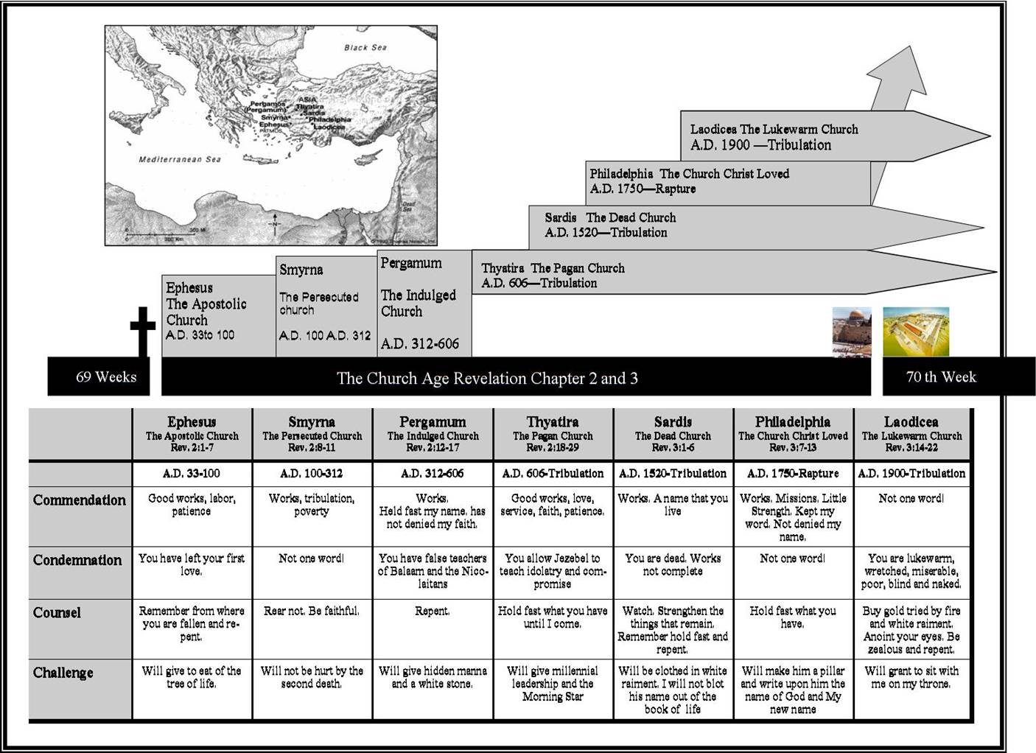

**The Daniel Connection:**

**PROMISE: JERMIAH 31:3, ROMANS 8:15-17**

**Assignment for Next Week: Read Rev. 3-4, Daniel 9-10**

**Prepare to “Be Amazed!” PTBA—Read Ezekiel 37:3, 20; Isaiah 66: 8-9 One Day? Leviticus 26:18-24. Ezekiel 4: 4-6. How does this equate to the date of May 15, 1948. Israel had been scattered, finally the southern tribes to Babylon for 70 years. In Leviticus 26 God tells us that four separate times that if Israel did not repent that He would “punish you for your sins seven times over.” FOUR TIMES HE WARNED? Vs. 18, 23, 24, and 28. They did not repent. In fact, when Cyrus released them to go back to Israel after their 70 year Babylonian captivity in the spring of 536 B.C. 1st Nisan. So, God pronounced a judgment on Israel to be scattered among all the nations. He demonstrated through Ezekiel how many years it would be. But, if they were disobedient, it would be 7 times longer, according to Isaiah. Cyrus released the Israelis from a 70 year captivity in the spring of 536, and they did not repent. In fact, the 42,000 of them went back to their homeland and did not repent. Ezekiel’s 390 + 40 days, 430 days (this is the 70 years of Babylon, plus 360 being scattered). So, take the total Ezekiel talked about—430 years minus the 70 years of Babylonian captivity=360 years. That occurred between 606 B.C. and 176 B.C. After the captivity in Babylon, the first seventy years, there was supposed to be repentance, but there was not. Then, you have to apply the rule of ‘SEVEN’ for the punishment of Israel with the remaining 360 years left after the captivity by SEVEN. That leaves 2520 years. Next, convert from the Hebrew lunar, 360 day calendar to our 365 ¼ day Solar calendar, and you will get that the new punishment period of scattering of the Jews would last 2,484 years, according to our Solar years. Then count 2,484 years from the 536 B.C. forward, we will come to the year 1948. Furthermore, if we take the total number of days of these years, you will get 907,200 and move forward from Cyrus’ decree, which we know in antique history, you will end up with May 15, 1948. And just like Isaiah 66:8, predicted that Israel would become a country in one day indeed that happened! Predicted 2500 years in advance**

**The Calculation   
The Babylonian captivity ended in the spring of 536 B.C.E., 1st  
Nisan. This date is the starting point for our calculations. The  
period of worldwide captivity would last 2,520 biblical years x  
360 days = 907,200 days. Converting this figure into our calendar  
year we divide the 907,200 days by 365.25 to reach a total of  
2,483.8 calendar years. (Remember that there is only one year  
between 1 B.C.E. and 1 C.E.; there was no Year Zero). The end of  
Israel's worldwide captivity would occur after a total of 2,483.8  
years had elapsed from the end of the Babylonian Captivity in the  
spring of 536 B.C.E.  
  
End of Babylonian Captivity: Spring 536 B.C.E. + the duration of  
Worldwide Captivity: 2,483.8 Calendar Years = When the Worldwide  
Captivity would end: Spring 1948.  The Rebirth of Israel: May 14th 1948  
   
On May 14, 1948, the Jewish people proclaimed the independence of  
Israel and the end of their worldwide captivity at the precise  
time prophesied by the prophet Ezekiel. On this very day a united  
Israel took its place as a sovereign, independent state among the nations.**

|  |  |  |  |  |
| --- | --- | --- | --- | --- |
| **Churches and title of Jesus** | **Strengths** | **Failures** | **Instruction** | **Promise To Faithful** |
| Loveless  **EPHESUS**  (Rev. 2:1-7) | Hard work  Patient endurance  Reject evil  Persevere | You have forsaken your first love | Repent and do the works as you did at first | **This is a Post Script:** You will eat from the tree of life |
| Suffering  **SMYRNA**  (Rev. 2:8-11) | Endure your suffering and poverty, yet you are rich | None | Remain faithful even when facing prison, persecution or death | I will give you the crown of life. You will not be hurt by the second death |
| Worldly  **PERGAMUM**  (Pergamos)  (Rev. 2:12-17) | Loyalty to Christ; refuse to deny Him | Tolerate cults, heresies, idolatry and immorality | Repent! | Hidden manna and a stone with a new name on it |
| Wrong Doctrine  **THYATIRA**  (Rev. 2:18-29) | Love, faith, works, patient endurance; constant improvement | Tolerate pagan cults, idolatry and immorality. Judgment coming! | Repent! | Faithful hold fast until I come. I will give you authority over the nations and gift of the morning star |
| Spiritually Dead  **SARDIS**  (Rev. 3:1-6) | Only a faithful remnant has kept the faith. Church is spiritually dead | Repent and turn back to Christ | Strengthen what little faith remains | Faithful will walk with Jesus and not be blotted out of the book of life |
| Spiritually Alive  **PHILADELPHIA**  (Rev. 3:7-13) | Kept my word and have not denied my name | None | I have placed before you an open door. I will keep you from the hour of trial. | I will make you a pillar in the temple of my God |
| Complacent  **LAODICEA**  (Rev. 3:14-22) |  |  |  |  |

**Parallels to the Seven Churches**

**Parable Scripture Reference Church**

**1. The Sower Matthew 13:1-23 Ephesus**

**2. The Tares Matthew 13:24-30 Smyrna**

**3. Mustard Seed Matthew 13:31-32 Pergamos**

**4. Woman/Leaven Matthew 13:33 Thyatira**

**5. The Field Matthew 13:44, Job 28:13 Sardis**

**6. The Pearl Matthew 13:45-46 Philadelphia**

**7. The Dragnet Matthew 13:47-50 Laodicea**

**Parallels to the Churches Paul Wrote**

**Revelation Churches Paul’s Letters**

**Ephesus, Apostolic Church Ephesians**

**Smyrna, Persecuted Church Philippians (Joy through suffering)**

**Pergamos, Church at Satan’s Throne Corinthians**

**Thyatira, Papacy, the Medieval Church Galatians (Call out of religious externalism)**

**Sardis, Denominational “Dead” Church Romans (Salvation by faith)**

**Philadelphia, Missionary Church Thessalonians (The Rapture)**

**Laodicea, Lukewarm Church Colossians (Speaks to the Cosmic Age or New Age)**