**Revelation Chapter 6, the Seven Seals,**

**The Seventieth Week of Daniel Begins (Rev. 6-19)!**

1. **In Daniel 9, list the reasons for “the 70th week,” a.k.a “the Tribulation.” Discuss each of the following.**
   1. **To finish the transgression**
   2. **To make an end of sins**
   3. **To make reconciliation for iniquity**
   4. **To bring in everlasting righteousness**
   5. **To seal up the vision and prophecy**
   6. **To anoint the most Holy**
2. **Discuss Daniel’s Seventieth Week. Daniel 9:27. Compare it to the “Tribulation Period.”**
3. **Discuss the purpose of seals on the sealed scroll. Was it a will? Or a title deed?**
4. **Read Matthew 24:21-22. Matt.23:37-39? Zech. 13:8-9? Daniel 12:1? Jeremiah 30:7? Is this referring to the same time period?**
5. **In Hosea 5:15, is this the prerequisite and purpose of the tribulation?**
6. **Does the tribulation begin when the lamb opens the first seal of the scroll? Defend your answer.**

[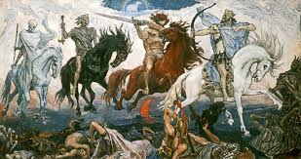](http://www.google.com/imgres?imgurl=http://www.themuslimtimes.org/wp-content/uploads/2011/09/Four-Horsemen-Mikh-L.jpg&imgrefurl=http://www.themuslimtimes.org/2012/01/religion/recruiting-the-four-horsemen-of-neo-atheism-into-cavalry-of-islam&h=291&w=550&tbnid=rFbG7wMBPvBWSM:&zoom=1&docid=LcIJ_Pm7YMO8RM&ei=mN2FU_OfJ5WqyASX44HYBA&tbm=isch&ved=0CLwBEDMoWzBb&iact=rc&uact=3&dur=709&page=8&start=83&ndsp=14)

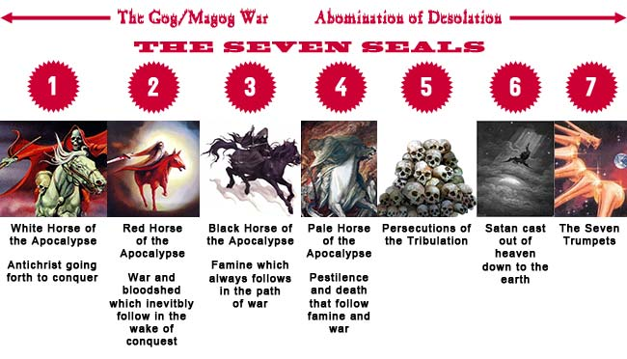

1. **What are the birth pangs? Read Mark 13:7-8.** **"The beginning of birth pains" (Mk 13:8). They "must happen, but the end is still to come" (Mk 13:7). Similarly in John's vision, the things described under the first four seals are harbingers of more terrible judgments to come.**
2. **What is “The Day of the Lord?**” When does it begin? Read Isaiah 13:34, Jeremiahs 4-7, Ezekiel 7:25, Amos 5:18-29, and Zephaniah 1-3.
3. **How do the upcoming judgments of “seven” correlate to Leviticus 26:**18? And 26:21, 26:24, 26:28? The seals affect ¼ of the earth; the trumpets affect 1/3 of the earth; and the bowls affect the whole earth, global.
4. **John explains the completeness of “the seven judgments” in Revelation 15:**1. Discuss. The Seven Trumpets—Rev. 8:6-11:19, and Seven Bowls –Rev. 15, 16.

### COMPARISON OF CHRIST'S "OLIVET DISCOURSE" AND REVELATION SIX"

By Clarence Larkin, MATT. 24:1-3

|  |  |
| --- | --- |
| **TUESDAY AFTERNOON APRIL 4: A.D. 30** | **And Jesus went out, and departed from the temple AFTERNOON and his disciples came to *him* for to show him the buildings of the temple.**  **2 And Jesus said unto them, See ye not all these things? Verily I say unto you, There shall not be left here one stone upon another, that shall not be thrown down.** |
| **TUESDAY EVENING** | **3 ¶ And as he sat upon the mount of Olives, the disciples came unto him privately, saying, Tell us, when shall these things be? And what *shall be* the sign of thy coming, and of the end of the world?** |

**THE THREE-FOLD QUESTION--**

***1--WHEN SHALL THESE THINGS BE?***

***2--WHAT SHALL BE THE SIGN OF THY COMING?***

***3--AND OF THE END OF THE WORLD (AGE)?***

***ANSWER TO FIRST QUESTION***

|  |  |  |
| --- | --- | --- |
| **MATT. 24:4-5**  **4 And Jesus answered and said unto them, Take heed that no man deceive you.**  **5 For many shall come in my name, saying, I am Christ; and shall deceive many.** | **1-SEAL**  **FALSE CHRIST'S** | **REV. 6:1-2**  **AND I saw when the Lamb opened one of the seals, and I heard, as it were the noise of thunder, one of the four beasts saying, Come and see.**  **2 And I saw, and behold a white horse: and he that sat on him had a bow; and a crown was given unto him: and he went forth conquering, and to conquer.** |
| **MATT. 24:6-7**  **6 And ye shall hear of wars and rumours of wars: see that ye be not troubled: for all *these things* must come to pass, but the end is not yet.**  **7 For nation shall rise against nation, and kingdom against kingdom:** | **2-SEAL**  **WARS** | **REV. 6:3-4**  **3 And when he had opened the second seal, I heard the second beast say, Come and see.**  **4 And there went out. Another horse that was red: and power was given to him that sat thereon to take peace from the earth, and that they should kill one another: and there was given unto him a great sword.** |
|  |  |  |
| **MATT 24:7**  **and there shall be famines,** | **3-SEAL**  **FAMINES** | **REV. 6:5-6**  **5 And when he had opened the third seal, I heard the third beast say, Come and see. And I beheld, and lo a black horse; and he that sat on him had a pair of balances in his hand.**  **6 And I heard a voice in the midst of the four beasts say, A measure of wheat for a penny, and three measures of barley for a penny; and see thou hurt not the oil and the wine.** |
| **MATT. 24:7-8**  **And pestilences, and earthquakes, in divers places.**  **8 All these *are* the beginning of sorrows.** | **4-SEAL**  **PESTILENCE AND DEATH** | **REV. 6:7-8**  **7 And when he had opened the fourth seal, I heard the voice of the fourth beast say, Come and see.**  **8 And I looked, and behold a pale horse: and his name that sat on him was Death, and Hell fol. lowed with him. And power was given unto them over the fourth part of the earth, to kill with sword, and with hunger, and with death, and with the beasts of the earth.** |
| **MATT. 24:9-13**  **9 Then shall they deliver you up to be afflicted, and shall kill you: and ye shall be hated of all nations for my name's sake.**  **10 And then shall many be offended, and shall betray one another, and shall hate one another.**  **11 And many false prophets shall rise, and shall deceive many.**  **12 And because iniquity shall abound, the love of many shall wax cold.**  **13 But he that shall endure unto the end, the same shall be saved.** | **5-SEAL**  **MARTYRDOMS** | **REV. 6:9-11**  **9 And when he had opened the fifth seal, I saw under the altar the souls of them that were slain for the word of God, and for the testimony which they held:**  **10 And they cried with a loud voice, saying, How long, O Lord, holy, and true, dost thou not judge and avenge our blood on them that dwell on the earth?**  **11, And white robes were given unto every one of them; and it was said unto them, that they should rest yet for a little season, until. their fellow servants also and their brethren, that should be killed as they *were*, should be fulfilled:** |
| **MATT. 24:14**  **14 And this gospel of the kingdom shall be preached in all the world for a witness unto all nations; and then shall the end come.** |  | **THE GOSPEL NOW BEING PREACHED IS THE "GOSPEL OF THE GRACE OF GOD": ACTS 20:24.** |
| **ANSWER TO THE SECOND QUESTION** |  |  |
| **MATT. 24:15**  **15 When ye therefore shall see the abomination of desolation, spoken of by Daniel the prophet, stand in the holy place, (whoso readeth, let him understand,)** |  | **"THE SIGN" OF THE "DESOLATOR"**  **DAN 9:27** |
| **p. 64** |  |  |
| **MATT. 24:16-22**  **16 Then let them which be in Judea flee into the mountains:**  **17 Let .him which is on the housetop not come down to take anything out of his house:**  **18 Neither let him which is in the field return back to take his. clothes.**  **19 And woe unto them that are with child, and to them that give. suck in those days!**  **20 But pray ye that your flight be not in the winter, neither on the Sabbath day:** |  |  |
| **21 For then shall be great tribulation, such as was not since the beginning of the world to this time, no, nor ever shall be.**  **22 And except those days should be shortened, there should no flesh be saved: but for the elect's sake those days shall be shortened.** | **GREAT TRIBULATION** |  |
| **ANSWER TO THIRD QUESTION** |  |  |
| **MATT. 24:29-30**  **29 ¶ Immediately after the tribulation of those days shall the sun be darkened, and the moon shall not give her light, and the stars shall fall from heaven, and the powers of the heavens shall be shaken:**  **30 And then shall appear the sign of the Son of man in heaven: and then shall all the tribes of the earth mourn, and they shall see the Son of man coming in the clouds of heaven with power and great glory.** | **6-SEAL**  **PHYSICAL CHANGES** | **REV. 6:12-17**  **12 And I beheld when he had opened the sixth seal, and, lo, there was a great earthquake; and the sun became black as sackcloth of hair, and the moon became as blood;**  **1 And the stars of heaven fell unto the earth, even as a fig tree casteth her untimely figs, when she is shaken of a mighty wind.**  **14 And the heaven departed as a scroll when it is rolled together; and every mountain and island were moved out of their places.**  **15 And the kings of the earth, and the great men, and the rich men, and the chief captains, and the mighty men, and every bond man, and every free man, hid themselves in the dens and in the rocks of the mountains;**  **16 And said to 'the mountains and rocks, Fall on us, and hide us from the face of him that sitteth on the throne, and from the wrath of the Lamb:**  **17 For the great day of his wrath is come; and who shall be able to stand?** |
| **THE "FIG-TREE" SIGN**  **MATT. 24:32-35**  **32 Now learn a parable of the fig tree; When his branch is yet tender, and putteth forth leaves, ye know that summer is nigh:**  **33 So likewise ye, when ye shall see all these things, know that it is near, even at the floors.** | **6-SEAL**  **PHYSICAL CHANGES** |  |
| **34 Verily I say unto you, This generation shall not pass, till all these things be fulfilled.**  **35 Heaven and earth shall pass away, but my words shall not pass away.** | **<-- JEWISH RACE** |  |

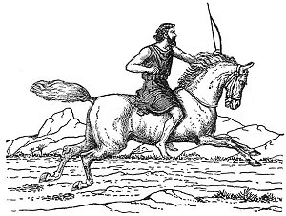

1. **What is “Seal One, the White Horse,” in Rev.6: 1-2, which the lamb opens?** **Read Zechariah 1:8-11**, 6:1-7. Compare. **T he opening of the first four seals is the work of the Lamb and the four living creatures together. As the Lamb opens each of the seals, one of the living creatures gives the command, *"Come!"* A horse and rider go forth, apparently on earth. Actions in heaven are determining events on earth. The series recalls similar groups of four horsemen or chariots sent throughout the earth according to Zechariah 1:8-11 and 6:1-7. The “White Horse”-Antichrist--This would parallel Jesus' last discourse in Mark, where false prophets are one of the signs, indeed the *first* sign, of the end of the age (Mk 13:5, 22).The white horse;** Note: When John has questions--The Living Creatures explain about earth, but one of the elders explains about heaven. There are different judgments, where there are six judgments, a parenthesis chapter or verse or section, and then the seventh judgment which opens up the next seven judgments. Sequential and increase in intensity. Between the sixth and seventh judgments, there is a break. First four seals are the “four horsemen.” What is a bow with no arrows?—Dan. 8:25, not war, but diplomacy. When the covenant with the antichrist is confirmed, then the seals will begin the tribulation. Rev. 19:11—white horse rider is Jesus, with a sharp sword. **The background of such imagery is that the God of Israel sends his "arrows" of judgment against the nations (Ps 45:5) and in two notable passages, Deuteronomy 32:23-25 and Ezekiel 5:16-17, even against *his own* people.**
2. **What is the Wrath of the Lamb in Revelation 6:1? This is the only time this phrase is used in the Bible.**
3. **In verse one, discuss John saying, “I saw.**” **And discuss what John hears.**
4. **Who is riding the white horse? What does the bow represent? This is an imposter Christ, holding a bow. His crown is a “victors’ crown” not a “reigning crown.” Jesus will show up on a white horse….who is the fifth horseman. The first is carrying a bow, not a sword. The bow implies darts or arrows, may imply Nimrod, the Hunter, or Nimrod II. Subtlety here—“bow” means Gen. 9:13, same word as “rainbow,” could this mean that what this imposter has is a token of a covenant—the covenant to Israel, as a pun. Zech.11:17—physical description of the antichrist.**
5. **Compare the “rider on the white horse” in Rec.19:11 to the white horse rider in Rev. 6:1. Discuss these two “bookends” to the judgments. Is Christ the “Fifth Horse Rider?” Explain**.
6. **Read Dan. 8:25; discuss “through his policy he will cause craft to prosper in his hand, and by peace he will destroy many.” Also read Dan. 9:27—what does “confirm the covenant for one week” imply?**
7. **Explain the wrath in Dan. 9:16-17?**
8. **What does “Day of the Lord” mean? Read Rev. 6:16-17, Acts 2:20, I Thess. 5:2, Zeph. 1:15, Joel 2:2, 2 Pet. 3:10, 12.**

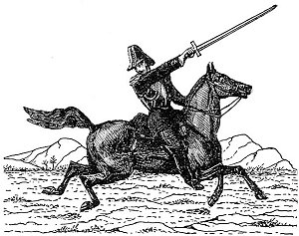

1. **What is Seal Two, The Red Horse, verses 3-4?** **Wars…..take peace from the earth….carries a sword. Nation against nation. Matthew 24:6….nation against nation; chaos of red horse brings the economic collapsed of the black horse.** "wars and rumors of wars" (Mk 13:7), "wars and revolutions" (Lk 21:9),
2. **What does the color red represent? BLOOD The sword? WAR Read Matthew 24:6-7 and I Thess.5:3.**

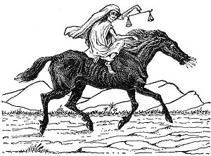

1. **What is Seal Three, The Black Horse, in verse 5-6? Compare with Ezekiel 5:16-17. He had a pair of balances; black is connected by famine “to eat bread by weight” is a Jewish term implying scarcity, Lev. 26:25-33, Ez. 4:10,11,16, and Lam. 4:4-8, Jer. 14:1-2. Famine and depravation. “When I shoot at you with my deadly and destructive *arrows of famine,* I will shoot to destroy you. . . . I will send *famine* and *wild beasts* against you, and they will leave you childless. *Plague* and bloodshed will sweep through you, and I will bring the *sword* against you. I the LORD have spoken. “(Ezek 5:16-17)**
2. **What is the cause of the famine? Try to correlate Amos 8:**11. implies a famine of the Word of God. **What is the cause of the famine? Oil and wine allude to luxuries, so that world-wide famine caused by politics. Abuse by politicians**

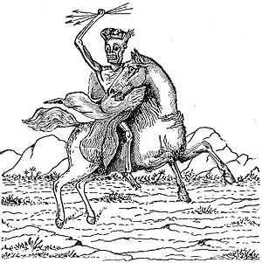

1. **What is Seal Four, The Pale Horse, verses 7-8? What does two riders, death and hell, over ¼ part of the earth? Chlorus…pale green. Could these microscopic beasts? Pestilences and organisms? Kills with sword, hunger, and disease….pale green, chlorophyll. Economic collapse will bring death and disease.** What then is the new terror brought by the fourth rider? Not killing as such, for that was intimated already in connection with the second (v. 4). Rather, *Death* is linked to *plague* (or "pestilence," NRSV), just as in the message to Thyatira (see note above on 2:23). So close is the connection that within one verse (v. 8) the same Greek word (*thanatos*) is translated both as *Death* and as *plague.* The fourth rider adds to the first three the awful prospect of disease, as well as the bearers of disease and desolation, *the wild beasts of the earth.*
2. **Who sends out these four horsemen?** At the same time, it is clear that these four terrible horsemen all stand under the sovereignty of God and the Lamb, who opens the seals. They all ride out at the bidding of the four living creatures who worship at God's throne. Whatever dreadful things may happen on earth, they are all within God's plan and under God's sovereign control. God in effect is the one who draws the bow and sends out the arrows of misfortune, here no less than in Deuteronomy or Ezekiel. Both the first and the second riders (vv. 2, 4), and then all four (v. 8), are said to have been *given* (Greek *edothe) the authority to do what they do. The first is given a crown,* or garland of victory (see Farrer 1964:100), the second *a large sword,* and all four *power over a fourth of the earth.* The true giver of such things can only be God or the Lamb. The terms of the famine introduced by the third rider are announced from the very throne of God. Perhaps the whiteness of the white horse is less a counterfeit of the purity of God and the Lamb and more a signal to John and to us that these horsemen are riding out as agents of God, even though the tasks they perform are destructive
3. **Read Ez. 14:21. Does this refer to the same pestilences?**
4. **Zechariah 6:1-13 portrays horses in prophecy. Are they the same as the first four seals of Rev. 6? Explain.**

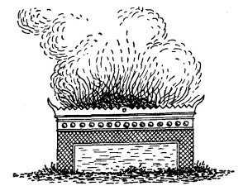

1. **What is Seal Five, Souls of the Slain, the Martyrs, Verses 9-10? Compare to Psalm 94:1-3.** Nowhere in the series is it more important to maintain "a sense of where we are" than in connection with the fifth seal. John is still in heaven, while the visions under the first four seals are calamities happening on earth (v. 4, "to take peace from the earth," and v. 8, "over a fourth of the earth"). **The martyrs who are asked to wait for yet a little while. These are souls that are slain for Jesus. They cry, “How long?” Greek Word for witness is “martyr.” Suffering of the people through the ages. These souls are not sleeping, but conscious. The GOSPEL OF THE GRACE OF GOD (Acts 20:25) ceases when the church is caught out. The GOSPEL OF THE KINGDOM (Matthew 24:9-14)will be revived through the tribulation. It is the gospel John the Baptist preached, Matthew 3:1-2, and Elijah will preach when he returns, Malachi 4:5-6.**The preposition translated *under* (Greek hypokato) is a strong one, meaning "below" or "beneath" (compare the phrase "under the earth," in distinction from "in heaven" or "on earth," in 5:3, 13). John's choice of words raises the distinct possibility that the souls he saw *under the altar* were not in heaven at all, but far below it on earth--the same earth that had just been scarred by the disasters of the first four seals. John could have written "under heaven" (in the sense of "on earth," as in Gen 6:17; 7:19) or "under the throne." Instead he wrote *under the altar,* probably because the vision centered on what he calls elsewhere "the prayers of the saints" (5:8; 8:3-4). Not the *souls* themselves but their prayers are the sacrifices that ascend like incense from earth to heaven--from "under the altar" to the altar itself. These *souls* are not disembodied spirits. They are, after all, visible to John. Nor are they the "lives" or "selves" of slaughtered victims as a kind of abstraction, nor are they typical of what theologians like to call "the intermediate state" (the interval between a believer's physical death and the final resurrection). Rather, at least within the horizons of John's vision, these *souls* are people with voices and real bodies, like the "beheaded" souls of 20:4. They are martyrs, not just in the sense of bearing *testimony* (Greek *martyria,* v. 9), but in the sense of having been "killed" (v. 11) for their testimony. Like Abel, the first martyr, who "still speaks, even though he is dead" (Heb 11:4; compare Gen 4:10), they cry out for justice to be done. Their prayer (v. 10) is the heart of the fifth seal. It is the prime example of what was meant by the "prayers of the saints" (5:8; compare 8:3-4)
2. **When do the martyred souls receive retribution? Read Rev. 20:4-6 and Daniel 7:27.**
3. **Does the fifth seal present a vision of earth or a vision of heaven**? **Describe God’s answer to the slain saints. Read Rev. 18:20, 24, 19:2.**  "And will not God bring about justice [literally "retribution"] for his chosen ones, who cry out to him day and night?" (Lk 18:7). When he blessed "those who hunger and thirst for righteousness" (Mt 5:6), his words could as easily be translated, "those who hunger and thirst for justice." As for Paul, he urged kindness toward our enemy in order to "heap burning coals on his head" (Rom 12:20). **The Great Day of Wrath. After a great earthquake the sun turns black and the moon red like blood, the stars fall from the sky, the sky itself crumples like a piece of paper, the mountains slide into the valleys and islands sink into the ocean. Survivors hide in caves and under rocks from more terrible disasters to come. What is wrong with this picture? Most Americans today would probably say, "Everything. It sounds like bad science fiction." However, if we rephrased the question--"What is *missing* from this picture?"---and if we directed it to John and his first-century readers, we would get a very different answer. The picture is not so strange to anyone who has read the Gospels. Jesus told his disciples that "in those days, following that distress, `the sun will be darkened, and the moon will not give its light; the stars will fall from the sky, and the heavenly bodies will be shaken'" (Mk 13:24-25; compare Mt 24:29; Lk 21:25-26). He immediately added that people "will see the Son of Man coming in clouds with great power and glory. And he will send his angels and gather his elect from the four winds, from the ends of the earth to the ends of the heavens" (Mk 13:26-27; compare Mt 24:30-31; Lk 21:27).**

**These parallels show what is missing from the picture in Revelation. There is no coming of the Son of Man in the clouds, no gathering of his chosen ones from all over the world. John sees all the terrible events heralding and accompanying the Second Coming of Jesus, but not the coming itself. The prophecy given in 1:7 ("Look, he is coming with the clouds") is almost, but not quite, fulfilled.**

**The scene echoes Zephaniah 1:14-15: "The great day of the LORD is near. . . . That day will be a day of wrath, a day of distress and anguish, a day of trouble and ruin, a day of darkness and gloom." What is striking in the book of Revelation--and strange, perhaps, to the modern reader--is that the wrath is *the wrath of the Lamb* (v. 16). The slaughtered Lamb of sacrifice in the center of the throne is no passive victim, but "the Lion of the tribe of Judah." The Lamb's role in judgment should come as no surprise in light of his equality and partnership with *him who sits on the throne* in the worship of the elders, living creatures and all creation (5:13). From that point on, God and the Lamb never act independently, but always in unison. When they act together in judgment, the inevitable question is, *Who can stand?* (v. 17).The question has its answer in chapter 7, where John sees four angels *standing* at the corners of the earth to preserve a group of *servants of our God* from destruction (7:1, 3) and an innumerable multitude *standing* in the presence of God and the Lamb (7:9). There are indeed those who will "stand" in the great day of wrath, but they must be prepared and protected.**

[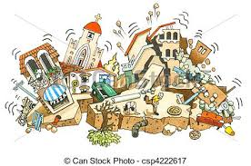](http://www.google.com/url?sa=i&rct=j&q=&esrc=s&frm=1&source=images&cd=&cad=rja&uact=8&docid=xMDN0ld-0ySMSM&tbnid=kbSA2FYAs2D1DM:&ved=0CAUQjRw&url=http://www.canstockphoto.com/earthquake-4222617.html&ei=0bWMU4TvBYSbyATc1IHYAw&bvm=bv.67720277,d.aWw&psig=AFQjCNHnPxFOaexrITVCiYkRMFL09ON4Zg&ust=1401816909621709)

1. **What is Seal Six, Great Earthquake, Cosmic Changes, Verses 12-14? This is the earth shaking, This is the cosmic changes in the earth.** "earthquakes in various places" (Mt 24:7).
2. **Discuss the three earthquakes of Revelation. Rev.6:12, 11:13, 16:18-19. This is the first of the three Rev.earthquakes—**
3. **Discuss the “darkness” in the Egypt/ Exodus story, Exodus 10:21-23, and Zech. 14:1-7.**
4. **What does it mean “the sun became black as sackcloth” in verse12? Refer to Isaiah 13:10, 24, Joel 2:10.**
5. **Read the cosmic disturbances in Joel 2:30-31, Haggai 2:6, Isaiah 2:19, 13:10, 34:4, and Jeremiah 4:23-28.**
6. **In verse 14, “heaven departed like a scroll”—does this compare to Job 9:8, Psalm 104:2, and Isaiah 40:22? Zech. 12:1? Isaiah 34:4? Stretching out the heavens occurs more than 12 times in the O.T.**
7. **Why did the kings and rich men hide themselves in the mountains?** **Whose wrath is being displayed? Leaders, etc. are hiding to escape the wrath of the lamb. Chapter Six—wrath is happening, from chapter six-nineteen. Joshua means “Jesus.” The Book of Joshua appears to be a model of Jesus’ story. Joshua is a military commander dispossessing usurpers in his land; seven year campaign, dealing with the last three of the ten opposing nations, Torah is ignored in Jericho, Levites lead procession,** Joshua sends in two witnesses, seven trumpet events, seventh time on seventh day march around and shout, silence in heaven for half an hour, what do the kings do at the end of Joshua? They hide in caves, just like Rev. 16:15.
8. **Verse 17 asks a very important question. Discuss.**
9. **Isaiah 23:9 displays the pride of men and their downfall. Discuss why God is pouring out His wrath in Revelation.**
10. **Where does the seventh seal occur? What happens in Chapter 7? What then does 6:12-17 contribute to chapter 7? In what sense can it be considered necessary background to the vision of the redeemed in that chapter? The simplest answer is that 6:12-17 describes in vivid detail the terrible judgment from which deliverance is promised in chapter 7. We might even argue that 6:12-17 is simply introductory to the vision proper, which comes in chapter 7. If the fifth seal dealt with the suffering people of God, looking toward the day when "the number of their fellow servants and brothers" would be completed (6:11), it is natural that the sixth seal should continue to focus on that group and mark the completion of that number (see 7:4).Chapter 8 opens up the seven trumpets. Chapter seven is the parenthesis between the 6th and 7th Seal, which seals the 144,000 Jews. Notice the “Jewish-ness.” The seventh seal will introduce the trumpet judgments, and the silence in heaven.**

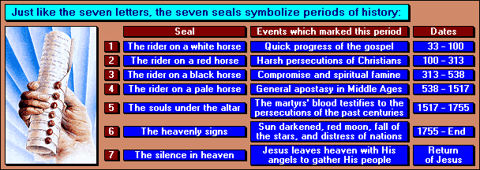

**Assignment for next week.**

**Read Matthew 24:4-13, Luke 21:4-25 and Revelation 6:1-17; compare the signs of Jesus’ Second Coming. Read Revelation Seven and Fourteen, SEVEN TIMES!**

**Promise--John 10:27-30, “My sheep hear my voice, and I know them, and they follow me: And I give unto them eternal life; and they shall never perish, neither shall any man pluck them out of my hand. My Father, which gave them me, is greater than all; and no man is able to pluck them out of my Father’s hand. I and my Father are one.”**