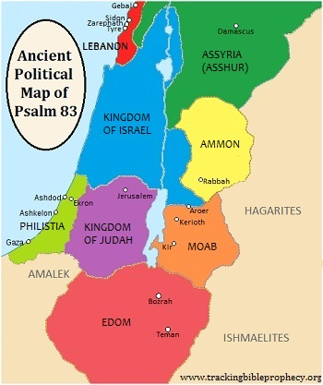

[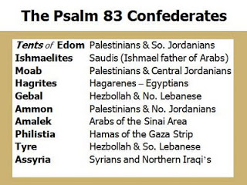](http://1.bp.blogspot.com/_ozlsCwnTla4/Sxh2qz2n0bI/AAAAAAAAA9I/tcxSgM5wV9g/s1600-h/ps+83.jpg)

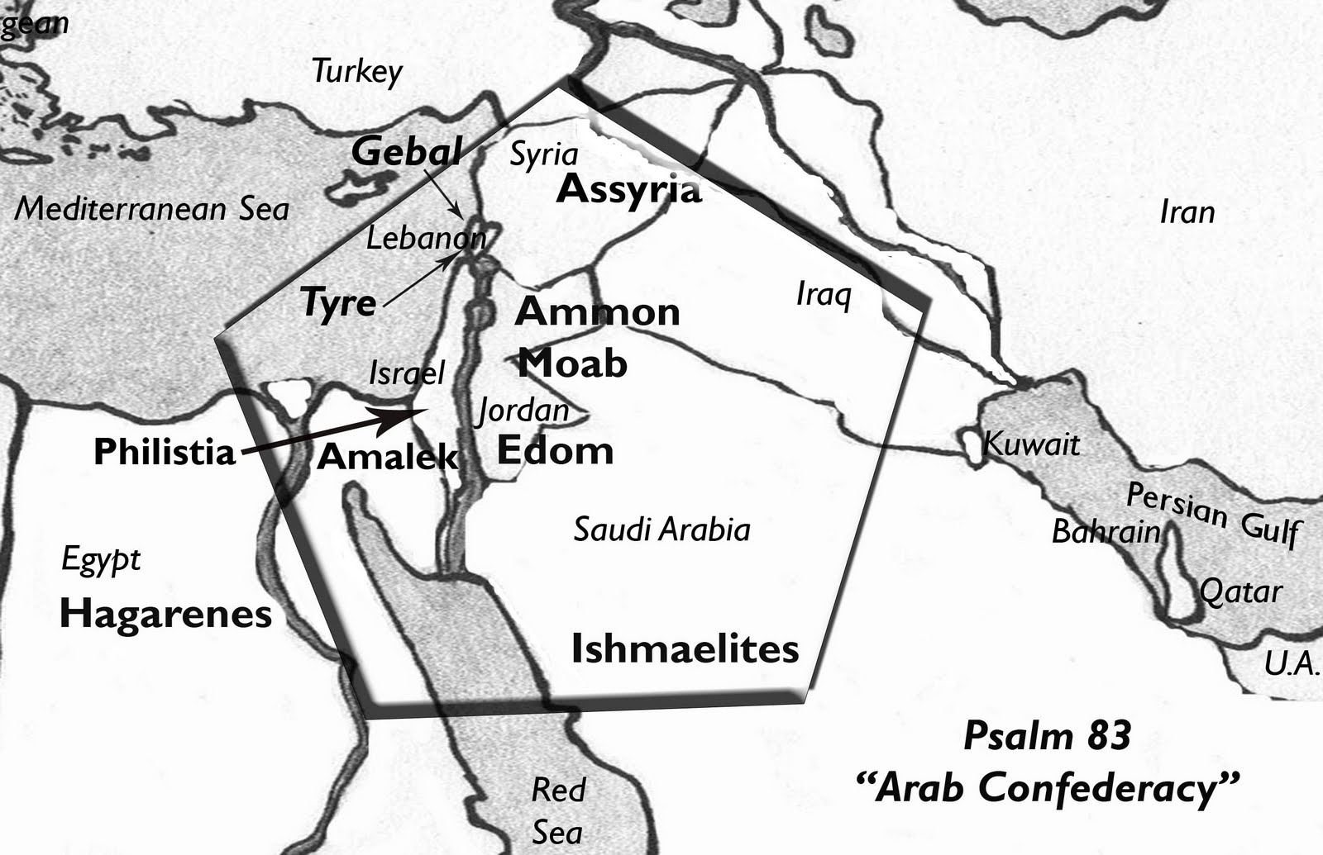

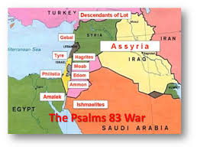

[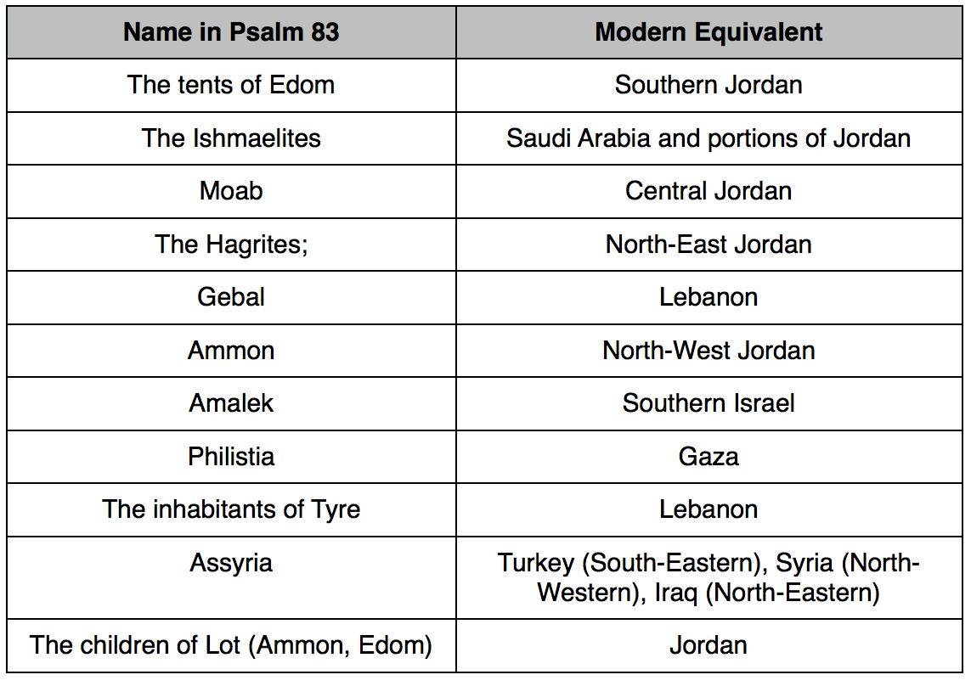](http://www.google.com/url?sa=i&rct=j&q=&esrc=s&frm=1&source=images&cd=&cad=rja&uact=8&docid=Zr9lLglbm1CQmM&tbnid=YbYbuSfV1d2JBM:&ved=0CAUQjRw&url=http%3A%2F%2Fwww.joelstrumpet.com%2F%3Fp%3D5731&ei=ha4ZU7izKaSV3AXB6ICoCw&bvm=bv.62578216,d.b2I&psig=AFQjCNHLZdxhx9Ft-zztOlre_boW3TUccA&ust=1394278326970659)

[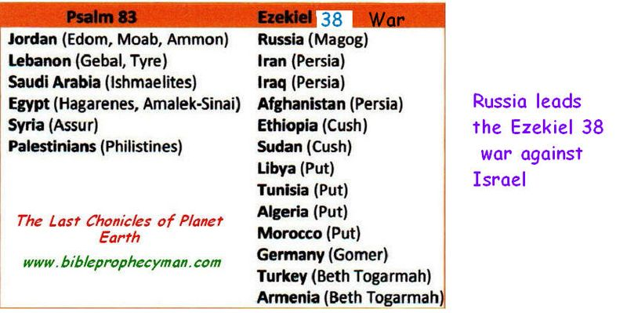](http://www.google.com/url?sa=i&rct=j&q=&esrc=s&frm=1&source=images&cd=&cad=rja&uact=8&docid=QI4O-XZfK2ESSM&tbnid=yxOVCW-TKa4ZJM:&ved=0CAUQjRw&url=http%3A%2F%2Ffrankdimora.typepad.com%2Fthe_last_chronicles%2F2012%2Fweek33%2F&ei=8q4ZU-XmF-e32wW8t4DwCQ&bvm=bv.62578216,d.b2I&psig=AFQjCNHLZdxhx9Ft-zztOlre_boW3TUccA&ust=1394278326970659)

[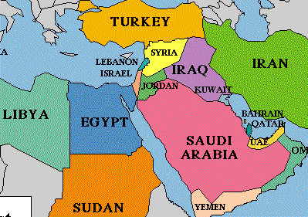](http://www.google.com/url?sa=i&rct=j&q=&esrc=s&frm=1&source=images&cd=&cad=rja&uact=8&docid=0je7DBhAY6MT2M&tbnid=WTl05932cU-AZM:&ved=0CAUQjRw&url=http%3A%2F%2Funsealedprophecy.wordpress.com%2F2011%2F08%2F24%2Fdaniel-11-in-modern-times%2F&ei=Sa8ZU7mPKKb82gXx9IHoDg&bvm=bv.62578216,d.b2I&psig=AFQjCNHLZdxhx9Ft-zztOlre_boW3TUccA&ust=1394278326970659)

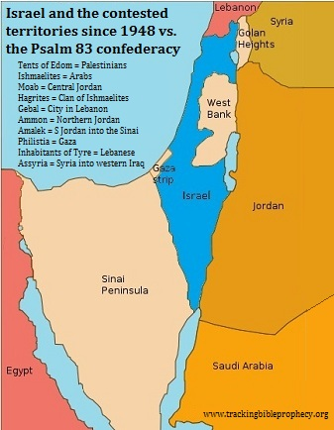

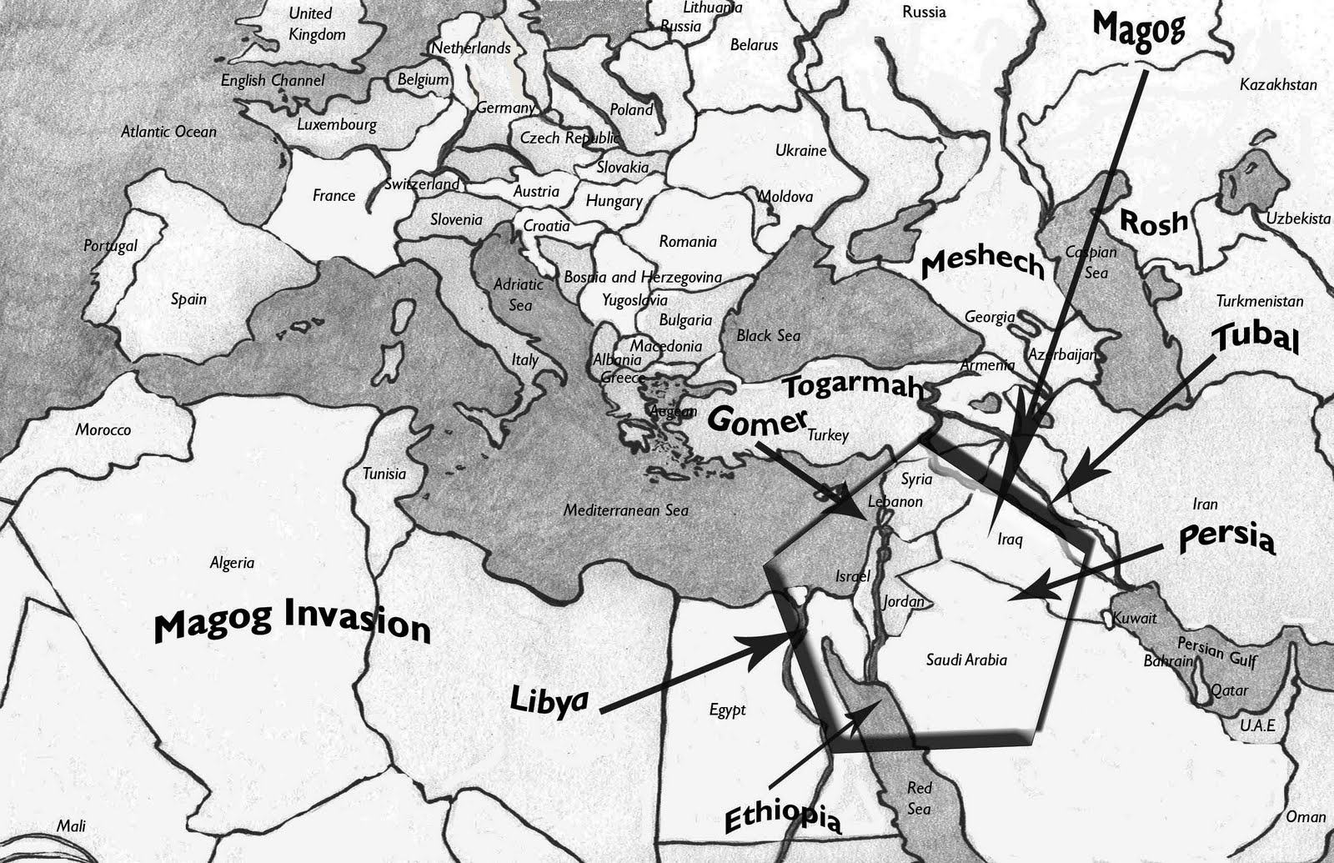

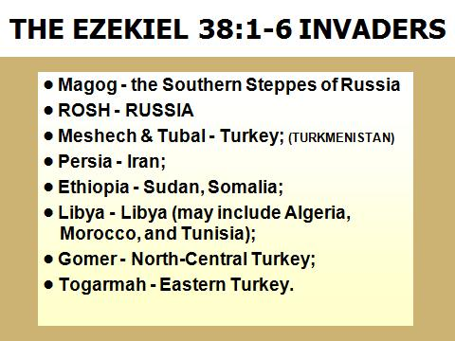

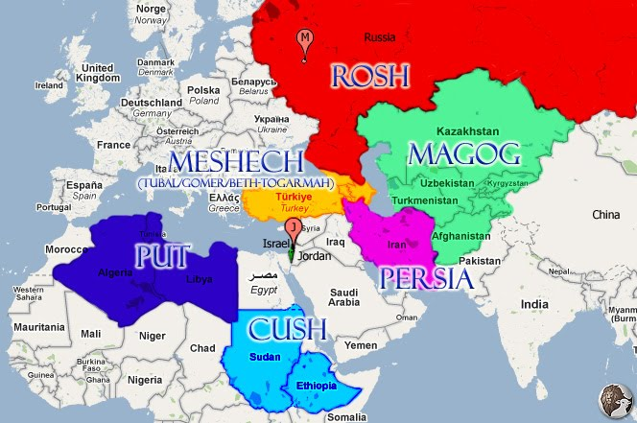

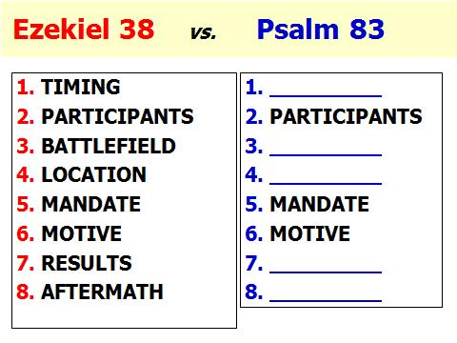

[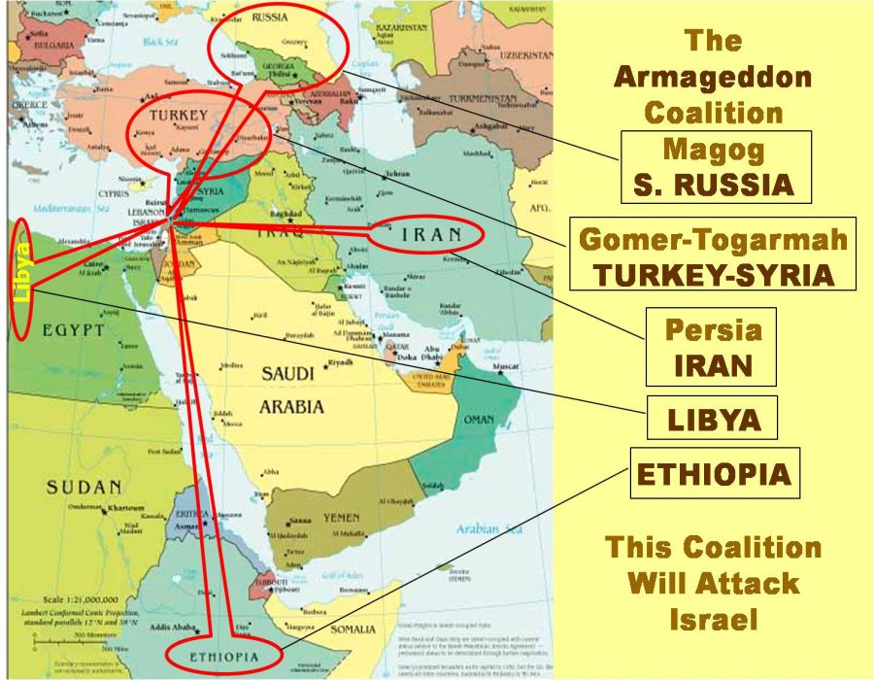](http://www.google.com/url?sa=i&rct=j&q=&esrc=s&frm=1&source=images&cd=&cad=rja&uact=8&docid=KyH_bAPbzrMYJM&tbnid=jfuYcl5oxxaN9M:&ved=0CAUQjRw&url=http%3A%2F%2Fwww.raptureforums.com%2Fforum%2Fprophecy-end-times-chat%2F77202-war-psalm-83-not-merely-imprecatory-prayer-3.html&ei=Rq4ZU8jEJ4fd2AWx6YH4CA&bvm=bv.62578216,d.b2I&psig=AFQjCNHLZdxhx9Ft-zztOlre_boW3TUccA&ust=1394278326970659)

[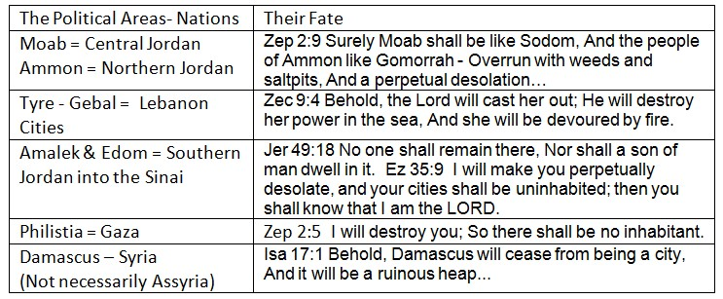](http://www.google.com/url?sa=i&rct=j&q=&esrc=s&frm=1&source=images&cd=&cad=rja&uact=8&docid=PgbgF-va9LrAcM&tbnid=4bEpdXXo0AtsJM:&ved=0CAUQjRw&url=http%3A%2F%2Fwww.raptureforums.com%2Fforum%2Fprophecy-end-times-chat%2F70330-recognition-palestines-statehood-un-prophetic-fulfilment-ezekiel-36-a.html&ei=6q8ZU6P7LaHF2QXd3oGADg&bvm=bv.62578216,d.b2I&psig=AFQjCNHLZdxhx9Ft-zztOlre_boW3TUccA&ust=1394278326970659)

[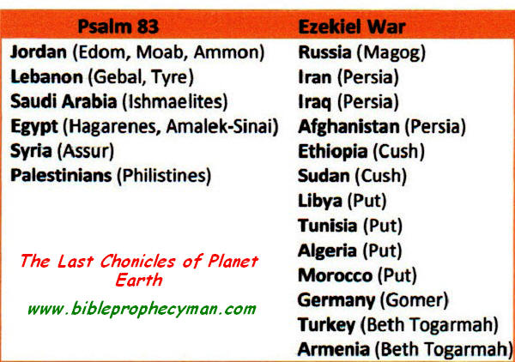](http://www.google.com/url?sa=i&rct=j&q=&esrc=s&frm=1&source=images&cd=&cad=rja&uact=8&docid=ZZxfK5GmXCn2OM&tbnid=lPEfG7oE4bbRWM:&ved=0CAUQjRw&url=http%3A%2F%2Feczp.blogspot.com%2F2012_09_01_archive.html&ei=RrAZU8fnG4fk2QWdzYCYAQ&bvm=bv.62578216,d.b2I&psig=AFQjCNHLZdxhx9Ft-zztOlre_boW3TUccA&ust=1394278326970659)