**The Relevance of Revelation**

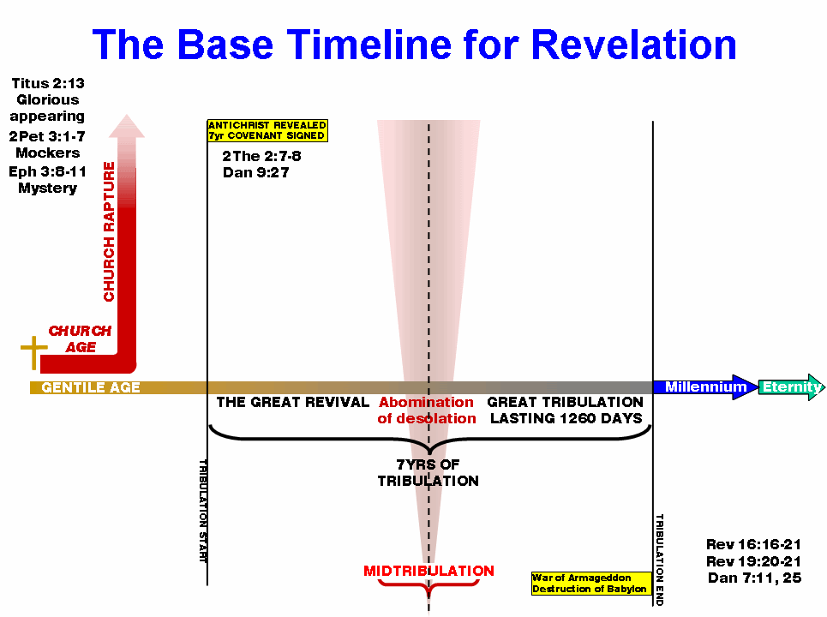

**Theme of our study—Isaiah 46:9-10, KJV, “Remember the former things of old: for I am God, and there is none else; I am God, and there is none like me, Declaring the end from the beginning, and from ancient times the things that are not yet done, saying, My counsel shall stand, and I will do all my pleasure:”**

**Biblical Numbers and their meanings—1=God the Father, or beginning, 2=Fullness of testimony or truth, 3=Trinity or Divinity, 4=God’s creative work, 5=God’s grace, 6=Man, 7=Perfection (God’s favorite number!), 8=Jesus, or a new beginning, 9=Finality, 10=Redemption, or responsibility, 11=Disorder, 12=Completeness, 13=Satan, 40=Testing or trial, 120=Holy Spirit, 666=Antichrist**

**Introduction**

1. **The Introduction (1:1-11, 19)**
2. **Who wrote the revelation?**
3. **What was “The Salutation?” (1:1-3)**
4. **What was “The Exaltation?” (1:5b, 6)**
5. **Explain “The Chief Theme.” (1:7)**
6. **How was “The Eternity of the Son of God” explained? (1:8)**
7. **Who was “The Prophet—John?” (1:9-11)**

**2 Timothy 3:1-3, NKJV, “But know this, that in the last days perilous times will come: 2For men will be lovers of themselves, lovers of money, boasters, proud, blasphemers, disobedient to parents, unthankful, unholy, 3unloving, unforgiving, slanderers, without self-control, brutal, despisers of good,”**

**I Timothy 4: 1, NKJV, “Now the Spirit expressly says that in latter times some will depart from the faith, giving heed to deceiving spirits and doctrines of demons.”**

**Matt. 24:3-14, NKJV, “Now as He sat on the Mount of Olives, the disciples came to Him privately, saying, “Tell us, when will these things be? And what *will be* the sign of Your coming, and of the end of the age?”And Jesus answered and said to them: “Take heed that no one deceives you. For many will come in My name, saying, ‘I am the Christ,’ and will deceive many. 6And you will hear of wars and rumors of wars. See that you are not troubled; for all *these things* must come to pass, but the end is not yet. 7For nation will rise against nation, and kingdom against kingdom. And there will be famines, pestilences,and earthquakes in various places. 8All these *are* the beginning of sorrows.“Then they will deliver you up to tribulation and kill you, and you will be hated by all nations for My name’s sake. 10And then many will be offended, will betray one another, and will hate one another. 11Then many false prophets will rise up and deceive many. 12And because lawlessness will abound, the love of many will grow cold. 13But he who endures to the end shall be saved. 14And this gospel of the kingdom will be preached in all the world as a witness to all the nations, and then the end will come.”**

I Peter 1: 17-21, NKJV, “And if you call on the Father, who without partiality judges according to each one’s work, conduct yourselves throughout the time of your stay *here* in fear; knowing that you were not redeemed with corruptible things, *like* silver or gold, from your aimless conduct *received* by tradition from your fathers, but with the precious blood of Christ, as of a lamb without blemish and without spot. **He indeed was foreordained before the foundation of the world, but was manifest in these last times for youwho through Him believe in God,** who raised Him from the dead and gave Him glory, so that your faith and hope are in God.”

**Revelation Chapter 1 (We shall see the Son)**

**Outline of Chapter 1  
Vs. 1-3 Introduction, Vs. 4-11 Salutation and Occasion, Vs. 12-18 Vision of the Risen Christ, Vs. 19 Outline of the Entire Book, Vs. 20 Preparation for Chapters 2 and 3**

**A. What are the divisions of the Book of Revelation? “The Things Which Thou Hast Seen” (1:1-20). “The Things Which Are” (2:1-3:22) and “The Things Which Will Take Place After This” (3:22-22:21)**

**B. Who was “The Revelation” given to? See Vs. 1. Why? Read Matthew 25:36. What does “shortly”/ “suddenly” mean?**

**C. What year did John write the Revelation? Who was emperor of Rome then?**

1. **What was the universal language of this time?**
2. **What does “signified” mean? Vs. 2.**
3. **Verse 3, who is blessed by reading this book? Explain the promise. Vs. 3.**
4. **Explain “The Prologue.” (1:1-8) Vs. 5—“loved us?”**
5. **Understand the “sevens” in this book. The Hepatic Structure. Begin compiling a list for this entire book: ***See sheet attached**(List of Sevens)**
6. **Name the three parts of Jesus Christ as explained in Verse 4.**
7. **Who are the seven spirits before the throne? Are they the same as the seven-fold nature of the Holy Spirit?**
8. **(Cry out for an outpouring of): The Spirit of the Lord….Is. 11:2, Rev. 4:5, Judges 6:34, Judges 14:6, I Sam. 16:13**
9. **(Cry out for an outpouring of): The Spirit of the Wisdom of the Lord….Is. 11:2, I Cor. 2:7-9, James 1:5-6, Ex. 28:3, Deut. 34:9, Proverbs 10:23**
10. **(Cry out for an outpouring of): The Spirit of the Understanding of the Lord….Is. 11:2, Rev. 4:5, Prov. 2:1-5, Col. 2:2**
11. **(Cry out for an outpouring of): The Spirit of the Counsel of the Lord….Is. 55:8-9, Heb. 10:35-36, Matt. 7:7-8, Romans 6:16-18**
12. **(Cry out for an outpouring of): The Spirit of the Might of the Lord…Is. 11:2, Rev. 4:5, Heb. 13:18-20, John 8:31-32**
13. **(Cry out for an outpouring of: The Spirit of the Knowledge of the Lord): Is. 11:2, Rev. 4:5, John 5:30, Psalm 25:14**
14. **(Cry out for an outpouring of): The Spirit of the Fear of the Lord…Is. 11:2, Rev. 4:5, Gal. 5:24-25, Prov. 8:13, Acts 9:31**

**K. In Verse 9, how does John describe himself?**

**L. Discuss “The Vision of the Glorified Christ” (1:9-18). Name the seven features.**

**M. Name the seven churches in Verse 8.**

**N. In Verse 9, what does “Lord’s Day” mean? Is that a reference to worshiping on Sunday?**

**O. Give a detailed description of Jesus in verses 11-15. In Verse 11, what is “first and last?” Brass means what?” Read Numbers 21:6-7. Read Daniel 7:9. Zech.12:10.**

**P. Seven lamp stands? Why is the church described as a lamp?**

**Q. Jesus’ clothing was that of a high priest in verse 13. Who was Melchizedek? Why was Jesus compared to him? Read Lev. 8:7-9 and Heb. 7:17-27.**

**R. What did He hold in His right hands? In His mouth? Read Hebrews 4:12. What did his countenance resemble? Verse 16.**

**S. Draw a diagram of the instructions given to John in verse 19-20.**

**T. What does the “right hand of God” represent?**

**U. What keys are held in verse 18? By whom?**

**V. What are the seven stars and the seven lamp stands? The Bible interprets itself in Rev. 1:20. The two-edged sword? Read Ephesian 6:12; Hebrews 4:12. Compare His countenance to the Matthew 16:28-17:2.**

**W. Vs. 11 and Vs. 17, define “first and last.”**

**X. Understand and restate Revelation 1:19…..The Divine Outline:**

**Y. How does Vs. 20 set us up for Chapter 2-3? Review the symbolisms. Where are the lamp stands in this chapter? Seven stars? Where are the lamp stands in Chapter 1?**

**Z. According to the Bible, define “church.” Read Acts 20:28, Romans 12:3-5, I Cor. 10: 31-33, I Cor.12: 12-26, Eph. 1: 18-23, Eph. 5: 25-32, Col. 1:17-20, Col. 3:14-16, I Peter 2:9-10, Eph.2:19-22.**

**Rapture Second Coming**

|  |  |  |  |  |  |  |  |  |
| --- | --- | --- | --- | --- | --- | --- | --- | --- |
| **Ch. 1-3** | **Ch. 4-5** | **Ch. 6** | **Ch. 7-10** | **Ch. 11-12** | **Ch. 14-15** | **Ch. 16-19** | **Ch. 20** | **Ch. 21-22** |
| **Church** | **Heaven** | **Pre/ Birth Pangs** | **Tribulation** | **Mid-Trib** | **Heaven** | **Great Trib** | **Millennium** | **Eternity** |
|  |  |  |  |  |  | **Ends with Battle of Armageddon** | **Ends with last Battle of Gog/Magog** |  |

**PROMISE: JERMIAH 31:3, ROMANS 8:15-17**

[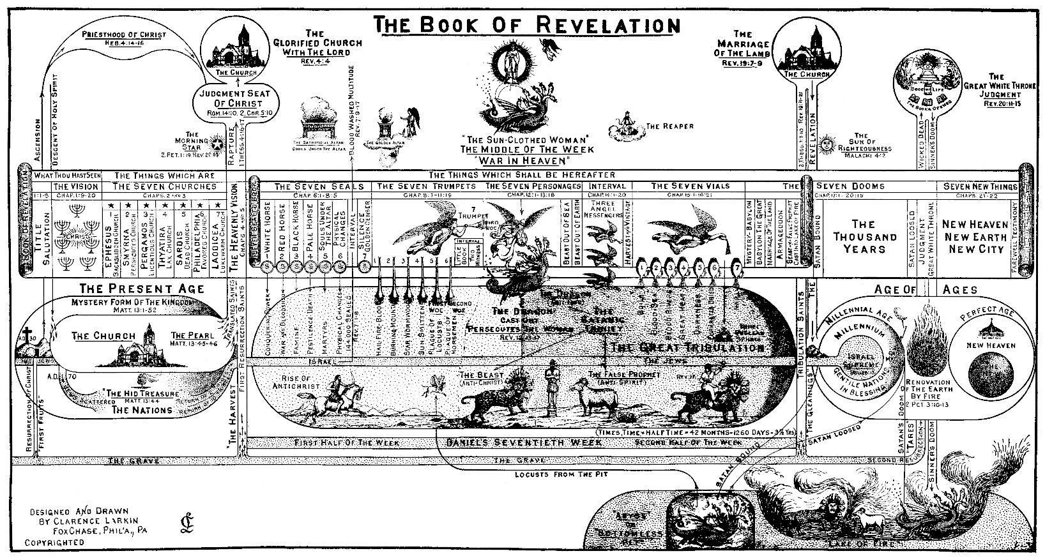](http://www.google.com/url?sa=i&rct=j&q=&esrc=s&frm=1&source=images&cd=&cad=rja&uact=8&docid=m95chdSGODAq7M&tbnid=VJISHE6qSINBpM:&ved=0CAUQjRw&url=http://www.preservedwords.com/disptruth/contents.htm&ei=9EtWU93zOKblyQHJqIHADA&bvm=bv.65177938,d.aWc&psig=AFQjCNHw32KAUNGqWzTzgDywGDTHCWGh3w&ust=1398250834306596)

**Assignment for Next Week: Read Rev. 2-3, Acts 20, and the Book of Ephesians**

**Prepare to “Be Amazed!” PTBA—Read John 21:1-4; look at the number 153 in verse 11. Read Mark 1:17, the “fishers of men” verse. Read John 21:1-14.**

**Compare this list from the gospels:**

Description Scripture # of People

1. The Leper Matt.8:2-4 1
2. Centurion and Servant Matt. 8:5-13 2
3. Peter’s Mother-in-law Matt. 8:14-15 1
4. Two Devil-possessed Matt. 8:18 2
5. Man with Palsy and Bearers Matt. 9:2 5
6. Jairus and His Daughter Matt. 9:18-25 2
7. Woman with Issue of Blood Matt. 9:21-22 1
8. Two Blind Men Matt. 9:27-31 2
9. Man Who Was Dumb Matt. 9:32-22 1
10. Eleven Apostles Matt.10:1-4 11
11. Man With Withered Hand Matt. 12:10-13 1
12. Devil-Possessed, Blind, Dumb Man Matt. 12:22 1
13. Brothers of Jesus Matt. 13:55 4
14. Woman of Canaan and Daughter Matt.15:22-28 2
15. Father and Son with Seizures Matt. 17:14-18 2
16. Blind Men at Jericho Matt. 20:30-34 2
17. Simon the Leper Matt. 26:6 1
18. Mary, Lazarus’ Sister Matt. 26:7 1
19. Centurion Matt. 27:54 1
20. Salome Matt. 27:56 1
21. Mary, Cleopas’ Wife Matt. 27:56 1
22. Mary Magdalene Matt. 27:56 1
23. Joseph of Arimathea Matt. 27:57-60 1
24. Man with Unclean Spirit Mark 1:23-26 1
25. Deaf and Dumb Man Mark 7:32-35 1
26. Blind Man Mark 8:22-26 1
27. Son of the Widow of Nain Luke 7:12-15 1
28. A Woman, a Sinner Luke 7:37-38 1
29. Joanna and Susanna Luke 8:3 2
30. Another Man (Follow Me) Luke 9:59-62 1
31. The Seventy Disciples Luke 10:1-9 70
32. Martha Luke 10:38-42 1
33. Crippled Woman Luke 13:11-13 1
34. Man With Dropsy Luke 14:2-4 1
35. Ten Lepers Luke 17:12-14 10
36. Blind Man Luke 18:35-43 1
37. Zacchaeus Luke 19:2-6 1
38. Malchus Luke 22:50-51 1
39. Thief on the Cross Luke 23:42-43 1
40. Two Disciples at Emmaus Luke 24:13-32 2
41. Nicodemus John 3:1-21 1
42. Samaritan Woman John 4:7-26 1
43. Nobleman with Sick Son John 4: 46-50 2
44. Invalid Man at Pool John 5:1-9 1
45. Adulteress John 8:3-11 1
46. Man Blind Since Birth John 9:1-41 1
47. Lazarus John 11:1-44 1
48. Mary, Mother of Jesus John 19:25 1

Total: **153 People,** “Fish,” Touched by Jesus (In Greek, the number 153 spells, “Sons of God”

### Connection to Daniel: Matthew 17:1, The Transfiguration, 17 And after six days Jesus took with him Peter and James, and John his brother, and led them up a high mountain by themselves.

#### Cross references:

1. [**Matthew 17:1**](http://www.biblegateway.com/passage/?search=Matthew+17%3A1%2CRevelation+1%3A13-17%2CDaniel+10%3A5-6&version=ESV#en-ESV-23701) **:** [**For ver. 1-8, see Mark 9:2-8; Luke 9:28-36**](http://www.biblegateway.com/passage/?search=Mark%209:2-Mark%209:8,%20Luke%209:28-Luke%209:36&version=ESV)
2. [**Matthew 17:1**](http://www.biblegateway.com/passage/?search=Matthew+17%3A1%2CRevelation+1%3A13-17%2CDaniel+10%3A5-6&version=ESV#en-ESV-23701) **:** [**ch. 26:37; Mark 5:37**](http://www.biblegateway.com/passage/?search=Matt%2026:37,%20Mark%205:37&version=ESV)

### Revelation 1:13-17,“and in the midst of the lampstands one like a son of man, clothed with a long robe and with a golden sash around his chest. 14The hairs of his head were white, like white wool, like snow. His eyes were like a flame of fire, 15his feet were like burnished bronze, refined in a furnace, and his voice was like the roar of many waters. 16In his right hand he held seven stars, from his mouth came a sharp two-edged sword, and his face was like the sun shining in full strength.”

1. [**Revelation 1:13**](http://www.biblegateway.com/passage/?search=Matthew+17%3A1%2CRevelation+1%3A13-17%2CDaniel+10%3A5-6&version=ESV#en-ESV-30695) **:** [**Dan. 7:13**](http://www.biblegateway.com/passage/?search=Dan%207:13&version=ESV)
2. [**Revelation 1:13**](http://www.biblegateway.com/passage/?search=Matthew+17%3A1%2CRevelation+1%3A13-17%2CDaniel+10%3A5-6&version=ESV#en-ESV-30695) **:** [**ch. 14:14; Dan. 10:16**](http://www.biblegateway.com/passage/?search=Rev%2014:14,%20Dan%2010:16&version=ESV)
3. [**Revelation 1:13**](http://www.biblegateway.com/passage/?search=Matthew+17%3A1%2CRevelation+1%3A13-17%2CDaniel+10%3A5-6&version=ESV#en-ESV-30695) **:** [**Dan. 10:5**](http://www.biblegateway.com/passage/?search=Dan%2010:5&version=ESV)
4. [**Revelation 1:13**](http://www.biblegateway.com/passage/?search=Matthew+17%3A1%2CRevelation+1%3A13-17%2CDaniel+10%3A5-6&version=ESV#en-ESV-30695) **:** [**ch. 15:6**](http://www.biblegateway.com/passage/?search=Rev%2015:6&version=ESV)
5. [**Revelation 1:14**](http://www.biblegateway.com/passage/?search=Matthew+17%3A1%2CRevelation+1%3A13-17%2CDaniel+10%3A5-6&version=ESV#en-ESV-30696) **:** [**Dan. 7:9**](http://www.biblegateway.com/passage/?search=Dan%207:9&version=ESV)
6. [**Revelation 1:14**](http://www.biblegateway.com/passage/?search=Matthew+17%3A1%2CRevelation+1%3A13-17%2CDaniel+10%3A5-6&version=ESV#en-ESV-30696) **:** [**ch. 2:18; 19:12; [Dan. 10:6]**](http://www.biblegateway.com/passage/?search=Rev%202:18,%20Rev%2019:12,%20Dan%2010:6&version=ESV)
7. [**Revelation 1:15**](http://www.biblegateway.com/passage/?search=Matthew+17%3A1%2CRevelation+1%3A13-17%2CDaniel+10%3A5-6&version=ESV#en-ESV-30697) **:** [**Ezek. 1:7; Dan. 10:6**](http://www.biblegateway.com/passage/?search=Ezek%201:7,%20Dan%2010:6&version=ESV)
8. [**Revelation 1:15**](http://www.biblegateway.com/passage/?search=Matthew+17%3A1%2CRevelation+1%3A13-17%2CDaniel+10%3A5-6&version=ESV#en-ESV-30697) **:** [**ch. 14:2; 19:6; Ezek. 43:2**](http://www.biblegateway.com/passage/?search=Rev%2014:2,%20Rev%2019:6,%20Ezek%2043:2&version=ESV)
9. [**Revelation 1:16**](http://www.biblegateway.com/passage/?search=Matthew+17%3A1%2CRevelation+1%3A13-17%2CDaniel+10%3A5-6&version=ESV#en-ESV-30698) **:** [**ver. 20; ch. 2:1; 3:1**](http://www.biblegateway.com/passage/?search=Rev%201:20,%20Rev%202:1,%20Rev%203:1&version=ESV)
10. [**Revelation 1:16**](http://www.biblegateway.com/passage/?search=Matthew+17%3A1%2CRevelation+1%3A13-17%2CDaniel+10%3A5-6&version=ESV#en-ESV-30698) **:** [**ch. 19:15; [ch. 2:12, 16; Isa. 49:2; Eph. 6:17; Heb. 4:12]**](http://www.biblegateway.com/passage/?search=Rev%2019:15,%20Rev%202:12,%20Rev%202:16,%20Isa%2049:2,%20Eph%206:17,%20Heb%204:12&version=ESV)
11. [**Revelation 1:16**](http://www.biblegateway.com/passage/?search=Matthew+17%3A1%2CRevelation+1%3A13-17%2CDaniel+10%3A5-6&version=ESV#en-ESV-30698) **:** [**Matt. 17:2**](http://www.biblegateway.com/passage/?search=Matt%2017:2&version=ESV)
12. [**Revelation 1:16**](http://www.biblegateway.com/passage/?search=Matthew+17%3A1%2CRevelation+1%3A13-17%2CDaniel+10%3A5-6&version=ESV#en-ESV-30698) **:** [**Judg. 5:31**](http://www.biblegateway.com/passage/?search=Judg%205:31&version=ESV)
13. [**Revelation 1:17**](http://www.biblegateway.com/passage/?search=Matthew+17%3A1%2CRevelation+1%3A13-17%2CDaniel+10%3A5-6&version=ESV#en-ESV-30699) **:** [**Dan. 8:17, 18; 10:9, 10, 15; [Luke 24:37; John 21:12]**](http://www.biblegateway.com/passage/?search=Dan%208:17-Dan%208:18,%20Dan%2010:9-Dan%2010:10,%20Dan%2010:15,%20Luke%2024:37,%20John%2021:12&version=ESV)
14. [**Revelation 1:17**](http://www.biblegateway.com/passage/?search=Matthew+17%3A1%2CRevelation+1%3A13-17%2CDaniel+10%3A5-6&version=ESV#en-ESV-30699) **:** [**Dan. 8:17, 18; 10:9, 10, 15; [Luke 24:37; John 21:12]**](http://www.biblegateway.com/passage/?search=Dan%208:17-Dan%208:18,%20Dan%2010:9-Dan%2010:10,%20Dan%2010:15,%20Luke%2024:37,%20John%2021:12&version=ESV)
15. [**Revelation 1:17**](http://www.biblegateway.com/passage/?search=Matthew+17%3A1%2CRevelation+1%3A13-17%2CDaniel+10%3A5-6&version=ESV#en-ESV-30699) **:** [**Matt. 17:7**](http://www.biblegateway.com/passage/?search=Matt%2017:7&version=ESV)
16. [**Revelation 1:17**](http://www.biblegateway.com/passage/?search=Matthew+17%3A1%2CRevelation+1%3A13-17%2CDaniel+10%3A5-6&version=ESV#en-ESV-30699) **:** [**ch. 2:8; 22:13; Isa. 41:4; 44:6; 48:12**](http://www.biblegateway.com/passage/?search=Rev%202:8,%20Rev%2022:13,%20Isa%2041:4,%20Isa%2044:6,%20Isa%2048:12&version=ESV)

**Daniel 10:5-6,** “**I lifted up my eyes and looked, and behold, a man clothed in linen, with a belt of fine gold from Uphaz around his waist. 6His body was like beryl, his face like the appearance of lightning, his eyes like flaming torches, his arms and legs like the gleam of burnished bronze, and the sound of his words like the sound of a multitude**